UNITED STATES
SECURITIES AND EXCHANGE COMMISSION
Washington, D.C. 20549
FORM 8-K

CURRENT REPORT
Pursuant to Section 13 or 15(d)
of the Securities Exchange Act of 1934

Date of Report (date of earliest event reported): September 30, 2026

CONDUENT INCORPORATED
(Exact name of registrant as specified in its charter)
New York |  |  |  |  |  | 001-37817 |  |  |  |  |  | 81-2983623
(State or other jurisdiction of  incorporation or organization) |  |  |  |  |  | (Commission  File Number) |  |  |  |  |  | (IRS Employer  Identification No.)
100 Campus Drive, |  |  |  |  |  | Suite 200,
Florham Park, |  |  | New Jersey
07932
(Address of principal executive offices) (Zip Code)

Registrant’s telephone number, including area code: (844) 663-2638
Not Applicable
(Former name or former address, if changed since last report)
Check the appropriate box below if the Form 8-K filing is intended to simultaneously satisfy the filing obligation of the registrant under any of the following provisions (see General Instruction A.2. below):

☐ |  |  | Written communications pursuant to Rule 425 under the Securities Act (17 CFR 230.425)
☐ |  |  | Soliciting material pursuant to Rule 14a-12 under the Exchange Act (17 CFR 240.14a-12)
☐ |  |  | Pre-commencement communications pursuant to Rule 14d-2(b) under the Exchange Act (17 CFR 240.14d-2(b))
☐ |  |  | Pre-commencement communications pursuant to Rule 13e-4(c) under the Exchange Act (17 CFR 240.13e-4(c))

Securities registered pursuant to Section 12(b) of the Act:
Title of each class |  |  | Trading Symbol(s) |  |  | Name of each exchange on which registered
Common Stock, $0.01 par value |  |  | CNDT |  |  | NASDAQ Global Select Market
Indicate by check mark whether the registrant is an emerging growth company as defined in Rule 405 of the Securities Act of 1933 (CFR 230.405) or Rule 12b-2 of the Securities Exchange Act of 1934 (CFR 240.12b-2).
Emerging Growth Company ☐
If an emerging growth company, indicate by check mark if the registrant has elected not to use the extended transition period for complying with any new or revised financial accounting standards provided pursuant to Section 13(a) of the Exchange Act. ☐

Item 1.01. Entry into a Material Definitive Agreement.
As previously announced on May 21, 2026, Conduent Incorporated ("Conduent"), by and through its wholly owned subsidiary, Conduent Business Services, LLC (“CBS” and together with Conduent, the "Company"), entered into an Equity Interest Purchase Agreement (the “Purchase Agreement”) with Modaxo USA Holdings, Inc. (“US Buyer”) and Modaxo France Holdings SAS (“French Buyer” and together with US Buyer, “Buyer”), and Modaxo Group Inc. Under the Purchase Agreement, CBS agreed to sell all of the issued and outstanding equity interests of Conduent Transport Solutions, Inc. and certain non-U.S. subsidiaries that comprise the Company’s public transit and fare collection business on the terms and subject to the conditions set forth therein for $164 million (the “Transit Sale”).
On September 30, 2026, CBS, Buyer and Modaxo Group, Inc. entered into the First Amendment to Equity Interest Purchase Agreement (the “Amendment”) to amend the Purchase Agreement to, among other things, (1) remove US Buyer as a party to the Purchase Agreement such that French Buyer is the sole Buyer under the Purchase Agreement, (2) provide for certain assets located in India and owned by Conduent Business Services India LLP to be sold to a subsidiary of French Buyer at a subsequent closing, subject to receipt of required regulatory approval in India, and (3) waive certain closing conditions related to certain governmental filings. All other material terms of the Purchase Agreement, which was previously filed by Conduent as Exhibit 2.3 to the Quarterly Report on Form 10-Q dated August 10, 2026, remain the same. The foregoing description of the Amendment does not purport to be complete and is qualified in its entirety by the full text of the Amendment, which is filed as Exhibit 2.1 to this Current Report on Form 8-K (this “Report”) and is incorporated herein by reference.
Item 2.01. Completion of Acquisition or Disposition of Assets.
The information set forth in Item 1.01 of this Report is incorporated by reference herein.
On October 1, 2026, the Transit Sale was completed and the Company received $140 million from the Buyer in the form of cash consideration. At closing the Buyer retained (i) a $10 million purchase price holdback for a maximum of one year to secure net tangible asset related adjustments, (ii) a $12 million special holdback, the release of which is dependent upon certain target completion dates for a former customer and (iii) certain other closing adjustments of $2 million. In the fourth quarter of 2026, the Company will pay transaction costs of $3 million and income taxes of $7 million. In addition, $15 million in cash was transferred to the Buyer at close. Conduent intends to use the net proceeds received from the Transit Sale of $125 million for the repayment of the revolving credit facility based on the terms of the credit agreement.
Other than in respect of the Purchase Agreement, the Amendment and the transition services arrangements entered into in connection with the Transit Sale, there is no material relationship between the Company and French Buyer.
Item 7.01. Regulation FD Disclosure
On October 1, 2026, the Company issued a press release announcing the completion of the Transit Sale, a copy of which is furnished as Exhibit 99.1 hereto.
The information furnished pursuant to this Item 7.01, including Exhibit 99.1, will not be deemed “filed” for purposes of Section 18 of the Securities Exchange Act of 1934, as amended (the “Exchange Act”), or incorporated by reference in any filing under the Securities Act of 1933, as amended, or the Exchange Act, except as may be expressly set forth by specific reference in such a filing.
Item 9.01. Financial Statements and Exhibits.
(b) Pro Forma Financial Information.
The following unaudited pro forma condensed consolidated financial statements of Conduent, after giving effect to the Transit Sale, are filed as Exhibit 99.2 to this Current Report on Form 8-K and incorporated by reference herein:
•Conduent’s unaudited pro forma condensed consolidated balance sheet as of June 30, 2026; and
•Conduent’s unaudited pro forma condensed consolidated statements of income (loss) for the years ended December 31, 2025, December 31, 2024, and December 31, 2023, and for the six months ended June 30, 2026.
The unaudited pro forma condensed consolidated financial statements are not intended to represent or be indicative of Conduent’s consolidated results of operations or financial position that would have been reported had the Transit

Sale been completed as of the dates presented and should not be taken as representation of Conduent’s future consolidated results of operations or financial condition. The pro forma adjustments are based on available information and certain assumptions that management believes are reasonable under the circumstances.
(d) Exhibits.
Exhibit No. |  |  |  |  |  | Description
2.1* |  |  |  |  |  | First Amendment to Equity Interest Purchase Agreement, dated September 30, 2026, among Conduent Business Services, LLC, Modaxo USA Holdings, Inc., Modaxo France Holdings SAS, and Modaxo Group, Inc.
99.1 |  |  |  |  |  | Press Release, dated October 1, 2026 (furnished pursuant to Item 7.01).
99.2 |  |  |  |  |  | Unaudited Pro Forma Condensed Consolidated Financial Statements of Conduent Incorporated
104 |  |  |  |  |  | Cover Page Interactive Data File (embedded within the Inline XBRL document)
*Certain attachments have been omitted pursuant to Item 601(a)(5) of Regulation S-K because the information contained therein is not material and is not otherwise publicly disclosed. Conduent will furnish supplementally copies of such attachments to the SEC or its staff upon request.

Forward-Looking Statements
This Report and any exhibits to this Report may contain "forward-looking statements" as defined in the Private Securities Litigation Reform Act of 1995, as amended. The words "anticipate," "believe," "estimate," "expect," "plan," "intend," "will," "aim," "should," "could," "forecast," "target," "may," "continue to," "endeavor," "if," "growing," "projected," "potential," "likely," "see," "ahead," "further," "going forward," "on the horizon," and similar expressions (including the negative and plural forms of such words and phrases), as they relate to us, are intended to identify forward-looking statements, but the absence of these words does not mean that a statement is not forward-looking. These statements include, but may not be limited to, statements regarding the Transit Sale, the expected receipt of the holdback amounts described in Item 2.01, the intended use of proceeds from the Transit Sale, expected transaction costs and income taxes and, as set forth in Exhibit 99.2, the pending sale of the Company's Tolling business. These statements reflect our current views with respect to future events and are subject to certain risks, uncertainties and assumptions, many of which are outside of our control, that could cause actual results to differ materially from those expected or implied by such forward-looking statements contained in this Report, any exhibits to this Report and other public statements we make. Important factors and uncertainties that could cause our actual results to differ materially from those in our forward-looking statements include, but are not limited to: the risk that we do not receive some or all of the holdback amounts, including as a result of post-closing purchase price adjustments, indemnification claims or the failure to satisfy the conditions to release; the risk that transaction costs, Taxes or other amounts payable in connection with the Transit Sale exceed our current expectations; unexpected costs or liabilities in connection with the Transit Sale, including under our post-closing obligations; with respect to the pending sale of our Tolling business, the risk that required regulatory approvals, third-party consents or other closing conditions are not satisfied such that the closing is delayed or does not occur; the risk of litigation or regulatory actions; our inability to retain and hire key personnel; and other factors that are set forth in the "Risk Factors" and other sections of our Annual Report on Form 10-K, as well as in our Quarterly Reports on Form 10-Q and Current Reports on Form 8-K filed with or furnished to the Securities and Exchange Commission. Any forward-looking statements made by us in this Report speak only as of the date on which they are made. We are under no obligation to, and expressly disclaim any obligation to, update or alter our forward-looking statements, whether because of new information, subsequent events or otherwise, except as required by law.

SIGNATURES
Pursuant to the requirements of the Securities Exchange Act of 1934, Registrant has duly authorized this report to be signed on its behalf by the undersigned duly authorized.
Date: October 6, 2026

CONDUENT INCORPORATED
By: |  |  |  |  |  | /s/ GEORGE ABATE
 |  |  |  |  |  | George Abate
 |  |  |  |  |  | Vice President, Chief Accounting Officer
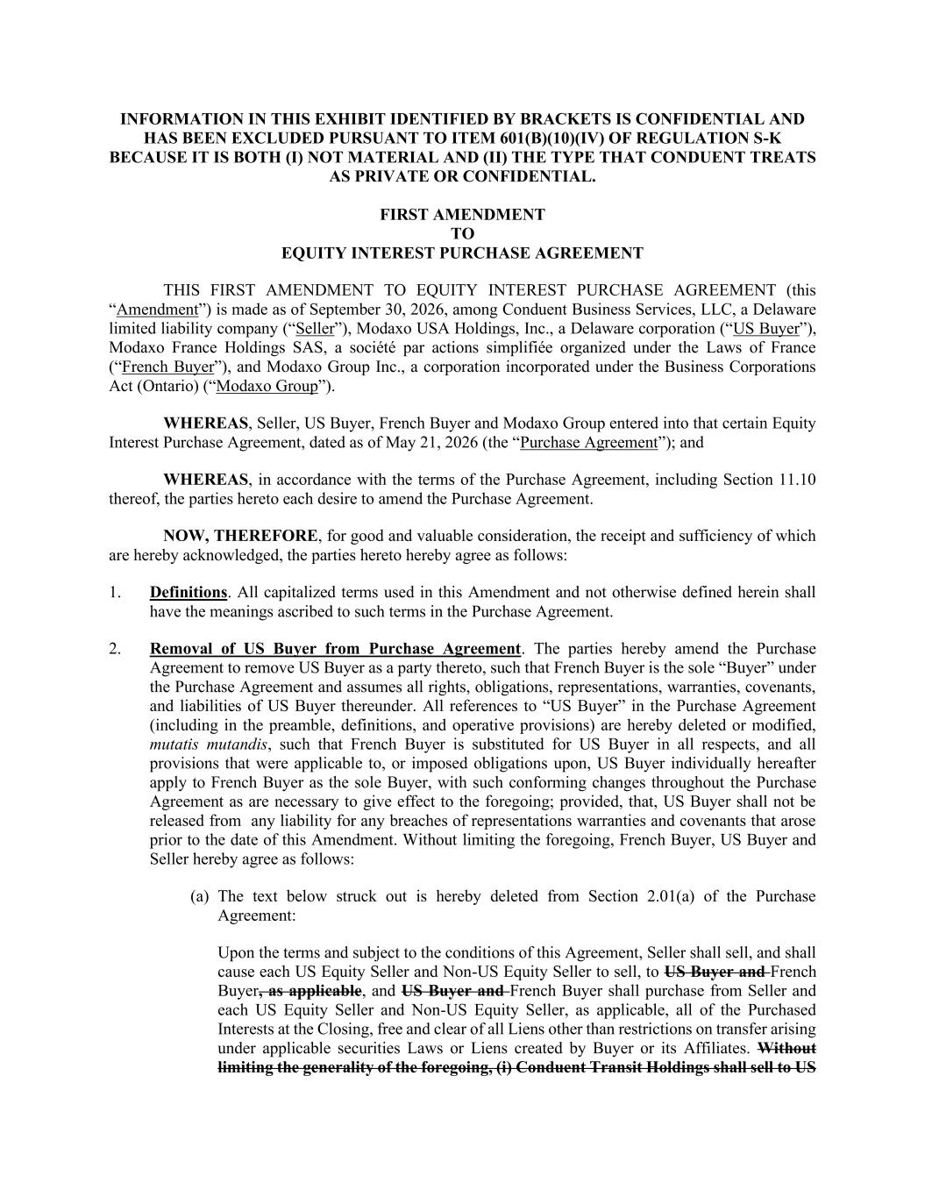

INFORMATION IN THIS EXHIBIT IDENTIFIED BY BRACKETS IS CONFIDENTIAL AND HAS BEEN EXCLUDED PURSUANT TO ITEM 601(B)(10)(IV) OF REGULATION S-K BECAUSE IT IS BOTH (I) NOT MATERIAL AND (II) THE TYPE THAT CONDUENT TREATS AS PRIVATE OR CONFIDENTIAL. FIRST AMENDMENT TO EQUITY INTEREST PURCHASE AGREEMENT THIS FIRST AMENDMENT TO EQUITY INTEREST PURCHASE AGREEMENT (this “Amendment”) is made as of September 30, 2026, among Conduent Business Services, LLC, a Delaware limited liability company (“Seller”), Modaxo USA Holdings, Inc., a Delaware corporation (“US Buyer”), Modaxo France Holdings SAS, a société par actions simplifiée organized under the Laws of France (“French Buyer”), and Modaxo Group Inc., a corporation incorporated under the Business Corporations Act (Ontario) (“Modaxo Group”). WHEREAS, Seller, US Buyer, French Buyer and Modaxo Group entered into that certain Equity Interest Purchase Agreement, dated as of May 21, 2026 (the “Purchase Agreement”); and WHEREAS, in accordance with the terms of the Purchase Agreement, including Section 11.10 thereof, the parties hereto each desire to amend the Purchase Agreement. NOW, THEREFORE, for good and valuable consideration, the receipt and sufficiency of which are hereby acknowledged, the parties hereto hereby agree as follows: 1. Definitions. All capitalized terms used in this Amendment and not otherwise defined herein shall have the meanings ascribed to such terms in the Purchase Agreement. 2. Removal of US Buyer from Purchase Agreement. The parties hereby amend the Purchase Agreement to remove US Buyer as a party thereto, such that French Buyer is the sole “Buyer” under the Purchase Agreement and assumes all rights, obligations, representations, warranties, covenants, and liabilities of US Buyer thereunder. All references to “US Buyer” in the Purchase Agreement (including in the preamble, definitions, and operative provisions) are hereby deleted or modified, mutatis mutandis, such that French Buyer is substituted for US Buyer in all respects, and all provisions that were applicable to, or imposed obligations upon, US Buyer individually hereafter apply to French Buyer as the sole Buyer, with such conforming changes throughout the Purchase Agreement as are necessary to give effect to the foregoing; provided, that, US Buyer shall not be released from any liability for any breaches of representations warranties and covenants that arose prior to the date of this Amendment. Without limiting the foregoing, French Buyer, US Buyer and Seller hereby agree as follows: (a) The text below struck out is hereby deleted from Section 2.01(a) of the Purchase Agreement: Upon the terms and subject to the conditions of this Agreement, Seller shall sell, and shall cause each US Equity Seller and Non-US Equity Seller to sell, to US Buyer and French Buyer, as applicable, and US Buyer and French Buyer shall purchase from Seller and each US Equity Seller and Non-US Equity Seller, as applicable, all of the Purchased Interests at the Closing, free and clear of all Liens other than restrictions on transfer arising under applicable securities Laws or Liens created by Buyer or its Affiliates. Without limiting the generality of the foregoing, (i) Conduent Transit Holdings shall sell to US

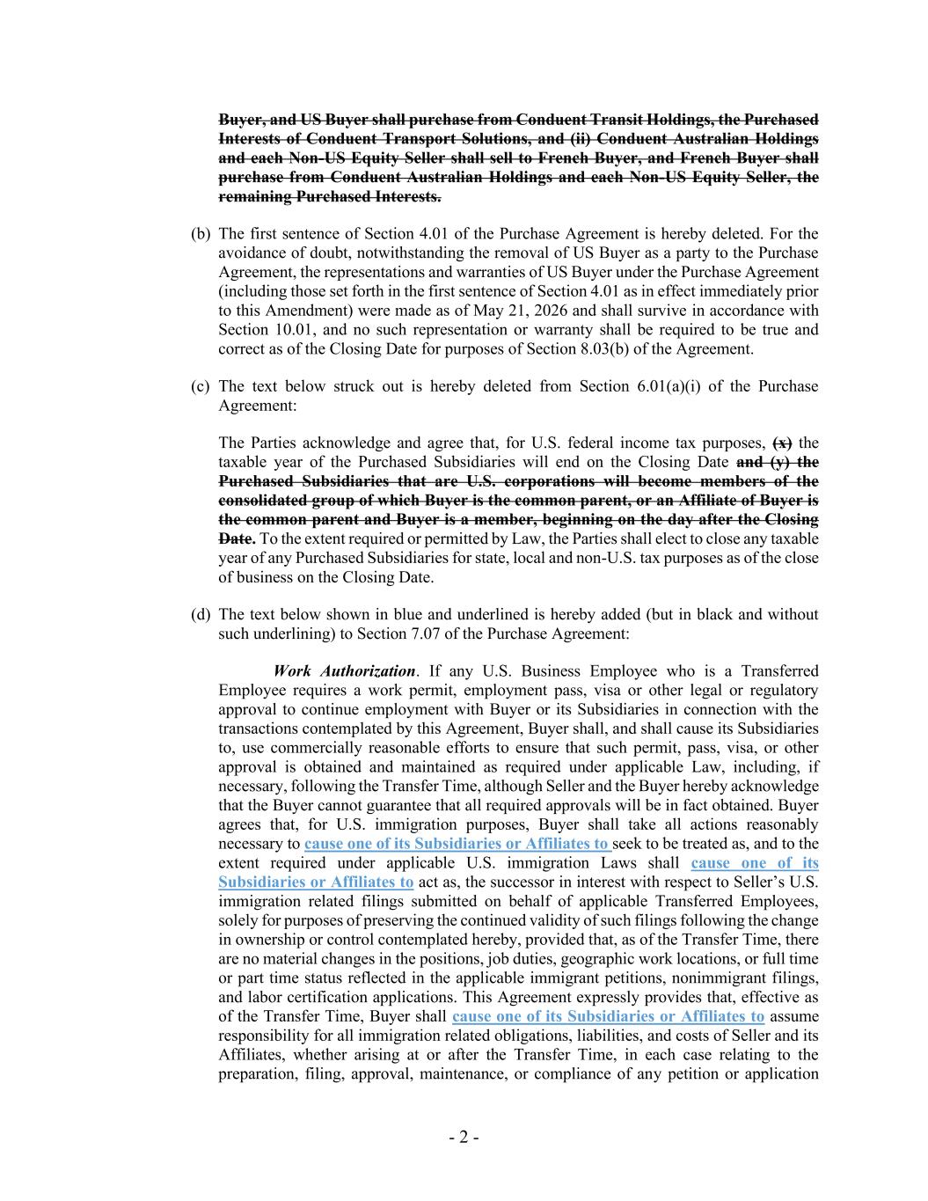
- 2 - Buyer, and US Buyer shall purchase from Conduent Transit Holdings, the Purchased Interests of Conduent Transport Solutions, and (ii) Conduent Australian Holdings and each Non-US Equity Seller shall sell to French Buyer, and French Buyer shall purchase from Conduent Australian Holdings and each Non-US Equity Seller, the remaining Purchased Interests. (b) The first sentence of Section 4.01 of the Purchase Agreement is hereby deleted. For the avoidance of doubt, notwithstanding the removal of US Buyer as a party to the Purchase Agreement, the representations and warranties of US Buyer under the Purchase Agreement (including those set forth in the first sentence of Section 4.01 as in effect immediately prior to this Amendment) were made as of May 21, 2026 and shall survive in accordance with Section 10.01, and no such representation or warranty shall be required to be true and correct as of the Closing Date for purposes of Section 8.03(b) of the Agreement. (c) The text below struck out is hereby deleted from Section 6.01(a)(i) of the Purchase Agreement: The Parties acknowledge and agree that, for U.S. federal income tax purposes, (x) the taxable year of the Purchased Subsidiaries will end on the Closing Date and (y) the Purchased Subsidiaries that are U.S. corporations will become members of the consolidated group of which Buyer is the common parent, or an Affiliate of Buyer is the common parent and Buyer is a member, beginning on the day after the Closing Date. To the extent required or permitted by Law, the Parties shall elect to close any taxable year of any Purchased Subsidiaries for state, local and non-U.S. tax purposes as of the close of business on the Closing Date. (d) The text below shown in blue and underlined is hereby added (but in black and without such underlining) to Section 7.07 of the Purchase Agreement: Work Authorization. If any U.S. Business Employee who is a Transferred Employee requires a work permit, employment pass, visa or other legal or regulatory approval to continue employment with Buyer or its Subsidiaries in connection with the transactions contemplated by this Agreement, Buyer shall, and shall cause its Subsidiaries to, use commercially reasonable efforts to ensure that such permit, pass, visa, or other approval is obtained and maintained as required under applicable Law, including, if necessary, following the Transfer Time, although Seller and the Buyer hereby acknowledge that the Buyer cannot guarantee that all required approvals will be in fact obtained. Buyer agrees that, for U.S. immigration purposes, Buyer shall take all actions reasonably necessary to cause one of its Subsidiaries or Affiliates to seek to be treated as, and to the extent required under applicable U.S. immigration Laws shall cause one of its Subsidiaries or Affiliates to act as, the successor in interest with respect to Seller’s U.S. immigration related filings submitted on behalf of applicable Transferred Employees, solely for purposes of preserving the continued validity of such filings following the change in ownership or control contemplated hereby, provided that, as of the Transfer Time, there are no material changes in the positions, job duties, geographic work locations, or full time or part time status reflected in the applicable immigrant petitions, nonimmigrant filings, and labor certification applications. This Agreement expressly provides that, effective as of the Transfer Time, Buyer shall cause one of its Subsidiaries or Affiliates to assume responsibility for all immigration related obligations, liabilities, and costs of Seller and its Affiliates, whether arising at or after the Transfer Time, in each case relating to the preparation, filing, approval, maintenance, or compliance of any petition or application

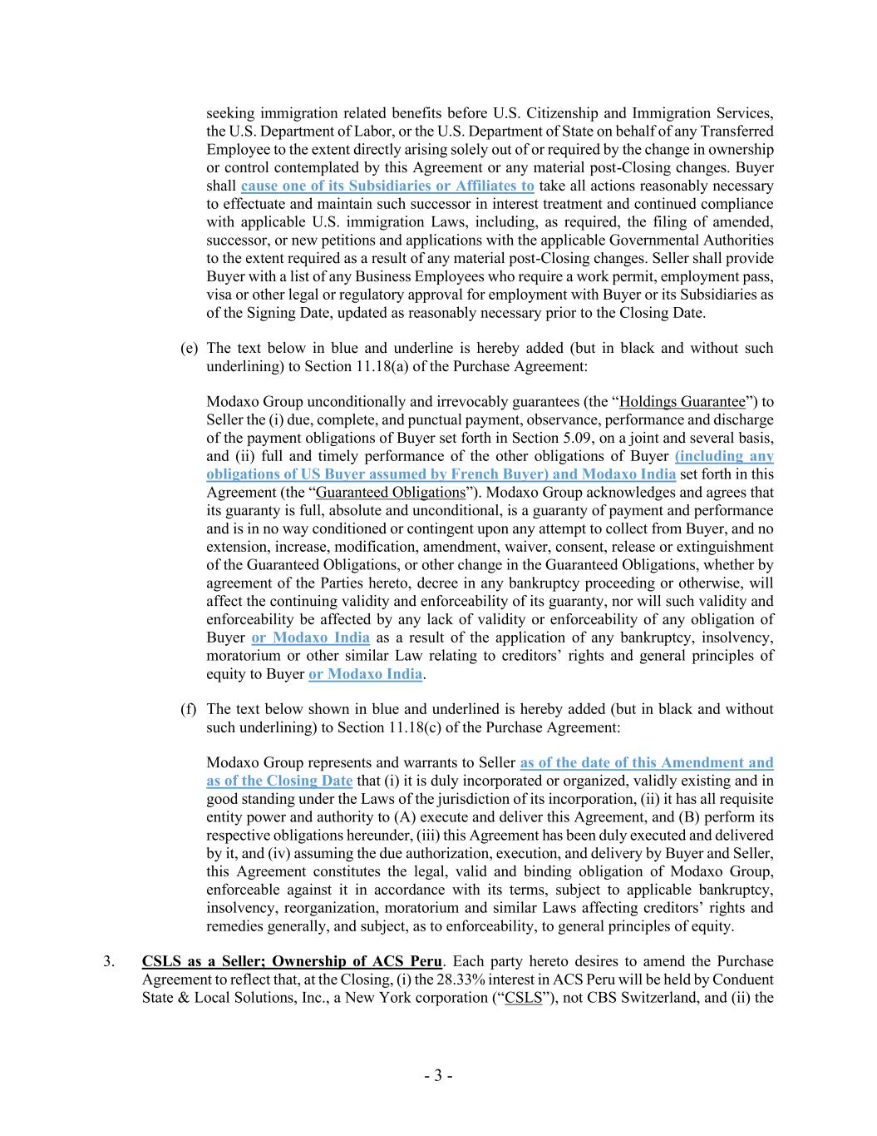
- 3 - seeking immigration related benefits before U.S. Citizenship and Immigration Services, the U.S. Department of Labor, or the U.S. Department of State on behalf of any Transferred Employee to the extent directly arising solely out of or required by the change in ownership or control contemplated by this Agreement or any material post-Closing changes. Buyer shall cause one of its Subsidiaries or Affiliates to take all actions reasonably necessary to effectuate and maintain such successor in interest treatment and continued compliance with applicable U.S. immigration Laws, including, as required, the filing of amended, successor, or new petitions and applications with the applicable Governmental Authorities to the extent required as a result of any material post-Closing changes. Seller shall provide Buyer with a list of any Business Employees who require a work permit, employment pass, visa or other legal or regulatory approval for employment with Buyer or its Subsidiaries as of the Signing Date, updated as reasonably necessary prior to the Closing Date. (e) The text below in blue and underline is hereby added (but in black and without such underlining) to Section 11.18(a) of the Purchase Agreement: Modaxo Group unconditionally and irrevocably guarantees (the “Holdings Guarantee”) to Seller the (i) due, complete, and punctual payment, observance, performance and discharge of the payment obligations of Buyer set forth in Section 5.09, on a joint and several basis, and (ii) full and timely performance of the other obligations of Buyer (including any obligations of US Buyer assumed by French Buyer) and Modaxo India set forth in this Agreement (the “Guaranteed Obligations”). Modaxo Group acknowledges and agrees that its guaranty is full, absolute and unconditional, is a guaranty of payment and performance and is in no way conditioned or contingent upon any attempt to collect from Buyer, and no extension, increase, modification, amendment, waiver, consent, release or extinguishment of the Guaranteed Obligations, or other change in the Guaranteed Obligations, whether by agreement of the Parties hereto, decree in any bankruptcy proceeding or otherwise, will affect the continuing validity and enforceability of its guaranty, nor will such validity and enforceability be affected by any lack of validity or enforceability of any obligation of Buyer or Modaxo India as a result of the application of any bankruptcy, insolvency, moratorium or other similar Law relating to creditors’ rights and general principles of equity to Buyer or Modaxo India. (f) The text below shown in blue and underlined is hereby added (but in black and without such underlining) to Section 11.18(c) of the Purchase Agreement: Modaxo Group represents and warrants to Seller as of the date of this Amendment and as of the Closing Date that (i) it is duly incorporated or organized, validly existing and in good standing under the Laws of the jurisdiction of its incorporation, (ii) it has all requisite entity power and authority to (A) execute and deliver this Agreement, and (B) perform its respective obligations hereunder, (iii) this Agreement has been duly executed and delivered by it, and (iv) assuming the due authorization, execution, and delivery by Buyer and Seller, this Agreement constitutes the legal, valid and binding obligation of Modaxo Group, enforceable against it in accordance with its terms, subject to applicable bankruptcy, insolvency, reorganization, moratorium and similar Laws affecting creditors’ rights and remedies generally, and subject, as to enforceability, to general principles of equity. 3. CSLS as a Seller; Ownership of ACS Peru. Each party hereto desires to amend the Purchase Agreement to reflect that, at the Closing, (i) the 28.33% interest in ACS Peru will be held by Conduent State & Local Solutions, Inc., a New York corporation (“CSLS”), not CBS Switzerland, and (ii) the

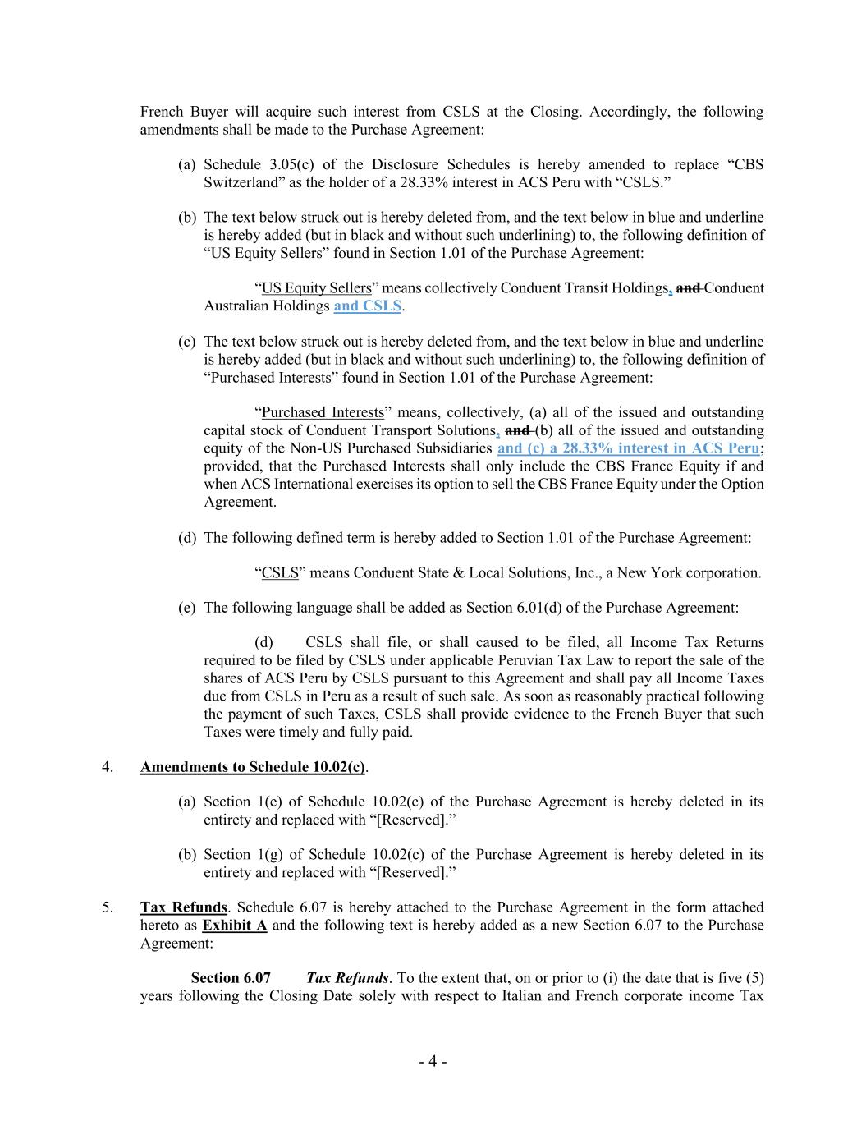
- 4 - French Buyer will acquire such interest from CSLS at the Closing. Accordingly, the following amendments shall be made to the Purchase Agreement: (a) Schedule 3.05(c) of the Disclosure Schedules is hereby amended to replace “CBS Switzerland” as the holder of a 28.33% interest in ACS Peru with “CSLS.” (b) The text below struck out is hereby deleted from, and the text below in blue and underline is hereby added (but in black and without such underlining) to, the following definition of “US Equity Sellers” found in Section 1.01 of the Purchase Agreement: “US Equity Sellers” means collectively Conduent Transit Holdings, and Conduent Australian Holdings and CSLS. (c) The text below struck out is hereby deleted from, and the text below in blue and underline is hereby added (but in black and without such underlining) to, the following definition of “Purchased Interests” found in Section 1.01 of the Purchase Agreement: “Purchased Interests” means, collectively, (a) all of the issued and outstanding capital stock of Conduent Transport Solutions, and (b) all of the issued and outstanding equity of the Non-US Purchased Subsidiaries and (c) a 28.33% interest in ACS Peru; provided, that the Purchased Interests shall only include the CBS France Equity if and when ACS International exercises its option to sell the CBS France Equity under the Option Agreement. (d) The following defined term is hereby added to Section 1.01 of the Purchase Agreement: “CSLS” means Conduent State & Local Solutions, Inc., a New York corporation. (e) The following language shall be added as Section 6.01(d) of the Purchase Agreement: (d) CSLS shall file, or shall caused to be filed, all Income Tax Returns required to be filed by CSLS under applicable Peruvian Tax Law to report the sale of the shares of ACS Peru by CSLS pursuant to this Agreement and shall pay all Income Taxes due from CSLS in Peru as a result of such sale. As soon as reasonably practical following the payment of such Taxes, CSLS shall provide evidence to the French Buyer that such Taxes were timely and fully paid. 4. Amendments to Schedule 10.02(c). (a) Section 1(e) of Schedule 10.02(c) of the Purchase Agreement is hereby deleted in its entirety and replaced with “[Reserved].” (b) Section 1(g) of Schedule 10.02(c) of the Purchase Agreement is hereby deleted in its entirety and replaced with “[Reserved].” 5. Tax Refunds. Schedule 6.07 is hereby attached to the Purchase Agreement in the form attached hereto as Exhibit A and the following text is hereby added as a new Section 6.07 to the Purchase Agreement: Section 6.07 Tax Refunds. To the extent that, on or prior to (i) the date that is five (5) years following the Closing Date solely with respect to Italian and French corporate income Tax

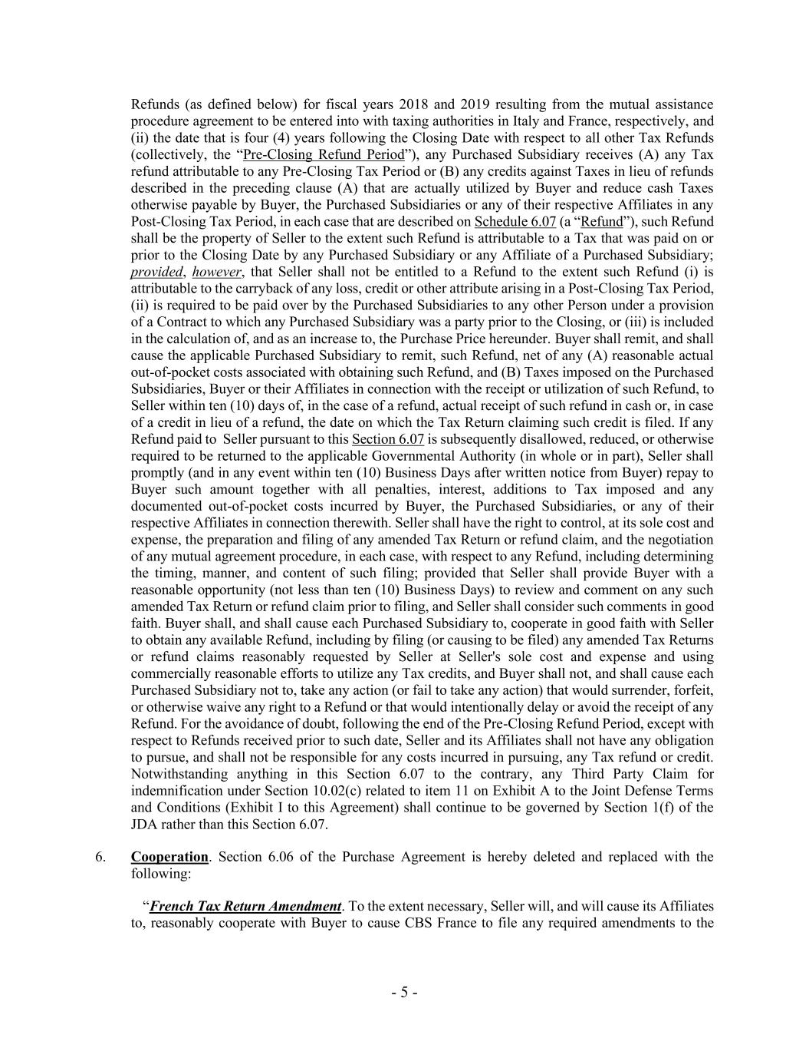
- 5 - Refunds (as defined below) for fiscal years 2018 and 2019 resulting from the mutual assistance procedure agreement to be entered into with taxing authorities in Italy and France, respectively, and (ii) the date that is four (4) years following the Closing Date with respect to all other Tax Refunds (collectively, the “Pre-Closing Refund Period”), any Purchased Subsidiary receives (A) any Tax refund attributable to any Pre-Closing Tax Period or (B) any credits against Taxes in lieu of refunds described in the preceding clause (A) that are actually utilized by Buyer and reduce cash Taxes otherwise payable by Buyer, the Purchased Subsidiaries or any of their respective Affiliates in any Post-Closing Tax Period, in each case that are described on Schedule 6.07 (a “Refund”), such Refund shall be the property of Seller to the extent such Refund is attributable to a Tax that was paid on or prior to the Closing Date by any Purchased Subsidiary or any Affiliate of a Purchased Subsidiary; provided, however, that Seller shall not be entitled to a Refund to the extent such Refund (i) is attributable to the carryback of any loss, credit or other attribute arising in a Post-Closing Tax Period, (ii) is required to be paid over by the Purchased Subsidiaries to any other Person under a provision of a Contract to which any Purchased Subsidiary was a party prior to the Closing, or (iii) is included in the calculation of, and as an increase to, the Purchase Price hereunder. Buyer shall remit, and shall cause the applicable Purchased Subsidiary to remit, such Refund, net of any (A) reasonable actual out-of-pocket costs associated with obtaining such Refund, and (B) Taxes imposed on the Purchased Subsidiaries, Buyer or their Affiliates in connection with the receipt or utilization of such Refund, to Seller within ten (10) days of, in the case of a refund, actual receipt of such refund in cash or, in case of a credit in lieu of a refund, the date on which the Tax Return claiming such credit is filed. If any Refund paid to Seller pursuant to this Section 6.07 is subsequently disallowed, reduced, or otherwise required to be returned to the applicable Governmental Authority (in whole or in part), Seller shall promptly (and in any event within ten (10) Business Days after written notice from Buyer) repay to Buyer such amount together with all penalties, interest, additions to Tax imposed and any documented out-of-pocket costs incurred by Buyer, the Purchased Subsidiaries, or any of their respective Affiliates in connection therewith. Seller shall have the right to control, at its sole cost and expense, the preparation and filing of any amended Tax Return or refund claim, and the negotiation of any mutual agreement procedure, in each case, with respect to any Refund, including determining the timing, manner, and content of such filing; provided that Seller shall provide Buyer with a reasonable opportunity (not less than ten (10) Business Days) to review and comment on any such amended Tax Return or refund claim prior to filing, and Seller shall consider such comments in good faith. Buyer shall, and shall cause each Purchased Subsidiary to, cooperate in good faith with Seller to obtain any available Refund, including by filing (or causing to be filed) any amended Tax Returns or refund claims reasonably requested by Seller at Seller's sole cost and expense and using commercially reasonable efforts to utilize any Tax credits, and Buyer shall not, and shall cause each Purchased Subsidiary not to, take any action (or fail to take any action) that would surrender, forfeit, or otherwise waive any right to a Refund or that would intentionally delay or avoid the receipt of any Refund. For the avoidance of doubt, following the end of the Pre-Closing Refund Period, except with respect to Refunds received prior to such date, Seller and its Affiliates shall not have any obligation to pursue, and shall not be responsible for any costs incurred in pursuing, any Tax refund or credit. Notwithstanding anything in this Section 6.07 to the contrary, any Third Party Claim for indemnification under Section 10.02(c) related to item 11 on Exhibit A to the Joint Defense Terms and Conditions (Exhibit I to this Agreement) shall continue to be governed by Section 1(f) of the JDA rather than this Section 6.07. 6. Cooperation. Section 6.06 of the Purchase Agreement is hereby deleted and replaced with the following: “French Tax Return Amendment. To the extent necessary, Seller will, and will cause its Affiliates to, reasonably cooperate with Buyer to cause CBS France to file any required amendments to the

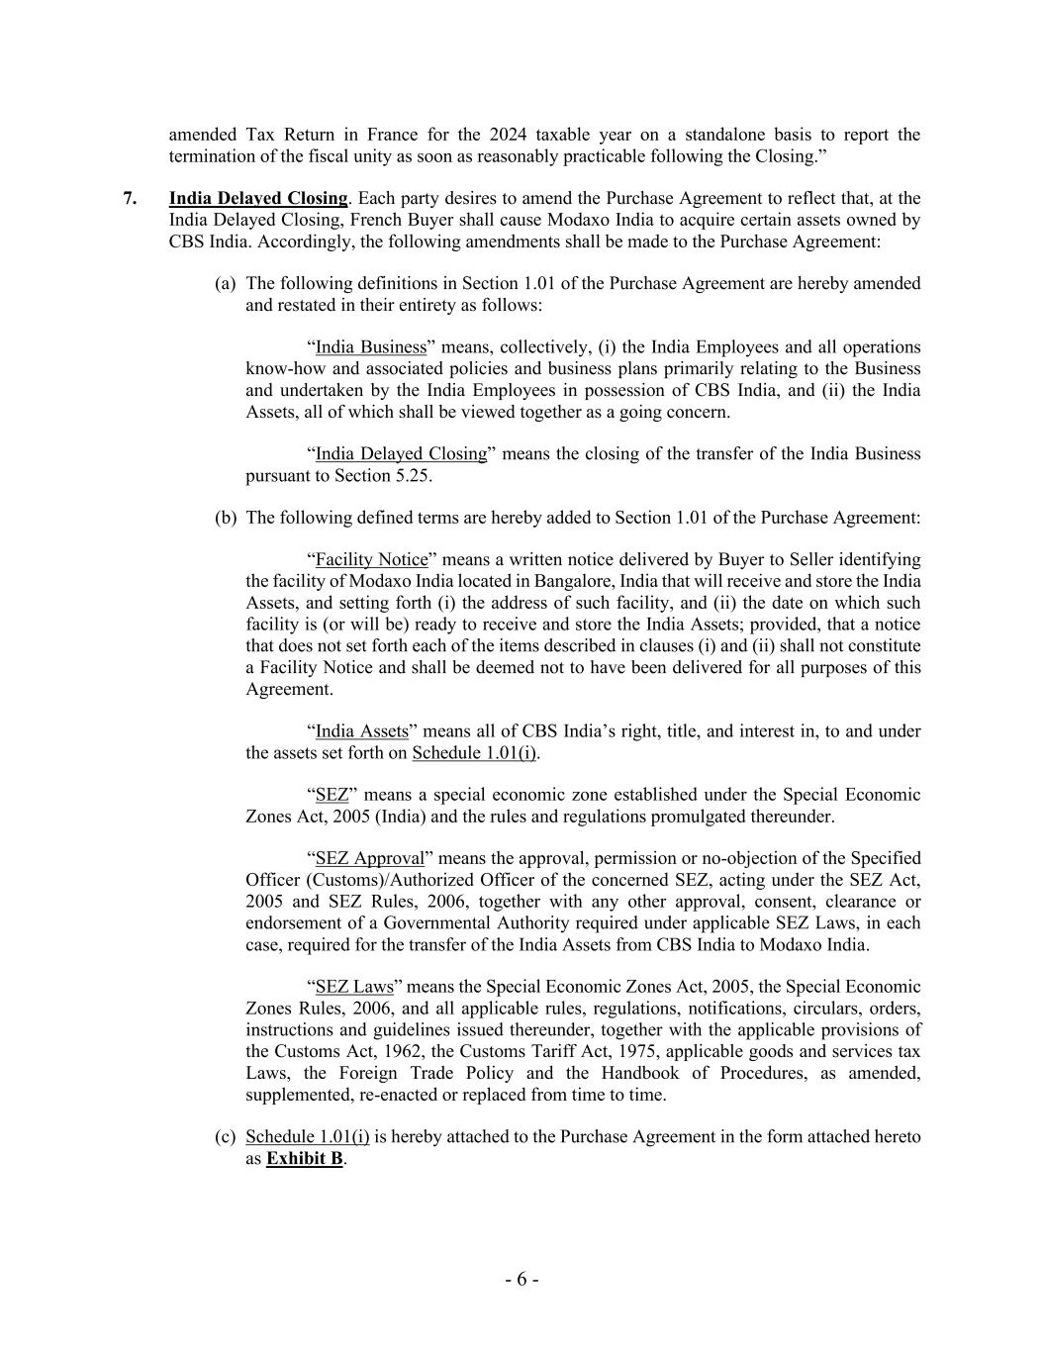
- 6 - amended Tax Return in France for the 2024 taxable year on a standalone basis to report the termination of the fiscal unity as soon as reasonably practicable following the Closing.” 7. India Delayed Closing. Each party desires to amend the Purchase Agreement to reflect that, at the India Delayed Closing, French Buyer shall cause Modaxo India to acquire certain assets owned by CBS India. Accordingly, the following amendments shall be made to the Purchase Agreement: (a) The following definitions in Section 1.01 of the Purchase Agreement are hereby amended and restated in their entirety as follows: “India Business” means, collectively, (i) the India Employees and all operations know-how and associated policies and business plans primarily relating to the Business and undertaken by the India Employees in possession of CBS India, and (ii) the India Assets, all of which shall be viewed together as a going concern. “India Delayed Closing” means the closing of the transfer of the India Business pursuant to Section 5.25. (b) The following defined terms are hereby added to Section 1.01 of the Purchase Agreement: “Facility Notice” means a written notice delivered by Buyer to Seller identifying the facility of Modaxo India located in Bangalore, India that will receive and store the India Assets, and setting forth (i) the address of such facility, and (ii) the date on which such facility is (or will be) ready to receive and store the India Assets; provided, that a notice that does not set forth each of the items described in clauses (i) and (ii) shall not constitute a Facility Notice and shall be deemed not to have been delivered for all purposes of this Agreement. “India Assets” means all of CBS India’s right, title, and interest in, to and under the assets set forth on Schedule 1.01(i). “SEZ” means a special economic zone established under the Special Economic Zones Act, 2005 (India) and the rules and regulations promulgated thereunder. “SEZ Approval” means the approval, permission or no-objection of the Specified Officer (Customs)/Authorized Officer of the concerned SEZ, acting under the SEZ Act, 2005 and SEZ Rules, 2006, together with any other approval, consent, clearance or endorsement of a Governmental Authority required under applicable SEZ Laws, in each case, required for the transfer of the India Assets from CBS India to Modaxo India. “SEZ Laws” means the Special Economic Zones Act, 2005, the Special Economic Zones Rules, 2006, and all applicable rules, regulations, notifications, circulars, orders, instructions and guidelines issued thereunder, together with the applicable provisions of the Customs Act, 1962, the Customs Tariff Act, 1975, applicable goods and services tax Laws, the Foreign Trade Policy and the Handbook of Procedures, as amended, supplemented, re-enacted or replaced from time to time. (c) Schedule 1.01(i) is hereby attached to the Purchase Agreement in the form attached hereto as Exhibit B.

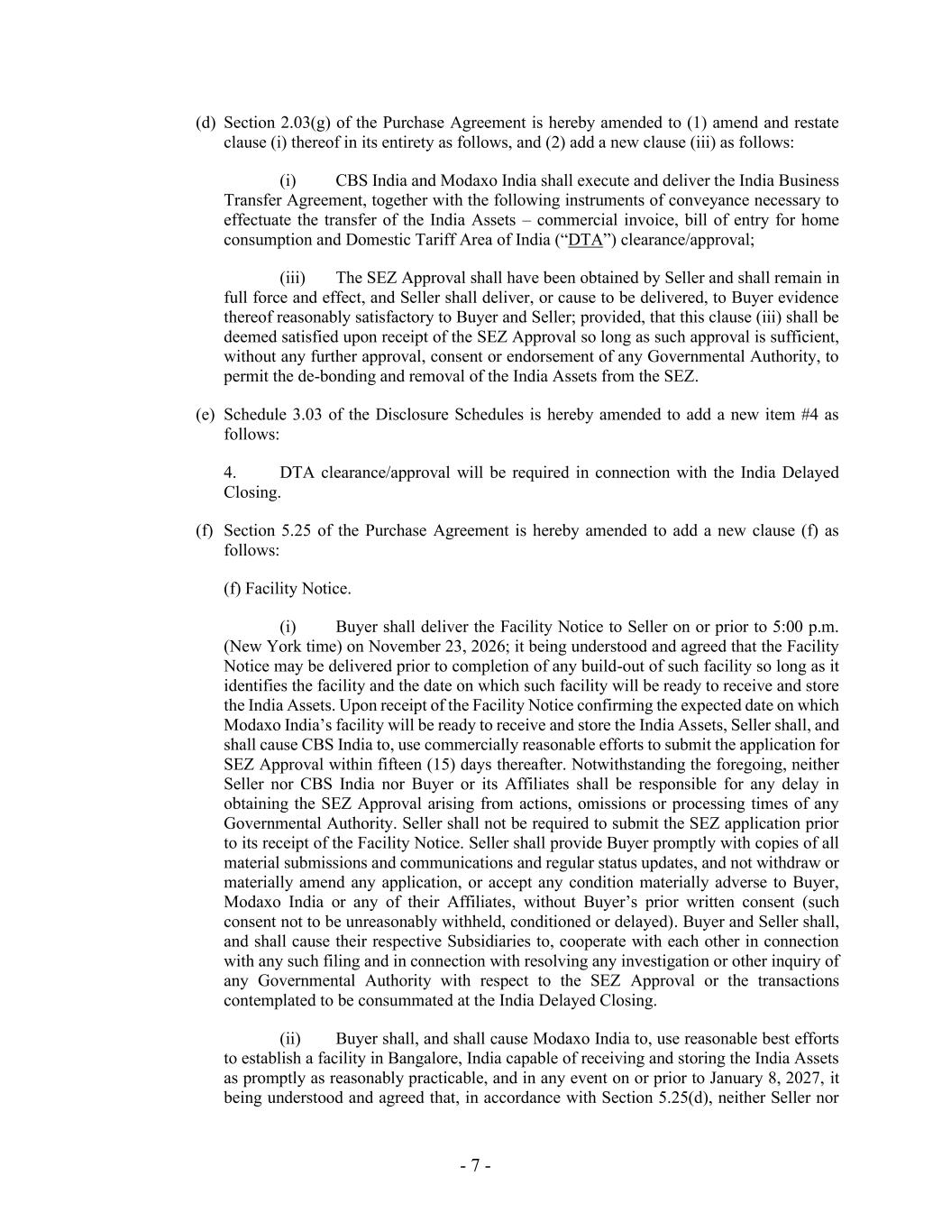
- 7 - (d) Section 2.03(g) of the Purchase Agreement is hereby amended to (1) amend and restate clause (i) thereof in its entirety as follows, and (2) add a new clause (iii) as follows: (i) CBS India and Modaxo India shall execute and deliver the India Business Transfer Agreement, together with the following instruments of conveyance necessary to effectuate the transfer of the India Assets – commercial invoice, bill of entry for home consumption and Domestic Tariff Area of India (“DTA”) clearance/approval; (iii) The SEZ Approval shall have been obtained by Seller and shall remain in full force and effect, and Seller shall deliver, or cause to be delivered, to Buyer evidence thereof reasonably satisfactory to Buyer and Seller; provided, that this clause (iii) shall be deemed satisfied upon receipt of the SEZ Approval so long as such approval is sufficient, without any further approval, consent or endorsement of any Governmental Authority, to permit the de-bonding and removal of the India Assets from the SEZ. (e) Schedule 3.03 of the Disclosure Schedules is hereby amended to add a new item #4 as follows: 4. DTA clearance/approval will be required in connection with the India Delayed Closing. (f) Section 5.25 of the Purchase Agreement is hereby amended to add a new clause (f) as follows: (f) Facility Notice. (i) Buyer shall deliver the Facility Notice to Seller on or prior to 5:00 p.m. (New York time) on November 23, 2026; it being understood and agreed that the Facility Notice may be delivered prior to completion of any build-out of such facility so long as it identifies the facility and the date on which such facility will be ready to receive and store the India Assets. Upon receipt of the Facility Notice confirming the expected date on which Modaxo India’s facility will be ready to receive and store the India Assets, Seller shall, and shall cause CBS India to, use commercially reasonable efforts to submit the application for SEZ Approval within fifteen (15) days thereafter. Notwithstanding the foregoing, neither Seller nor CBS India nor Buyer or its Affiliates shall be responsible for any delay in obtaining the SEZ Approval arising from actions, omissions or processing times of any Governmental Authority. Seller shall not be required to submit the SEZ application prior to its receipt of the Facility Notice. Seller shall provide Buyer promptly with copies of all material submissions and communications and regular status updates, and not withdraw or materially amend any application, or accept any condition materially adverse to Buyer, Modaxo India or any of their Affiliates, without Buyer’s prior written consent (such consent not to be unreasonably withheld, conditioned or delayed). Buyer and Seller shall, and shall cause their respective Subsidiaries to, cooperate with each other in connection with any such filing and in connection with resolving any investigation or other inquiry of any Governmental Authority with respect to the SEZ Approval or the transactions contemplated to be consummated at the India Delayed Closing. (ii) Buyer shall, and shall cause Modaxo India to, use reasonable best efforts to establish a facility in Bangalore, India capable of receiving and storing the India Assets as promptly as reasonably practicable, and in any event on or prior to January 8, 2027, it being understood and agreed that, in accordance with Section 5.25(d), neither Seller nor

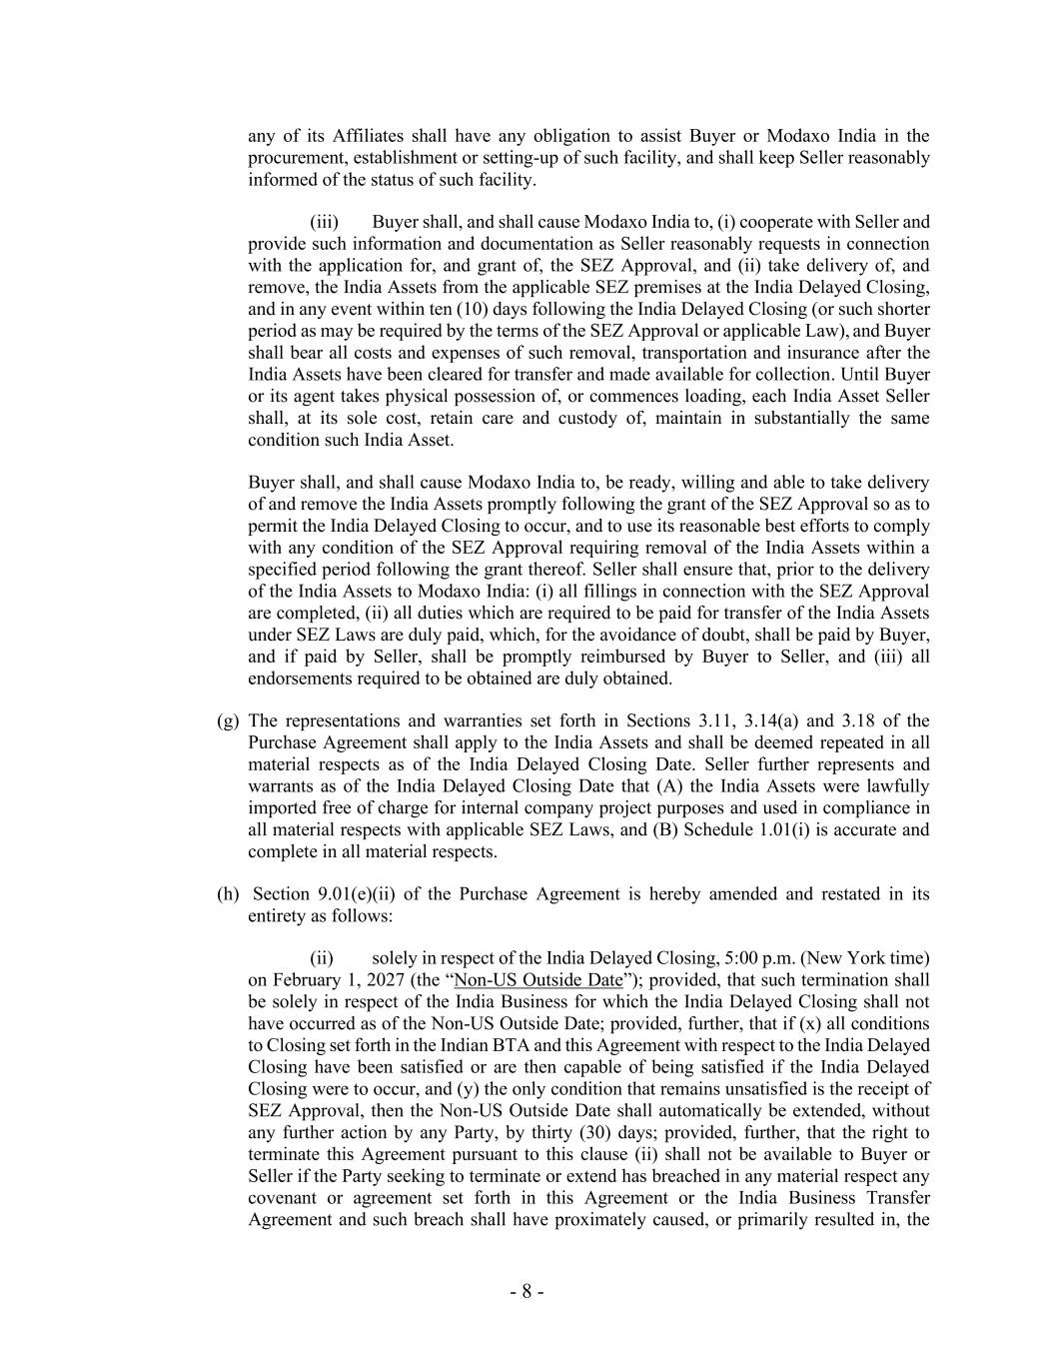
- 8 - any of its Affiliates shall have any obligation to assist Buyer or Modaxo India in the procurement, establishment or setting-up of such facility, and shall keep Seller reasonably informed of the status of such facility. (iii) Buyer shall, and shall cause Modaxo India to, (i) cooperate with Seller and provide such information and documentation as Seller reasonably requests in connection with the application for, and grant of, the SEZ Approval, and (ii) take delivery of, and remove, the India Assets from the applicable SEZ premises at the India Delayed Closing, and in any event within ten (10) days following the India Delayed Closing (or such shorter period as may be required by the terms of the SEZ Approval or applicable Law), and Buyer shall bear all costs and expenses of such removal, transportation and insurance after the India Assets have been cleared for transfer and made available for collection. Until Buyer or its agent takes physical possession of, or commences loading, each India Asset Seller shall, at its sole cost, retain care and custody of, maintain in substantially the same condition such India Asset. Buyer shall, and shall cause Modaxo India to, be ready, willing and able to take delivery of and remove the India Assets promptly following the grant of the SEZ Approval so as to permit the India Delayed Closing to occur, and to use its reasonable best efforts to comply with any condition of the SEZ Approval requiring removal of the India Assets within a specified period following the grant thereof. Seller shall ensure that, prior to the delivery of the India Assets to Modaxo India: (i) all fillings in connection with the SEZ Approval are completed, (ii) all duties which are required to be paid for transfer of the India Assets under SEZ Laws are duly paid, which, for the avoidance of doubt, shall be paid by Buyer, and if paid by Seller, shall be promptly reimbursed by Buyer to Seller, and (iii) all endorsements required to be obtained are duly obtained. (g) The representations and warranties set forth in Sections 3.11, 3.14(a) and 3.18 of the Purchase Agreement shall apply to the India Assets and shall be deemed repeated in all material respects as of the India Delayed Closing Date. Seller further represents and warrants as of the India Delayed Closing Date that (A) the India Assets were lawfully imported free of charge for internal company project purposes and used in compliance in all material respects with applicable SEZ Laws, and (B) Schedule 1.01(i) is accurate and complete in all material respects. (h) Section 9.01(e)(ii) of the Purchase Agreement is hereby amended and restated in its entirety as follows: (ii) solely in respect of the India Delayed Closing, 5:00 p.m. (New York time) on February 1, 2027 (the “Non-US Outside Date”); provided, that such termination shall be solely in respect of the India Business for which the India Delayed Closing shall not have occurred as of the Non-US Outside Date; provided, further, that if (x) all conditions to Closing set forth in the Indian BTA and this Agreement with respect to the India Delayed Closing have been satisfied or are then capable of being satisfied if the India Delayed Closing were to occur, and (y) the only condition that remains unsatisfied is the receipt of SEZ Approval, then the Non-US Outside Date shall automatically be extended, without any further action by any Party, by thirty (30) days; provided, further, that the right to terminate this Agreement pursuant to this clause (ii) shall not be available to Buyer or Seller if the Party seeking to terminate or extend has breached in any material respect any covenant or agreement set forth in this Agreement or the India Business Transfer Agreement and such breach shall have proximately caused, or primarily resulted in, the

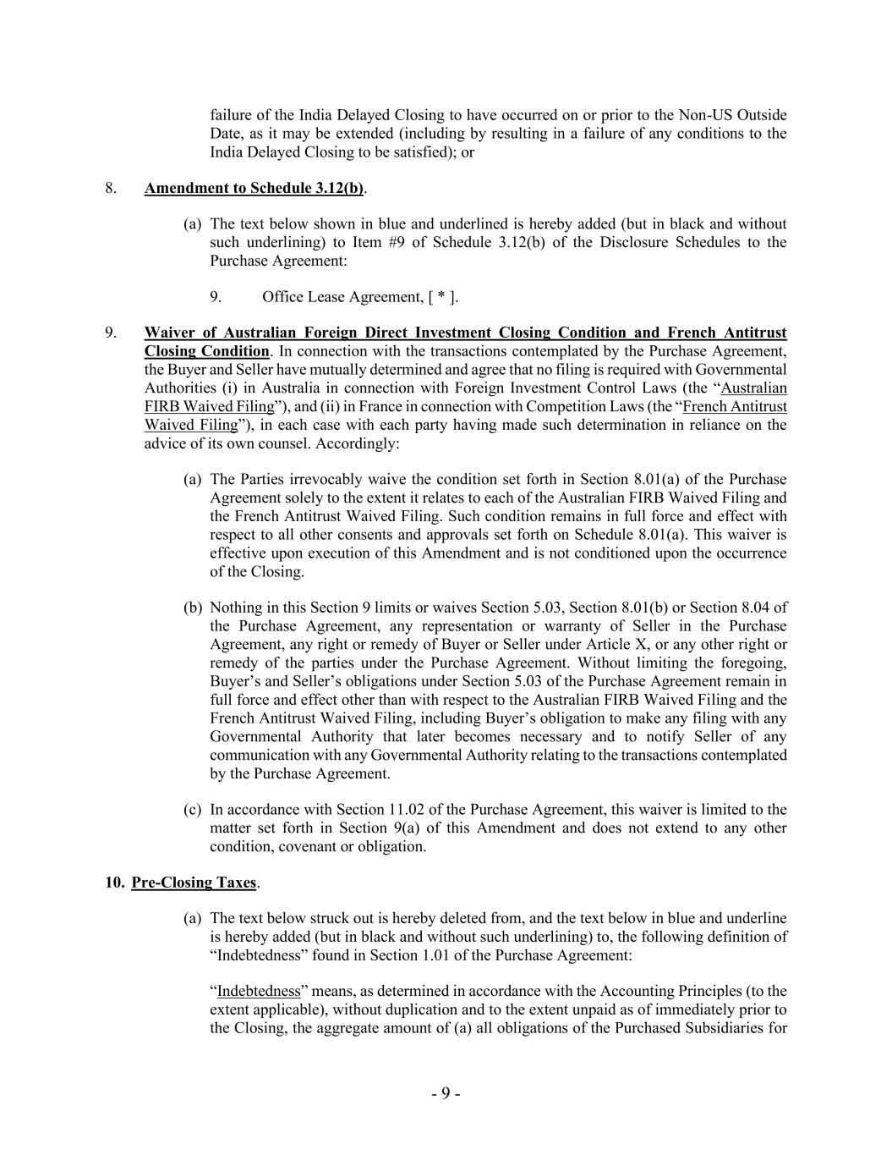
- 9 - failure of the India Delayed Closing to have occurred on or prior to the Non-US Outside Date, as it may be extended (including by resulting in a failure of any conditions to the India Delayed Closing to be satisfied); or 8. Amendment to Schedule 3.12(b). (a) The text below shown in blue and underlined is hereby added (but in black and without such underlining) to Item #9 of Schedule 3.12(b) of the Disclosure Schedules to the Purchase Agreement: 9. Office Lease Agreement, [ * ]. 9. Waiver of Australian Foreign Direct Investment Closing Condition and French Antitrust Closing Condition. In connection with the transactions contemplated by the Purchase Agreement, the Buyer and Seller have mutually determined and agree that no filing is required with Governmental Authorities (i) in Australia in connection with Foreign Investment Control Laws (the “Australian FIRB Waived Filing”), and (ii) in France in connection with Competition Laws (the “French Antitrust Waived Filing”), in each case with each party having made such determination in reliance on the advice of its own counsel. Accordingly: (a) The Parties irrevocably waive the condition set forth in Section 8.01(a) of the Purchase Agreement solely to the extent it relates to each of the Australian FIRB Waived Filing and the French Antitrust Waived Filing. Such condition remains in full force and effect with respect to all other consents and approvals set forth on Schedule 8.01(a). This waiver is effective upon execution of this Amendment and is not conditioned upon the occurrence of the Closing. (b) Nothing in this Section 9 limits or waives Section 5.03, Section 8.01(b) or Section 8.04 of the Purchase Agreement, any representation or warranty of Seller in the Purchase Agreement, any right or remedy of Buyer or Seller under Article X, or any other right or remedy of the parties under the Purchase Agreement. Without limiting the foregoing, Buyer’s and Seller’s obligations under Section 5.03 of the Purchase Agreement remain in full force and effect other than with respect to the Australian FIRB Waived Filing and the French Antitrust Waived Filing, including Buyer’s obligation to make any filing with any Governmental Authority that later becomes necessary and to notify Seller of any communication with any Governmental Authority relating to the transactions contemplated by the Purchase Agreement. (c) In accordance with Section 11.02 of the Purchase Agreement, this waiver is limited to the matter set forth in Section 9(a) of this Amendment and does not extend to any other condition, covenant or obligation. 10. Pre-Closing Taxes. (a) The text below struck out is hereby deleted from, and the text below in blue and underline is hereby added (but in black and without such underlining) to, the following definition of “Indebtedness” found in Section 1.01 of the Purchase Agreement: “Indebtedness” means, as determined in accordance with the Accounting Principles (to the extent applicable), without duplication and to the extent unpaid as of immediately prior to the Closing, the aggregate amount of (a) all obligations of the Purchased Subsidiaries for

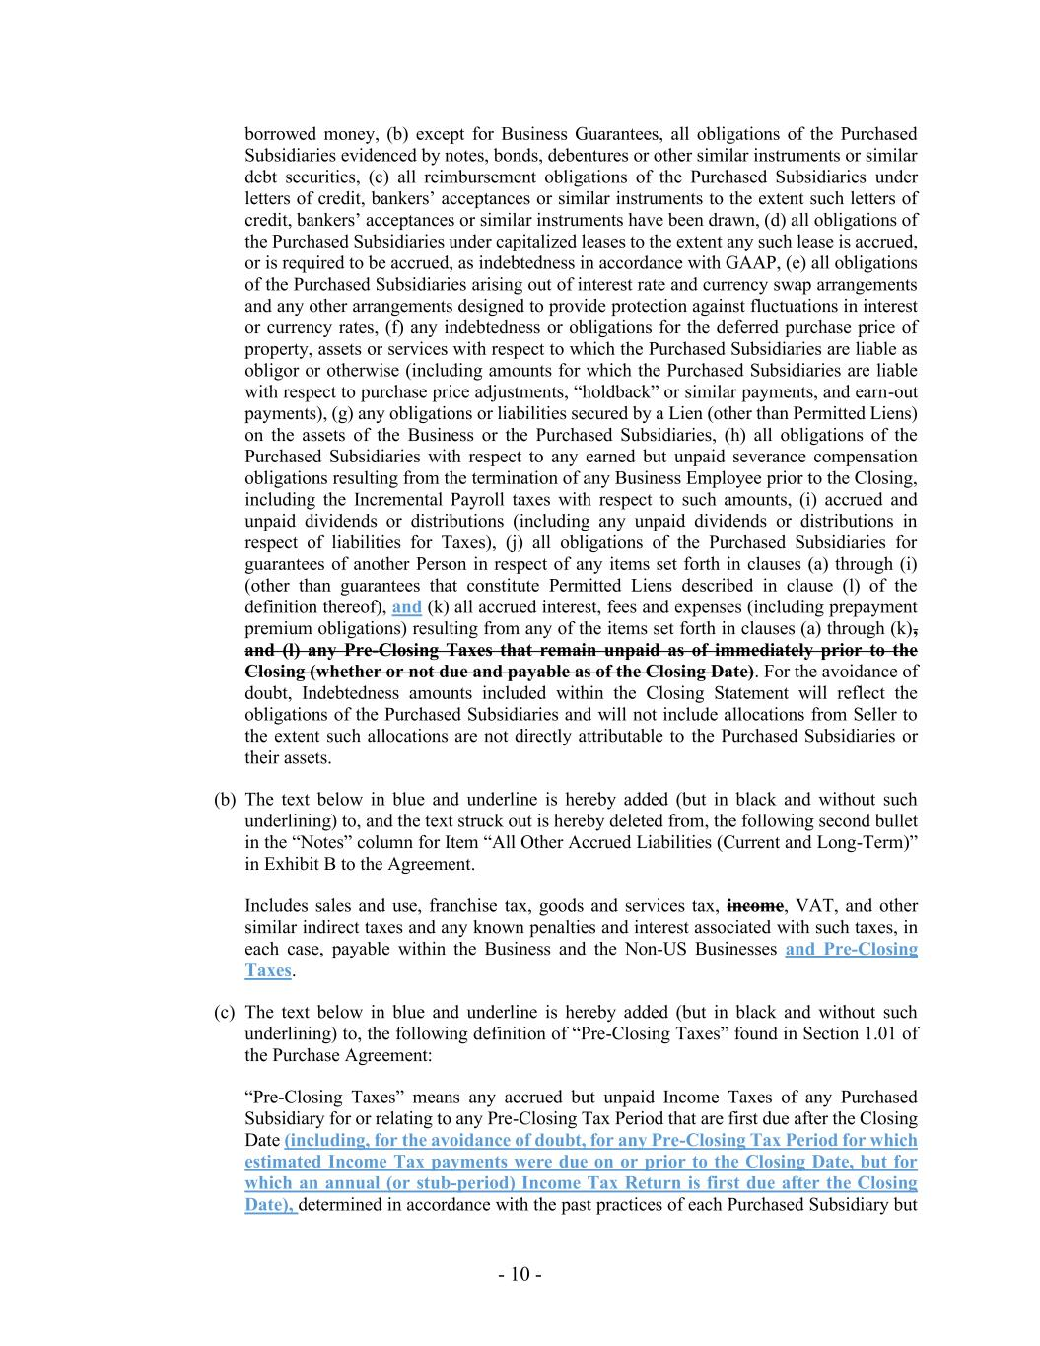
- 10 - borrowed money, (b) except for Business Guarantees, all obligations of the Purchased Subsidiaries evidenced by notes, bonds, debentures or other similar instruments or similar debt securities, (c) all reimbursement obligations of the Purchased Subsidiaries under letters of credit, bankers’ acceptances or similar instruments to the extent such letters of credit, bankers’ acceptances or similar instruments have been drawn, (d) all obligations of the Purchased Subsidiaries under capitalized leases to the extent any such lease is accrued, or is required to be accrued, as indebtedness in accordance with GAAP, (e) all obligations of the Purchased Subsidiaries arising out of interest rate and currency swap arrangements and any other arrangements designed to provide protection against fluctuations in interest or currency rates, (f) any indebtedness or obligations for the deferred purchase price of property, assets or services with respect to which the Purchased Subsidiaries are liable as obligor or otherwise (including amounts for which the Purchased Subsidiaries are liable with respect to purchase price adjustments, “holdback” or similar payments, and earn-out payments), (g) any obligations or liabilities secured by a Lien (other than Permitted Liens) on the assets of the Business or the Purchased Subsidiaries, (h) all obligations of the Purchased Subsidiaries with respect to any earned but unpaid severance compensation obligations resulting from the termination of any Business Employee prior to the Closing, including the Incremental Payroll taxes with respect to such amounts, (i) accrued and unpaid dividends or distributions (including any unpaid dividends or distributions in respect of liabilities for Taxes), (j) all obligations of the Purchased Subsidiaries for guarantees of another Person in respect of any items set forth in clauses (a) through (i) (other than guarantees that constitute Permitted Liens described in clause (l) of the definition thereof), and (k) all accrued interest, fees and expenses (including prepayment premium obligations) resulting from any of the items set forth in clauses (a) through (k), and (l) any Pre-Closing Taxes that remain unpaid as of immediately prior to the Closing (whether or not due and payable as of the Closing Date). For the avoidance of doubt, Indebtedness amounts included within the Closing Statement will reflect the obligations of the Purchased Subsidiaries and will not include allocations from Seller to the extent such allocations are not directly attributable to the Purchased Subsidiaries or their assets. (b) The text below in blue and underline is hereby added (but in black and without such underlining) to, and the text struck out is hereby deleted from, the following second bullet in the “Notes” column for Item “All Other Accrued Liabilities (Current and Long-Term)” in Exhibit B to the Agreement. Includes sales and use, franchise tax, goods and services tax, income, VAT, and other similar indirect taxes and any known penalties and interest associated with such taxes, in each case, payable within the Business and the Non-US Businesses and Pre-Closing Taxes. (c) The text below in blue and underline is hereby added (but in black and without such underlining) to, the following definition of “Pre-Closing Taxes” found in Section 1.01 of the Purchase Agreement: “Pre-Closing Taxes” means any accrued but unpaid Income Taxes of any Purchased Subsidiary for or relating to any Pre-Closing Tax Period that are first due after the Closing Date (including, for the avoidance of doubt, for any Pre-Closing Tax Period for which estimated Income Tax payments were due on or prior to the Closing Date, but for which an annual (or stub-period) Income Tax Return is first due after the Closing Date), determined in accordance with the past practices of each Purchased Subsidiary but

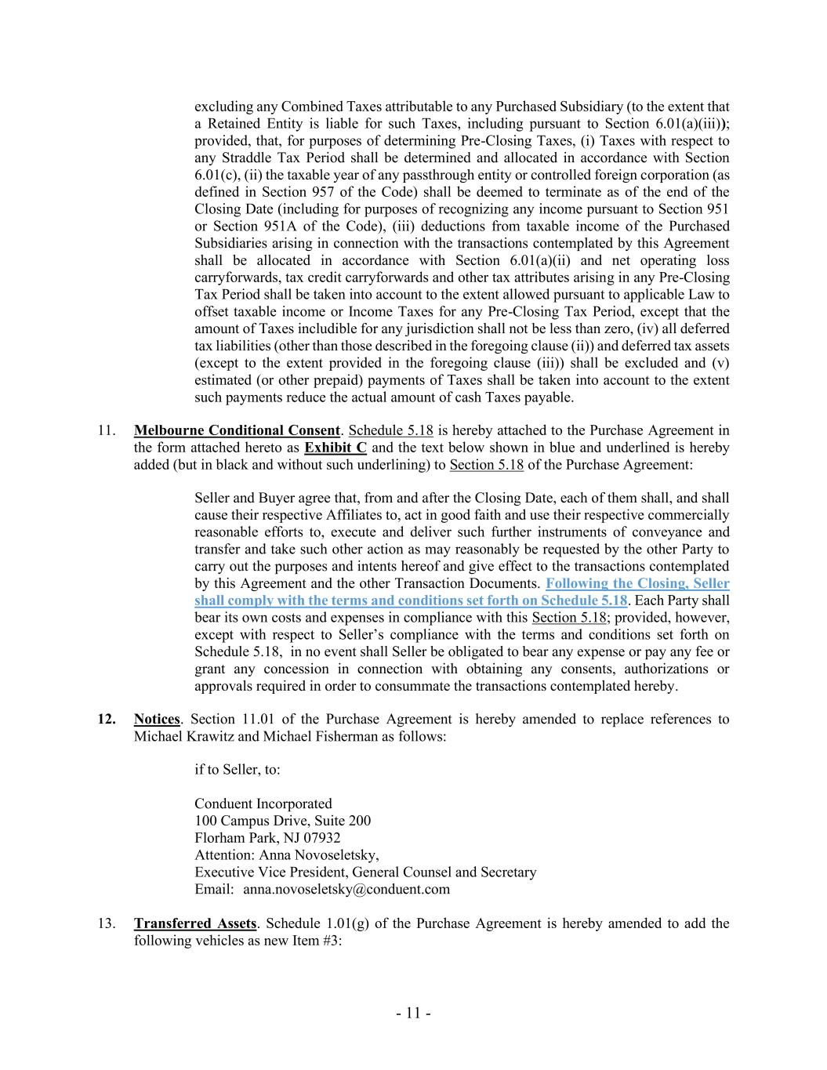
- 11 - excluding any Combined Taxes attributable to any Purchased Subsidiary (to the extent that a Retained Entity is liable for such Taxes, including pursuant to Section 6.01(a)(iii)); provided, that, for purposes of determining Pre-Closing Taxes, (i) Taxes with respect to any Straddle Tax Period shall be determined and allocated in accordance with Section 6.01(c), (ii) the taxable year of any passthrough entity or controlled foreign corporation (as defined in Section 957 of the Code) shall be deemed to terminate as of the end of the Closing Date (including for purposes of recognizing any income pursuant to Section 951 or Section 951A of the Code), (iii) deductions from taxable income of the Purchased Subsidiaries arising in connection with the transactions contemplated by this Agreement shall be allocated in accordance with Section 6.01(a)(ii) and net operating loss carryforwards, tax credit carryforwards and other tax attributes arising in any Pre-Closing Tax Period shall be taken into account to the extent allowed pursuant to applicable Law to offset taxable income or Income Taxes for any Pre-Closing Tax Period, except that the amount of Taxes includible for any jurisdiction shall not be less than zero, (iv) all deferred tax liabilities (other than those described in the foregoing clause (ii)) and deferred tax assets (except to the extent provided in the foregoing clause (iii)) shall be excluded and (v) estimated (or other prepaid) payments of Taxes shall be taken into account to the extent such payments reduce the actual amount of cash Taxes payable. 11. Melbourne Conditional Consent. Schedule 5.18 is hereby attached to the Purchase Agreement in the form attached hereto as Exhibit C and the text below shown in blue and underlined is hereby added (but in black and without such underlining) to Section 5.18 of the Purchase Agreement: Seller and Buyer agree that, from and after the Closing Date, each of them shall, and shall cause their respective Affiliates to, act in good faith and use their respective commercially reasonable efforts to, execute and deliver such further instruments of conveyance and transfer and take such other action as may reasonably be requested by the other Party to carry out the purposes and intents hereof and give effect to the transactions contemplated by this Agreement and the other Transaction Documents. Following the Closing, Seller shall comply with the terms and conditions set forth on Schedule 5.18. Each Party shall bear its own costs and expenses in compliance with this Section 5.18; provided, however, except with respect to Seller’s compliance with the terms and conditions set forth on Schedule 5.18, in no event shall Seller be obligated to bear any expense or pay any fee or grant any concession in connection with obtaining any consents, authorizations or approvals required in order to consummate the transactions contemplated hereby. 12. Notices. Section 11.01 of the Purchase Agreement is hereby amended to replace references to Michael Krawitz and Michael Fisherman as follows: if to Seller, to: Conduent Incorporated 100 Campus Drive, Suite 200 Florham Park, NJ 07932 Attention: Anna Novoseletsky, Executive Vice President, General Counsel and Secretary Email: anna.novoseletsky@conduent.com 13. Transferred Assets. Schedule 1.01(g) of the Purchase Agreement is hereby amended to add the following vehicles as new Item #3:

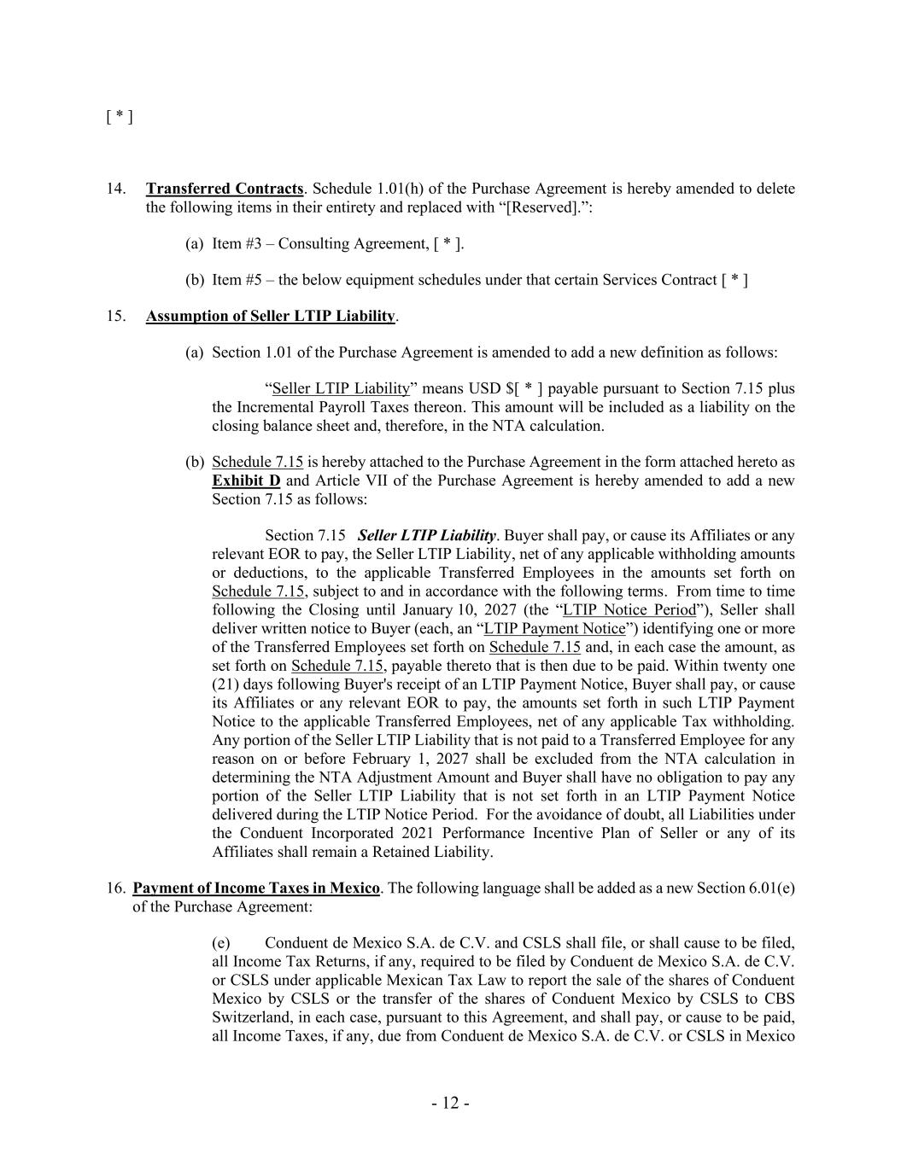
- 12 - [ * ] 14. Transferred Contracts. Schedule 1.01(h) of the Purchase Agreement is hereby amended to delete the following items in their entirety and replaced with “[Reserved].”: (a) Item #3 – Consulting Agreement, [ * ]. (b) Item #5 – the below equipment schedules under that certain Services Contract [ * ] 15. Assumption of Seller LTIP Liability. (a) Section 1.01 of the Purchase Agreement is amended to add a new definition as follows: “Seller LTIP Liability” means USD $[ * ] payable pursuant to Section 7.15 plus the Incremental Payroll Taxes thereon. This amount will be included as a liability on the closing balance sheet and, therefore, in the NTA calculation. (b) Schedule 7.15 is hereby attached to the Purchase Agreement in the form attached hereto as Exhibit D and Article VII of the Purchase Agreement is hereby amended to add a new Section 7.15 as follows: Section 7.15 Seller LTIP Liability. Buyer shall pay, or cause its Affiliates or any relevant EOR to pay, the Seller LTIP Liability, net of any applicable withholding amounts or deductions, to the applicable Transferred Employees in the amounts set forth on Schedule 7.15, subject to and in accordance with the following terms. From time to time following the Closing until January 10, 2027 (the “LTIP Notice Period”), Seller shall deliver written notice to Buyer (each, an “LTIP Payment Notice”) identifying one or more of the Transferred Employees set forth on Schedule 7.15 and, in each case the amount, as set forth on Schedule 7.15, payable thereto that is then due to be paid. Within twenty one (21) days following Buyer's receipt of an LTIP Payment Notice, Buyer shall pay, or cause its Affiliates or any relevant EOR to pay, the amounts set forth in such LTIP Payment Notice to the applicable Transferred Employees, net of any applicable Tax withholding. Any portion of the Seller LTIP Liability that is not paid to a Transferred Employee for any reason on or before February 1, 2027 shall be excluded from the NTA calculation in determining the NTA Adjustment Amount and Buyer shall have no obligation to pay any portion of the Seller LTIP Liability that is not set forth in an LTIP Payment Notice delivered during the LTIP Notice Period. For the avoidance of doubt, all Liabilities under the Conduent Incorporated 2021 Performance Incentive Plan of Seller or any of its Affiliates shall remain a Retained Liability. 16. Payment of Income Taxes in Mexico. The following language shall be added as a new Section 6.01(e) of the Purchase Agreement: (e) Conduent de Mexico S.A. de C.V. and CSLS shall file, or shall cause to be filed, all Income Tax Returns, if any, required to be filed by Conduent de Mexico S.A. de C.V. or CSLS under applicable Mexican Tax Law to report the sale of the shares of Conduent Mexico by CSLS or the transfer of the shares of Conduent Mexico by CSLS to CBS Switzerland, in each case, pursuant to this Agreement, and shall pay, or cause to be paid, all Income Taxes, if any, due from Conduent de Mexico S.A. de C.V. or CSLS in Mexico

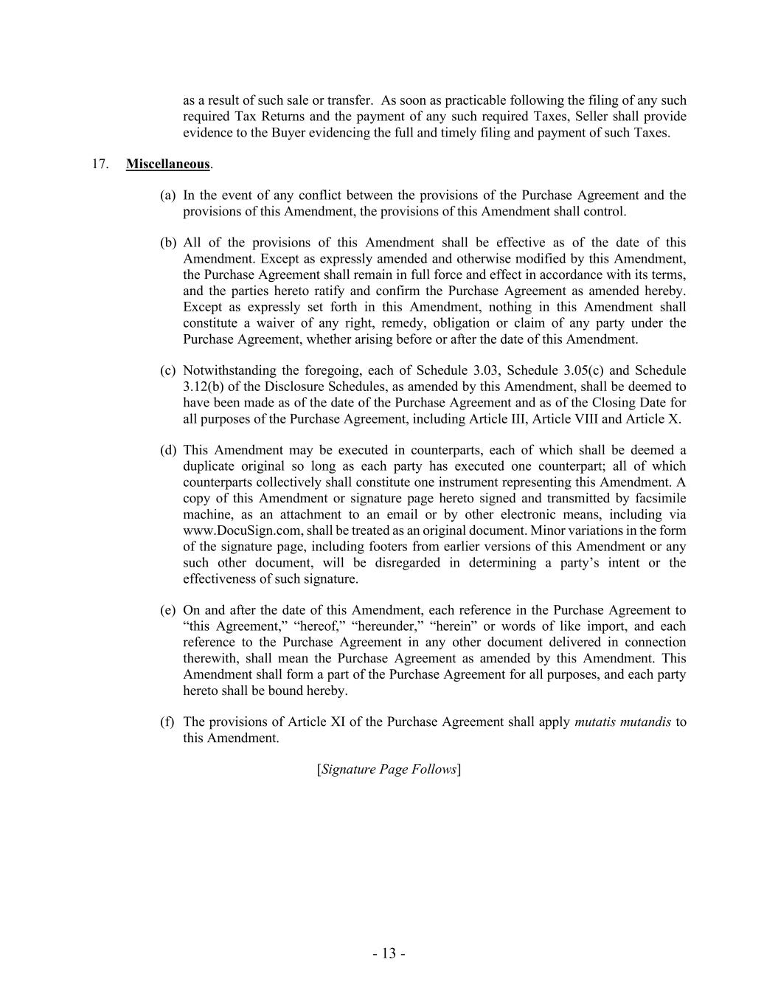
- 13 - as a result of such sale or transfer. As soon as practicable following the filing of any such required Tax Returns and the payment of any such required Taxes, Seller shall provide evidence to the Buyer evidencing the full and timely filing and payment of such Taxes. 17. Miscellaneous. (a) In the event of any conflict between the provisions of the Purchase Agreement and the provisions of this Amendment, the provisions of this Amendment shall control. (b) All of the provisions of this Amendment shall be effective as of the date of this Amendment. Except as expressly amended and otherwise modified by this Amendment, the Purchase Agreement shall remain in full force and effect in accordance with its terms, and the parties hereto ratify and confirm the Purchase Agreement as amended hereby. Except as expressly set forth in this Amendment, nothing in this Amendment shall constitute a waiver of any right, remedy, obligation or claim of any party under the Purchase Agreement, whether arising before or after the date of this Amendment. (c) Notwithstanding the foregoing, each of Schedule 3.03, Schedule 3.05(c) and Schedule 3.12(b) of the Disclosure Schedules, as amended by this Amendment, shall be deemed to have been made as of the date of the Purchase Agreement and as of the Closing Date for all purposes of the Purchase Agreement, including Article III, Article VIII and Article X. (d) This Amendment may be executed in counterparts, each of which shall be deemed a duplicate original so long as each party has executed one counterpart; all of which counterparts collectively shall constitute one instrument representing this Amendment. A copy of this Amendment or signature page hereto signed and transmitted by facsimile machine, as an attachment to an email or by other electronic means, including via www.DocuSign.com, shall be treated as an original document. Minor variations in the form of the signature page, including footers from earlier versions of this Amendment or any such other document, will be disregarded in determining a party’s intent or the effectiveness of such signature. (e) On and after the date of this Amendment, each reference in the Purchase Agreement to “this Agreement,” “hereof,” “hereunder,” “herein” or words of like import, and each reference to the Purchase Agreement in any other document delivered in connection therewith, shall mean the Purchase Agreement as amended by this Amendment. This Amendment shall form a part of the Purchase Agreement for all purposes, and each party hereto shall be bound hereby. (f) The provisions of Article XI of the Purchase Agreement shall apply mutatis mutandis to this Amendment. [Signature Page Follows]

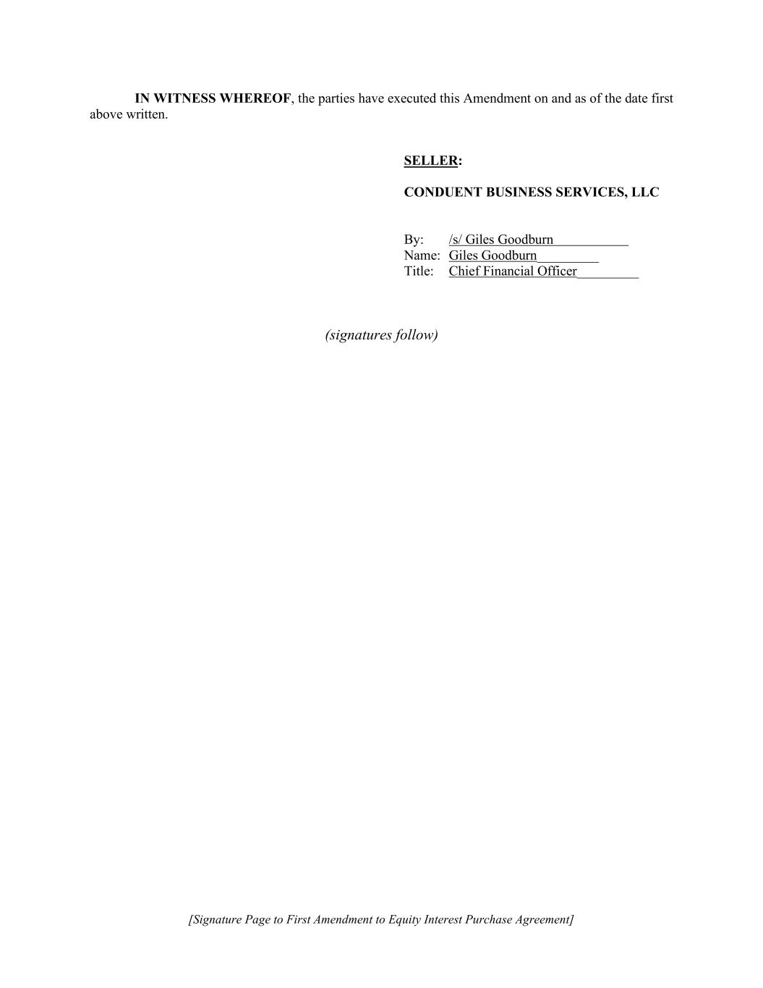
[Signature Page to First Amendment to Equity Interest Purchase Agreement] IN WITNESS WHEREOF, the parties have executed this Amendment on and as of the date first above written. SELLER: CONDUENT BUSINESS SERVICES, LLC By: /s/ Giles Goodburn Name: Giles Goodburn_________ Title: Chief Financial Officer_________ (signatures follow)

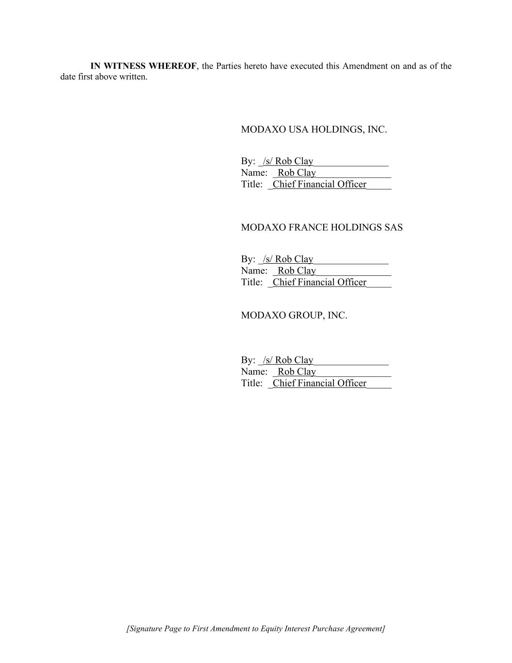
[Signature Page to First Amendment to Equity Interest Purchase Agreement] IN WITNESS WHEREOF, the Parties hereto have executed this Amendment on and as of the date first above written. MODAXO USA HOLDINGS, INC. By: _/s/ Rob Clay_______________ Name: _Rob Clay_______________ Title: _Chief Financial Officer_____ MODAXO FRANCE HOLDINGS SAS By: _/s/ Rob Clay_______________ Name: _Rob Clay_______________ Title: _Chief Financial Officer_____ MODAXO GROUP, INC. By: _/s/ Rob Clay_______________ Name: _Rob Clay_______________ Title: _Chief Financial Officer_____

EXHIBIT 99.1
News from Conduent

Conduent Completes Sale of Its Public Transit Business to Modaxo
$164 million transaction advances Conduent’s strategy to simplify its portfolio and sharpen its focus
FLORHAM PARK, N.J.--(BUSINESS WIRE)--Oct. 1, 2026-- Conduent Incorporated (Nasdaq: CNDT), a global technology-driven business solutions and services provider, today announced that it has completed the sale of its Public Transit Business to Modaxo, a global technology organization focused on moving the world’s people. The transaction has a base purchase price of $164 million, subject to customary adjustments. Conduent announced the agreement on May 21, 2026.
“This divestiture is an important step in our strategy to simplify our portfolio, sharpen our focus on our core businesses and strengthen our financial foundation,” said Harsha V. Agadi, Conduent President and Chief Executive Officer. “With the completion of this transaction, and our planned exit from the Transportation segment upon the anticipated closing of the Tolling transaction, we are creating a more focused portfolio positioned to deliver sustainable, long-term value for our shareholders, clients and employees.”
The Public Transit Business includes Conduent’s Transit Fare Management and Fleet Management Solutions businesses, with operations across North America, Europe, Australia, the Middle East and Latin America.
The completed sale follows Conduent’s June announcement that it has agreed to sell its Tolling business to Quarterhill Inc. (TSX: QTRH) (OTCQX: QTRHF), a leading global provider of intelligent transportation system solutions. The transaction is expected to close before the end of 2026. Upon completion of the Tolling transaction, Conduent will have exited its Transportation segment and will operate across its Commercial and Government segments.
“We wish our employees in the Public Transit Business all the best as they begin this next chapter with Modaxo, and we thank them for their contributions and dedication to Conduent,” Agadi added.
EXHIBIT 99.1
1
About Conduent
Conduent is a global technology-enabled operating partner that helps businesses and governments simplify complexity, modernize mission-critical operations and deliver measurable outcomes through AI, automation, data and human expertise. Learn more at www.conduent.com.
Note: To receive RSS news feeds, visit www.news.conduent.com. For open commentary, industry perspectives and views, visit https://x.com/Conduent, http://www.linkedin.com/company/conduent or http://www.facebook.com/Conduent.
Trademarks
Conduent is a trademark of Conduent Incorporated in the United States and/or other countries. Other names may be trademarks of their respective owners.
Forward-Looking Statements
This press release may contain "forward-looking statements" as defined in the Private Securities Litigation Reform Act of 1995. The words "anticipate," "believe," "estimate," "expect," "plan," "intend," "will," "aim," "should," "could," "forecast," "target," "may," "continue to," "endeavor," "if," "growing," "projected," "potential," "likely," "see," "ahead," "further," "going forward," "on the horizon," and similar expressions (including the negative and plural forms of such words and phrases), as they relate to us, are intended to identify forward-looking statements, but the absence of these words does not mean that a statement is not forward-looking. All statements other than statements of historical fact included in this press release are forward-looking statements, including, but not limited to, statements regarding the expected receipt of additional proceeds from the sale of Conduent's Public Transit business; the pending sale of Conduent's Tolling business, including that such transaction will be consummated and the timing of such consummation; our planned exit from the Transportation segment; and expectations regarding our strategy to simplify our portfolio, sharpen our focus, strengthen our financial foundation, and drive value for our shareholders, clients and employees. These statements reflect our current views with respect to future events and are subject to certain risks, uncertainties and assumptions, many of which are outside of our control, that could cause actual results to differ materially from those expected or implied by such forward-looking statements contained in this press release, any exhibits to this press release and other public statements we make. Important factors and uncertainties that could cause actual results to differ materially from those in our forward-looking statements include, but are not limited to: the risk that we do not receive
EXHIBIT 99.1
2
some or all of the additional proceeds expected from the sale of our Public Transit business, including as a result of post-closing purchase price adjustments or the failure to satisfy any post-closing conditions; with respect to the pending sale of our Tolling business, the risk that required regulatory approvals, third-party consents or other closing conditions are not satisfied such that the closing is delayed or does not occur, unexpected costs, liabilities or delays, significant transaction costs, negative effects of the pendency of the transaction on the market price of our common stock or operating results, including as a result of changes in key customer, supplier, employee or other business relationships, and contractual restrictions during the pendency of the transaction that could adversely affect our ability to pursue business opportunities or strategic transactions; the risk of litigation or regulatory actions; our inability to retain and hire key personnel; and other factors that are set forth in the "Risk Factors" and other sections of our Annual Report on Form 10-K, as well as in our Quarterly Reports on Form 10-Q and Current Reports on Form 8-K filed with or furnished to the Securities and Exchange Commission. Any forward-looking statements made by us in this press release speak only as of the date on which they are made. We are under no obligation to, and expressly disclaim any obligation to, update or alter our forward-looking statements, whether because of new information, subsequent events or otherwise, except as required by law. any obligation to, update or alter our forward-looking statements, whether because of new information, subsequent events or otherwise, except as required by law.
View source version on businesswire.com: https://www.businesswire.com/news/home/20261001420244/en/
Media Contact:
Remy Kaul, Conduent, media@conduent.com
Investor Relations Contact:
Nick Goel, Conduent, ir@conduent.com
Source: Conduent Incorporated

EXHIBIT 99.2
3
Conduent Incorporated
Unaudited Pro Forma Condensed Consolidated Financial Statements
Introduction
As previously announced on May 21, 2026, Conduent Incorporated ("Conduent"), by and through its wholly owned subsidiary, Conduent Business Services, LLC (“CBS” and together with Conduent, the "Company"), entered into an Equity Interest Purchase Agreement (the “Purchase Agreement”) with Modaxo USA Holdings, Inc. (“US Buyer”) and Modaxo France Holdings SAS (“French Buyer” and together with US Buyer, “Buyer”), and Modaxo Group Inc. Under the Purchase Agreement, CBS agreed to sell all of the issued and outstanding equity interests of Conduent Transport Solutions, Inc. and certain non-U.S. subsidiaries that comprise the Company’s public transit and fare collection business (the “Business”) on the terms and subject to the conditions set forth therein for $164 million (the “Transit Sale”).
On September 30, 2026, CBS, Buyer and Modaxo Group, Inc. entered into the First Amendment to Equity Interest Purchase Agreement (the “Amendment”) to amend the Purchase Agreement to, among other things, (1) remove US Buyer as a party to the Purchase Agreement such that French Buyer is the sole Buyer under the Purchase Agreement, (2) provide for certain assets located in India and owned by Conduent Business Services India LLP to be sold to a subsidiary of French Buyer at a subsequent closing, subject to receipt of required regulatory approval in India, and (3) waive certain closing conditions related to certain governmental filings. All other material terms of the Purchase Agreement, which was previously filed by Conduent as Exhibit 2.3 to the Quarterly Report on Form 10-Q dated August 10, 2026, remain the same. The foregoing description of the Amendment does not purport to be complete and is qualified in its entirety by the full text of the Amendment.
On October 1, 2026, the Transit Sale was completed and the Company received $140 million from the Buyer in the form of cash consideration. At closing the Buyer retained (i) a $10 million purchase price holdback for a maximum of one year to secure net tangible asset related adjustments, (ii) a $12 million special holdback, the release of which is dependent upon certain target completion dates for a former customer and (iii) other closing adjustments of $2 million. In the fourth quarter of 2026, the Company will pay transaction costs of $3 million and income taxes of $7 million. In addition, $15 million in cash was transferred to the Buyer at close. Conduent intends to use the net proceeds received from the Transit Sale of $125 million for the repayment of the revolving credit facility based on the terms of the credit agreement.
The unaudited pro forma condensed consolidated financial information of the Company was derived from the historical condensed consolidated financial statements. The unaudited pro forma condensed consolidated balance sheet gives effect to the Transit Sale as if it occurred on June 30, 2026. The unaudited pro forma condensed consolidated statement of income (loss) for the six months ended June 30, 2026, gives effect to the Transit Sale as if it occurred on January 1, 2026. The unaudited pro forma condensed consolidated statements of income (loss) for the years ended December 31, 2025, 2024, and 2023, give effect to the Transit Sale as if it occurred on January 1, 2023. The following unaudited pro forma condensed consolidated financial information should be read in conjunction with the Company’s historical financial statements and accompanying notes for the six months ended June 30, 2026, and years ended December 31, 2025, 2024, and 2023, which were included in the Company’s Form 10-Q filed on August 10, 2026, and Form 10-K filed on February 19, 2026, respectively.
The unaudited pro forma condensed consolidated financial information is based on information currently available and assumptions that the Company believes are reasonable. Such information is provided for illustrative and informational purposes only and is not intended to reflect what the Company’s consolidated financial position and results of operations would have been had the Transit Sale occurred on the dates indicated above and is not necessarily indicative of the Company’s future consolidated financial position and results of operations.

EXHIBIT 99.2
1
Conduent Incorporated
Unaudited Pro Forma Condensed Consolidated Balance Sheet
As of June 30, 2026

(in millions) |  |  |  |  |  | Conduent Historical |  |  |  |  |  | Sale of Transit (Note b) |  |  |  |  |  | Transaction Adjustments |  |  |  |  |  | Notes |  |  |  |  |  | Unaudited Pro Forma
Assets
Cash and cash equivalents |  |  |  |  |  | $ | 228 |  |  |  |  | $ | (15) |  |  |  |  | $ | 15 |  |  |  |  | (a) |  |  |  |  |  | $ | 228
Accounts receivable, net |  |  |  |  |  | 337 |  |  |  |  |  | — |  |  |  |  |  | — |  |  |  |  |  |  |  |  |  |  |  | 337
Assets of discontinued operations held for sale |  |  |  |  |  | 386 |  |  |  |  |  | (235) |  |  |  |  |  | — |  |  |  |  |  |  |  |  |  |  |  | 151
Contract assets |  |  |  |  |  | 10 |  |  |  |  |  | — |  |  |  |  |  | — |  |  |  |  |  |  |  |  |  |  |  | 10
Other current assets |  |  |  |  |  | 136 |  |  |  |  |  | — |  |  |  |  |  | 13 |  |  |  |  |  | (a)(d) |  |  |  |  |  | 149
Total current assets |  |  |  |  |  | 1,097 |  |  |  |  |  | (250) |  |  |  |  |  | 28 |  |  |  |  |  |  |  |  |  |  |  | 875
Land, buildings and equipment, net |  |  |  |  |  | 152 |  |  |  |  |  | — |  |  |  |  |  | — |  |  |  |  |  |  |  |  |  |  |  | 152
Operating lease right-of-use assets |  |  |  |  |  | 110 |  |  |  |  |  | — |  |  |  |  |  | — |  |  |  |  |  |  |  |  |  |  |  | 110
Deferred contract costs, net |  |  |  |  |  | 72 |  |  |  |  |  | — |  |  |  |  |  | — |  |  |  |  |  |  |  |  |  |  |  | 72
Goodwill |  |  |  |  |  | 614 |  |  |  |  |  | — |  |  |  |  |  | — |  |  |  |  |  |  |  |  |  |  |  | 614
Other long-term assets |  |  |  |  |  | 200 |  |  |  |  |  | — |  |  |  |  |  | 9 |  |  |  |  |  | (a)(c) |  |  |  |  |  | 209
Total Assets |  |  |  |  |  | $ | 2,245 |  |  |  |  | $ | (250) |  |  |  |  | $ | 37 |  |  |  |  |  |  |  |  |  |  | $ | 2,032
Liabilities and Equity
Current portion of long-term debt |  |  |  |  |  | $ | 21 |  |  |  |  | $ | — |  |  |  |  | $ | — |  |  |  |  |  |  |  |  |  |  | $ | 21
Accounts payable |  |  |  |  |  | 95 |  |  |  |  |  | — |  |  |  |  |  | — |  |  |  |  |  |  |  |  |  |  |  | 95
Accrued compensation and benefits costs |  |  |  |  |  | 127 |  |  |  |  |  | — |  |  |  |  |  | — |  |  |  |  |  |  |  |  |  |  |  | 127
Contract liabilities |  |  |  |  |  | 46 |  |  |  |  |  | — |  |  |  |  |  | — |  |  |  |  |  |  |  |  |  |  |  | 46
Liabilities of discontinued operations held for sale |  |  |  |  |  | 206 |  |  |  |  |  | (135) |  |  |  |  |  | — |  |  |  |  |  |  |  |  |  |  |  | 71
Other current liabilities |  |  |  |  |  | 212 |  |  |  |  |  | — |  |  |  |  |  | 6 |  |  |  |  |  | (c)(e) |  |  |  |  |  | 218
Total current liabilities |  |  |  |  |  | 707 |  |  |  |  |  | (135) |  |  |  |  |  | 6 |  |  |  |  |  |  |  |  |  |  |  | 578
Long-term debt |  |  |  |  |  | 697 |  |  |  |  |  | — |  |  |  |  |  | (125) |  |  |  |  |  | (e) |  |  |  |  |  | 572
Deferred taxes |  |  |  |  |  | 16 |  |  |  |  |  | — |  |  |  |  |  | — |  |  |  |  |  |  |  |  |  |  |  | 16
Operating lease liabilities |  |  |  |  |  | 83 |  |  |  |  |  | — |  |  |  |  |  | — |  |  |  |  |  |  |  |  |  |  |  | 83
Other long-term liabilities |  |  |  |  |  | 74 |  |  |  |  |  | — |  |  |  |  |  | — |  |  |  |  |  |  |  |  |  |  |  | 74
Total Liabilities |  |  |  |  |  | 1,577 |  |  |  |  |  | (135) |  |  |  |  |  | (119) |  |  |  |  |  |  |  |  |  |  |  | 1,323
Series A convertible preferred stock |  |  |  |  |  | 142 |  |  |  |  |  | — |  |  |  |  |  | — |  |  |  |  |  |  |  |  |  |  |  | 142
Common stock |  |  |  |  |  | 2 |  |  |  |  |  | — |  |  |  |  |  | — |  |  |  |  |  |  |  |  |  |  |  | 2
Treasury stock at cost |  |  |  |  |  | (235) |  |  |  |  |  | — |  |  |  |  |  | — |  |  |  |  |  |  |  |  |  |  |  | (235)
Additional paid-in capital |  |  |  |  |  | 3,969 |  |  |  |  |  | — |  |  |  |  |  | — |  |  |  |  |  |  |  |  |  |  |  | 3,969
Retained earnings (deficit) |  |  |  |  |  | (2,767) |  |  |  |  |  | — |  |  |  |  |  | 18 |  |  |  |  |  | (c)(d)(e) |  |  |  |  |  | (2,749)
Accumulated other comprehensive loss |  |  |  |  |  | (443) |  |  |  |  |  | — |  |  |  |  |  | 23 |  |  |  |  |  | (c) |  |  |  |  |  | (420)
Total Equity |  |  |  |  |  | 526 |  |  |  |  |  | — |  |  |  |  |  | 41 |  |  |  |  |  |  |  |  |  |  |  | 567
Total Liabilities and Equity |  |  |  |  |  | $ | 2,245 |  |  |  |  | $ | (135) |  |  |  |  | $ | (78) |  |  |  |  |  |  |  |  |  |  | $ | 2,032

EXHIBIT 99.2
2
Conduent Incorporated
Unaudited Pro Forma Condensed Consolidated Statement of Income (Loss)
For the Six Months Ended June 30, 2026
(in millions, except per share data. Shares in thousands) |  |  |  |  |  | Conduent Historical |  |  |  |  |  | Sale of Transit (Note b) |  |  |  |  |  | Transaction Adjustments |  |  |  |  |  | Notes |  |  |  |  |  | Unaudited Pro Forma
Revenue |  |  |  |  |  | $ | 1,118 |  |  |  |  | $ | — |  |  |  |  | $ | — |  |  |  |  |  |  |  |  |  |  | $ | 1,118
Operating Costs and Expenses
Cost of services (excluding depreciation and amortization) |  |  |  |  |  | 897 |  |  |  |  |  | — |  |  |  |  |  | (3) |  |  |  |  |  | (d) |  |  |  |  |  | 894
Selling, general and administrative (excluding depreciation and amortization) |  |  |  |  |  | 158 |  |  |  |  |  | — |  |  |  |  |  | — |  |  |  |  |  |  |  |  |  |  |  | 158
Research and development (excluding depreciation and amortization) |  |  |  |  |  | 1 |  |  |  |  |  | — |  |  |  |  |  | — |  |  |  |  |  |  |  |  |  |  |  | 1
Depreciation and amortization |  |  |  |  |  | 78 |  |  |  |  |  | — |  |  |  |  |  | — |  |  |  |  |  |  |  |  |  |  |  | 78
Restructuring and related costs |  |  |  |  |  | 28 |  |  |  |  |  | — |  |  |  |  |  | — |  |  |  |  |  |  |  |  |  |  |  | 28
Interest expense |  |  |  |  |  | 25 |  |  |  |  |  | — |  |  |  |  |  | (4) |  |  |  |  |  | (e) |  |  |  |  |  | 21
(Gain) loss on divestitures and transaction costs, net |  |  |  |  |  | 3 |  |  |  |  |  | — |  |  |  |  |  | — |  |  |  |  |  |  |  |  |  |  |  | 3
Litigation settlements (recoveries), net |  |  |  |  |  | 1 |  |  |  |  |  | — |  |  |  |  |  | — |  |  |  |  |  |  |  |  |  |  |  | 1
Other (income) expenses, net |  |  |  |  |  | 3 |  |  |  |  |  | — |  |  |  |  |  | — |  |  |  |  |  |  |  |  |  |  |  | 3
Total Operating Costs and Expenses |  |  |  |  |  | 1,194 |  |  |  |  |  | — |  |  |  |  |  | (7) |  |  |  |  |  |  |  |  |  |  |  | 1,187
Income (Loss) Before Income Taxes from Continuing Operations |  |  |  |  |  | (76) |  |  |  |  |  | — |  |  |  |  |  | 7 |  |  |  |  |  |  |  |  |  |  |  | (69)
Income tax expense (benefit) from Continuing Operations |  |  |  |  |  | 15 |  |  |  |  |  | — |  |  |  |  |  | — |  |  |  |  |  | (f) |  |  |  |  |  | 15
Net Income (Loss) from Continuing Operations |  |  |  |  |  | (91) |  |  |  |  |  | — |  |  |  |  |  | 7 |  |  |  |  |  |  |  |  |  |  |  | (84)
Net Income (Loss) per Share:
Basic |  |  |  |  |  | $ | (0.62) |  |  |  |  |  |  |  |  |  |  |  |  |  |  |  |  |  |  |  |  |  |  | $ | (0.57)
Diluted |  |  |  |  |  | $ | (0.62) |  |  |  |  |  |  |  |  |  |  |  |  |  |  |  |  |  |  |  |  |  |  | $ | (0.57)
Weighted Average Shares Outstanding
Basic |  |  |  |  |  | 155,095 |  |  |  |  |  |  |  |  |  |  |  |  |  |  |  |  |  |  |  |  |  |  |  | 155,095
Diluted |  |  |  |  |  | 155,095 |  |  |  |  |  |  |  |  |  |  |  |  |  |  |  |  |  |  |  |  |  |  |  | 155,095

EXHIBIT 99.2
3
Conduent Incorporated
Unaudited Pro Forma Condensed Consolidated Statement of Income (Loss)
For the Year Ended December 31, 2025
(in millions, except per share data. Shares in thousands) |  |  |  |  |  | Conduent Historical |  |  |  |  |  | Sale of Transit (Note b) |  |  |  |  |  | Transaction Adjustments |  |  |  |  |  | Notes |  |  |  |  |  | Unaudited Pro Forma
Revenue |  |  |  |  |  | $ | 3,042 |  |  |  |  | $ | (371) |  |  |  |  | $ | — |  |  |  |  |  |  |  |  |  |  | $ | 2,671
Operating Costs and Expenses
Cost of services (excluding depreciation and amortization) |  |  |  |  |  | 2,490 |  |  |  |  |  | (298) |  |  |  |  |  | (6) |  |  |  |  |  | (d) |  |  |  |  |  | 2,186
Selling, general and administrative (excluding depreciation and amortization) |  |  |  |  |  | 412 |  |  |  |  |  | (41) |  |  |  |  |  | (1) |  |  |  |  |  | (d) |  |  |  |  |  | 370
Research and development (excluding depreciation and amortization) |  |  |  |  |  | 4 |  |  |  |  |  | — |  |  |  |  |  | — |  |  |  |  |  |  |  |  |  |  |  | 4
Depreciation and amortization |  |  |  |  |  | 194 |  |  |  |  |  | (14) |  |  |  |  |  | — |  |  |  |  |  |  |  |  |  |  |  | 180
Restructuring and related costs |  |  |  |  |  | 35 |  |  |  |  |  | — |  |  |  |  |  | — |  |  |  |  |  |  |  |  |  |  |  | 35
Interest expense |  |  |  |  |  | 48 |  |  |  |  |  | — |  |  |  |  |  | (8) |  |  |  |  |  | (e) |  |  |  |  |  | 40
Loss on extinguishment of debt |  |  |  |  |  | 1 |  |  |  |  |  | — |  |  |  |  |  | — |  |  |  |  |  |  |  |  |  |  |  | 1
Goodwill impairment |  |  |  |  |  | — |  |  |  |  |  | — |  |  |  |  |  | — |  |  |  |  |  |  |  |  |  |  |  | —
(Gain) loss on divestitures and transaction costs, net |  |  |  |  |  | 11 |  |  |  |  |  | — |  |  |  |  |  | — |  |  |  |  |  |  |  |  |  |  |  | 11
Litigation settlements (recoveries), net |  |  |  |  |  | (1) |  |  |  |  |  | — |  |  |  |  |  | — |  |  |  |  |  |  |  |  |  |  |  | (1)
Other (income) expenses, net |  |  |  |  |  | 8 |  |  |  |  |  | — |  |  |  |  |  | — |  |  |  |  |  |  |  |  |  |  |  | 8
Total Operating Costs and Expenses |  |  |  |  |  | 3,202 |  |  |  |  |  | (353) |  |  |  |  |  | (15) |  |  |  |  |  |  |  |  |  |  |  | 2,834
Income (Loss) Before Income Taxes |  |  |  |  |  | (160) |  |  |  |  |  | (18) |  |  |  |  |  | 15 |  |  |  |  |  |  |  |  |  |  |  | (163)
Income tax expense (benefit) |  |  |  |  |  | 10 |  |  |  |  |  | (5) |  |  |  |  |  | — |  |  |  |  |  | (f) |  |  |  |  |  | 5
Net Income (Loss) |  |  |  |  |  | (170) |  |  |  |  |  | (13) |  |  |  |  |  | 15 |  |  |  |  |  |  |  |  |  |  |  | (168)
Net Income (Loss) per Share:
Basic |  |  |  |  |  | $ | (1.14) |  |  |  |  |  |  |  |  |  |  |  |  |  |  |  |  |  |  |  |  |  |  | $ | (1.13)
Diluted |  |  |  |  |  | $ | (1.14) |  |  |  |  |  |  |  |  |  |  |  |  |  |  |  |  |  |  |  |  |  |  | $ | (1.13)
Weighted Average Shares Outstanding
Basic |  |  |  |  |  | 158,422 |  |  |  |  |  |  |  |  |  |  |  |  |  |  |  |  |  |  |  |  |  |  |  | 158,422
Diluted |  |  |  |  |  | 158,422 |  |  |  |  |  |  |  |  |  |  |  |  |  |  |  |  |  |  |  |  |  |  |  | 158,422

EXHIBIT 99.2
4
Conduent Incorporated
Unaudited Pro Forma Condensed Consolidated Statement of Income (Loss)
For the Year Ended December 31, 2024
(in millions, except per share data. Shares in thousands) |  |  |  |  |  | Conduent Historical |  |  |  |  |  | Sale of Transit (Note b) |  |  |  |  |  |  |  |  |  | Unaudited Pro Forma
Revenue |  |  |  |  |  | $ | 3,356 |  |  |  |  | $ | (341) |  |  |  |  |  |  |  |  | $ | 3,015
Operating Costs and Expenses
Cost of services (excluding depreciation and amortization) |  |  |  |  |  | 2,730 |  |  |  |  |  | (291) |  |  |  |  |  |  |  |  |  | 2,439
Selling, general and administrative (excluding depreciation and amortization) |  |  |  |  |  | 455 |  |  |  |  |  | (31) |  |  |  |  |  |  |  |  |  | 424
Research and development (excluding depreciation and amortization) |  |  |  |  |  | 6 |  |  |  |  |  | — |  |  |  |  |  |  |  |  |  | 6
Depreciation and amortization |  |  |  |  |  | 204 |  |  |  |  |  | (14) |  |  |  |  |  |  |  |  |  | 190
Restructuring and related costs |  |  |  |  |  | 46 |  |  |  |  |  | — |  |  |  |  |  |  |  |  |  | 46
Interest expense |  |  |  |  |  | 75 |  |  |  |  |  | (1) |  |  |  |  |  |  |  |  |  | 74
Loss on extinguishment of debt |  |  |  |  |  | 8 |  |  |  |  |  | — |  |  |  |  |  |  |  |  |  | 8
Goodwill impairment |  |  |  |  |  | 28 |  |  |  |  |  | — |  |  |  |  |  |  |  |  |  | 28
(Gain) loss on divestitures and transaction costs, net |  |  |  |  |  | (696) |  |  |  |  |  | — |  |  |  |  |  |  |  |  |  | (696)
Litigation settlements (recoveries), net |  |  |  |  |  | 9 |  |  |  |  |  | — |  |  |  |  |  |  |  |  |  | 9
Other (income) expenses, net |  |  |  |  |  | (13) |  |  |  |  |  | 3 |  |  |  |  |  |  |  |  |  | (10)
Total Operating Costs and Expenses |  |  |  |  |  | 2,852 |  |  |  |  |  | (334) |  |  |  |  |  |  |  |  |  | 2,518
Income (Loss) Before Income Taxes |  |  |  |  |  | 504 |  |  |  |  |  | (7) |  |  |  |  |  |  |  |  |  | 497
Income tax expense (benefit) |  |  |  |  |  | 78 |  |  |  |  |  | (3) |  |  |  |  |  |  |  |  |  | 75
Net Income (Loss) |  |  |  |  |  | $ | 426 |  |  |  |  | $ | (4) |  |  |  |  |  |  |  |  | $ | 422
Net Income (Loss) per Share:
Basic |  |  |  |  |  | $ | 2.28 |  |  |  |  |  |  |  |  |  |  |  |  |  |  | $ | 2.26
Diluted |  |  |  |  |  | $ | 2.23 |  |  |  |  |  |  |  |  |  |  |  |  |  |  | $ | 2.21
Weighted Average Shares Outstanding
Basic |  |  |  |  |  | 182,513 |  |  |  |  |  |  |  |  |  |  |  |  |  |  |  | 182,513
Diluted |  |  |  |  |  | 191,130 |  |  |  |  |  |  |  |  |  |  |  |  |  |  |  | 191,130

EXHIBIT 99.2
5
Conduent Incorporated
Unaudited Pro Forma Condensed Consolidated Statement of Income (Loss)
For the Year Ended December 31, 2023
(in millions, except per share data. Shares in thousands) |  |  |  |  |  | Conduent Historical |  |  |  |  |  | Sale of Transit (Note b) |  |  |  |  |  |  |  |  |  | Unaudited Pro Forma
Revenue |  |  |  |  |  | $ | 3,722 |  |  |  |  | $ | (237) |  |  |  |  |  |  |  |  | $ | 3,485
Operating Costs and Expenses
Cost of services (excluding depreciation and amortization) |  |  |  |  |  | 2,888 |  |  |  |  |  | (217) |  |  |  |  |  |  |  |  |  | 2,671
Selling, general and administrative (excluding depreciation and amortization) |  |  |  |  |  | 458 |  |  |  |  |  | (24) |  |  |  |  |  |  |  |  |  | 434
Research and development (excluding depreciation and amortization) |  |  |  |  |  | 7 |  |  |  |  |  | — |  |  |  |  |  |  |  |  |  | 7
Depreciation and amortization |  |  |  |  |  | 264 |  |  |  |  |  | (13) |  |  |  |  |  |  |  |  |  | 251
Restructuring and related costs |  |  |  |  |  | 62 |  |  |  |  |  | — |  |  |  |  |  |  |  |  |  | 62
Interest expense |  |  |  |  |  | 111 |  |  |  |  |  | (2) |  |  |  |  |  |  |  |  |  | 109
Goodwill impairment |  |  |  |  |  | 287 |  |  |  |  |  | — |  |  |  |  |  |  |  |  |  | 287
(Gain) loss on divestitures and transaction costs, net |  |  |  |  |  | 10 |  |  |  |  |  | — |  |  |  |  |  |  |  |  |  | 10
Litigation settlements (recoveries), net |  |  |  |  |  | (30) |  |  |  |  |  | — |  |  |  |  |  |  |  |  |  | (30)
Other (income) expenses, net |  |  |  |  |  | (3) |  |  |  |  |  | — |  |  |  |  |  |  |  |  |  | (3)
Total Operating Costs and Expenses |  |  |  |  |  | 4,054 |  |  |  |  |  | (256) |  |  |  |  |  |  |  |  |  | 3,798
Income (Loss) Before Income Taxes |  |  |  |  |  | (332) |  |  |  |  |  | 19 |  |  |  |  |  |  |  |  |  | (313)
Income tax expense (benefit) |  |  |  |  |  | (36) |  |  |  |  |  | 5 |  |  |  |  |  |  |  |  |  | (31)
Net Income (Loss) |  |  |  |  |  | $ | (296) |  |  |  |  | $ | 14 |  |  |  |  |  |  |  |  | $ | (282)
Net Income (Loss) per Share:
Basic |  |  |  |  |  | $ | (1.41) |  |  |  |  |  |  |  |  |  |  |  |  |  |  | $ | (1.35)
Diluted |  |  |  |  |  | $ | (1.41) |  |  |  |  |  |  |  |  |  |  |  |  |  |  | $ | (1.35)
Weighted Average Shares Outstanding
Basic |  |  |  |  |  | 216,779 |  |  |  |  |  |  |  |  |  |  |  |  |  |  |  | 216,779
Diluted |  |  |  |  |  | 216,779 |  |  |  |  |  |  |  |  |  |  |  |  |  |  |  | 216,779

EXHIBIT 99.2
6
Conduent Incorporated
Notes to Unaudited Pro Forma Condensed Consolidated Financial Statements
1. Basis of Presentation
The unaudited pro forma condensed consolidated financial statements give effect to the pro forma transaction accounting adjustments necessary to reflect the Transit Sale as if it had occurred as of January 1, 2026, in the unaudited pro forma condensed consolidated statement of income (loss) for the six months ended June 30, 2026, and on June 30, 2026 in the unaudited pro forma condensed consolidated balance sheet. The pro forma adjustments also reflect the Transit Sale as if it had occurred as of January 1, 2023 in the unaudited pro forma condensed consolidated statement of income (loss) for each of the years ended December 31, 2025, 2024 and 2023.
2. Pro Forma Adjustments
The unaudited pro forma condensed consolidated financial statements reflect the following adjustments:
(a) Adjustment reflects components of the Transit Sale to calculate the pro forma cash adjustment, as follows:
 |  |  | (in millions)
Purchase price per Purchase Agreement |  |  | $ | 164
Less: Purchase price holdback |  |  | 10
Less: Special holdback |  |  | 12
Less: Other closing adjustments |  |  | 2
Total cash proceeds at closing |  |  | 140
Less: Net cash proceeds used to pay down revolving credit facility |  |  | 125
Pro forma cash adjustment |  |  | $ | 15
(b) Adjustments reflect the disposition of net assets and liabilities of the Business as of June 30, 2026, and the elimination of revenue, costs of services, selling, general and administrative, and other operating expenses of the Business.
(c) Adjustment reflects after-tax gain of $11 million calculated as follows: $164 million representing the purchase price less (i) the net assets of the disposed Business of $115 million, including cash of $15 million, (ii) estimated direct transaction costs of $3 million, (iii) cumulative translation adjustment of $23 million, (iv) discount on the special holdback of $3 million, (v) other closing adjustments of $2 million and (vi) estimated income tax provision of $7 million. The balance sheet effects of the adjustment for transaction costs and income taxes are included in other current liabilities.
(d) Adjustment reflects TSA fees included in cost of services and selling, general and administrative expenses of $3 million and $0 million for the six months ended June 30, 2026, and $6 million and $1 million for the year ended December 31, 2025, respectively. The TSA terms range from 6 to 12 months depending on the service. When the TSA terminates, we expect to eliminate the related costs. The balance sheet effects of the TSA are reflected in Other current assets.
(e) Adjustments reflect the estimated reduction to interest expense related to the intended use of the estimated net proceeds from the Transit Sale for repayment of $125 million of the Company’s revolving credit facility as if such debt was repaid on January 1, 2026 for the six months ended June 30, 2026 and January 1 for the year ended December 31, 2025. For purposes of the pro forma interest expense adjustment, the weighted average interest rate of the revolving credit
EXHIBIT 99.2
7
facility was used to calculate the adjustment. The balance sheet effects of the adjustment are included in other current liabilities.
(f) Adjustment represents the estimated income tax effects related to the pro forma adjustments tax effected at the applicable US effective rate, net of valuation allowances.
8

