UNITED STATES
SECURITIES AND EXCHANGE COMMISSION
Washington, D.C. 20549
FORM 8-K

CURRENT REPORT
Pursuant to Section 13 or 15(d)
of the Securities Exchange Act of 1934

Date of Report (date of earliest event reported): September 30, 2026

CONDUENT INCORPORATED
(Exact name of registrant as specified in its charter)
New York |  |  |  |  |  | 001-37817 |  |  |  |  |  | 81-2983623
(State or other jurisdiction of  incorporation or organization) |  |  |  |  |  | (Commission  File Number) |  |  |  |  |  | (IRS Employer  Identification No.)
100 Campus Drive, |  |  |  |  |  | Suite 200,
Florham Park, |  |  | New Jersey
07932
(Address of principal executive offices) (Zip Code)

Registrant’s telephone number, including area code: (844) 663-2638
Not Applicable
(Former name or former address, if changed since last report)
Check the appropriate box below if the Form 8-K filing is intended to simultaneously satisfy the filing obligation of the registrant under any of the following provisions (see General Instruction A.2. below):

☐ |  |  | Written communications pursuant to Rule 425 under the Securities Act (17 CFR 230.425)
☐ |  |  | Soliciting material pursuant to Rule 14a-12 under the Exchange Act (17 CFR 240.14a-12)
☐ |  |  | Pre-commencement communications pursuant to Rule 14d-2(b) under the Exchange Act (17 CFR 240.14d-2(b))
☐ |  |  | Pre-commencement communications pursuant to Rule 13e-4(c) under the Exchange Act (17 CFR 240.13e-4(c))

Securities registered pursuant to Section 12(b) of the Act:
Title of each class |  |  | Trading Symbol(s) |  |  | Name of each exchange on which registered
Common Stock, $0.01 par value |  |  | CNDT |  |  | NASDAQ Global Select Market
Indicate by check mark whether the registrant is an emerging growth company as defined in Rule 405 of the Securities Act of 1933 (CFR 230.405) or Rule 12b-2 of the Securities Exchange Act of 1934 (CFR 240.12b-2).
Emerging Growth Company ☐
If an emerging growth company, indicate by check mark if the registrant has elected not to use the extended transition period for complying with any new or revised financial accounting standards provided pursuant to Section 13(a) of the Exchange Act. ☐

Item 7.01. Regulation FD Disclosure.
On September 30, 2026, Conduent Incorporated (the “Company”) will hold an investor day meeting at the Pierre Hotel in New York City and via live webcast open to the public available at investor.conduent.com (the “Investor Day”). During the Investor Day, Harsha V. Agadi, President and Chief Executive Officer, and members of the Company’s executive leadership team will provide an overview of the Company’s long-term strategy, portfolio priorities and growth opportunities across its markets, followed by a question-and-answer session. A copy of the Investor Day presentation is attached hereto as Exhibit 99.1 and is incorporated herein by reference.
The information contained in Item 7.01 of this Current Report on Form 8-K (the “Report”) and in Exhibit 99.1 to this Report shall not be deemed “filed” with the Securities and Exchange Commission (the “Commission”) for purposes of Section 18 of the Exchange Act of 1934, as amended (the “Exchange Act”), or otherwise subject to the liability of that section. The information contained in Item 7.01 of this Report shall not be incorporated by reference into any registration statement or other document or filing under the Securities Act of 1933, as amended (the “Securities Act”), or the Exchange Act, except as shall be expressly set forth by specific reference in such filing.
Cautionary Note on Information Regarding Projections
The inclusion of financial and other information, including our outlook and growth expectations for future periods (the “financial outlook”), presented in the Investor Day presentation included as an exhibit (the “presentation”) to this Report should not be regarded as a prediction of future events, and readers are cautioned not to place undue reliance thereon. While the financial outlook may be presented with numerical specificity, the data presented is based on current expectations, estimates and assumptions, which management believes are reasonable, and on information currently available to management, regarding financial condition, business and industry performance, general economic, market and financial conditions and other matters, including the timing and impact of the divestitures described therein. The assumptions and estimates underlying the financial outlook are inherently uncertain and are subject to a wide variety of significant risks and uncertainties, which are difficult or impossible to predict accurately and many of which are beyond the control of the Company and may not prove to be accurate. The financial outlook also does not reflect future changes in general business and economic conditions, or any other transaction or event that may occur and that was not anticipated at the time the financial outlook was prepared. Such risks, uncertainties and future changes could cause actual results to differ materially from those presented. As the financial outlook covers multiple future years, such information by its nature becomes less predictive and less reliable with each successive year. Accordingly, there can be no assurance that the assumptions used in preparing the financial outlook will prove accurate.
The information contained in the presentation, including the financial outlook, contain forward-looking statements and should be read together with the Company’s historical financial statements and filings with the Commission, including the risk factors and cautionary statements in the Company’s most recent Annual Report on Form 10-K and Quarterly Reports on Form 10-Q. The data in the presentation includes non-GAAP financial measures. The Company cannot provide a reconciliation between the non-GAAP financial measures included in the financial outlook and the most directly comparable GAAP measures without unreasonable efforts because it is unable to predict with reasonable certainty the ultimate outcome of certain significant items required for the reconciliation. These items are uncertain, depend on various factors and could have a material impact on GAAP-reported results. Neither the Company nor any of its affiliates or representatives has made or makes any representation to any person regarding the accuracy or completeness of the financial outlook, and the financial outlook should not be relied upon as being a representation by the Company or necessarily indicative of future results, and you are cautioned not to place undue reliance on this information. While the Company currently expects that it may prepare or update some or all of its financial outlook for disclosure in the future, the Company undertakes no obligation to update the financial outlook after the date of this Report or to reflect the occurrence of future events.

Forward-Looking Statements
This Report and any exhibits to this Report may contain "forward-looking statements" as defined in the Private Securities Litigation Reform Act of 1995, as amended (the "Litigation Reform Act"). The words “anticipate,” “believe,” “estimate,” “expect,” "plan," “intend,” “will,” “aim,” “should,” “could,” “forecast,” “target,” “may,” "continue to," "endeavor," "if,” “growing,” “projected,” “potential,” “likely,” "see," "ahead," "further," "going forward," "on the horizon," "as we progress," "going to," "path from here forward," "think," "path to deliver," "from here," “on track”, “remain” and similar expressions (including the negative and plural forms of such words and phrases), as they relate to us, are intended to identify forward-looking statements, but the absence of these words does not mean that a statement is not forward-looking. These statements reflect our current views with respect to future events and are subject to certain risks, uncertainties and assumptions, many of which are outside of our control. Should one or more of these risks or uncertainties materialize, or should underlying assumptions prove incorrect, actual results may vary materially from those expressed or implied in this Report, any exhibits to this Report and other public statements we make.
Important factors and uncertainties that could cause our actual results to differ materially from those in our forward-looking statements include, but are not limited to: risks related to recently announced divestitures including the sale of the Company’s (i) Public Transit business and (ii) Tolling business, including but not limited to our ability to realize the benefits anticipated from such transactions, as well as unexpected costs, liabilities or delays associated with such transactions; competitive restrictions applicable to the Company and its affiliates under the definitive transaction agreements; risks related to the equity interest in Quarterhill Inc. to be received as partial consideration in the Tolling transaction, including fluctuations in the value of such interest; government appropriations and termination rights contained in our government contracts; the impact of changes in government spending levels, budget priorities or efficiency initiatives, including federal cost-reduction programs, on demand for our government solutions and services; the competitiveness of the markets in which we operate and our ability to renew commercial and government contracts, including contracts awarded through competitive bidding processes; our ability to recover capital and other investments in connection with our contracts; the impact of geopolitical events and geopolitical tensions (such as the war in Ukraine and conflict in the Middle East), macroeconomic conditions, natural disasters and other factors in a particular country or region on our workforce, customers and vendors; the impact of changes in trade policies, tariffs or export controls on our cost structure, supply chain and business operations; our reliance on third-party providers; our ability to deliver on our contractual obligations properly and on time; changes in continued interest in outsourced business process services; the adverse effect of claims of infringement of third-party intellectual property rights; our ability to estimate the scope of work or the costs of performance in our contracts; the loss of key senior management and our ability to attract and retain necessary technical personnel and qualified subcontractors; our failure to develop new service offerings and protect our intellectual property rights; our ability to modernize our information technology infrastructure and consolidate data centers; expectations relating to environmental, social and governance considerations; utilization of our stock repurchase program; the effects related to our use of artificial intelligence ("AI") on our business; the failure to comply with laws relating to individually identifiable information and personal health information; the failure to comply with laws relating to processing certain financial transactions, including payment card transactions and debit or credit card transactions; breaches of our information systems or security systems or any service interruptions; risks related to hacking or other cybersecurity threats to our data systems, information systems and network infrastructure and other service interruptions, including relating to the previously disclosed cyber event that took place in January 2025 (the "January 2025 Cyber Event"), including our investigation of such incident and mitigation and remediation efforts, the nature and extent of such incident, the potential disruption to our business or operations, the potential impact on our reputation, and our assessments of the likely financial and operational impacts of such incident; our ability to comply with data security standards; developments in various contingent liabilities that are not reflected on our balance sheet, including those arising as a result of being involved in a variety of claims, lawsuits, investigations and proceedings; the impact of potential goodwill and other asset impairments on our results of operations; our significant indebtedness and the terms of such indebtedness; our ability to refinance, extend or replace our indebtedness, including our senior secured revolving credit facility and our receivables facilities, on acceptable terms or at all; our failure to obtain or maintain a satisfactory credit rating and financial performance; our ability to obtain adequate pricing for our services and to improve our cost structure; our ability to realize the cost savings we have identified, including on the anticipated timeline or at all; our ability to convert contract value and our identified pipeline into revenue; our ability to collect our receivables, including those for unbilled services; a decline in revenues from, or a loss of, or a reduction in business from or failure of significant clients; fluctuations in our non-recurring revenue; increases in the cost of voice and data services or significant interruptions in such services; our ability to receive dividends or other payments from our subsidiaries; and other factors that are set forth in the “Risk Factors” section, the “Legal Proceedings” section, the “Management's Discussion and Analysis of Financial

Condition and Results of Operations” section and other sections in our Annual Reports on Form 10-K, as well as in our Quarterly Reports on Form 10-Q and Current Reports on Form 8-K filed with or furnished to the Commission. Any forward-looking statements made by us in this Report speak only as of the date on which they are made. We are under no obligation to, and expressly disclaim any obligation to, update or alter our forward-looking statements, whether because of new information, subsequent events or otherwise, except as required by law.
Item 9.01. Financial Statements and Exhibits.
(d) Exhibits.
Exhibit No. |  |  |  |  |  | Description
99.1 |  |  |  |  |  | Registrant’s Investor Day presentation dated September 30, 2026
104 |  |  |  |  |  | Cover Page Interactive Data File (embedded within the Inline XBRL document)

SIGNATURES
Pursuant to the requirements of the Securities Exchange Act of 1934, Registrant has duly authorized this report to be signed on its behalf by the undersigned duly authorized.
Date: September 30, 2026

CONDUENT INCORPORATED
By: |  |  |  |  |  | /s/ GEORGE ABATE
 |  |  |  |  |  | George Abate
 |  |  |  |  |  | Vice President and Chief Accounting Officer



Investor Day | September 29, 2026 Conduent Investor Day September 30, 2026

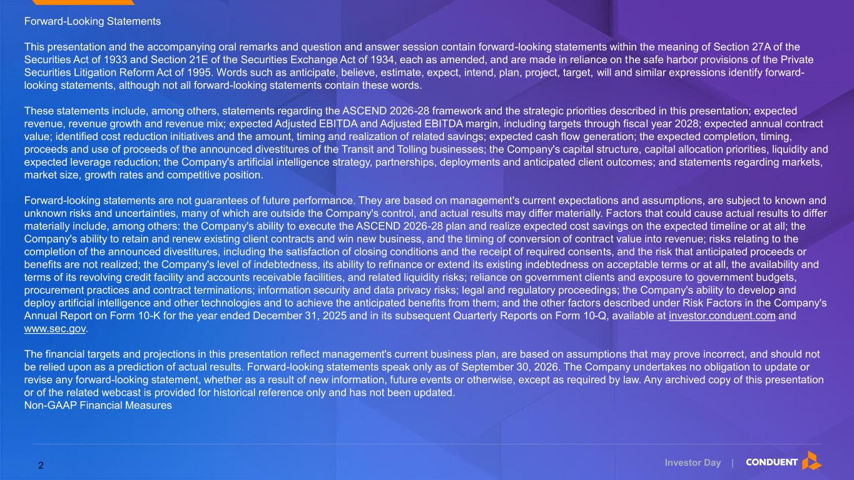
Investor Day | Forward-Looking Statements This presentation and the accompanying oral remarks and question and answer session contain forward-looking statements within the meaning of Section 27A of the Securities Act of 1933 and Section 21E of the Securities Exchange Act of 1934, each as amended, and are made in reliance on the safe harbor provisions of the Private Securities Litigation Reform Act of 1995. Words such as anticipate, believe, estimate, expect, intend, plan, project, target, will and similar expressions identify forward- looking statements, although not all forward-looking statements contain these words. These statements include, among others, statements regarding the ASCEND 2026-28 framework and the strategic priorities described in this presentation; expected revenue, revenue growth and revenue mix; expected Adjusted EBITDA and Adjusted EBITDA margin, including targets through fiscal year 2028; expected annual contract value; identified cost reduction initiatives and the amount, timing and realization of related savings; expected cash flow generation; the expected completion, timing, proceeds and use of proceeds of the announced divestitures of the Transit and Tolling businesses; the Company's capital structure, capital allocation priorities, liquidity and expected leverage reduction; the Company's artificial intelligence strategy, partnerships, deployments and anticipated client outcomes; and statements regarding markets, market size, growth rates and competitive position. Forward-looking statements are not guarantees of future performance. They are based on management's current expectations and assumptions, are subject to known and unknown risks and uncertainties, many of which are outside the Company's control, and actual results may differ materially. Factors that could cause actual results to differ materially include, among others: the Company's ability to execute the ASCEND 2026-28 plan and realize expected cost savings on the expected timeline or at all; the Company's ability to retain and renew existing client contracts and win new business, and the timing of conversion of contract value into revenue; risks relating to the completion of the announced divestitures, including the satisfaction of closing conditions and the receipt of required consents, and the risk that anticipated proceeds or benefits are not realized; the Company's level of indebtedness, its ability to refinance or extend its existing indebtedness on acceptable terms or at all, the availability and terms of its revolving credit facility and accounts receivable facilities, and related liquidity risks; reliance on government clients and exposure to government budgets, procurement practices and contract terminations; information security and data privacy risks; legal and regulatory proceedings; the Company's ability to develop and deploy artificial intelligence and other technologies and to achieve the anticipated benefits from them; and the other factors described under Risk Factors in the Company's Annual Report on Form 10-K for the year ended December 31, 2025 and in its subsequent Quarterly Reports on Form 10-Q, available at investor.conduent.com and www.sec.gov. The financial targets and projections in this presentation reflect management's current business plan, are based on assumptions that may prove incorrect, and should not be relied upon as a prediction of actual results. Forward-looking statements speak only as of September 30, 2026. The Company undertakes no obligation to update or revise any forward-looking statement, whether as a result of new information, future events or otherwise, except as required by law. Any archived copy of this presentation or of the related webcast is provided for historical reference only and has not been updated. Non-GAAP Financial Measures 2

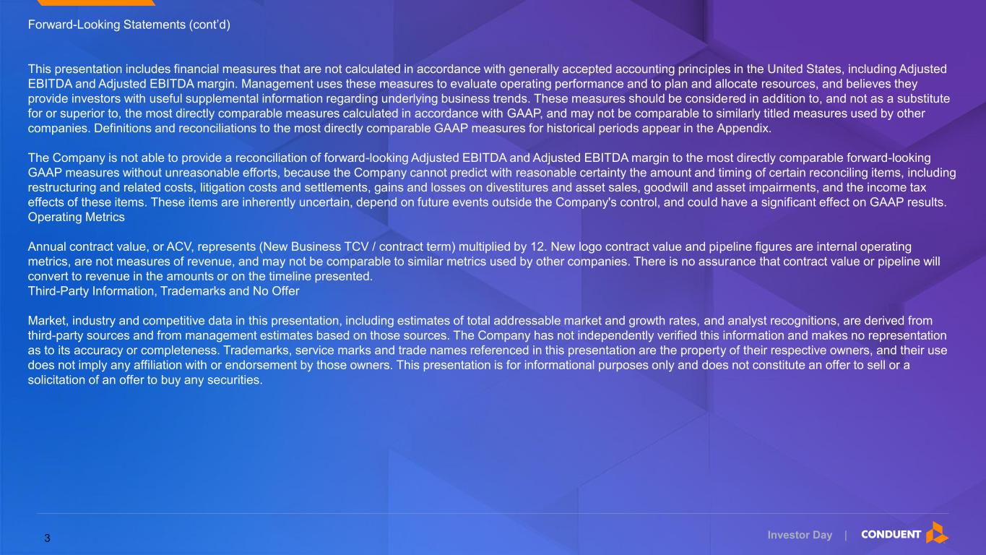
Investor Day | Forward-Looking Statements (cont’d) This presentation includes financial measures that are not calculated in accordance with generally accepted accounting principles in the United States, including Adjusted EBITDA and Adjusted EBITDA margin. Management uses these measures to evaluate operating performance and to plan and allocate resources, and believes they provide investors with useful supplemental information regarding underlying business trends. These measures should be considered in addition to, and not as a substitute for or superior to, the most directly comparable measures calculated in accordance with GAAP, and may not be comparable to similarly titled measures used by other companies. Definitions and reconciliations to the most directly comparable GAAP measures for historical periods appear in the Appendix. The Company is not able to provide a reconciliation of forward-looking Adjusted EBITDA and Adjusted EBITDA margin to the most directly comparable forward-looking GAAP measures without unreasonable efforts, because the Company cannot predict with reasonable certainty the amount and timing of certain reconciling items, including restructuring and related costs, litigation costs and settlements, gains and losses on divestitures and asset sales, goodwill and asset impairments, and the income tax effects of these items. These items are inherently uncertain, depend on future events outside the Company's control, and could have a significant effect on GAAP results. Operating Metrics Annual contract value, or ACV, represents (New Business TCV / contract term) multiplied by 12. New logo contract value and pipeline figures are internal operating metrics, are not measures of revenue, and may not be comparable to similar metrics used by other companies. There is no assurance that contract value or pipeline will convert to revenue in the amounts or on the timeline presented. Third-Party Information, Trademarks and No Offer Market, industry and competitive data in this presentation, including estimates of total addressable market and growth rates, and analyst recognitions, are derived from third-party sources and from management estimates based on those sources. The Company has not independently verified this information and makes no representation as to its accuracy or completeness. Trademarks, service marks and trade names referenced in this presentation are the property of their respective owners, and their use does not imply any affiliation with or endorsement by those owners. This presentation is for informational purposes only and does not constitute an offer to sell or a solicitation of an offer to buy any securities. 3

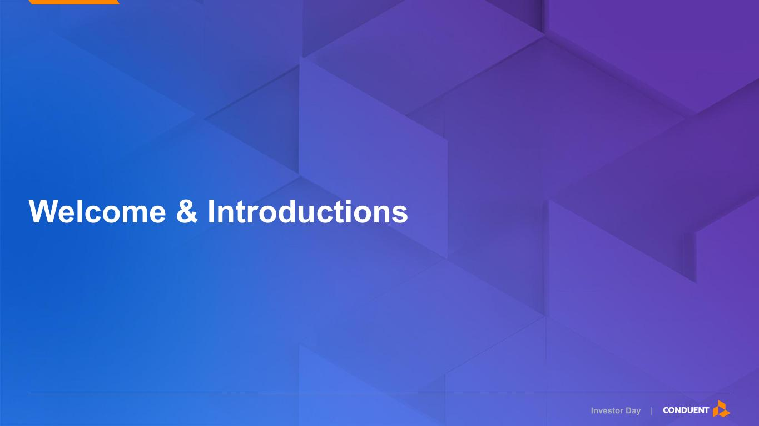
Investor Day | Welcome & Introductions

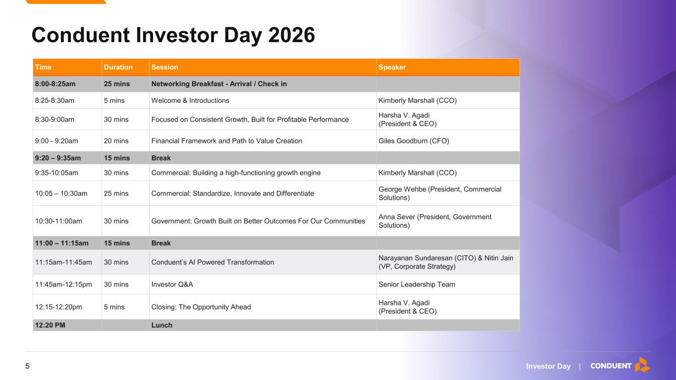
Investor Day | Conduent Investor Day 2026 03 Time Duration Session Speaker 8:00-8:25am 25 mins Networking Breakfast - Arrival / Check in 8:25-8:30am 5 mins Welcome & Introductions Kimberly Marshall (CCO) 8:30-9:00am 30 mins Focused on Consistent Growth, Built for Profitable Performance Harsha V. Agadi (President & CEO) 9:00 - 9:20am 20 mins Financial Framework and Path to Value Creation Giles Goodburn (CFO) 9:20 – 9:35am 15 mins Break 9:35-10:05am 30 mins Commercial: Building a high-functioning growth engine Kimberly Marshall (CCO) 10:05 – 10:30am 25 mins Commercial: Standardize, Innovate and Differentiate George Wehbe (President, Commercial Solutions) 10:30-11:00am 30 mins Government: Growth Built on Better Outcomes For Our Communities Anna Sever (President, Government Solutions) 11:00 – 11:15am 15 mins Break 11:15am-11:45am 30 mins Conduent’s AI Powered Transformation Narayanan Sundaresan (CITO) & Nitin Jain (VP, Corporate Strategy) 11:45am-12:15pm 30 mins Investor Q&A Senior Leadership Team 12:15-12:20pm 5 mins Closing: The Opportunity Ahead Harsha V. Agadi (President & CEO) 12:20 PM Lunch 5

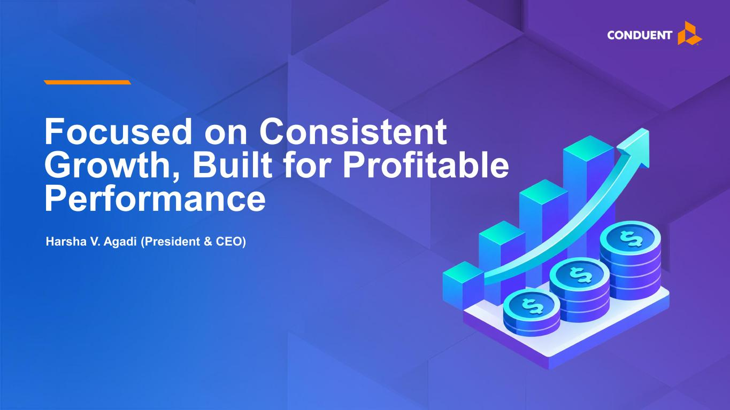
Investor Day | Focused on Consistent Growth, Built for Profitable Performance Harsha V. Agadi (President & CEO)

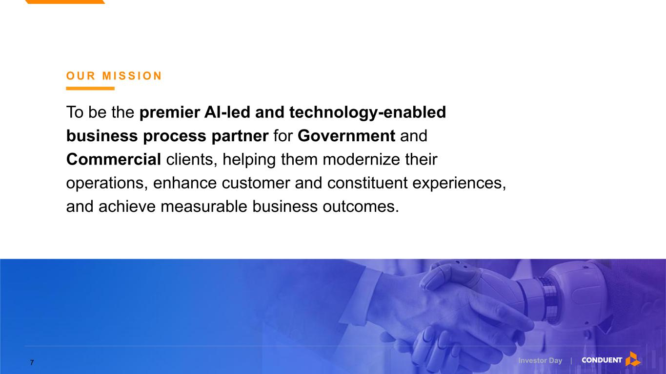
Investor Day | O U R M I S S I O N To be the premier AI-led and technology-enabled business process partner for Government and Commercial clients, helping them modernize their operations, enhance customer and constituent experiences, and achieve measurable business outcomes. 7

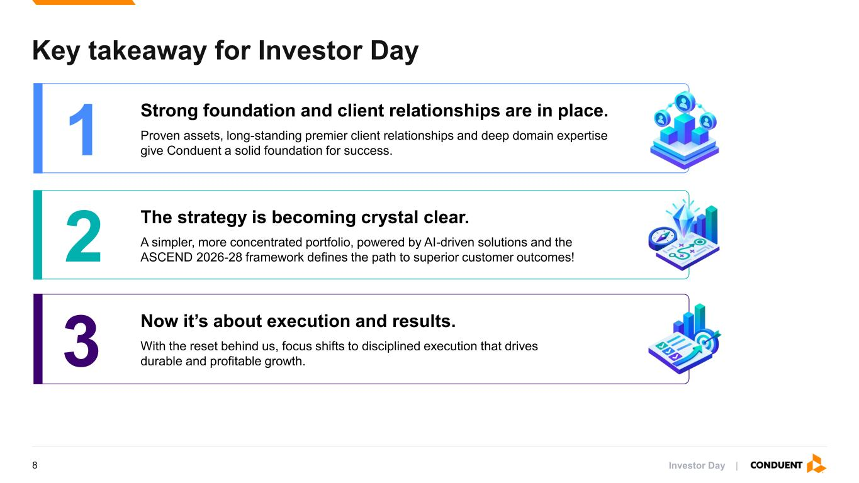
Investor Day | Key takeaway for Investor Day 1 Strong foundation and client relationships are in place. Proven assets, long-standing premier client relationships and deep domain expertise give Conduent a solid foundation for success. 2 The strategy is becoming crystal clear. A simpler, more concentrated portfolio, powered by AI-driven solutions and the ASCEND 2026-28 framework defines the path to superior customer outcomes! 3 Now it’s about execution and results. With the reset behind us, focus shifts to disciplined execution that drives durable and profitable growth. 8

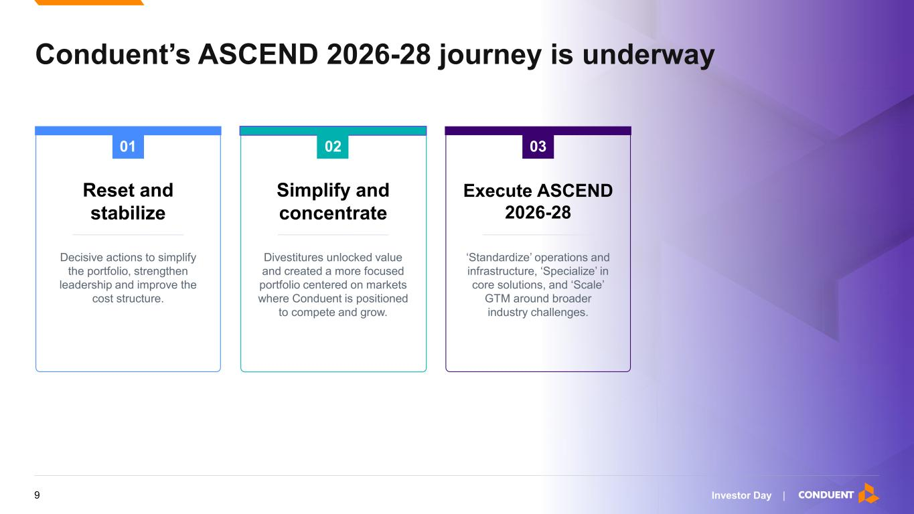
Investor Day | Conduent’s ASCEND 2026-28 journey is underway 01 Reset and stabilize Decisive actions to simplify the portfolio, strengthen leadership and improve the cost structure. Simplify and concentrate Divestitures unlocked value and created a more focused portfolio centered on markets where Conduent is positioned to compete and grow. Execute ASCEND 2026-28 ‘Standardize’ operations and infrastructure, ‘Specialize’ in core solutions, and ‘Scale’ GTM around broader industry challenges. 02 03 9

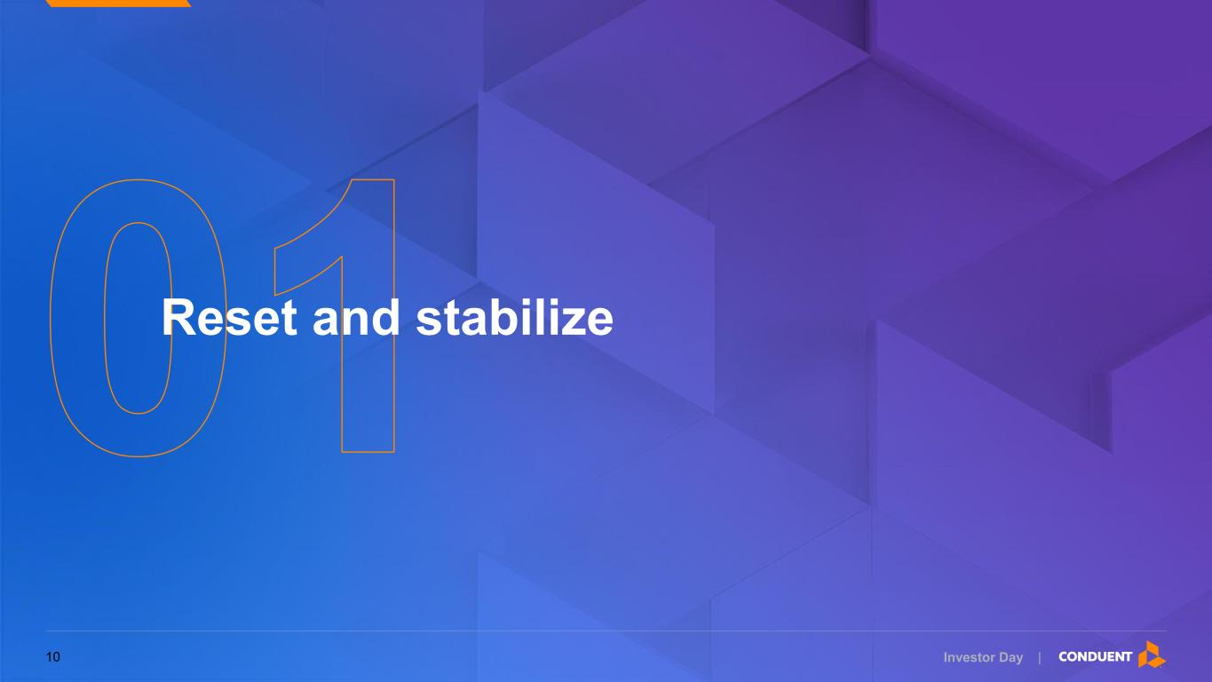
Investor Day | Reset and stabilize 10

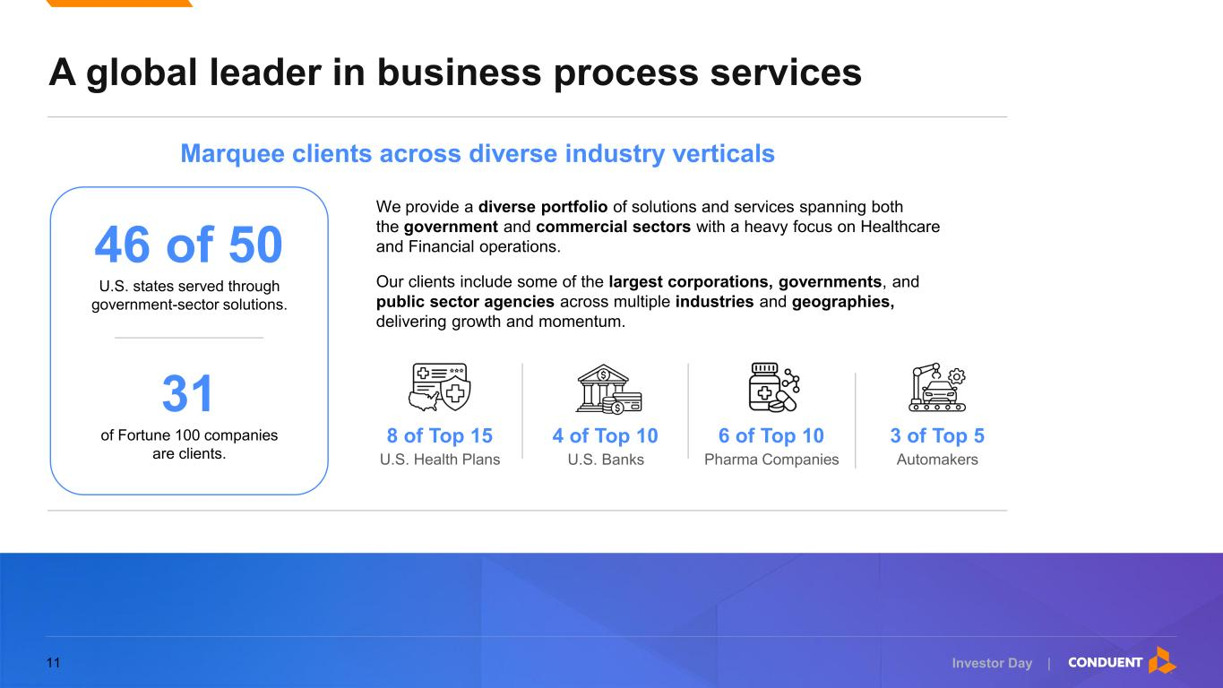
Investor Day | We provide a diverse portfolio of solutions and services spanning both the government and commercial sectors with a heavy focus on Healthcare and Financial operations. Our clients include some of the largest corporations, governments, and public sector agencies across multiple industries and geographies, delivering growth and momentum. A global leader in business process services 46 of 50 U.S. states served through government-sector solutions. 31 of Fortune 100 companies are clients. Marquee clients across diverse industry verticals 8 of Top 15 U.S. Health Plans 4 of Top 10 U.S. Banks 6 of Top 10 Pharma Companies 3 of Top 5 Automakers 11

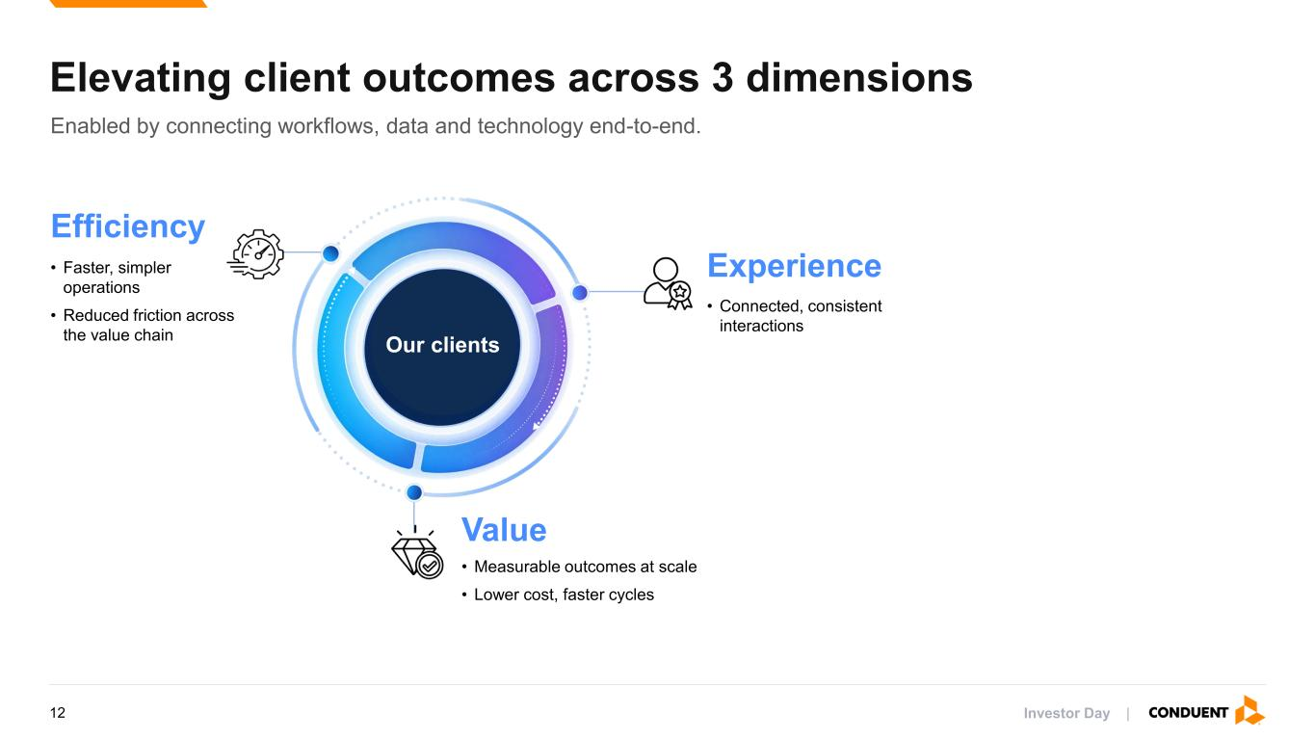
Investor Day | Enabled by connecting workflows, data and technology end-to-end. Elevating client outcomes across 3 dimensions Our clients Efficiency • Faster, simpler operations • Reduced friction across the value chain Experience • Connected, consistent interactions Value • Measurable outcomes at scale • Lower cost, faster cycles 12

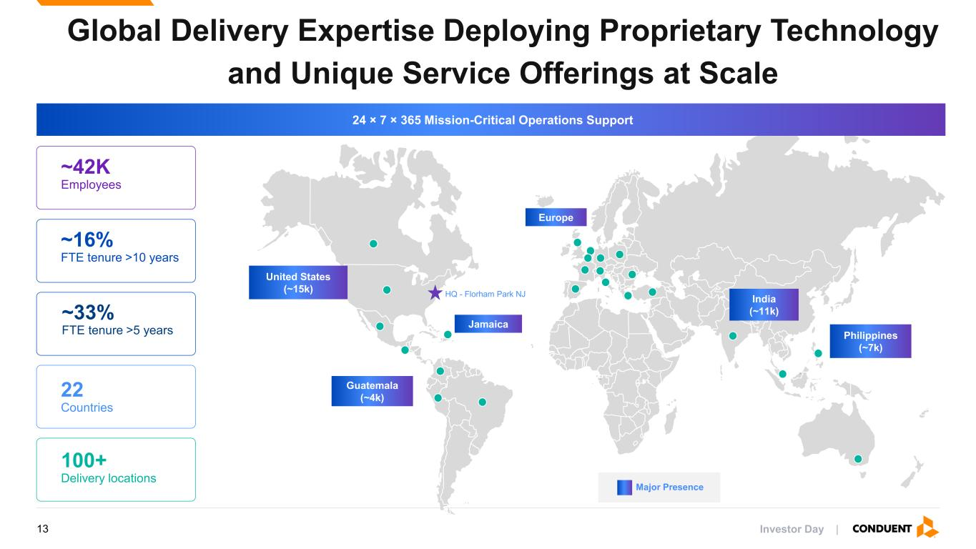
Investor Day | Global Delivery Expertise Deploying Proprietary Technology and Unique Service Offerings at Scale ~42K Employees 22 Countries 100+ Delivery locations ~16% FTE tenure >10 years United States (~15k) India (~11k) Philippines (~7k) Europe Jamaica Guatemala (~4k) Major Presence ~33% FTE tenure >5 years HQ - Florham Park NJ 24 × 7 × 365 Mission-Critical Operations Support 13

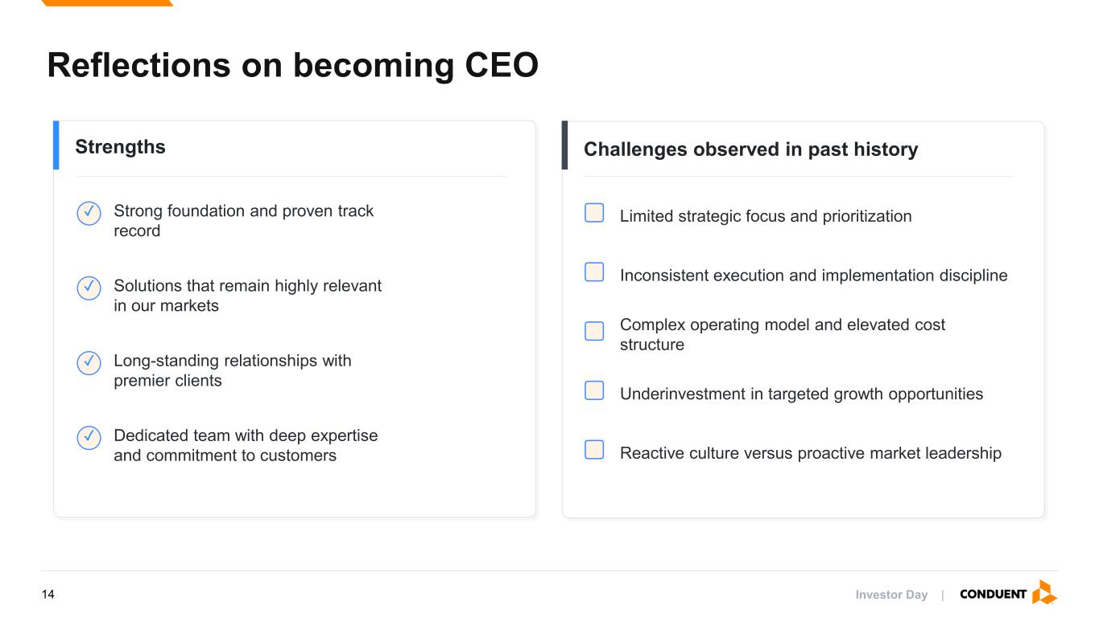
Investor Day | Reflections on becoming CEO Strengths Challenges observed in past history ✓ Strong foundation and proven track record ✓ Solutions that remain highly relevant in our markets ✓ Long-standing relationships with premier clients ✓ Dedicated team with deep expertise and commitment to customers Limited strategic focus and prioritization Inconsistent execution and implementation discipline Complex operating model and elevated cost structure Underinvestment in targeted growth opportunities Reactive culture versus proactive market leadership 14

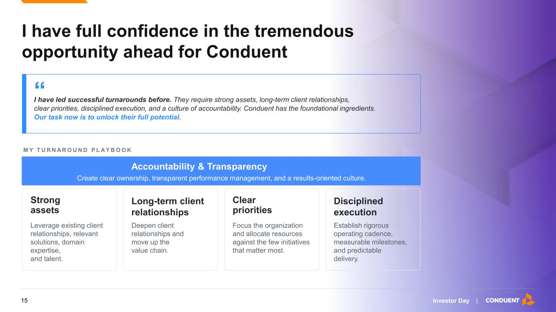
Investor Day | I have full confidence in the tremendous opportunity ahead for Conduent “ I have led successful turnarounds before. They require strong assets, long-term client relationships, clear priorities, disciplined execution, and a culture of accountability. Conduent has the foundational ingredients. Our task now is to unlock their full potential. Strong assets Leverage existing client relationships, relevant solutions, domain expertise, and talent. Clear priorities Focus the organization and allocate resources against the few initiatives that matter most. Disciplined execution Establish rigorous operating cadence, measurable milestones, and predictable delivery. Accountability & Transparency Create clear ownership, transparent performance management, and a results-oriented culture. Long-term client relationships Deepen client relationships and move up the value chain. M Y T U R N A R O U N D P L A Y B O O K 15

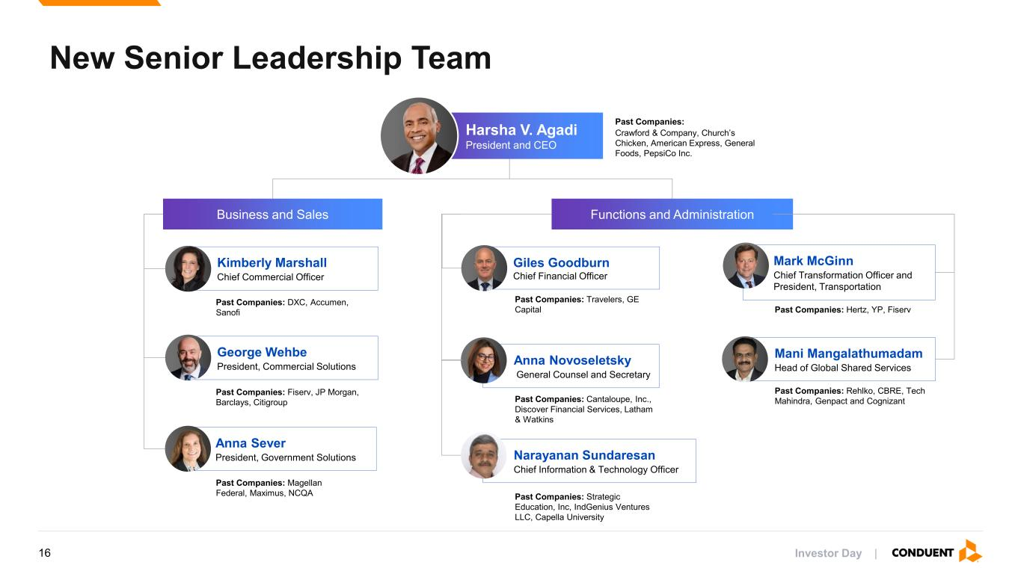
Investor Day | New Senior Leadership Team Harsha V. Agadi President and CEO Past Companies: Crawford & Company, Church’s Chicken, American Express, General Foods, PepsiCo Inc. Business and Sales Functions and Administration Giles Goodburn Chief Financial Officer Past Companies: Travelers, GE Capital Anna Novoseletsky General Counsel and Secretary Past Companies: Cantaloupe, Inc., Discover Financial Services, Latham & Watkins Anna Sever President, Government Solutions Past Companies: Magellan Federal, Maximus, NCQA George Wehbe President, Commercial Solutions Past Companies: Fiserv, JP Morgan, Barclays, Citigroup Mark McGinn Chief Transformation Officer and President, Transportation Past Companies: Hertz, YP, Fiserv Kimberly Marshall Chief Commercial Officer Past Companies: DXC, Accumen, Sanofi Mani Mangalathumadam Head of Global Shared Services Past Companies: Rehlko, CBRE, Tech Mahindra, Genpact and Cognizant Narayanan Sundaresan Chief Information & Technology Officer Past Companies: Strategic Education, Inc, IndGenius Ventures LLC, Capella University 16

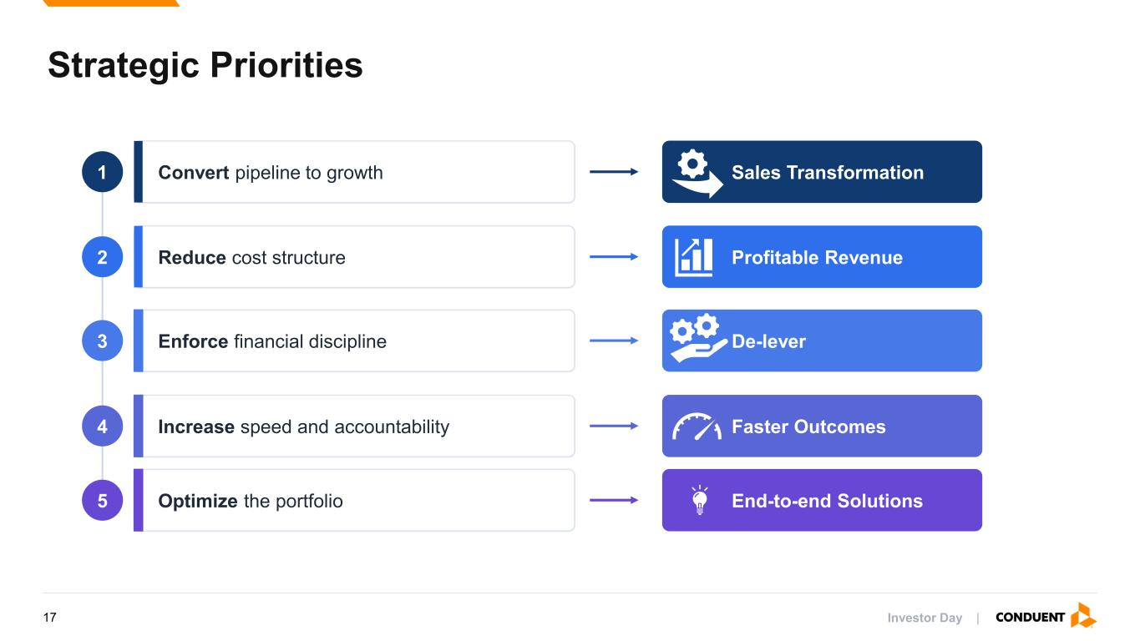
Investor Day | Strategic Priorities 2 Reduce cost structure Profitable Revenue 4 Increase speed and accountability Faster Outcomes 3 Enforce financial discipline De-lever 5 Optimize the portfolio End-to-end Solutions 1 Convert pipeline to growth Sales Transformation 17

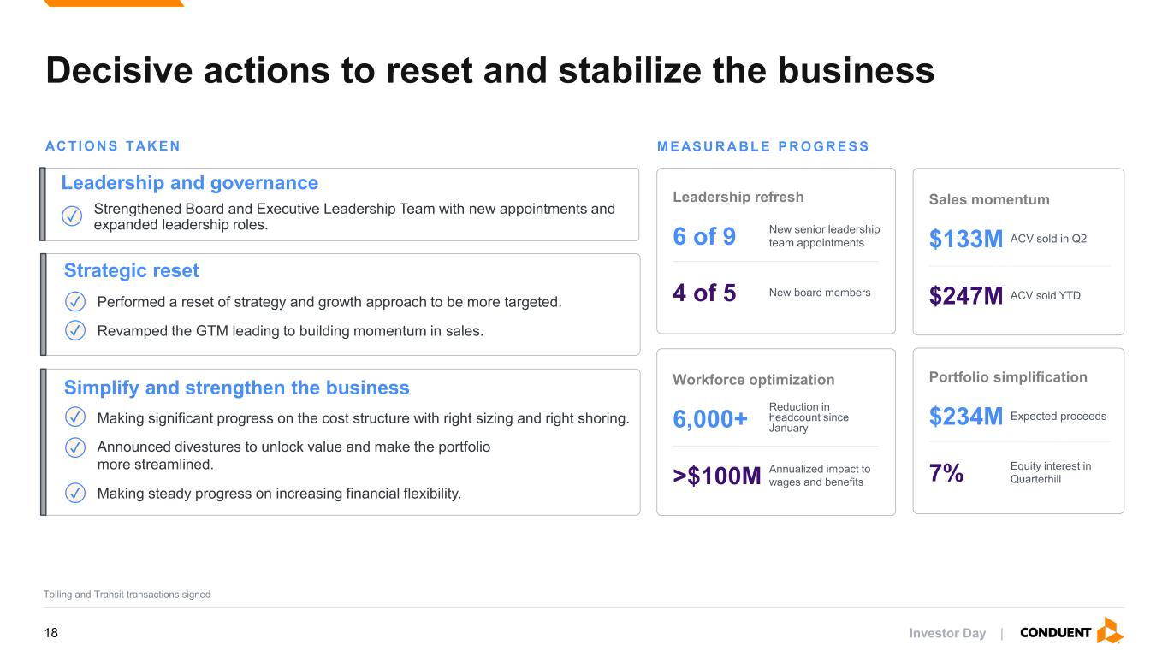
Investor Day | Decisive actions to reset and stabilize the business AC TI O N S TAK E N Strategic reset ✓ Performed a reset of strategy and growth approach to be more targeted. ✓ Revamped the GTM leading to building momentum in sales. Simplify and strengthen the business ✓ Making significant progress on the cost structure with right sizing and right shoring. ✓ Announced divestures to unlock value and make the portfolio more streamlined. ✓ Making steady progress on increasing financial flexibility. Leadership and governance ✓ Strengthened Board and Executive Leadership Team with new appointments and expanded leadership roles. M E AS U R A B L E P R O G R E S S Workforce optimization 6,000+ Reduction in headcount since January >$100M Annualized impact to wages and benefits Sales momentum $133M ACV sold in Q2 $247M ACV sold YTD Leadership refresh 6 of 9 New senior leadership team appointments 4 of 5 New board members Portfolio simplification $234M Expected proceeds 7% Equity interest in Quarterhill Tolling and Transit transactions signed 18

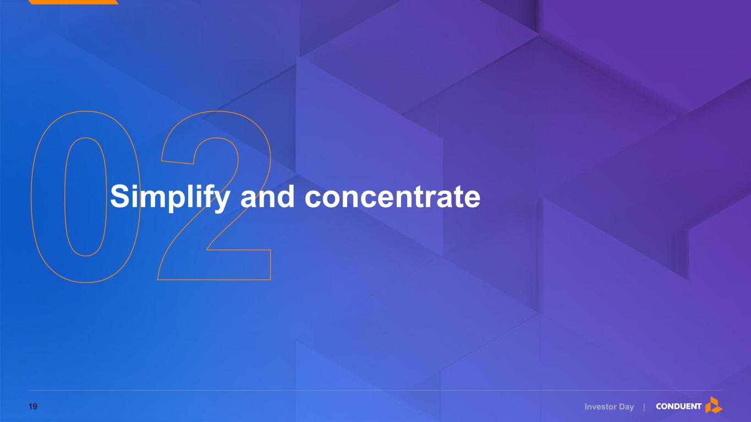
Investor Day | Simplify and concentrate 19

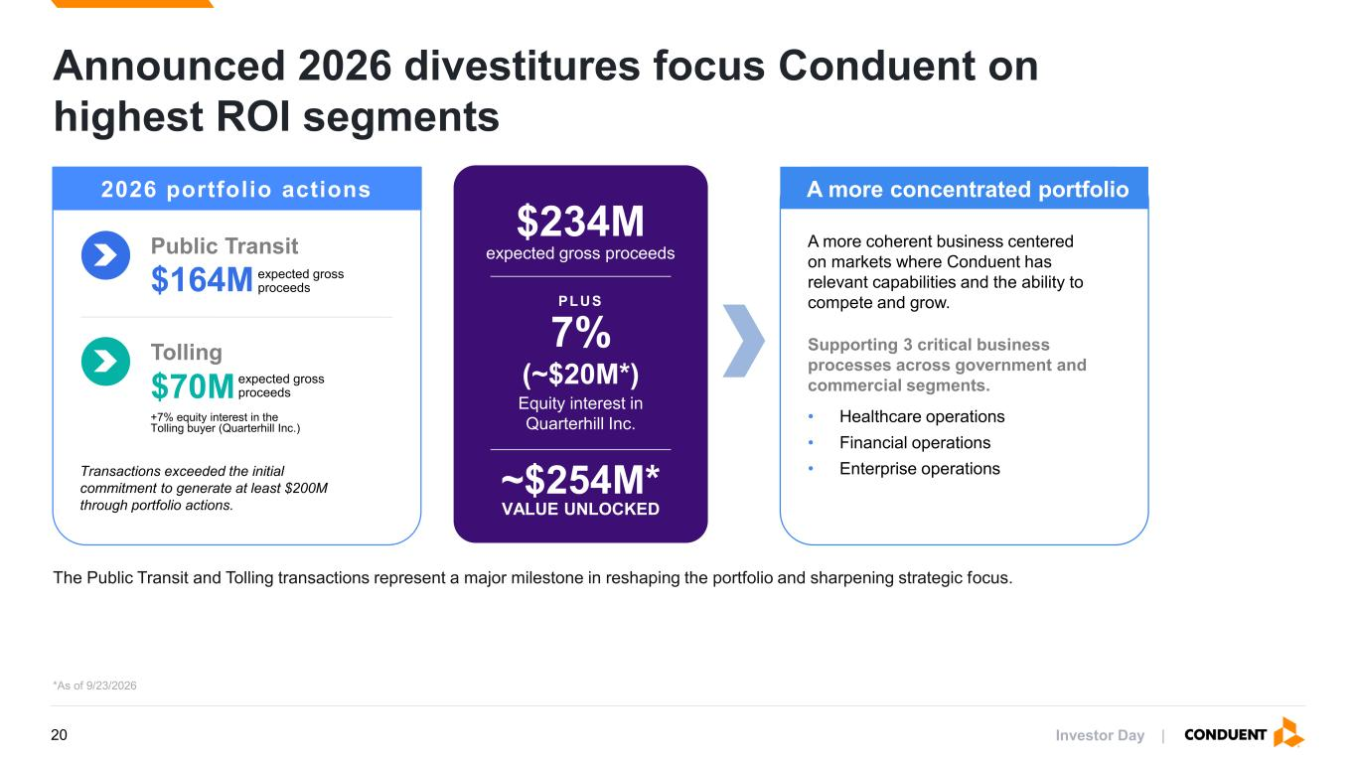
Investor Day | Announced 2026 divestitures focus Conduent on highest ROI segments The Public Transit and Tolling transactions represent a major milestone in reshaping the portfolio and sharpening strategic focus. Public Transit $164M expected gross proceeds Tolling $70M expected gross proceeds +7% equity interest in the Tolling buyer (Quarterhill Inc.) Transactions exceeded the initial commitment to generate at least $200M through portfolio actions. A more concentrated portfolio A more coherent business centered on markets where Conduent has relevant capabilities and the ability to compete and grow. • Healthcare operations • Financial operations • Enterprise operations Supporting 3 critical business processes across government and commercial segments. *As of 9/23/2026 2026 portfolio actions $234M expected gross proceeds PLUS 7% (~$20M*) Equity interest in Quarterhill Inc. ~$254M* VALUE UNLOCKED 20

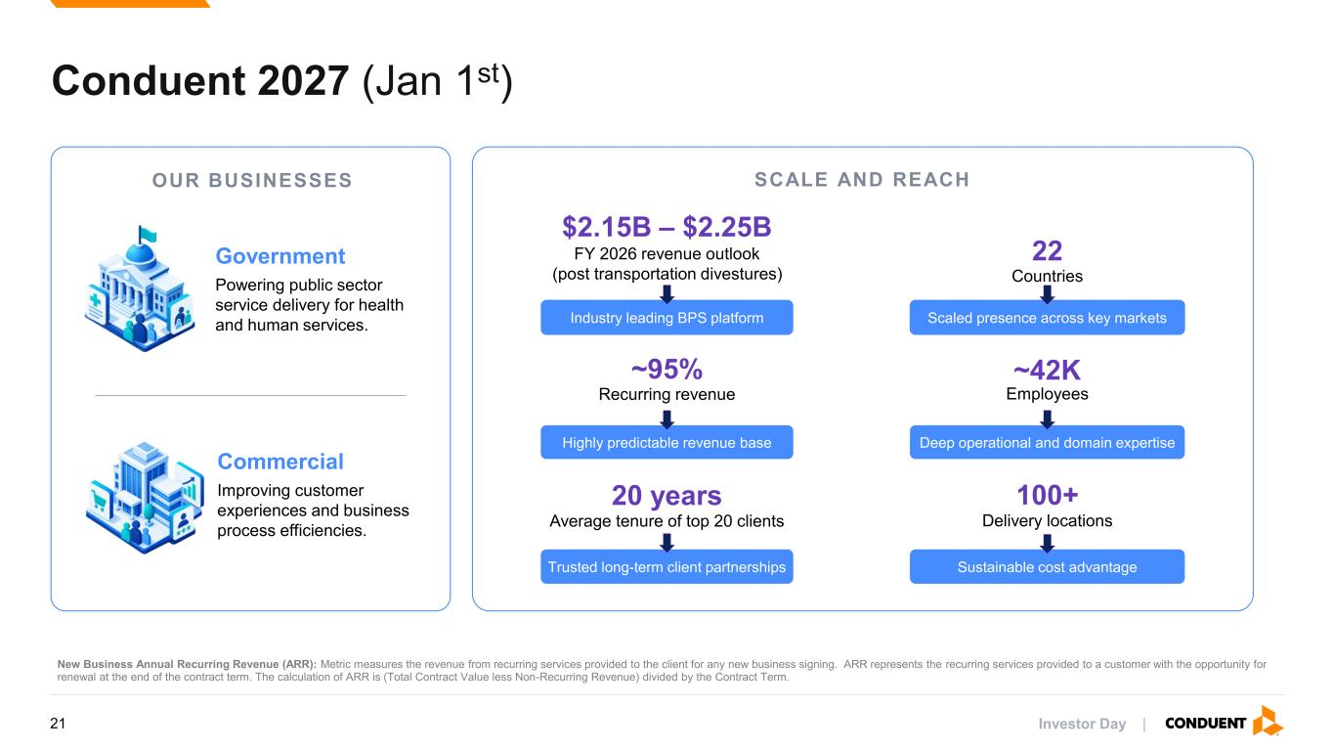
Investor Day | SCALE AND REACH Conduent 2027 (Jan 1st) 100+ Delivery locations 20 years Average tenure of top 20 clients Trusted long-term client partnerships Sustainable cost advantage ~42K Employees ~95% Recurring revenue Highly predictable revenue base Deep operational and domain expertise 22 Countries $2.15B – $2.25B FY 2026 revenue outlook (post transportation divestures) Industry leading BPS platform Scaled presence across key markets OUR BUSINESSES Government Powering public sector service delivery for health and human services. Commercial Improving customer experiences and business process efficiencies. New Business Annual Recurring Revenue (ARR): Metric measures the revenue from recurring services provided to the client for any new business signing. ARR represents the recurring services provided to a customer with the opportunity for renewal at the end of the contract term. The calculation of ARR is (Total Contract Value less Non-Recurring Revenue) divided by the Contract Term. 21

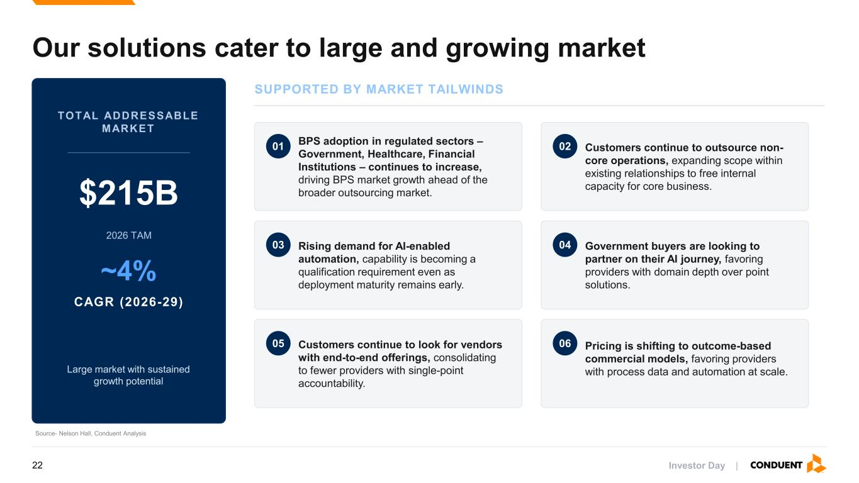
Investor Day | Our solutions cater to large and growing market TOTAL ADDRESSABLE MARKET $215B 2026 TAM ~4% CAGR (2026-29) Large market with sustained growth potential SUPPORTED BY MARKET TAILWINDS 01 BPS adoption in regulated sectors – Government, Healthcare, Financial Institutions – continues to increase, driving BPS market growth ahead of the broader outsourcing market. 02 Customers continue to outsource non- core operations, expanding scope within existing relationships to free internal capacity for core business. 03 Rising demand for AI-enabled automation, capability is becoming a qualification requirement even as deployment maturity remains early. 04 Government buyers are looking to partner on their AI journey, favoring providers with domain depth over point solutions. 05 Customers continue to look for vendors with end-to-end offerings, consolidating to fewer providers with single-point accountability. 06 Pricing is shifting to outcome-based commercial models, favoring providers with process data and automation at scale. Source- Nelson Hall, Conduent Analysis 22

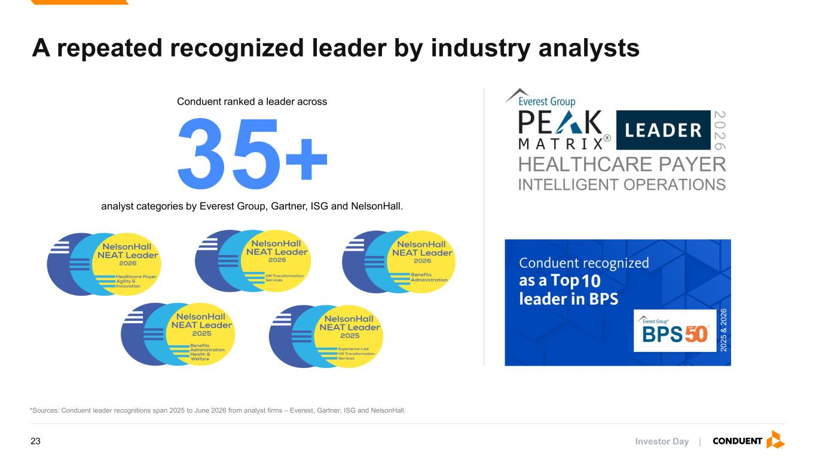
Investor Day | 35+ A repeated recognized leader by industry analysts *Sources: Conduent leader recognitions span 2025 to June 2026 from analyst firms – Everest, Gartner, ISG and NelsonHall. 2 0 2 5 & 2 0 2 6 Conduent ranked a leader across analyst categories by Everest Group, Gartner, ISG and NelsonHall. 23

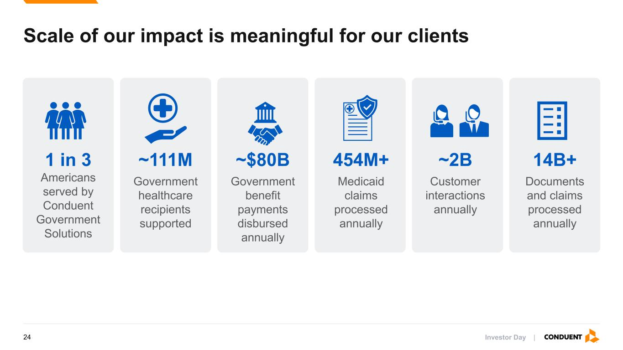
Investor Day | Scale of our impact is meaningful for our clients ~2B Customer interactions annually 1 in 3 Americans served by Conduent Government Solutions ~$80B Government benefit payments disbursed annually 454M+ Medicaid claims processed annually 14B+ Documents and claims processed annually ~111M Government healthcare recipients supported 24

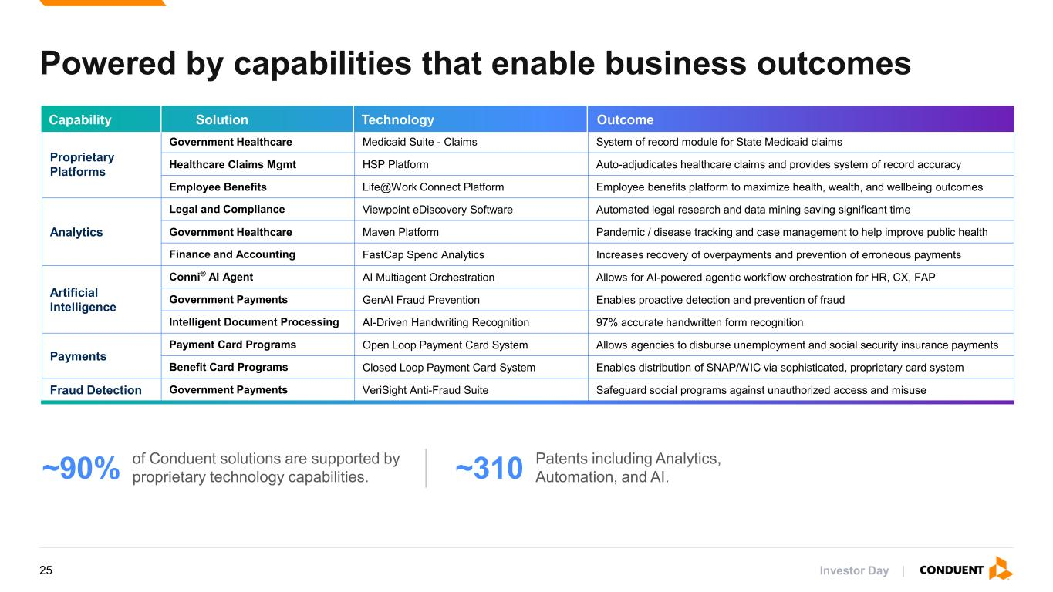
Investor Day | Proprietary Platforms Government Healthcare Medicaid Suite - Claims System of record module for State Medicaid claims Healthcare Claims Mgmt HSP Platform Auto-adjudicates healthcare claims and provides system of record accuracy Employee Benefits Life@Work Connect Platform Employee benefits platform to maximize health, wealth, and wellbeing outcomes Analytics Legal and Compliance Viewpoint eDiscovery Software Automated legal research and data mining saving significant time Government Healthcare Maven Platform Pandemic / disease tracking and case management to help improve public health Finance and Accounting FastCap Spend Analytics Increases recovery of overpayments and prevention of erroneous payments Artificial Intelligence Conni® AI Agent AI Multiagent Orchestration Allows for AI-powered agentic workflow orchestration for HR, CX, FAP Government Payments GenAI Fraud Prevention Enables proactive detection and prevention of fraud Intelligent Document Processing AI-Driven Handwriting Recognition 97% accurate handwritten form recognition Payments Payment Card Programs Open Loop Payment Card System Allows agencies to disburse unemployment and social security insurance payments Benefit Card Programs Closed Loop Payment Card System Enables distribution of SNAP/WIC via sophisticated, proprietary card system Fraud Detection Government Payments VeriSight Anti-Fraud Suite Safeguard social programs against unauthorized access and misuse Capability Solution Technology Outcome Powered by capabilities that enable business outcomes of Conduent solutions are supported by proprietary technology capabilities.~90% Patents including Analytics, Automation, and AI.~310 25

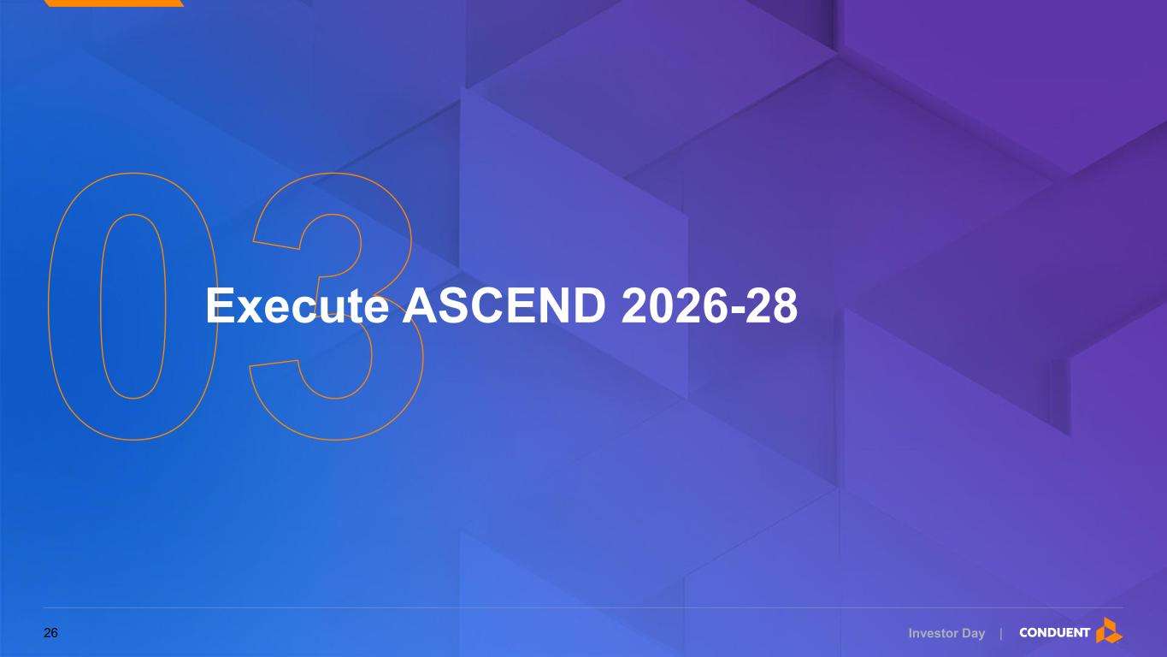
Investor Day | Execute ASCEND 2026-28 26

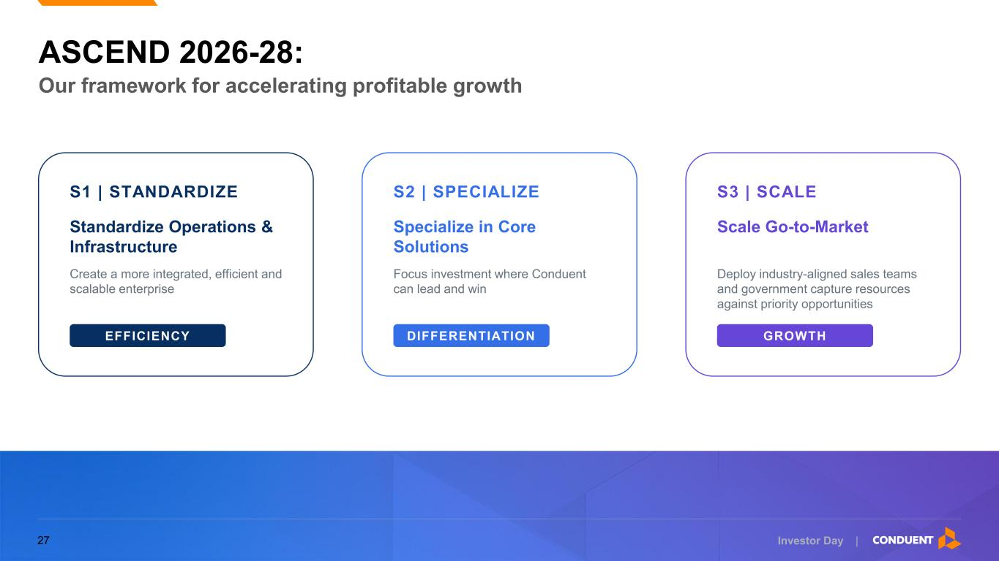
Investor Day | ASCEND 2026-28: S1 | STANDARDIZE Standardize Operations & Infrastructure Create a more integrated, efficient and scalable enterprise EFFICIENCY S2 | SPECIALIZE Specialize in Core Solutions Focus investment where Conduent can lead and win DIFFERENTIATION S3 | SCALE Scale Go-to-Market Deploy industry-aligned sales teams and government capture resources against priority opportunities GROWTH Our framework for accelerating profitable growth 27

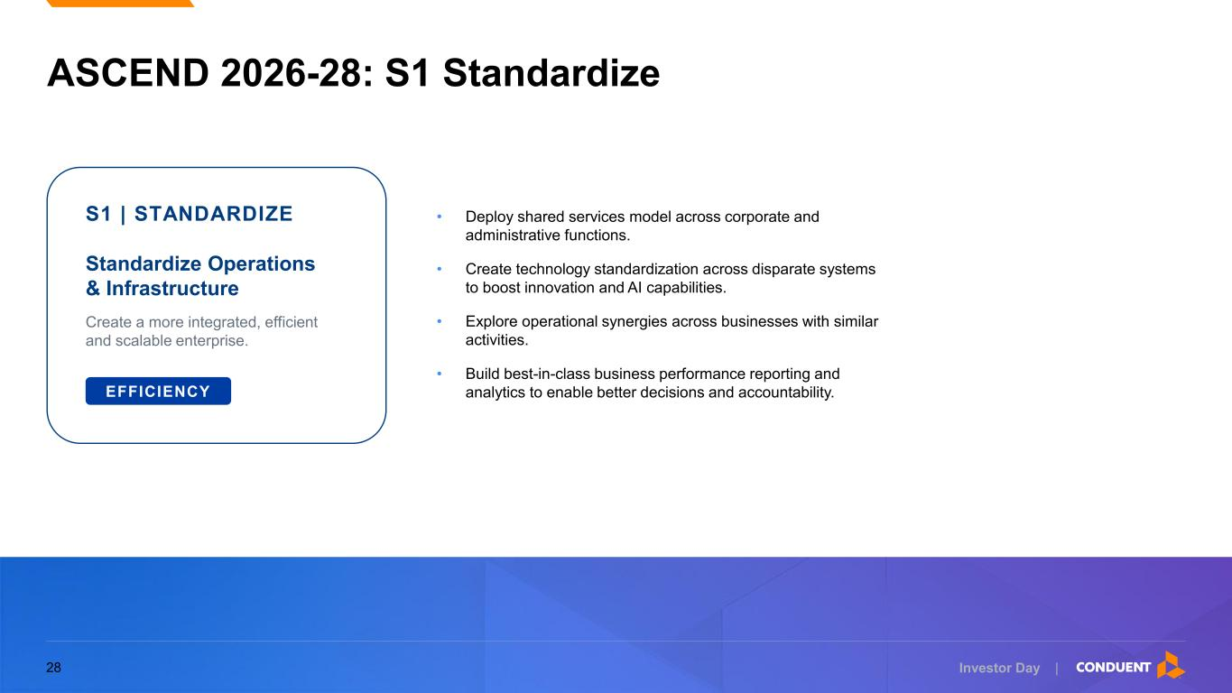
Investor Day | ASCEND 2026-28: S1 Standardize S1 | STANDARDIZE Standardize Operations & Infrastructure Create a more integrated, efficient and scalable enterprise. EFFICIENCY • Deploy shared services model across corporate and administrative functions. • Create technology standardization across disparate systems to boost innovation and AI capabilities. • Explore operational synergies across businesses with similar activities. • Build best-in-class business performance reporting and analytics to enable better decisions and accountability. 28

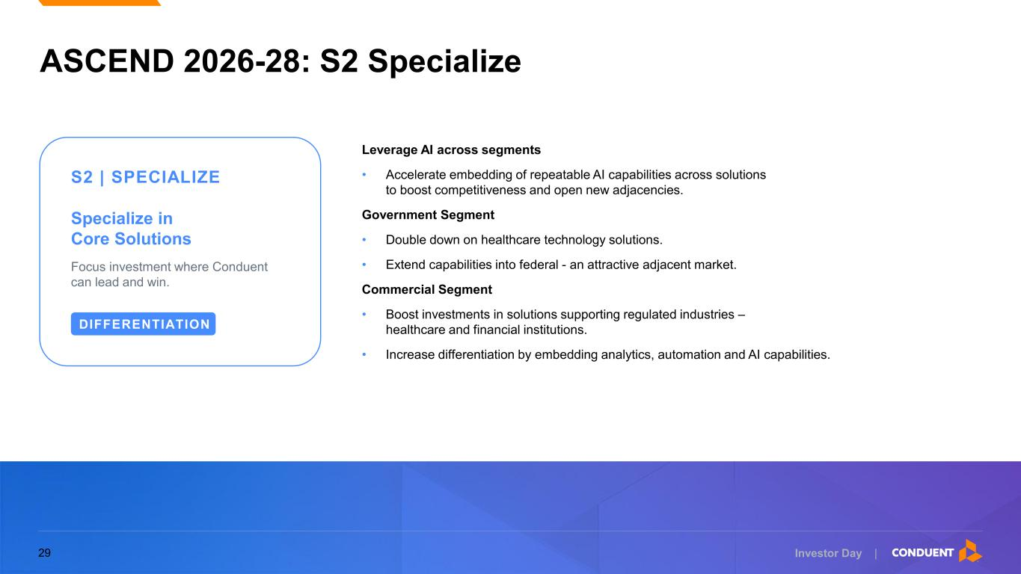
Investor Day | ASCEND 2026-28: S2 Specialize S2 | SPECIALIZE Specialize in Core Solutions Focus investment where Conduent can lead and win. DIFFERENTIATION Leverage AI across segments • Accelerate embedding of repeatable AI capabilities across solutions to boost competitiveness and open new adjacencies. Government Segment • Double down on healthcare technology solutions. • Extend capabilities into federal - an attractive adjacent market. Commercial Segment • Boost investments in solutions supporting regulated industries – healthcare and financial institutions. • Increase differentiation by embedding analytics, automation and AI capabilities. 29

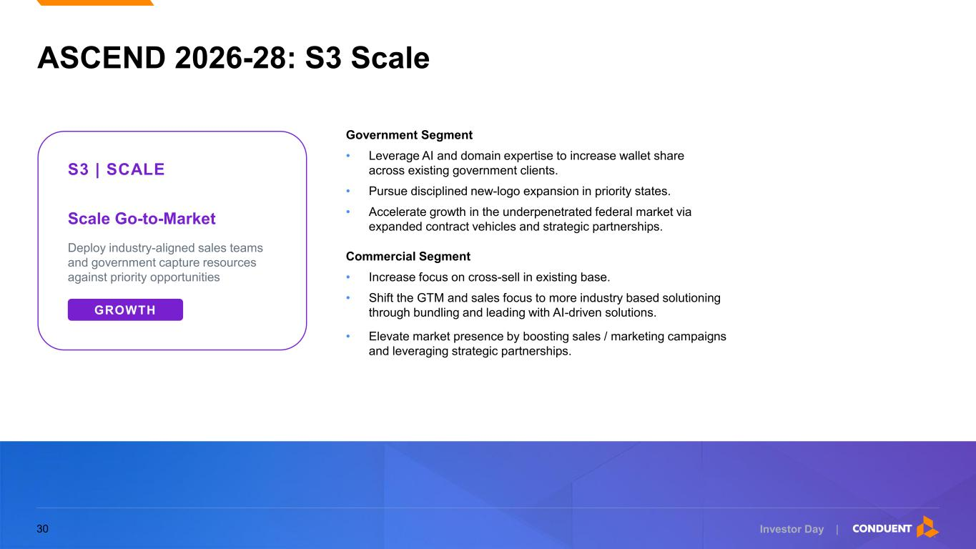
Investor Day | ASCEND 2026-28: S3 Scale S3 | SCALE Scale Go-to-Market Deploy industry-aligned sales teams and government capture resources against priority opportunities GROWTH Government Segment • Leverage AI and domain expertise to increase wallet share across existing government clients. • Pursue disciplined new-logo expansion in priority states. • Accelerate growth in the underpenetrated federal market via expanded contract vehicles and strategic partnerships. Commercial Segment • Increase focus on cross-sell in existing base. • Shift the GTM and sales focus to more industry based solutioning through bundling and leading with AI-driven solutions. • Elevate market presence by boosting sales / marketing campaigns and leveraging strategic partnerships. 30

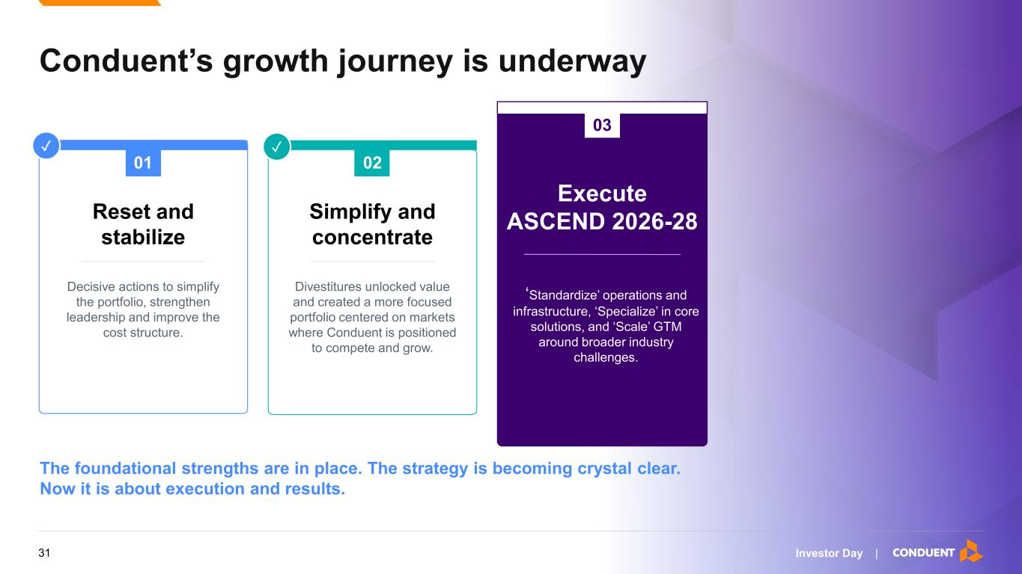
Investor Day | Conduent’s growth journey is underway 01 Reset and stabilize Decisive actions to simplify the portfolio, strengthen leadership and improve the cost structure. Simplify and concentrate Divestitures unlocked value and created a more focused portfolio centered on markets where Conduent is positioned to compete and grow. 02 Execute ASCEND 2026-28 ‘Standardize’ operations and infrastructure, ‘Specialize’ in core solutions, and ‘Scale’ GTM around broader industry challenges. ✓✓ The foundational strengths are in place. The strategy is becoming crystal clear. Now it is about execution and results. 03 31

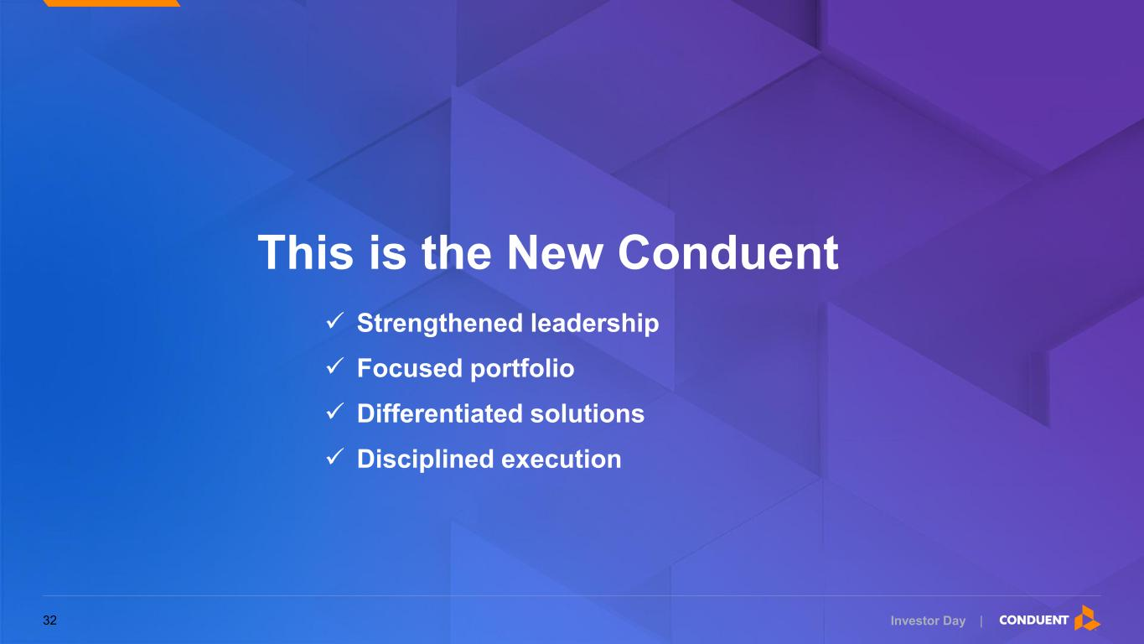
Investor Day | This is the New Conduent ✓ Strengthened leadership ✓ Focused portfolio ✓ Differentiated solutions ✓ Disciplined execution 32

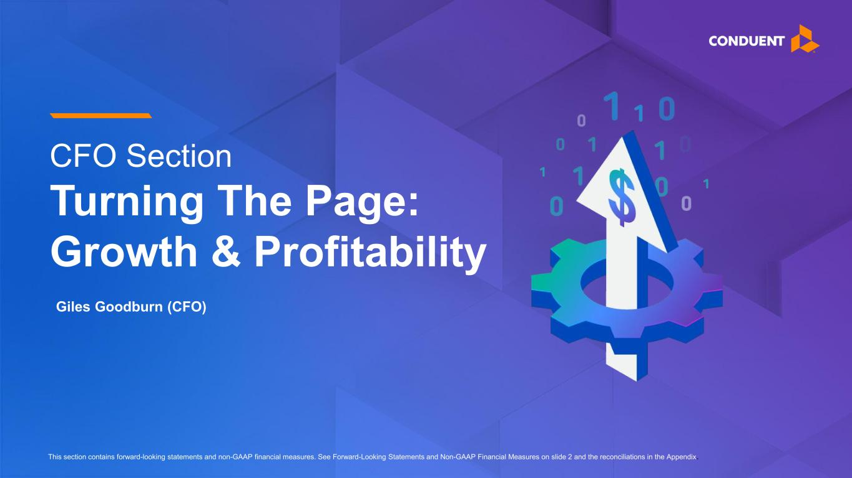
Investor Day | CFO Section Turning The Page: Growth & Profitability This section contains forward-looking statements and non-GAAP financial measures. See Forward-Looking Statements and Non-GAAP Financial Measures on slide 2 and the reconciliations in the Appendix. Giles Goodburn (CFO)

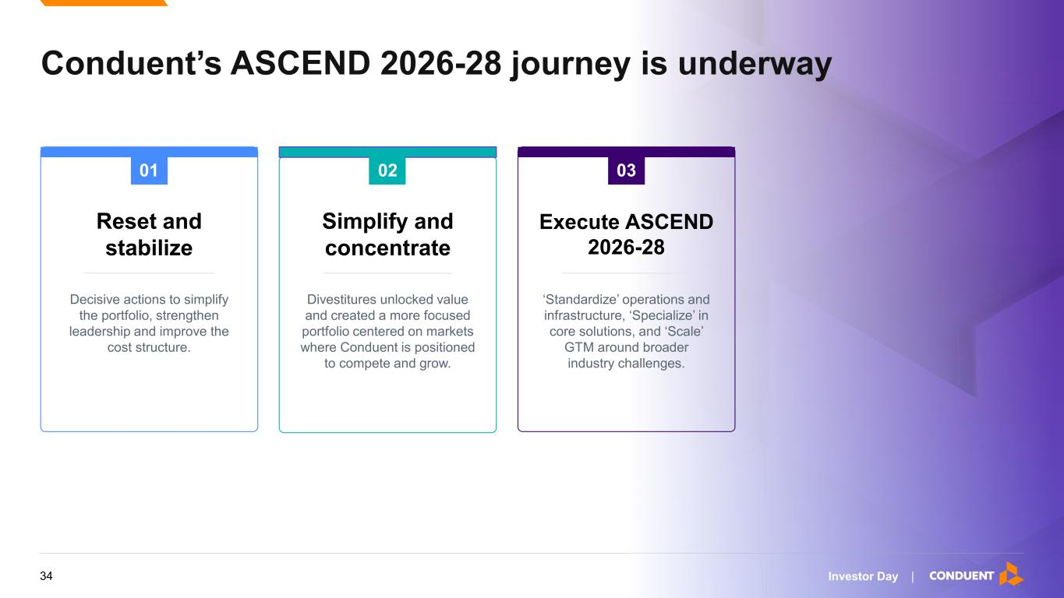
Investor Day | Conduent’s ASCEND 2026-28 journey is underway 01 Reset and stabilize Decisive actions to simplify the portfolio, strengthen leadership and improve the cost structure. Simplify and concentrate Divestitures unlocked value and created a more focused portfolio centered on markets where Conduent is positioned to compete and grow. Execute ASCEND 2026-28 ‘Standardize’ operations and infrastructure, ‘Specialize’ in core solutions, and ‘Scale’ GTM around broader industry challenges. 02 03 34

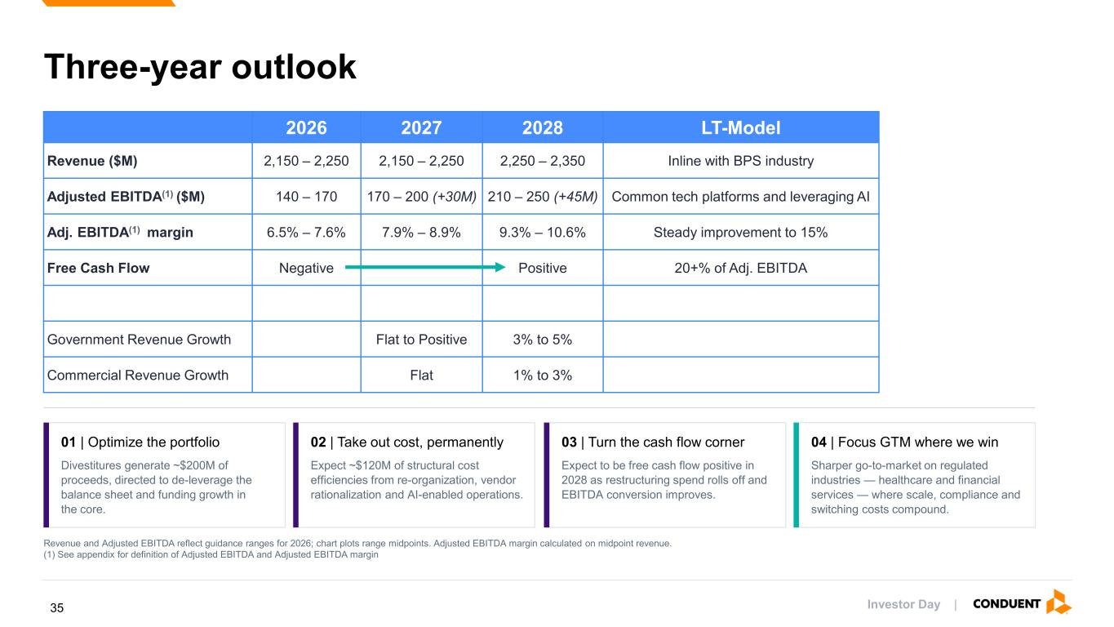
Investor Day | Three-year outlook How we get there 01 | Optimize the portfolio Divestitures generate ~$200M of proceeds, directed to de-leverage the balance sheet and funding growth in the core. 02 | Take out cost, permanently Expect ~$120M of structural cost efficiencies from re-organization, vendor rationalization and AI-enabled operations. 03 | Turn the cash flow corner Expect to be free cash flow positive in 2028 as restructuring spend rolls off and EBITDA conversion improves. 04 | Focus GTM where we win Sharper go-to-market on regulated industries — healthcare and financial services — where scale, compliance and switching costs compound. Revenue and Adjusted EBITDA reflect guidance ranges for 2026; chart plots range midpoints. Adjusted EBITDA margin calculated on midpoint revenue. (1) See appendix for definition of Adjusted EBITDA and Adjusted EBITDA margin 2026 2027 2028 LT-Model Revenue ($M) 2,150 – 2,250 2,150 – 2,250 2,250 – 2,350 Inline with BPS industry Adjusted EBITDA(1) ($M) 140 – 170 170 – 200 (+30M) 210 – 250 (+45M) Common tech platforms and leveraging AI Adj. EBITDA(1) margin 6.5% – 7.6% 7.9% – 8.9% 9.3% – 10.6% Steady improvement to 15% Free Cash Flow Negative Positive 20+% of Adj. EBITDA Government Revenue Growth Flat to Positive 3% to 5% Commercial Revenue Growth Flat 1% to 3% 35

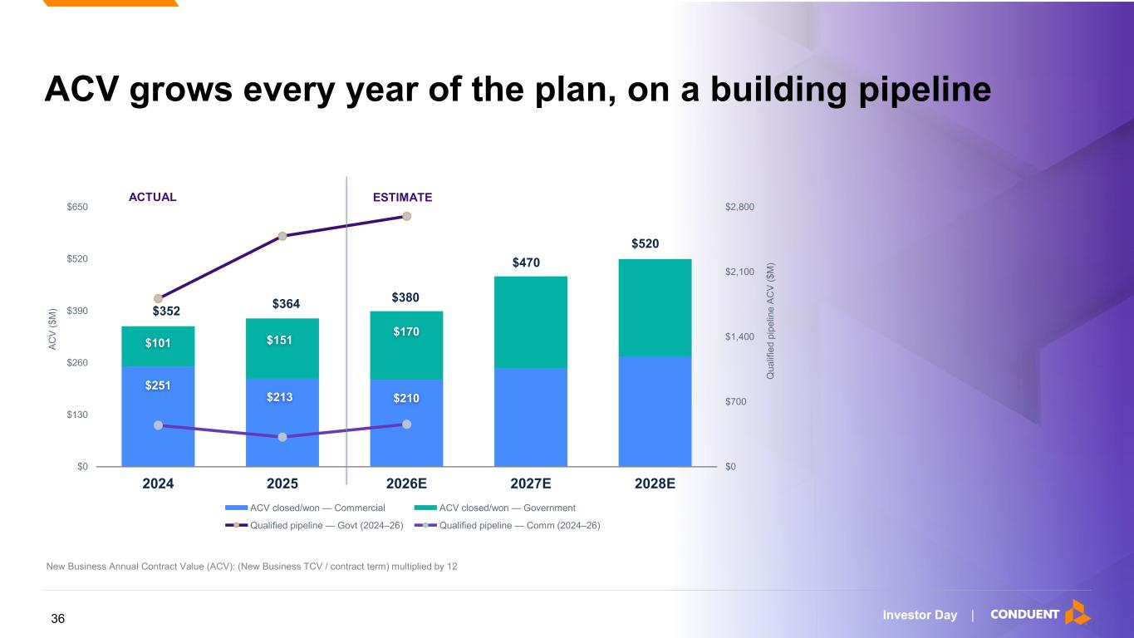
Investor Day | ACV grows every year of the plan, on a building pipeline $0 $700 $1,400 $2,100 $2,800 $0 $130 $260 $390 $520 $650 2024 2025 2026E 2027E 2028E Q u a lif ie d p ip e lin e A C V ( $ M ) A C V ( $ M ) ACV closed/won — Commercial ACV closed/won — Government Qualified pipeline — Govt (2024–26) Qualified pipeline — Comm (2024–26) $352 $101 $251 $364 $151 $213 $380 $170 $210 $520 $470 New Business Annual Contract Value (ACV): (New Business TCV / contract term) multiplied by 12 ACTUAL ESTIMATE 36

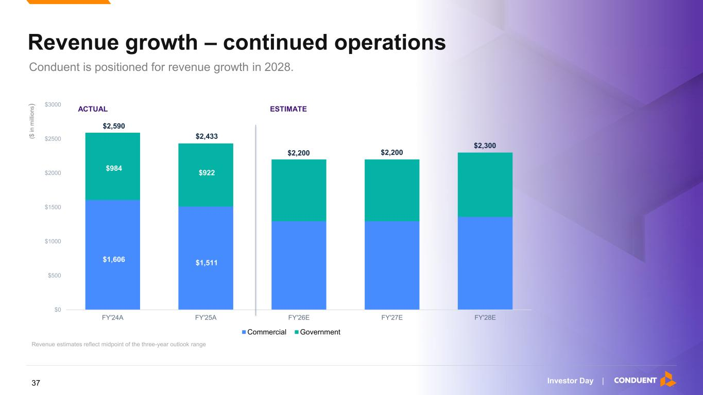
Investor Day | Revenue growth – continued operations Conduent is positioned for revenue growth in 2028. ($ i n m ill io n s ) $0 $500 $1000 $1500 $2000 $2500 $3000 FY'24A FY'25A FY'26E FY'27E FY'28E Commercial Government ACTUAL ESTIMATE $2,590 $2,433 $2,200 $2,200 $2,300 $1,606 $984 $1,511 $922 Revenue estimates reflect midpoint of the three-year outlook range 37

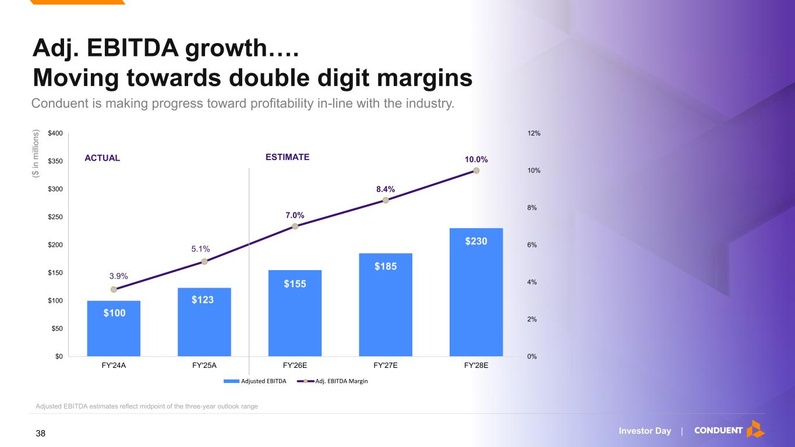
Investor Day | Adj. EBITDA growth…. Moving towards double digit margins Conduent is making progress toward profitability in-line with the industry. $100 $123 $155 $185 $230 3.9% 5.1% 7.0% 8.4% 10.0% 0% 2% 4% 6% 8% 10% 12% $0 $50 $100 $150 $200 $250 $300 $350 $400 FY'24A FY'25A FY'26E FY'27E FY'28E Adjusted EBITDA Adj. EBITDA Margin ACTUAL ESTIMATE ($ i n m ill io n s ) Adjusted EBITDA estimates reflect midpoint of the three-year outlook range 38

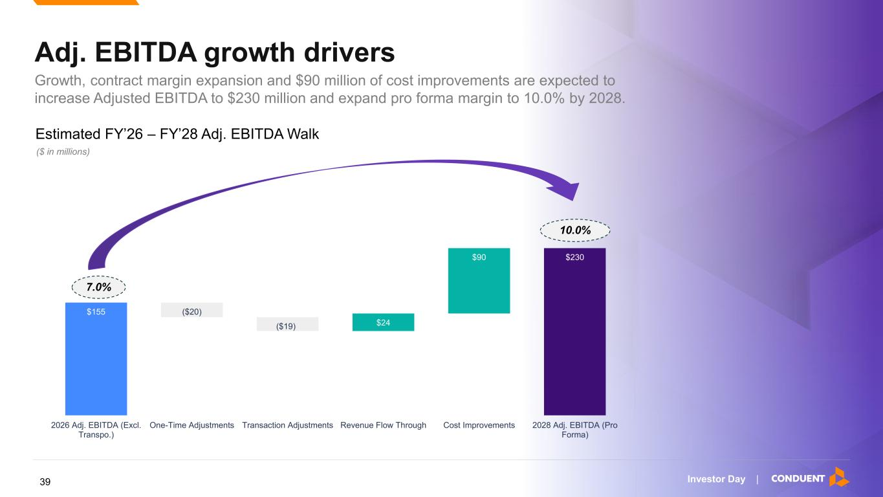
Investor Day | $155 ($20) ($19) $24 $90 $230 2026 Adj. EBITDA (Excl. Transpo.) One-Time Adjustments Transaction Adjustments Revenue Flow Through Cost Improvements 2028 Adj. EBITDA (Pro Forma) Adj. EBITDA growth drivers Growth, contract margin expansion and $90 million of cost improvements are expected to increase Adjusted EBITDA to $230 million and expand pro forma margin to 10.0% by 2028. ($ in millions) Estimated FY’26 – FY’28 Adj. EBITDA Walk 7.0% 10.0% 39

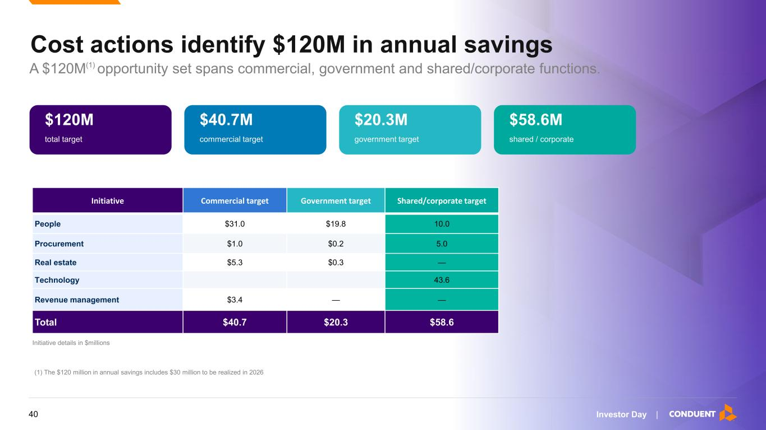
Investor Day | Cost actions identify $120M in annual savings A $120M(1) opportunity set spans commercial, government and shared/corporate functions. $120M total target $40.7M commercial target $20.3M government target $58.6M shared / corporate Initiative details in $millions Initiative Commercial target Government target Shared/corporate target People $31.0 $19.8 10.0 Procurement $1.0 $0.2 5.0 Real estate $5.3 $0.3 — Technology 43.6 Revenue management $3.4 — — Total $40.7 $20.3 $58.6 (1) The $120 million in annual savings includes $30 million to be realized in 2026 40

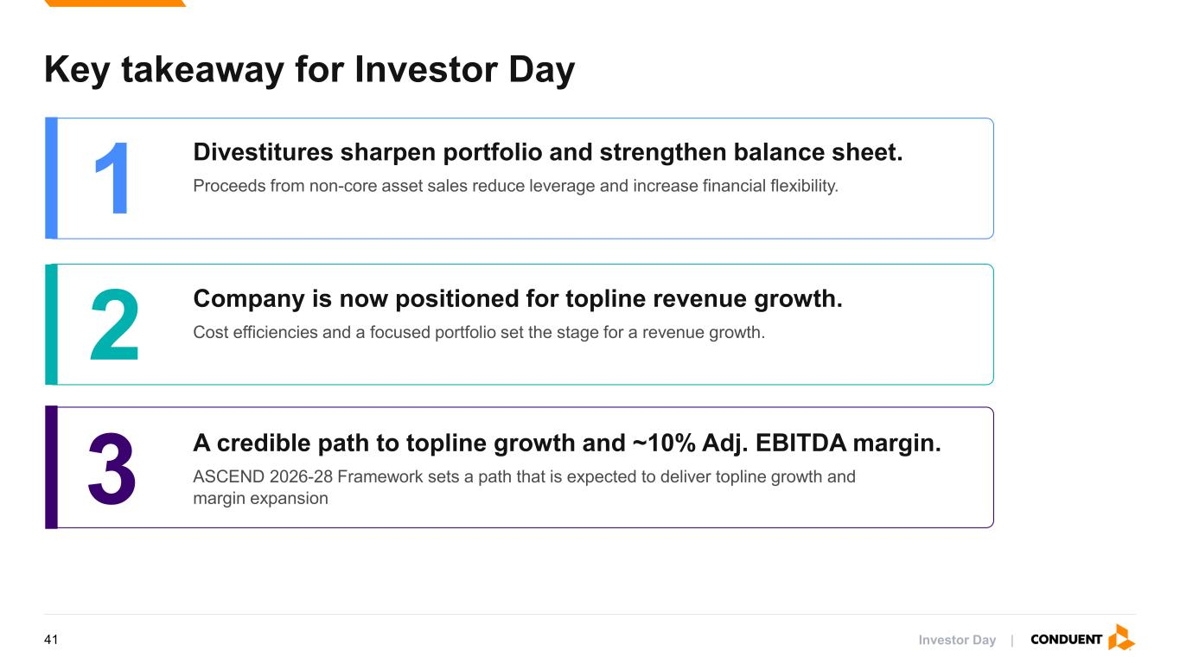
Investor Day | Key takeaway for Investor Day 1 Divestitures sharpen portfolio and strengthen balance sheet. Proceeds from non-core asset sales reduce leverage and increase financial flexibility. 2 Company is now positioned for topline revenue growth. Cost efficiencies and a focused portfolio set the stage for a revenue growth. 3 A credible path to topline growth and ~10% Adj. EBITDA margin. ASCEND 2026-28 Framework sets a path that is expected to deliver topline growth and margin expansion 41

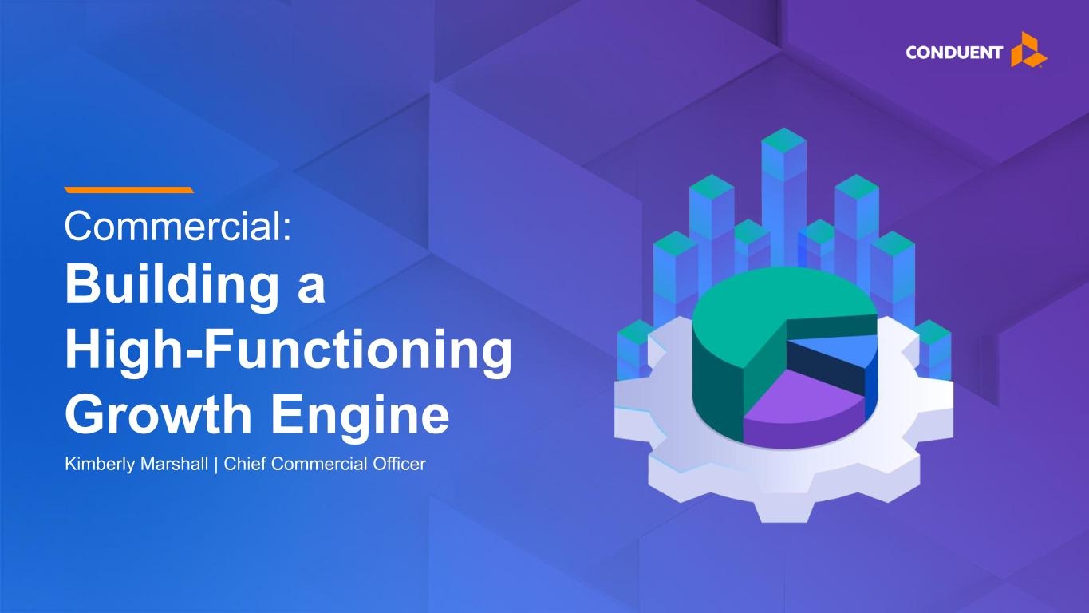
Investor Day | Commercial: Building a High-Functioning Growth Engine Kimberly Marshall | Chief Commercial Officer

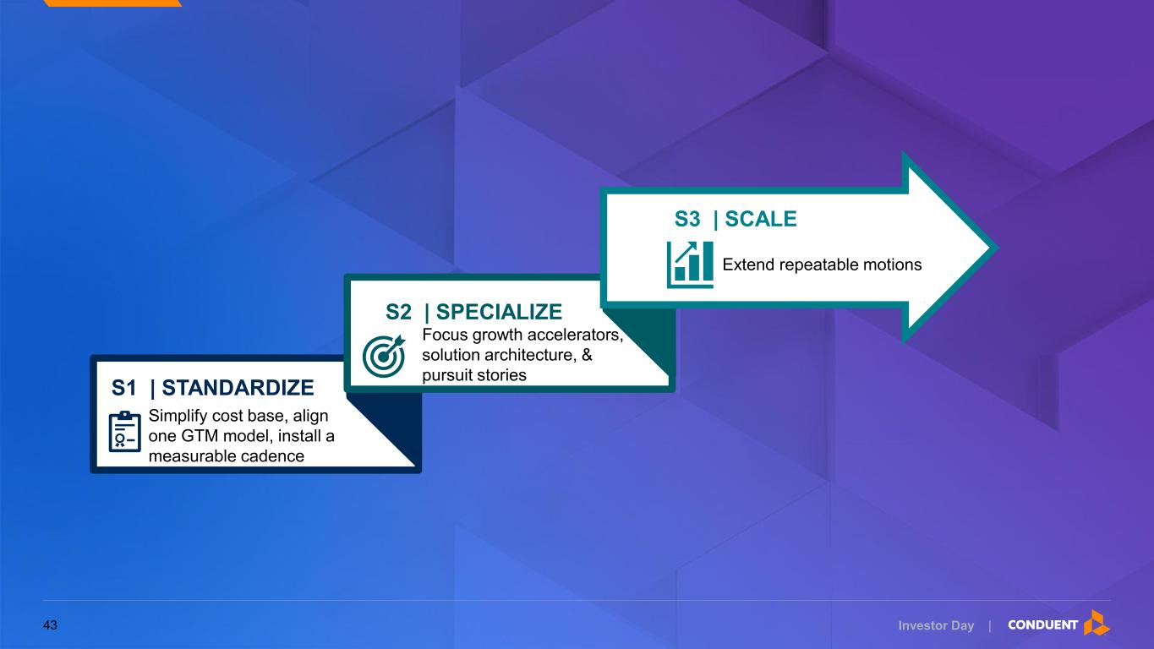
Investor Day | Simplify cost base, align one GTM model, install a measurable cadence S1 | STANDARDIZE Focus growth accelerators, solution architecture, & pursuit stories S2 | SPECIALIZE Extend repeatable motions S3 | SCALE 43


Investor Day | Standardize 44

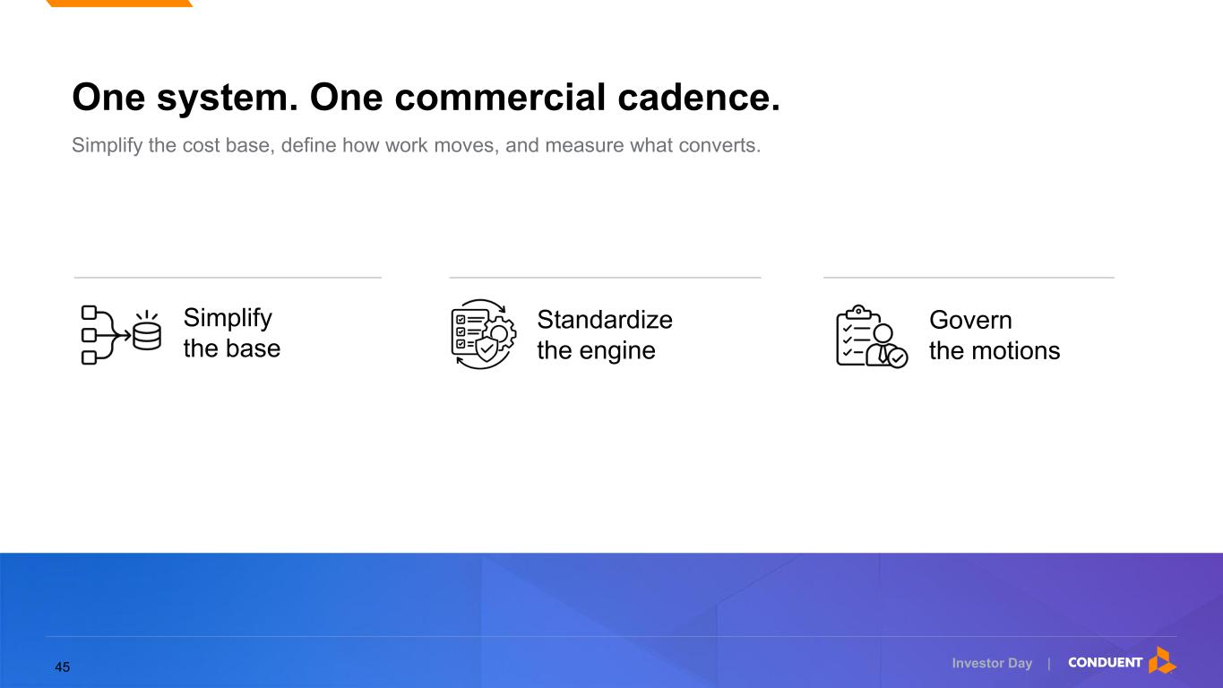
Investor Day | Simplify the base Govern the motions Standardize the engine Simplify the cost base, define how work moves, and measure what converts. One system. One commercial cadence. 45

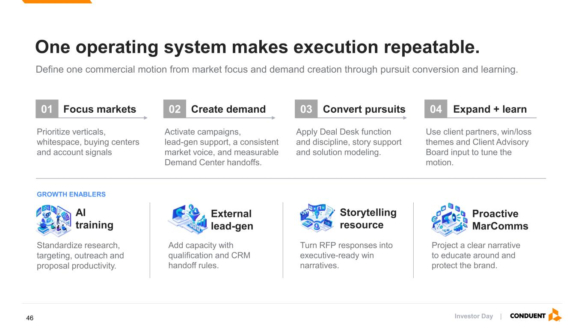
Investor Day | Focus markets Prioritize verticals, whitespace, buying centers and account signals Create demand Activate campaigns, lead-gen support, a consistent market voice, and measurable Demand Center handoffs. Convert pursuits Apply Deal Desk function and discipline, story support and solution modeling. Expand + learn Use client partners, win/loss themes and Client Advisory Board input to tune the motion. GROWTH ENABLERS AI training Standardize research, targeting, outreach and proposal productivity. External lead-gen Add capacity with qualification and CRM handoff rules. Storytelling resource Turn RFP responses into executive-ready win narratives. Proactive MarComms Project a clear narrative to educate around and protect the brand. Define one commercial motion from market focus and demand creation through pursuit conversion and learning. One operating system makes execution repeatable. 01 02 03 04 46

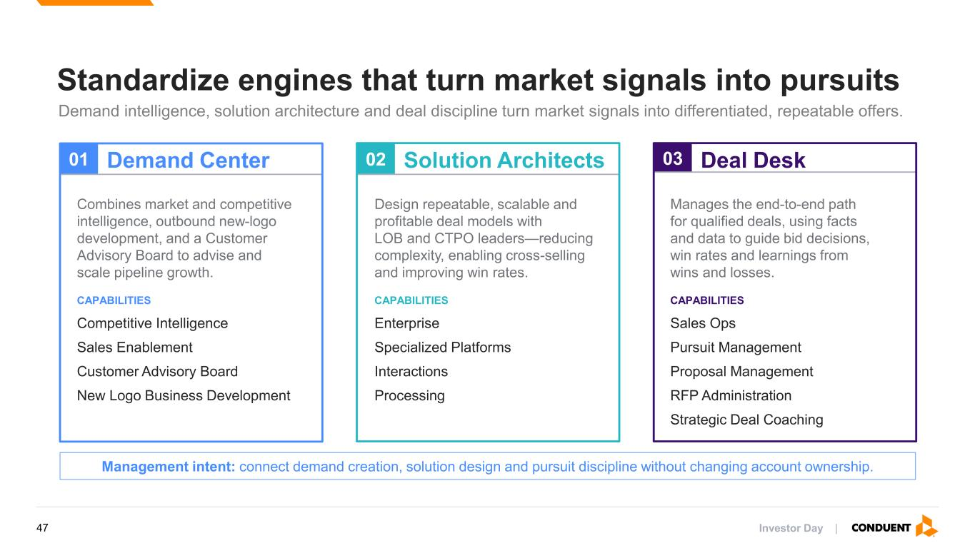
Investor Day | 01 Demand Center Combines market and competitive intelligence, outbound new-logo development, and a Customer Advisory Board to advise and scale pipeline growth. CAPABILITIES Competitive Intelligence Sales Enablement Customer Advisory Board New Logo Business Development 02 Solution Architects Design repeatable, scalable and profitable deal models with LOB and CTPO leaders—reducing complexity, enabling cross-selling and improving win rates. CAPABILITIES Enterprise Specialized Platforms Interactions Processing 03 Deal Desk Manages the end-to-end path for qualified deals, using facts and data to guide bid decisions, win rates and learnings from wins and losses. CAPABILITIES Sales Ops Pursuit Management Proposal Management RFP Administration Strategic Deal Coaching Management intent: connect demand creation, solution design and pursuit discipline without changing account ownership. Standardize engines that turn market signals into pursuits Demand intelligence, solution architecture and deal discipline turn market signals into differentiated, repeatable offers. 47

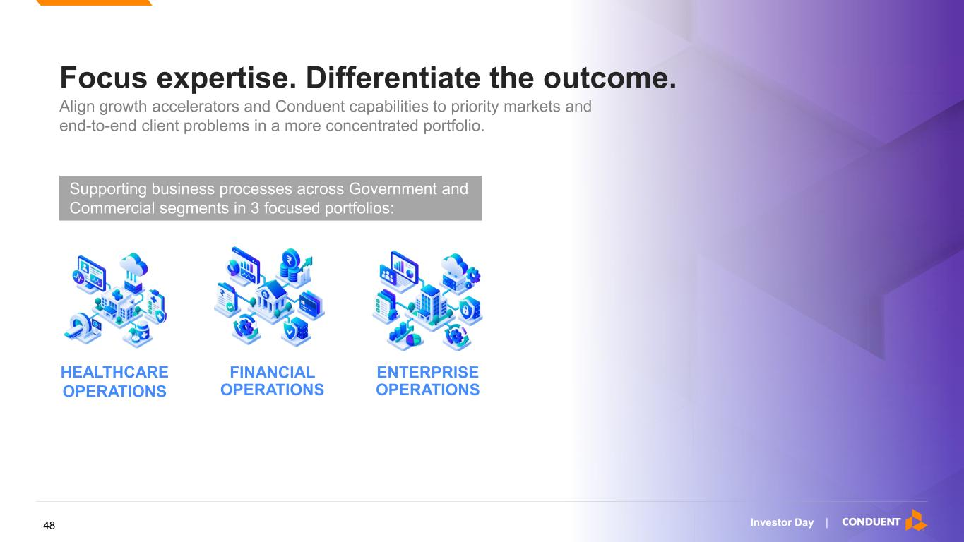
Investor Day | Focus expertise. Differentiate the outcome. Align growth accelerators and Conduent capabilities to priority markets and end-to-end client problems in a more concentrated portfolio. FINANCIAL OPERATIONS Supporting business processes across Government and Commercial segments in 3 focused portfolios: HEALTHCARE OPERATIONS ENTERPRISE OPERATIONS 48

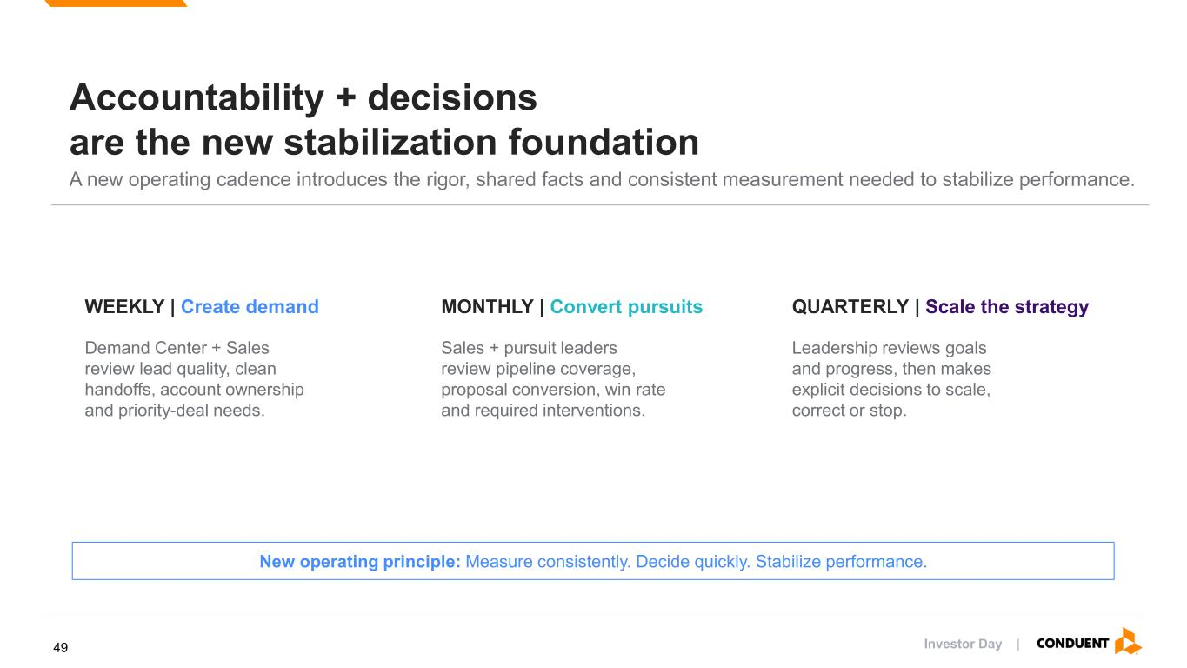
Investor Day | WEEKLY | Create demand Demand Center + Sales review lead quality, clean handoffs, account ownership and priority-deal needs. MONTHLY | Convert pursuits Sales + pursuit leaders review pipeline coverage, proposal conversion, win rate and required interventions. QUARTERLY | Scale the strategy Leadership reviews goals and progress, then makes explicit decisions to scale, correct or stop. New operating principle: Measure consistently. Decide quickly. Stabilize performance. Accountability + decisions are the new stabilization foundation A new operating cadence introduces the rigor, shared facts and consistent measurement needed to stabilize performance. 49


Investor Day | Specialize 50

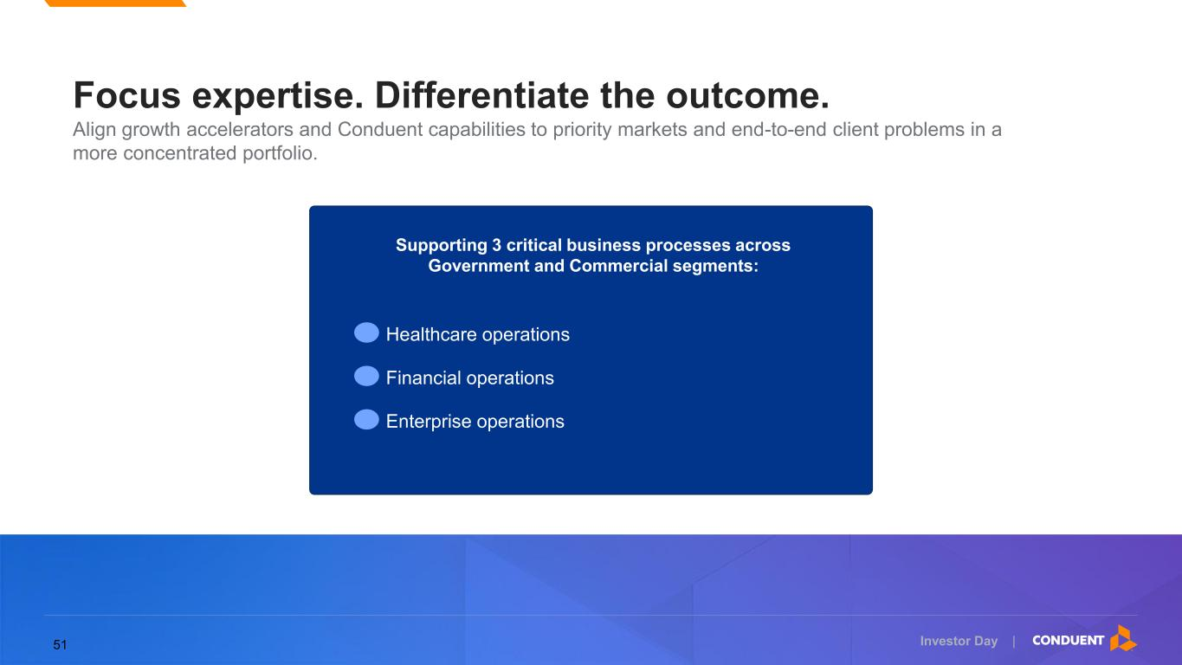
Investor Day | Focus expertise. Differentiate the outcome. Align growth accelerators and Conduent capabilities to priority markets and end-to-end client problems in a more concentrated portfolio. Healthcare operations Financial operations Enterprise operations Supporting 3 critical business processes across Government and Commercial segments: 51

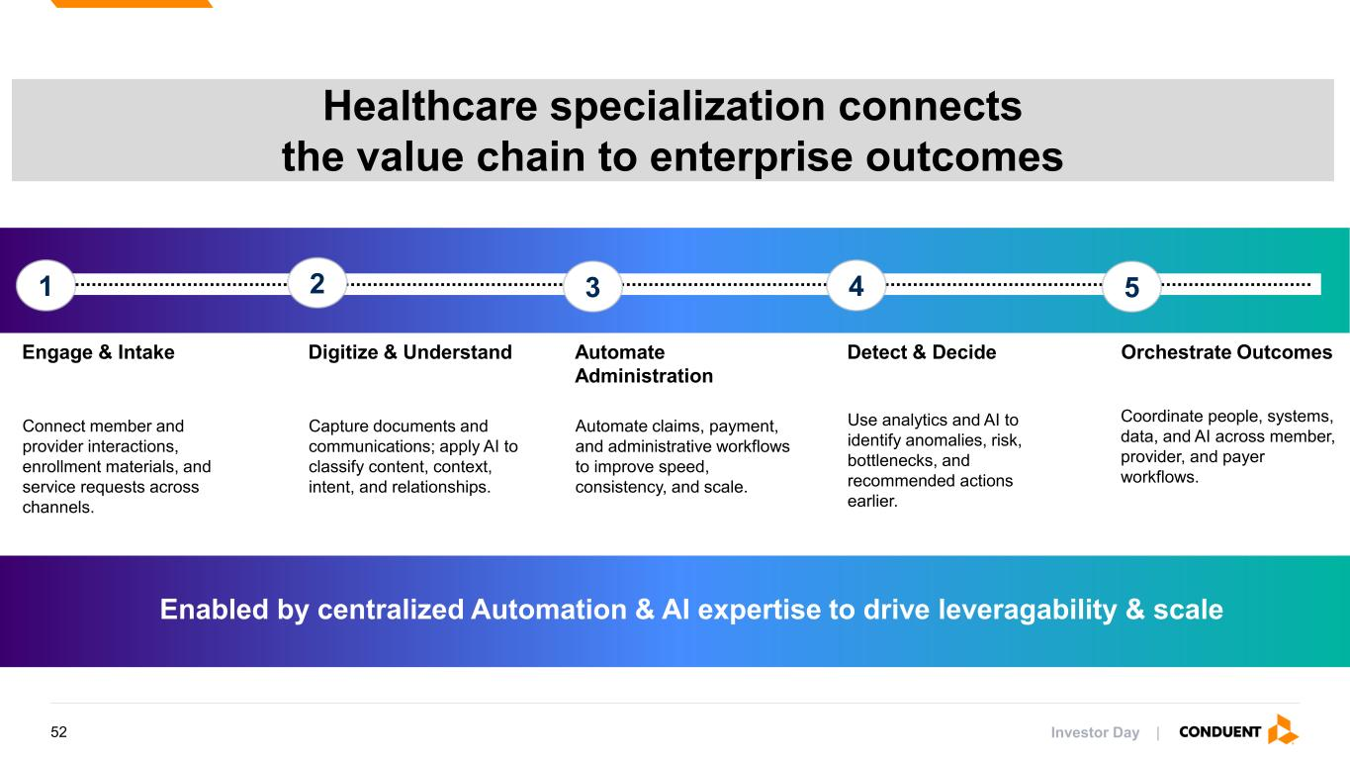
Investor Day | Healthcare specialization connects the value chain to enterprise outcomes 1 2 3 4 5 Engage & Intake Connect member and provider interactions, enrollment materials, and service requests across channels. Digitize & Understand Capture documents and communications; apply AI to classify content, context, intent, and relationships. Automate Administration Automate claims, payment, and administrative workflows to improve speed, consistency, and scale. Detect & Decide Use analytics and AI to identify anomalies, risk, bottlenecks, and recommended actions earlier. Orchestrate Outcomes Coordinate people, systems, data, and AI across member, provider, and payer workflows. Enabled by centralized Automation & AI expertise to drive leveragability & scale 52

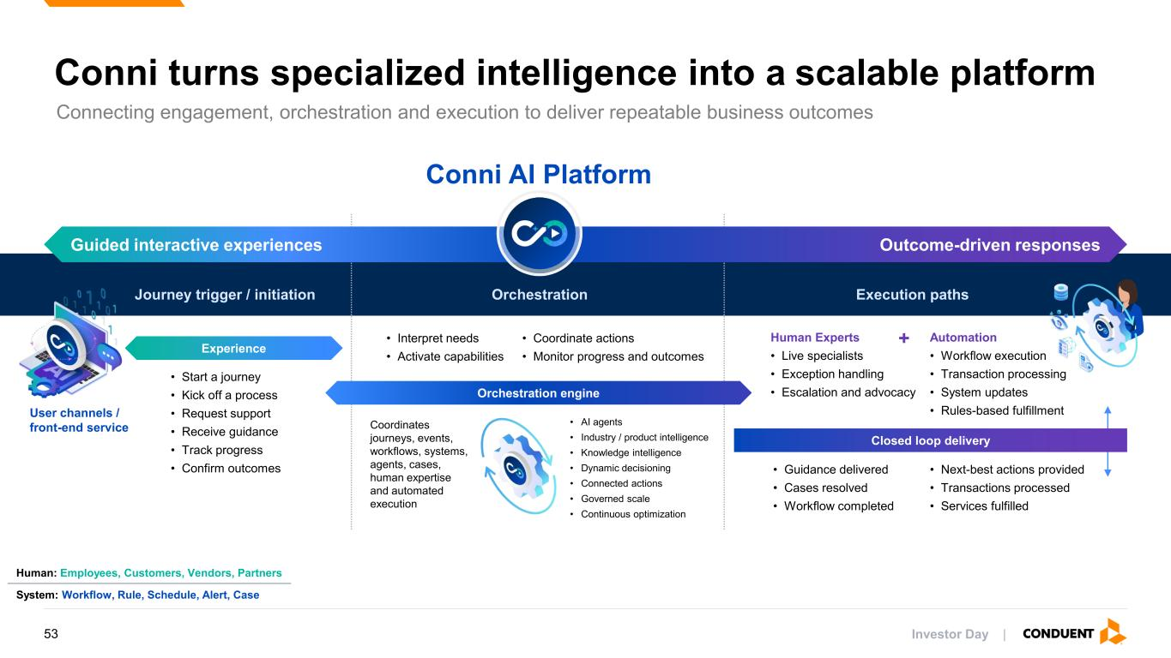
Investor Day | Orchestration engine Connecting engagement, orchestration and execution to deliver repeatable business outcomes Conni turns specialized intelligence into a scalable platform Conni AI Platform Outcome-driven responses Journey trigger / initiation Orchestration Execution paths • Interpret needs • Activate capabilities Human Experts • Live specialists • Exception handling • Escalation and advocacy Automation • Workflow execution • Transaction processing • System updates • Rules-based fulfillment • Start a journey • Kick off a process • Request support • Receive guidance • Track progress • Confirm outcomes Coordinates journeys, events, workflows, systems, agents, cases, human expertise and automated execution • AI agents • Industry / product intelligence • Knowledge intelligence • Dynamic decisioning • Connected actions • Governed scale • Continuous optimization • Guidance delivered • Cases resolved • Workflow completed Guided interactive experiences Outcome-driven responses User channels / front-end service Experience • Coordinate actions • Monitor progress and outcomes • Next-best actions provided • Transactions processed • Services fulfilled Closed loop delivery Human: Employees, Customers, Vendors, Partners System: Workflow, Rule, Schedule, Alert, Case + 53

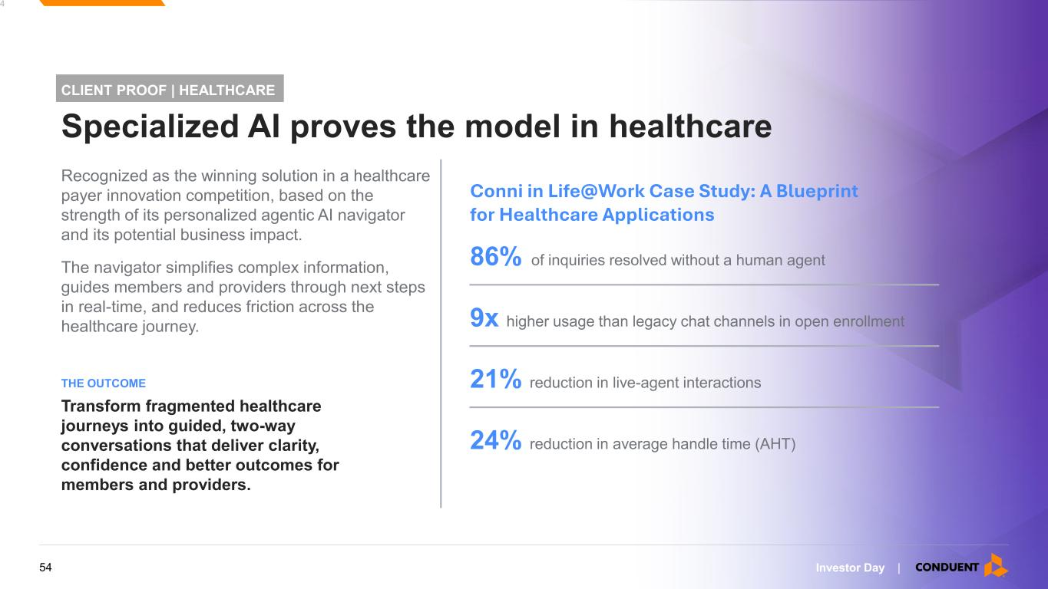
Investor Day | 5 4 Recognized as the winning solution in a healthcare payer innovation competition, based on the strength of its personalized agentic AI navigator and its potential business impact. The navigator simplifies complex information, guides members and providers through next steps in real-time, and reduces friction across the healthcare journey. Transform fragmented healthcare journeys into guided, two-way conversations that deliver clarity, confidence and better outcomes for members and providers. THE OUTCOME CLIENT PROOF | HEALTHCARE Specialized AI proves the model in healthcare 86% of inquiries resolved without a human agent Conni in Life@Work Case Study: A Blueprint for Healthcare Applications 9x higher usage than legacy chat channels in open enrollment 21% reduction in live-agent interactions 24% reduction in average handle time (AHT) 54


Investor Day | Scale 55

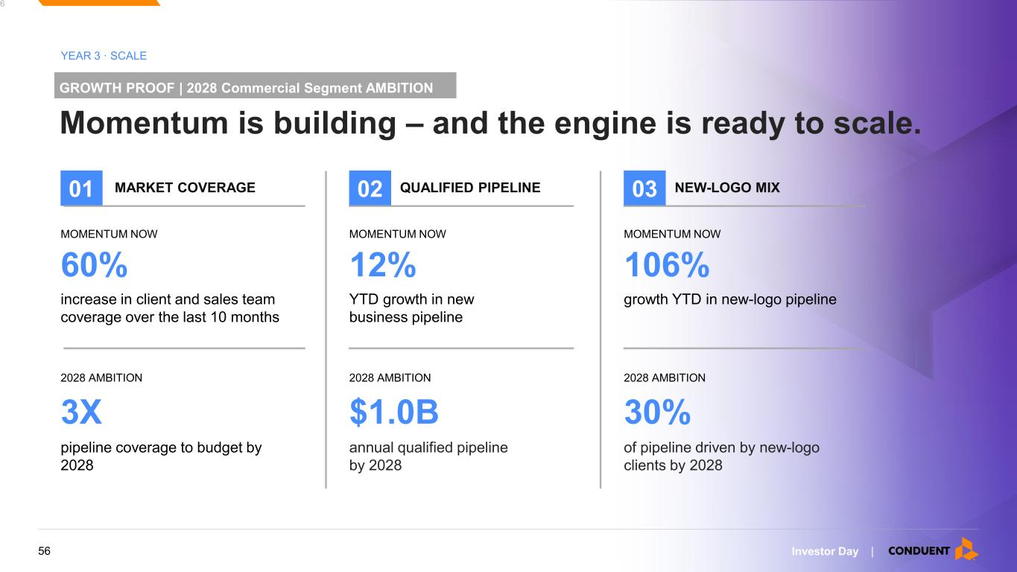
Investor Day | 5 6 GROWTH PROOF | 2028 Commercial Segment AMBITION Momentum is building – and the engine is ready to scale. YEAR 3 · SCALE 01 MARKET COVERAGE MOMENTUM NOW 60% increase in client and sales team coverage over the last 10 months 2028 AMBITION 3X pipeline coverage to budget by 2028 02 QUALIFIED PIPELINE MOMENTUM NOW 12% YTD growth in new business pipeline 2028 AMBITION $1.0B annual qualified pipeline by 2028 03 NEW-LOGO MIX MOMENTUM NOW 106% growth YTD in new-logo pipeline 2028 AMBITION 30% of pipeline driven by new-logo clients by 2028 56

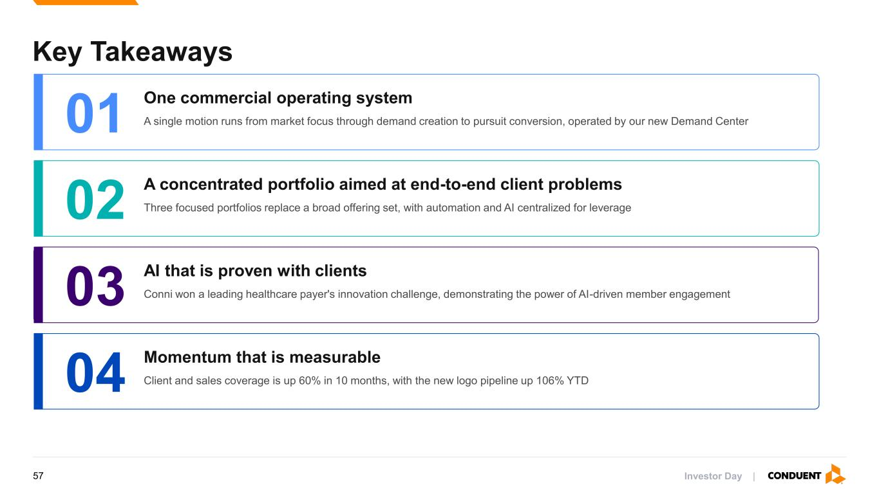
Key Takeaways 01 One commercial operating system A single motion runs from market focus through demand creation to pursuit conversion, operated by our new Demand Center 02 A concentrated portfolio aimed at end-to-end client problems Three focused portfolios replace a broad offering set, with automation and AI centralized for leverage 03 AI that is proven with clients Conni won a leading healthcare payer's innovation challenge, demonstrating the power of AI-driven member engagement 04 Momentum that is measurable Client and sales coverage is up 60% in 10 months, with the new logo pipeline up 106% YTD Investor Day |57

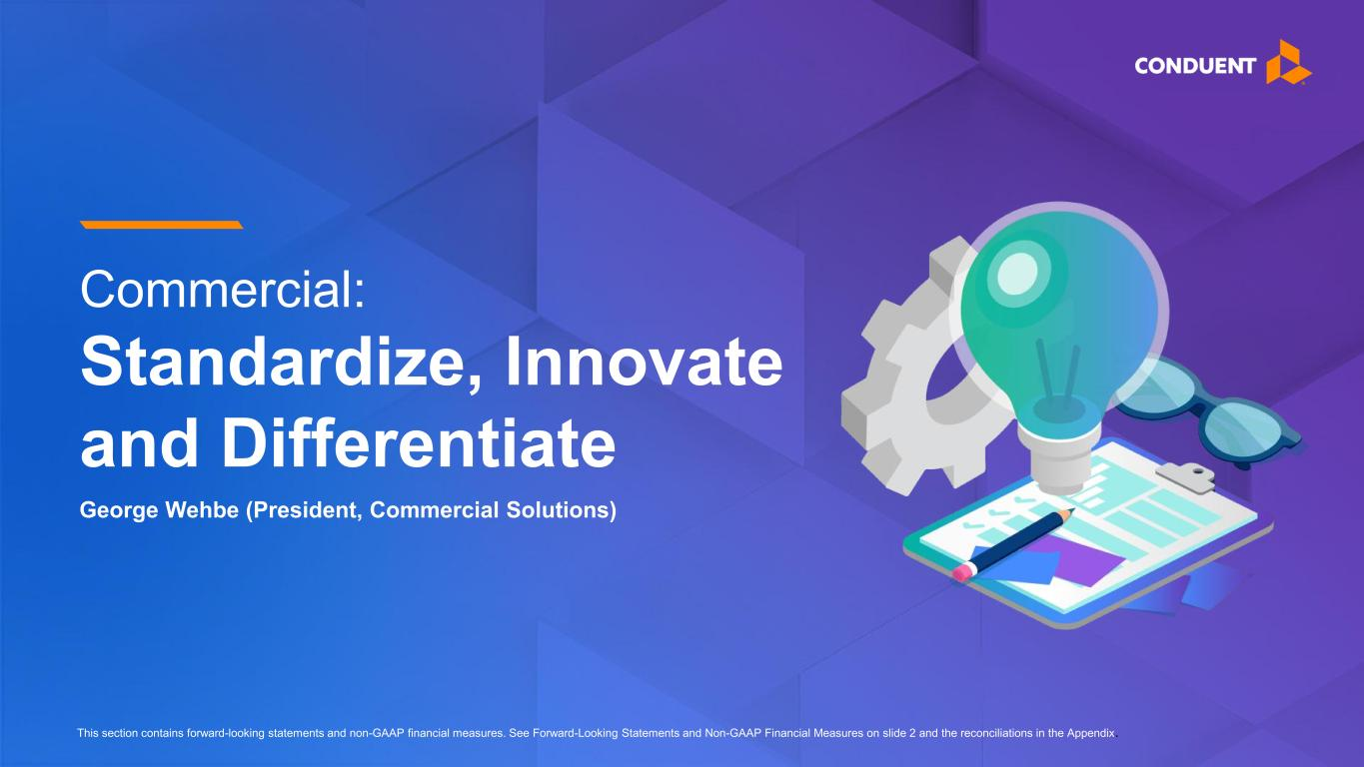
Commercial: Standardize, Innovate and Differentiate This section contains forward-looking statements and non-GAAP financial measures. See Forward-Looking Statements and Non-GAAP Financial Measures on slide 2 and the reconciliations in the Appendix. George Wehbe (President, Commercial Solutions)

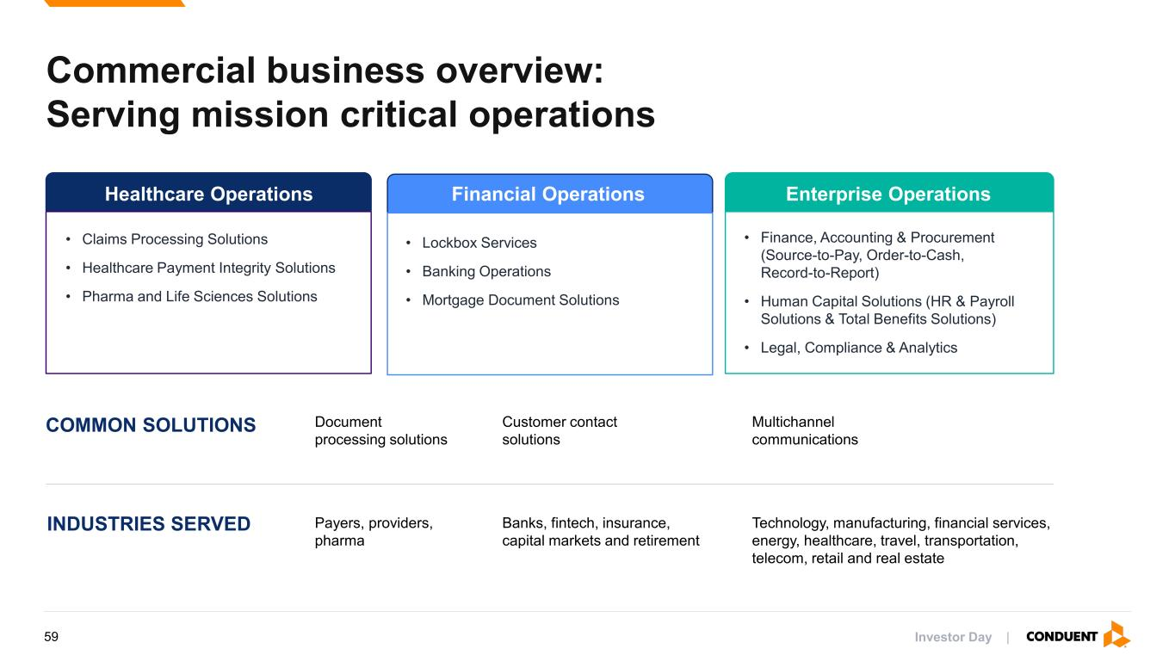
Commercial business overview: Serving mission critical operations Healthcare Operations Financial Operations Enterprise Operations • Claims Processing Solutions • Healthcare Payment Integrity Solutions • Pharma and Life Sciences Solutions • Lockbox Services • Banking Operations • Mortgage Document Solutions • Finance, Accounting & Procurement (Source-to-Pay, Order-to-Cash, Record-to-Report) • Human Capital Solutions (HR & Payroll Solutions & Total Benefits Solutions) • Legal, Compliance & Analytics Payers, providers, pharma Document processing solutions Banks, fintech, insurance, capital markets and retirement Customer contact solutions Technology, manufacturing, financial services, energy, healthcare, travel, transportation, telecom, retail and real estate Multichannel communications COMMON SOLUTIONS INDUSTRIES SERVED Investor Day |59

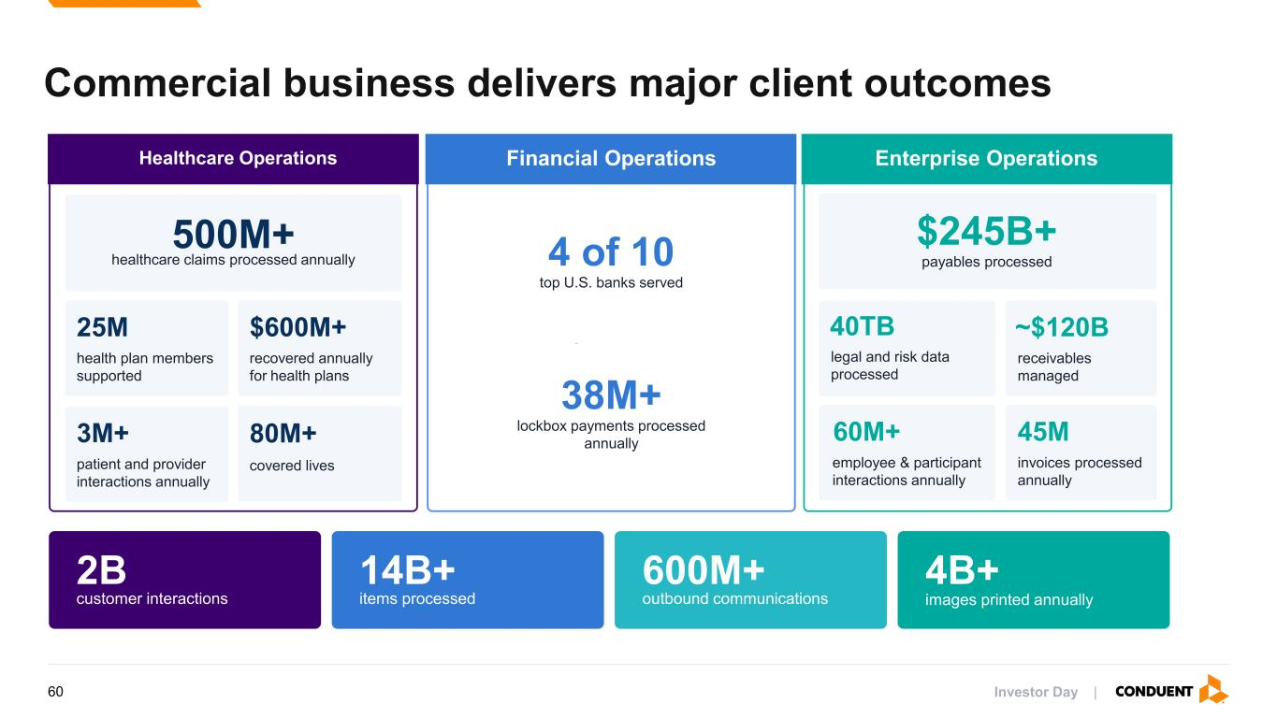
Commercial business delivers major client outcomes 60 2B customer interactions 14B+ items processed 600M+ outbound communications 4B+ images printed annually Healthcare Operations 500M+ healthcare claims processed annually 80M+ covered lives 25M health plan members supported $600M+ recovered annually for health plans 3M+ patient and provider interactions annually Financial Operations 4 of 10 top U.S. banks served 38M+ lockbox payments processed annually Enterprise Operations 60M+ employee & participant interactions annually 45M invoices processed annually $245B+ payables processed ~$120B receivables managed 40TB legal and risk data processed Investor Day |60

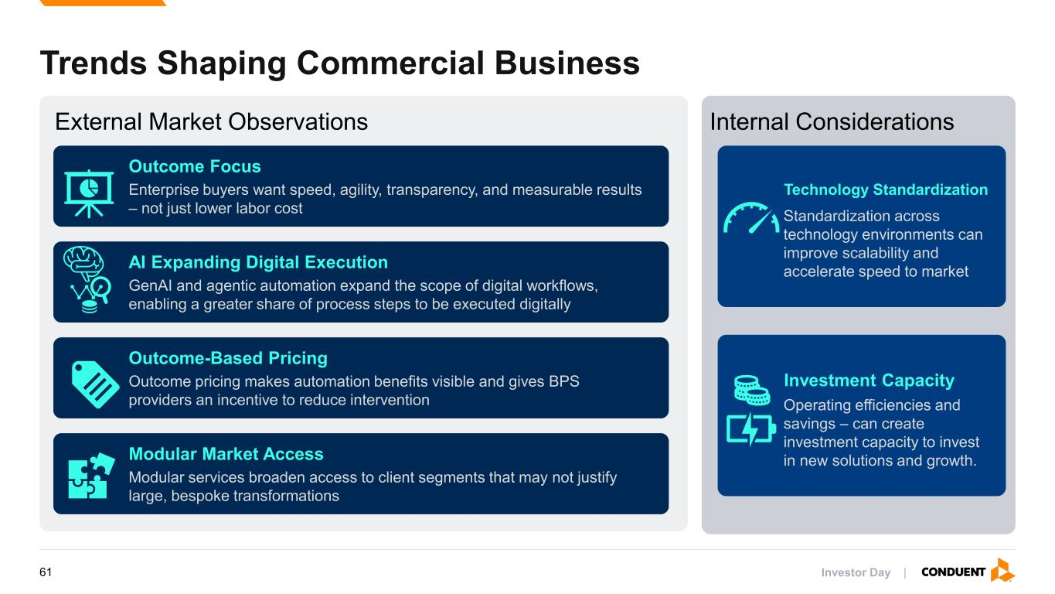
Trends Shaping Commercial Business Outcome Focus Enterprise buyers want speed, agility, transparency, and measurable results – not just lower labor cost AI Expanding Digital Execution GenAI and agentic automation expand the scope of digital workflows, enabling a greater share of process steps to be executed digitally Outcome-Based Pricing Outcome pricing makes automation benefits visible and gives BPS providers an incentive to reduce intervention Modular Market Access Modular services broaden access to client segments that may not justify large, bespoke transformations Technology Standardization Standardization across technology environments can improve scalability and accelerate speed to market Investment Capacity Operating efficiencies and savings – can create investment capacity to invest in new solutions and growth. External Market Observations Internal Considerations Investor Day |61

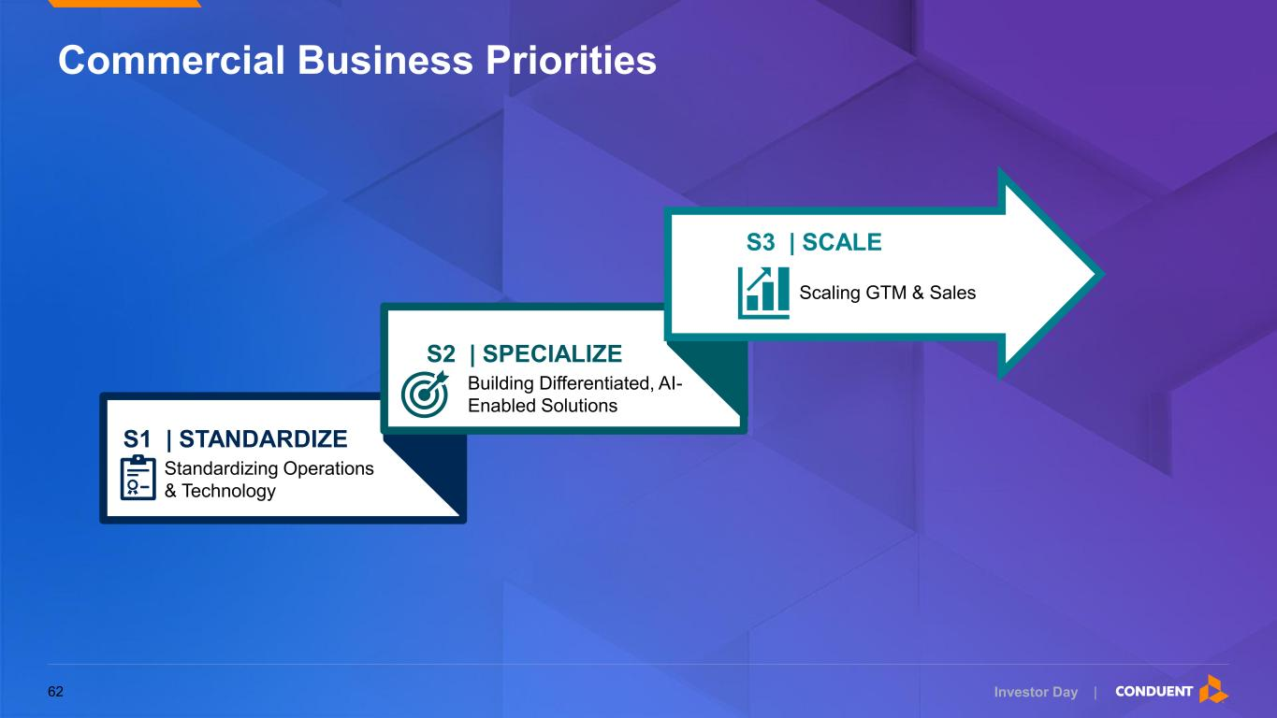
Investor Day | Standardizing Operations & Technology S1 | STANDARDIZE Building Differentiated, AI- Enabled Solutions S2 | SPECIALIZE Scaling GTM & Sales S3 | SCALE Commercial Business Priorities 62


Investor Day | Standardize 63

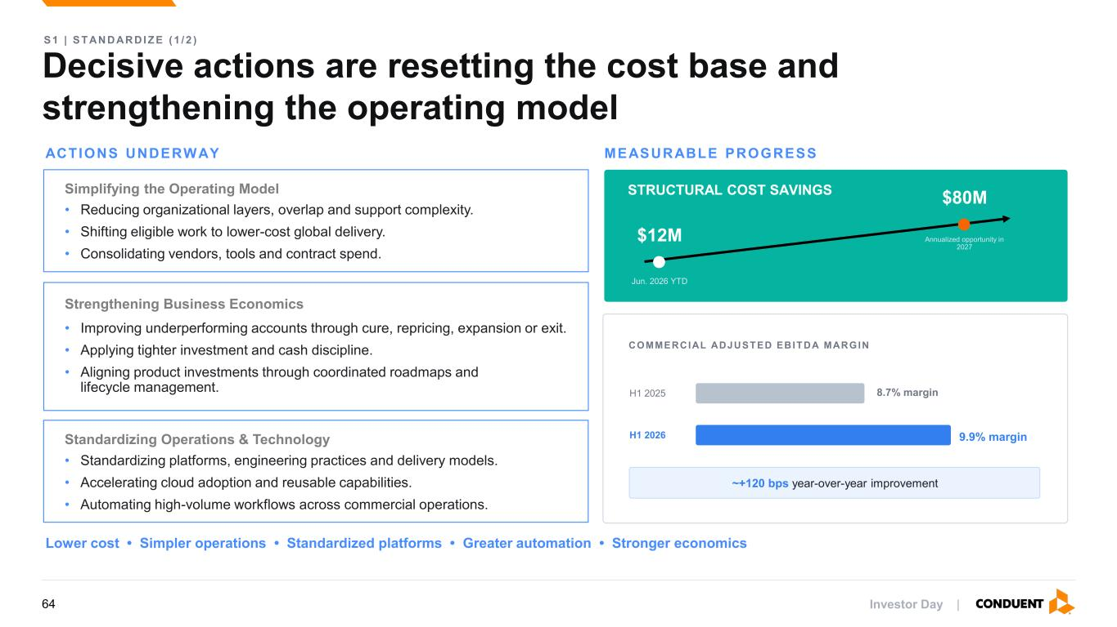
Decisive actions are resetting the cost base and strengthening the operating model S 1 | S T AN D AR D I Z E ( 1 / 2 ) ACTIONS UNDERWAY MEASURABLE PROGRESS Simplifying the Operating Model • Reducing organizational layers, overlap and support complexity. • Shifting eligible work to lower-cost global delivery. • Consolidating vendors, tools and contract spend. Standardizing Operations & Technology • Standardizing platforms, engineering practices and delivery models. • Accelerating cloud adoption and reusable capabilities. • Automating high-volume workflows across commercial operations. Strengthening Business Economics • Improving underperforming accounts through cure, repricing, expansion or exit. • Applying tighter investment and cash discipline. • Aligning product investments through coordinated roadmaps and lifecycle management. STRUCTURAL COST SAVINGS $12M Jun. 2026 YTD $80M Annualized opportunity in 2027 COMMERCIAL ADJUSTED EBITDA MARGIN H1 2025 H1 2026 ~+120 bps year-over-year improvement Lower cost • Simpler operations • Standardized platforms • Greater automation • Stronger economics 9.9% margin 8.7% margin Investor Day |64

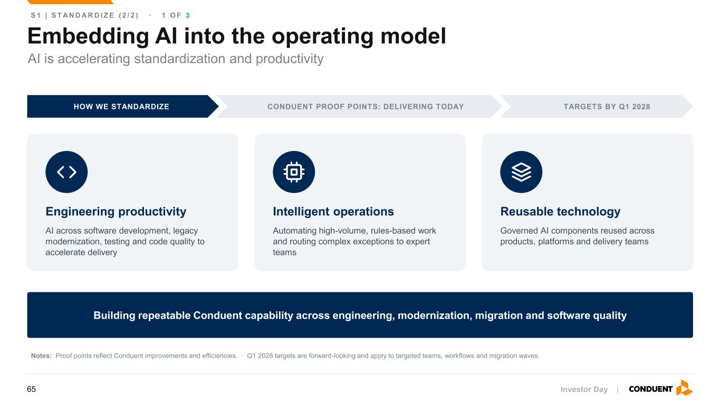
Embedding AI into the operating model S 1 | S T AN D A R D I Z E ( 2 / 2 ) · 1 O F 3 HOW WE STANDARDIZE CONDUENT PROOF POINTS: DELIVERING TODAY TARGETS BY Q1 2028 Engineering productivity AI across software development, legacy modernization, testing and code quality to accelerate delivery Intelligent operations Automating high-volume, rules-based work and routing complex exceptions to expert teams Reusable technology Governed AI components reused across products, platforms and delivery teams Building repeatable Conduent capability across engineering, modernization, migration and software quality Notes: Proof points reflect Conduent improvements and efficiencies. · Q1 2028 targets are forward-looking and apply to targeted teams, workflows and migration waves. AI is accelerating standardization and productivity Investor Day |65

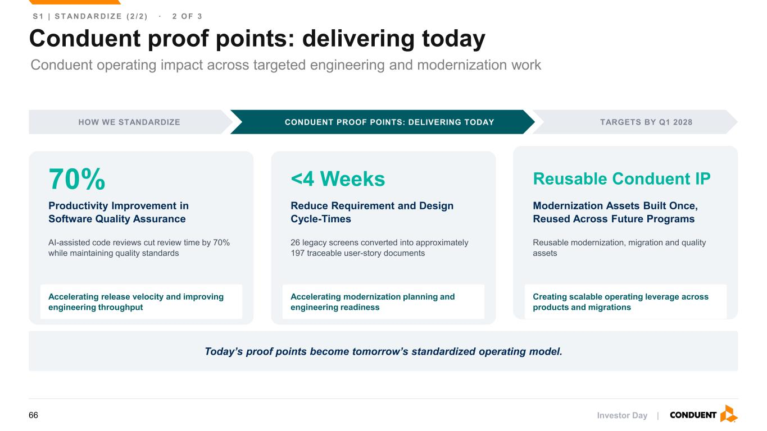
Conduent proof points: delivering today S 1 | S T AN D A R D I Z E ( 2 / 2 ) · 2 O F 3 HOW WE STANDARDIZE CONDUENT PROOF POINTS: DELIVERING TODAY TARGETS BY Q1 2028 70% Productivity Improvement in Software Quality Assurance AI-assisted code reviews cut review time by 70% while maintaining quality standards Accelerating release velocity and improving engineering throughput <4 Weeks Reduce Requirement and Design Cycle-Times 26 legacy screens converted into approximately 197 traceable user-story documents Accelerating modernization planning and engineering readiness Reusable Conduent IP Modernization Assets Built Once, Reused Across Future Programs Reusable modernization, migration and quality assets Creating scalable operating leverage across products and migrations Today’s proof points become tomorrow’s standardized operating model. Conduent operating impact across targeted engineering and modernization work Investor Day |66

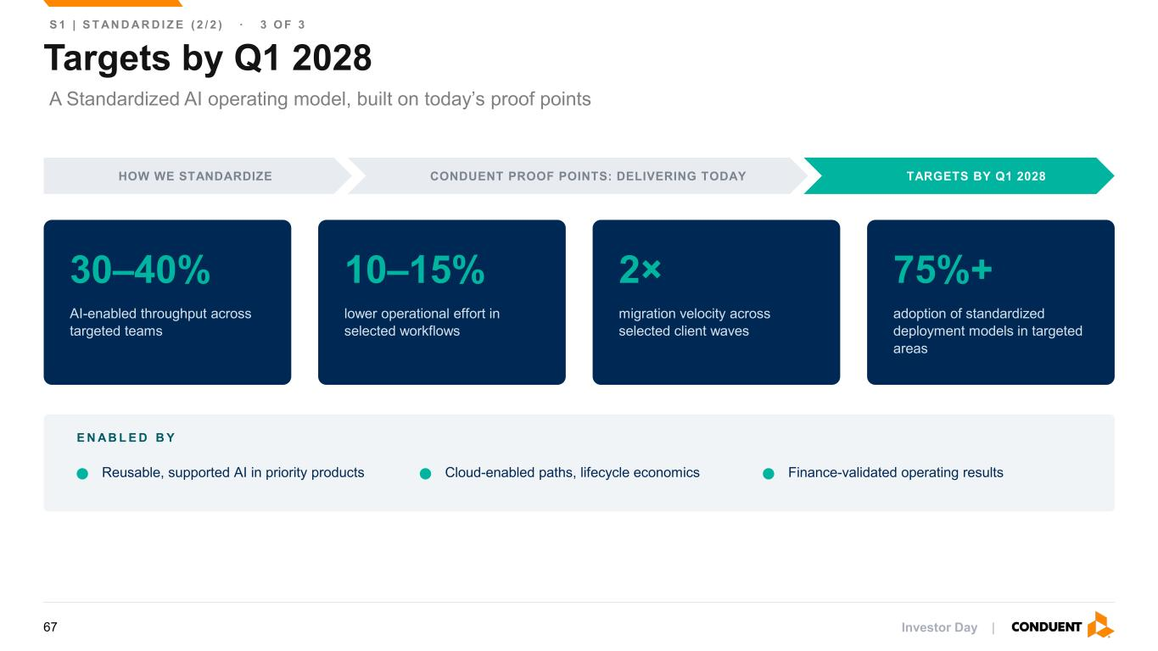
Targets by Q1 2028 S 1 | S T AN D A R D I Z E ( 2 / 2 ) · 3 O F 3 HOW WE STANDARDIZE CONDUENT PROOF POINTS: DELIVERING TODAY TARGETS BY Q1 2028 30–40% AI-enabled throughput across targeted teams 10–15% lower operational effort in selected workflows 2× migration velocity across selected client waves 75%+ adoption of standardized deployment models in targeted areas E N A B L E D B Y Reusable, supported AI in priority products Cloud-enabled paths, lifecycle economics Finance-validated operating results A Standardized AI operating model, built on today’s proof points Investor Day |67


Investor Day | Specialize 68

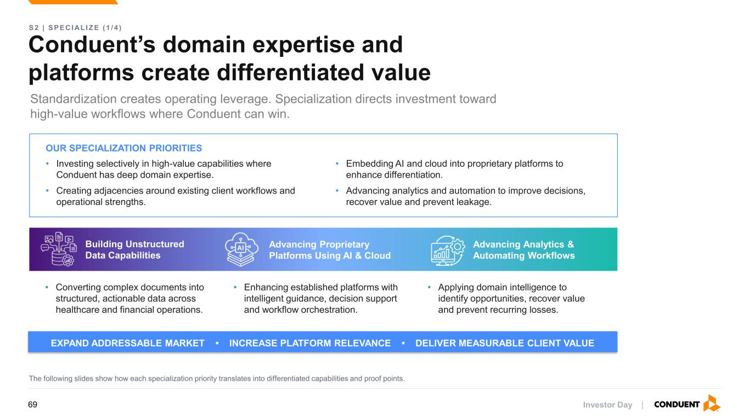
Conduent’s domain expertise and platforms create differentiated value S 2 | S P E C I AL I Z E ( 1 / 4 ) Standardization creates operating leverage. Specialization directs investment toward high-value workflows where Conduent can win. EXPAND ADDRESSABLE MARKET • INCREASE PLATFORM RELEVANCE • DELIVER MEASURABLE CLIENT VALUE The following slides show how each specialization priority translates into differentiated capabilities and proof points. OUR SPECIALIZATION PRIORITIES • Investing selectively in high-value capabilities where Conduent has deep domain expertise. • Creating adjacencies around existing client workflows and operational strengths. • Converting complex documents into structured, actionable data across healthcare and financial operations. • Enhancing established platforms with intelligent guidance, decision support and workflow orchestration. • Applying domain intelligence to identify opportunities, recover value and prevent recurring losses. Building Unstructured Data Capabilities Advancing Proprietary Platforms Using AI & Cloud Advancing Analytics & Automating Workflows • Embedding AI and cloud into proprietary platforms to enhance differentiation. • Advancing analytics and automation to improve decisions, recover value and prevent leakage. Investor Day |69

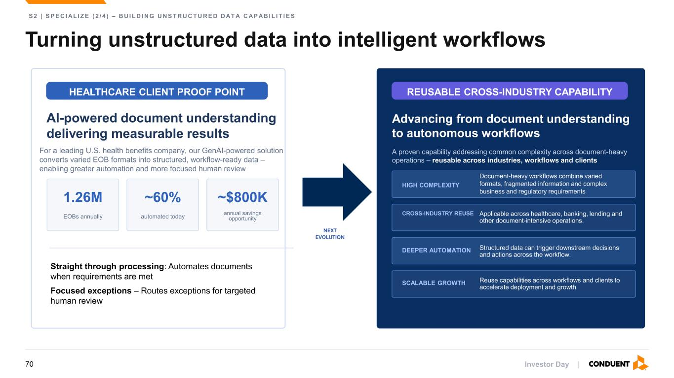
Turning unstructured data into intelligent workflows S 2 | S P E C I AL I Z E ( 2 / 4 ) – B U I L D I N G U N S T R U C T U R E D D AT A C AP AB I L I T I E S HEALTHCARE CLIENT PROOF POINT AI-powered document understanding delivering measurable results For a leading U.S. health benefits company, our GenAI-powered solution converts varied EOB formats into structured, workflow-ready data – enabling greater automation and more focused human review 1.26M EOBs annually ~60% automated today ~$800K annual savings opportunity Straight through processing: Automates documents when requirements are met Focused exceptions – Routes exceptions for targeted human review REUSABLE CROSS-INDUSTRY CAPABILITY Advancing from document understanding to autonomous workflows A proven capability addressing common complexity across document-heavy operations – reusable across industries, workflows and clients HIGH COMPLEXITY Document-heavy workflows combine varied formats, fragmented information and complex business and regulatory requirements CROSS-INDUSTRY REUSE Applicable across healthcare, banking, lending and other document-intensive operations. DEEPER AUTOMATION Structured data can trigger downstream decisions and actions across the workflow. SCALABLE GROWTH Reuse capabilities across workflows and clients to accelerate deployment and growth NEXT EVOLUTION Investor Day |70

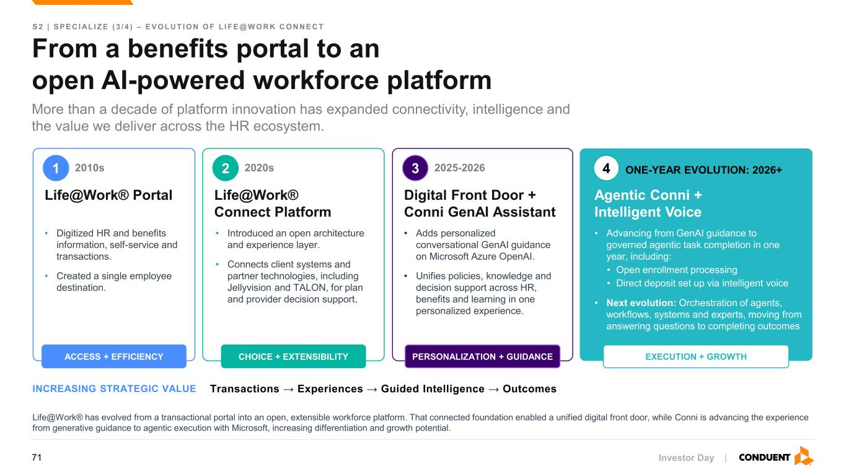
From a benefits portal to an open AI-powered workforce platform S 2 | S P E C I AL I Z E ( 3 / 4 ) – E V O L U T I O N O F L I F E @ W O R K C O N N E C T More than a decade of platform innovation has expanded connectivity, intelligence and the value we deliver across the HR ecosystem. 1 2010s Life@Work® Portal • Digitized HR and benefits information, self-service and transactions. • Created a single employee destination. ACCESS + EFFICIENCY 2 2020s Life@Work® Connect Platform • Introduced an open architecture and experience layer. • Connects client systems and partner technologies, including Jellyvision and TALON, for plan and provider decision support. CHOICE + EXTENSIBILITY 3 2025-2026 Digital Front Door + Conni GenAI Assistant • Adds personalized conversational GenAI guidance on Microsoft Azure OpenAI. • Unifies policies, knowledge and decision support across HR, benefits and learning in one personalized experience. PERSONALIZATION + GUIDANCE 4 ONE-YEAR EVOLUTION: 2026+ Agentic Conni + Intelligent Voice • Advancing from GenAI guidance to governed agentic task completion in one year, including: • Open enrollment processing • Direct deposit set up via intelligent voice • Next evolution: Orchestration of agents, workflows, systems and experts, moving from answering questions to completing outcomes EXECUTION + GROWTH INCREASING STRATEGIC VALUE Life@Work® has evolved from a transactional portal into an open, extensible workforce platform. That connected foundation enabled a unified digital front door, while Conni is advancing the experience from generative guidance to agentic execution with Microsoft, increasing differentiation and growth potential. Transactions → Experiences → Guided Intelligence → Outcomes Investor Day |71

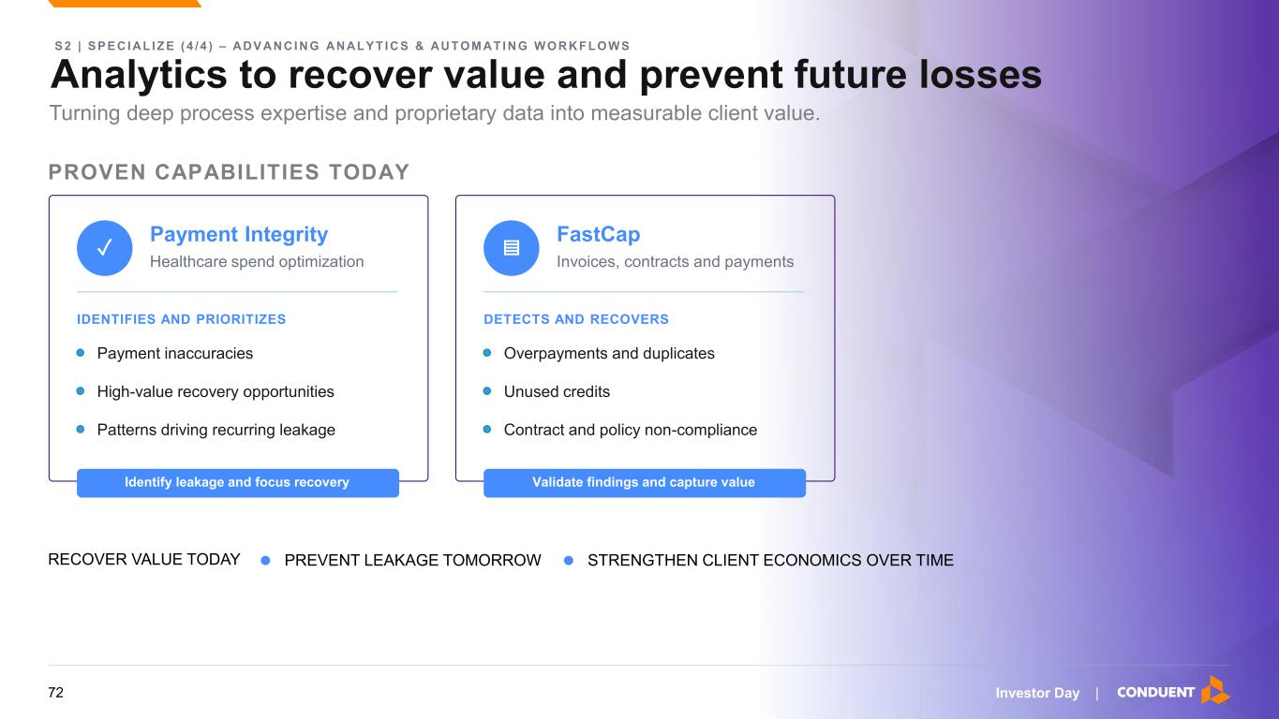
Analytics to recover value and prevent future losses S 2 | S P E C I AL I Z E ( 4 / 4 ) – AD V AN C I N G AN AL Y T I C S & AU T O M AT I N G W O R K F L O W S Turning deep process expertise and proprietary data into measurable client value. PROVEN CAPABILITIES TODAY ✓ Payment Integrity Healthcare spend optimization IDENTIFIES AND PRIORITIZES Payment inaccuracies High-value recovery opportunities Patterns driving recurring leakage Identify leakage and focus recovery ▤ FastCap Invoices, contracts and payments DETECTS AND RECOVERS Overpayments and duplicates Unused credits Contract and policy non-compliance Validate findings and capture value RECOVER VALUE TODAY • PREVENT LEAKAGE TOMORROW • STRENGTHEN CLIENT ECONOMICS OVER TIME Investor Day |72

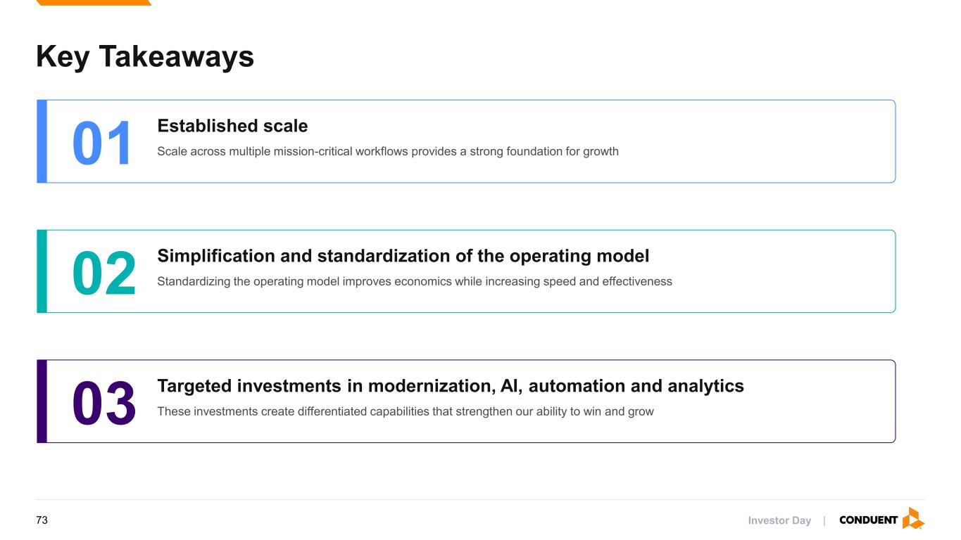
Key Takeaways 01 Established scale Scale across multiple mission-critical workflows provides a strong foundation for growth 02 Simplification and standardization of the operating model Standardizing the operating model improves economics while increasing speed and effectiveness 03 Targeted investments in modernization, AI, automation and analytics These investments create differentiated capabilities that strengthen our ability to win and grow Investor Day |73

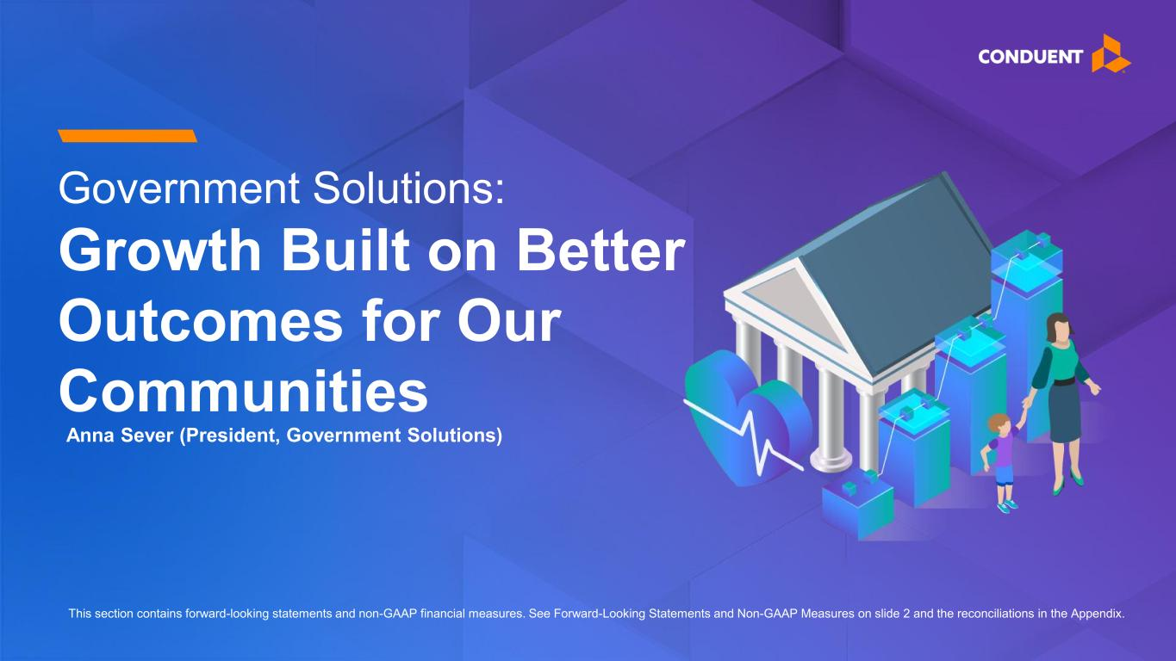
Government Solutions: Growth Built on Better Outcomes for Our Communities This section contains forward-looking statements and non-GAAP financial measures. See Forward-Looking Statements and Non-GAAP Measures on slide 2 and the reconciliations in the Appendix. Anna Sever (President, Government Solutions)

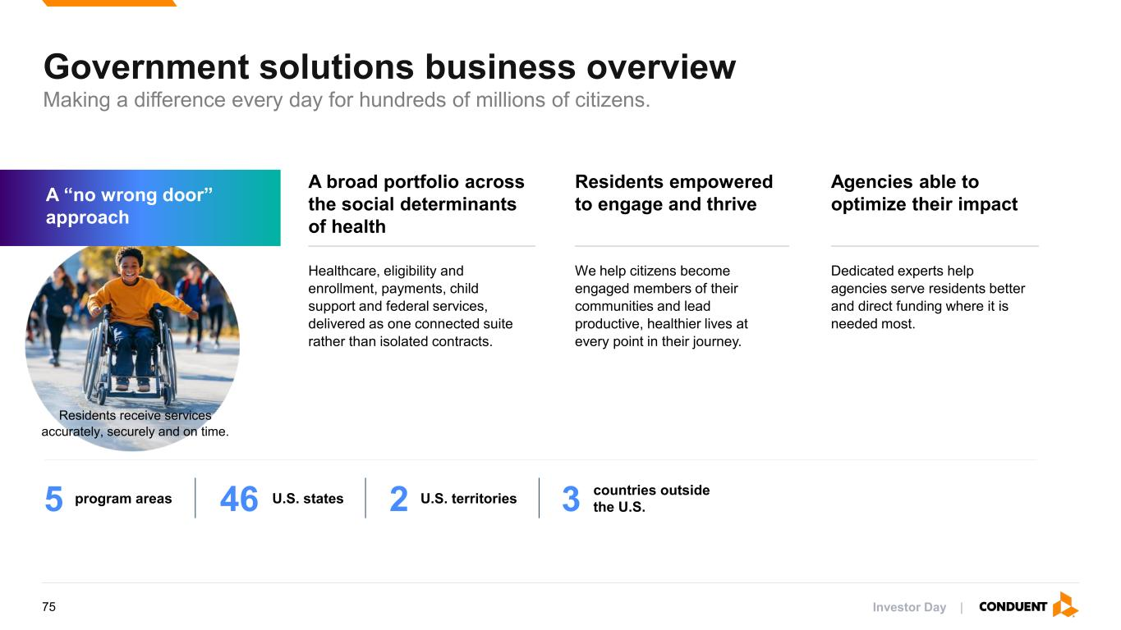
Investor Day | Government solutions business overview Residents receive services accurately, securely and on time. A “no wrong door” approach Residents empowered to engage and thrive Agencies able to optimize their impact We help citizens become engaged members of their communities and lead productive, healthier lives at every point in their journey. Dedicated experts help agencies serve residents better and direct funding where it is needed most. Healthcare, eligibility and enrollment, payments, child support and federal services, delivered as one connected suite rather than isolated contracts. A broad portfolio across the social determinants of health 5 program areas 46 U.S. states 2 U.S. territories 3 countries outside the U.S. Making a difference every day for hundreds of millions of citizens. 75

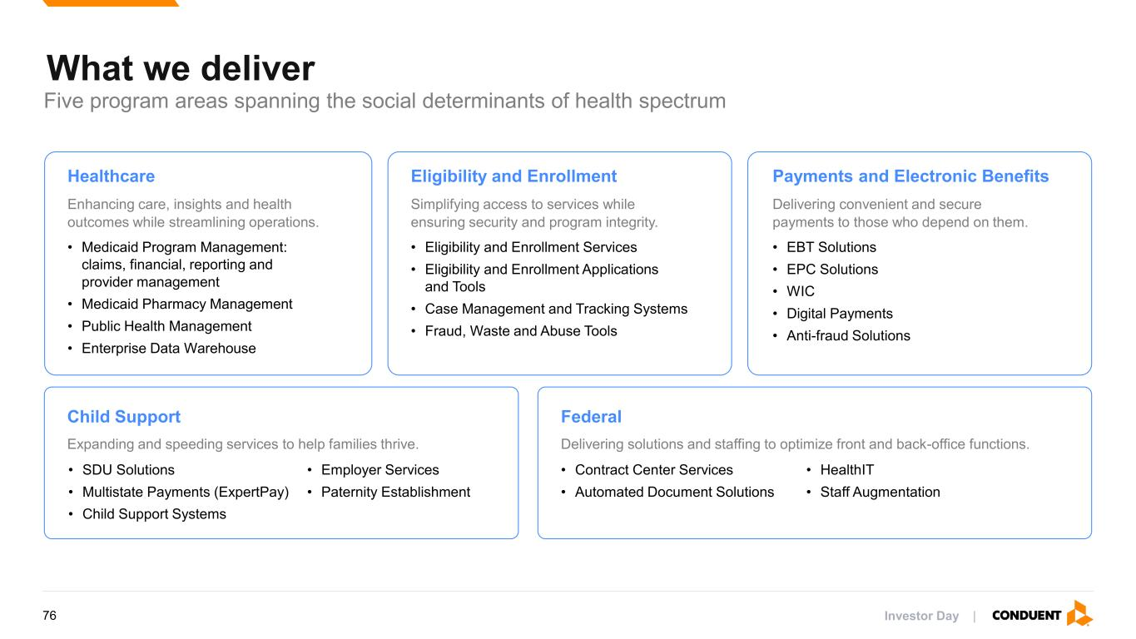
What we deliver Five program areas spanning the social determinants of health spectrum Healthcare Enhancing care, insights and health outcomes while streamlining operations. • Medicaid Program Management: claims, financial, reporting and provider management • Medicaid Pharmacy Management • Public Health Management • Enterprise Data Warehouse Eligibility and Enrollment Simplifying access to services while ensuring security and program integrity. • Eligibility and Enrollment Services • Eligibility and Enrollment Applications and Tools • Case Management and Tracking Systems • Fraud, Waste and Abuse Tools Payments and Electronic Benefits Delivering convenient and secure payments to those who depend on them. • EBT Solutions • EPC Solutions • WIC • Digital Payments • Anti-fraud Solutions Child Support Expanding and speeding services to help families thrive. • SDU Solutions • Multistate Payments (ExpertPay) • Child Support Systems • Employer Services • Paternity Establishment Federal Delivering solutions and staffing to optimize front and back-office functions. • Contract Center Services • Automated Document Solutions • HealthIT • Staff Augmentation Investor Day |76

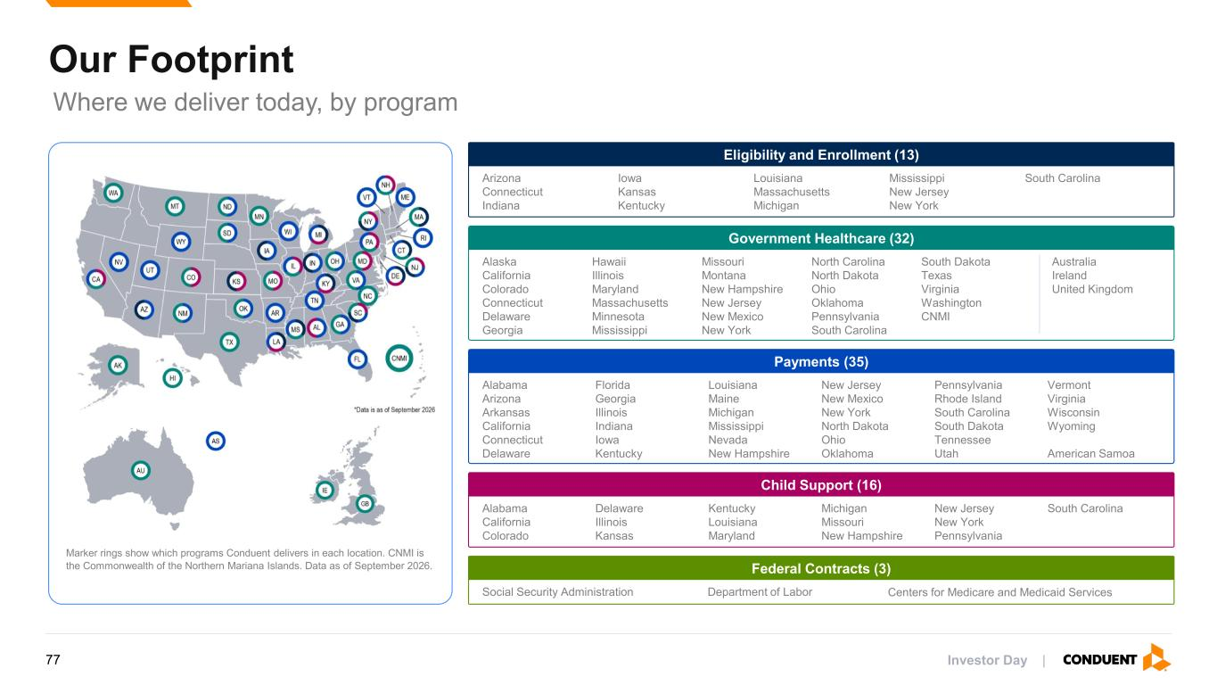
Our Footprint Where we deliver today, by program Marker rings show which programs Conduent delivers in each location. CNMI is the Commonwealth of the Northern Mariana Islands. Data as of September 2026. Eligibility and Enrollment (13) Arizona Connecticut Indiana Iowa Kansas Kentucky Louisiana Massachusetts Michigan Mississippi New Jersey New York South Carolina Government Healthcare (32) Alaska California Colorado Connecticut Delaware Georgia Hawaii Illinois Maryland Massachusetts Minnesota Mississippi Missouri Montana New Hampshire New Jersey New Mexico New York North Carolina North Dakota Ohio Oklahoma Pennsylvania South Carolina South Dakota Texas Virginia Washington CNMI Australia Ireland United Kingdom Payments (35) Alabama Arizona Arkansas California Connecticut Delaware Florida Georgia Illinois Indiana Iowa Kentucky Louisiana Maine Michigan Mississippi Nevada New Hampshire New Jersey New Mexico New York North Dakota Ohio Oklahoma Pennsylvania Rhode Island South Carolina South Dakota Tennessee Utah Vermont Virginia Wisconsin Wyoming American Samoa Child Support (16) Alabama California Colorado Delaware Illinois Kansas Kentucky Louisiana Maryland Michigan Missouri New Hampshire New Jersey New York Pennsylvania South Carolina Federal Contracts (3) Social Security Administration Department of Labor Centers for Medicare and Medicaid Services Investor Day |77

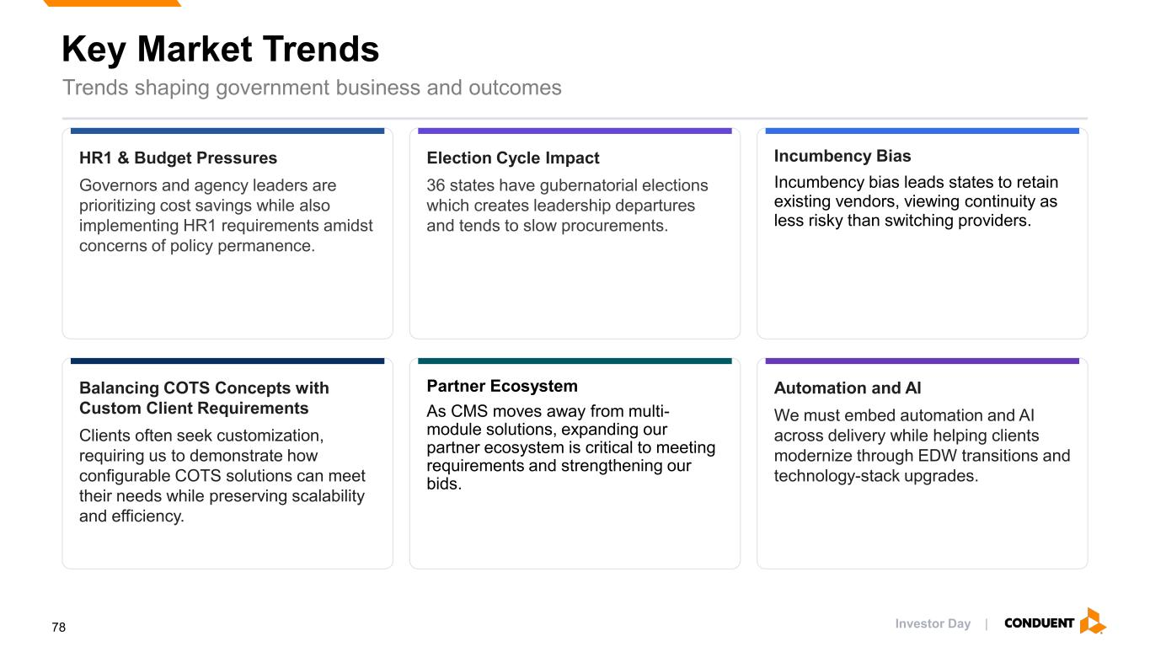
Key Market Trends Trends shaping government business and outcomes HR1 & Budget Pressures Governors and agency leaders are prioritizing cost savings while also implementing HR1 requirements amidst concerns of policy permanence. Election Cycle Impact 36 states have gubernatorial elections which creates leadership departures and tends to slow procurements. Incumbency Bias Incumbency bias leads states to retain existing vendors, viewing continuity as less risky than switching providers. Balancing COTS Concepts with Custom Client Requirements Clients often seek customization, requiring us to demonstrate how configurable COTS solutions can meet their needs while preserving scalability and efficiency. Partner Ecosystem As CMS moves away from multi- module solutions, expanding our partner ecosystem is critical to meeting requirements and strengthening our bids. Automation and AI We must embed automation and AI across delivery while helping clients modernize through EDW transitions and technology-stack upgrades. Investor Day |78

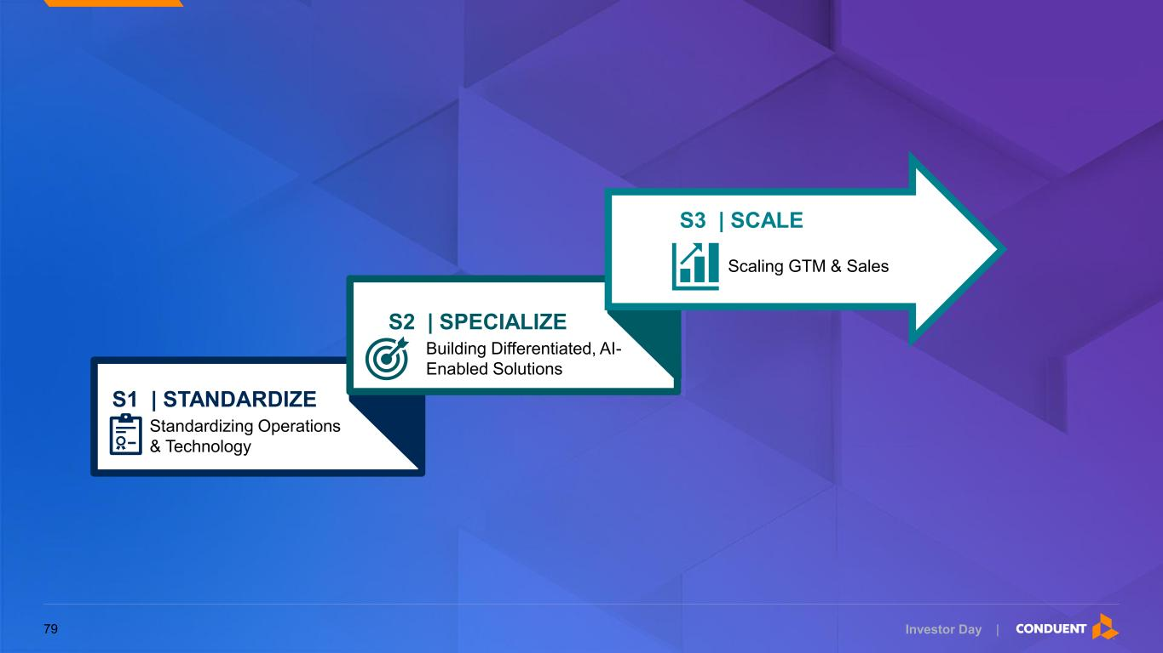
Investor Day | Standardizing Operations & Technology S1 | STANDARDIZE Building Differentiated, AI- Enabled Solutions S2 | SPECIALIZE Scaling GTM & Sales S3 | SCALE 79

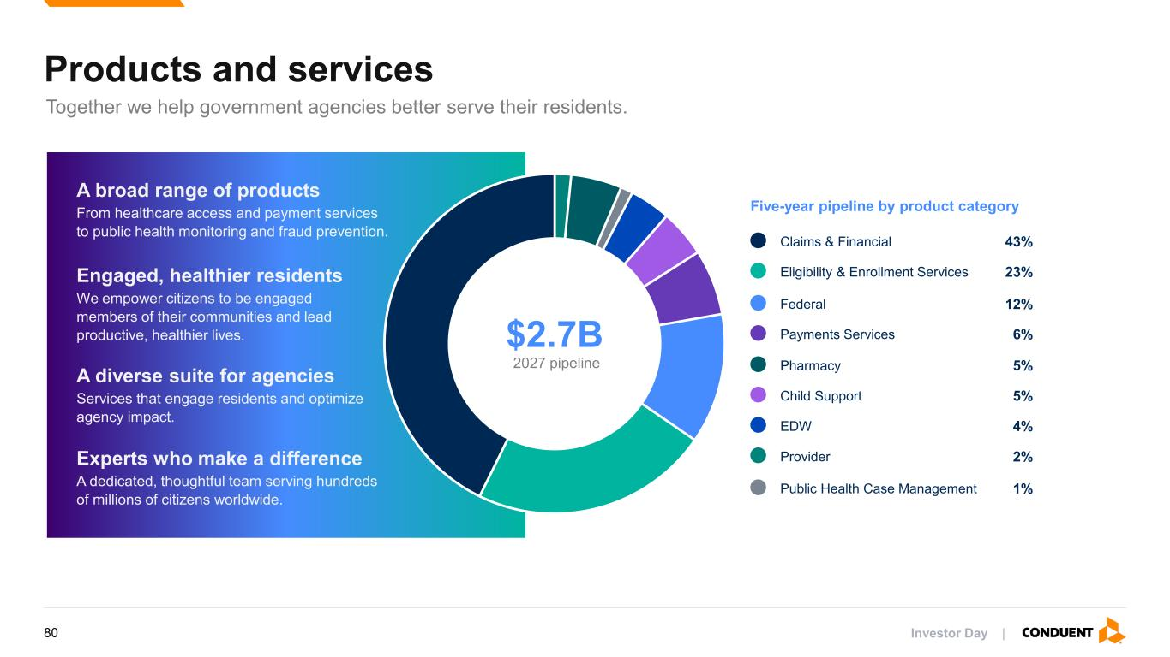
Products and services Together we help government agencies better serve their residents. A broad range of products From healthcare access and payment services to public health monitoring and fraud prevention. Engaged, healthier residents We empower citizens to be engaged members of their communities and lead productive, healthier lives. A diverse suite for agencies Services that engage residents and optimize agency impact. Experts who make a difference A dedicated, thoughtful team serving hundreds of millions of citizens worldwide. $2.7B 2027 pipeline Five-year pipeline by product category Claims & Financial 43% Eligibility & Enrollment Services 23% Federal 12% Payments Services 6% Pharmacy 5% Child Support 5% EDW 4% Provider 2% Public Health Case Management 1% Investor Day |80


Investor Day | Standardize 81

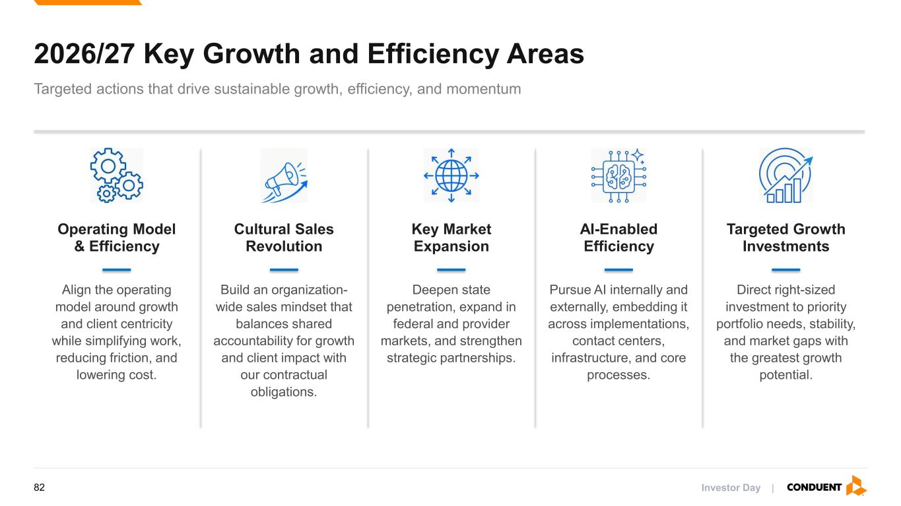
2026/27 Key Growth and Efficiency Areas Targeted actions that drive sustainable growth, efficiency, and momentum Operating Model & Efficiency Align the operating model around growth and client centricity while simplifying work, reducing friction, and lowering cost. Cultural Sales Revolution Build an organization- wide sales mindset that balances shared accountability for growth and client impact with our contractual obligations. Key Market Expansion Deepen state penetration, expand in federal and provider markets, and strengthen strategic partnerships. AI-Enabled Efficiency Pursue AI internally and externally, embedding it across implementations, contact centers, infrastructure, and core processes. Targeted Growth Investments Direct right-sized investment to priority portfolio needs, stability, and market gaps with the greatest growth potential. Investor Day |82

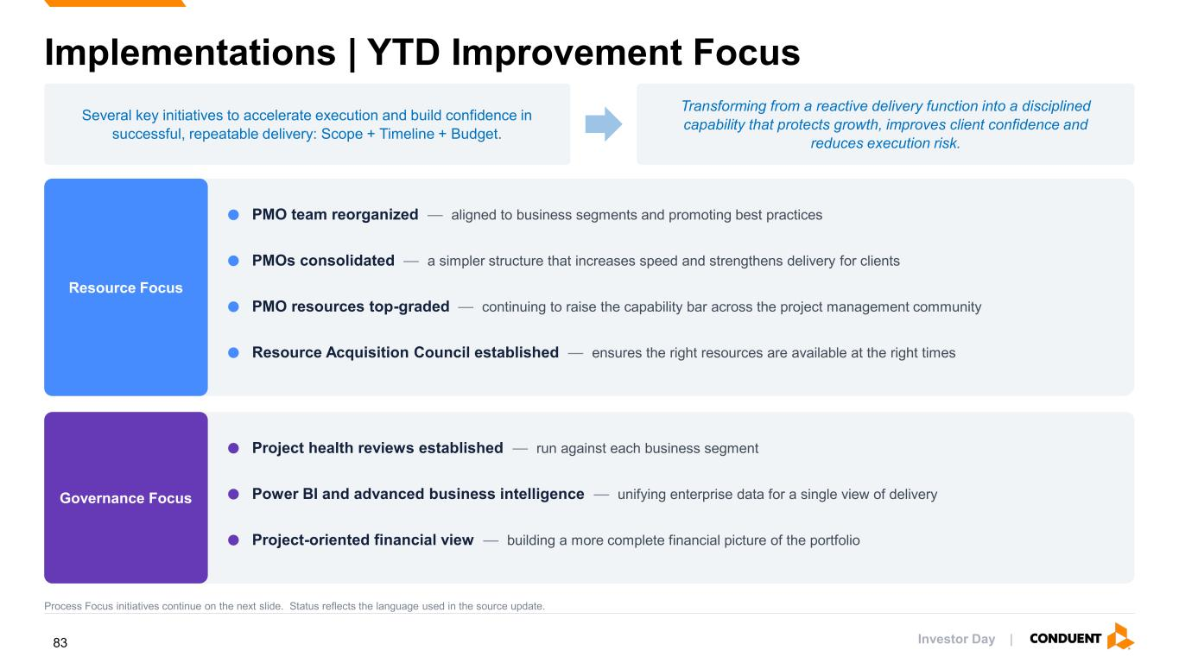
Implementations | YTD Improvement Focus Several key initiatives to accelerate execution and build confidence in successful, repeatable delivery: Scope + Timeline + Budget. Transforming from a reactive delivery function into a disciplined capability that protects growth, improves client confidence and reduces execution risk. Resource Focus PMO team reorganized — aligned to business segments and promoting best practices PMOs consolidated — a simpler structure that increases speed and strengthens delivery for clients PMO resources top-graded — continuing to raise the capability bar across the project management community Resource Acquisition Council established — ensures the right resources are available at the right times Governance Focus Project health reviews established — run against each business segment Power BI and advanced business intelligence — unifying enterprise data for a single view of delivery Project-oriented financial view — building a more complete financial picture of the portfolio Process Focus initiatives continue on the next slide. Status reflects the language used in the source update. Investor Day |83

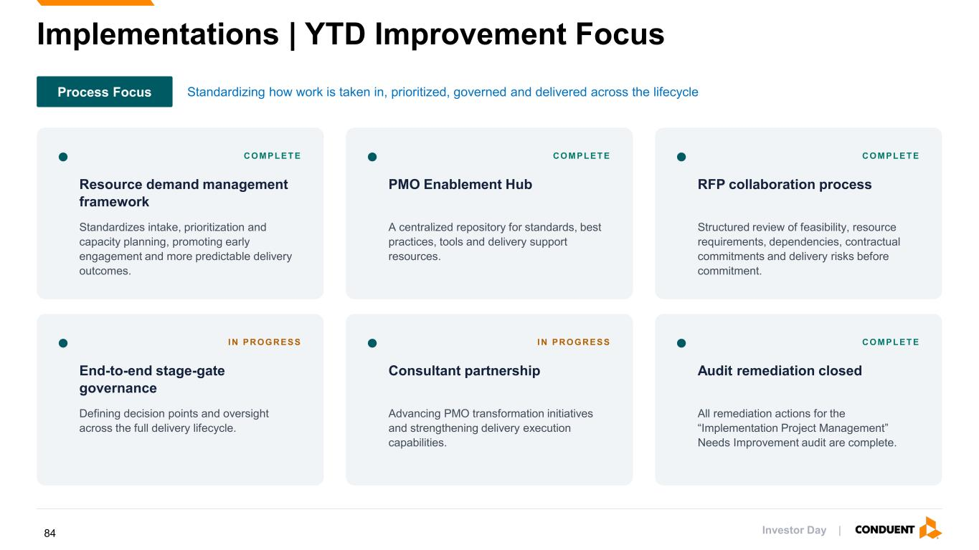
Implementations | YTD Improvement Focus Process Focus Standardizing how work is taken in, prioritized, governed and delivered across the lifecycle COMPLET E Resource demand management framework Standardizes intake, prioritization and capacity planning, promoting early engagement and more predictable delivery outcomes. COMPLET E PMO Enablement Hub A centralized repository for standards, best practices, tools and delivery support resources. COMPLET E RFP collaboration process Structured review of feasibility, resource requirements, dependencies, contractual commitments and delivery risks before commitment. I N PROGRESS End-to-end stage-gate governance Defining decision points and oversight across the full delivery lifecycle. I N PROGRESS Consultant partnership Advancing PMO transformation initiatives and strengthening delivery execution capabilities. COMPLET E Audit remediation closed All remediation actions for the “Implementation Project Management” Needs Improvement audit are complete. Investor Day |84


Investor Day | Specialize 85

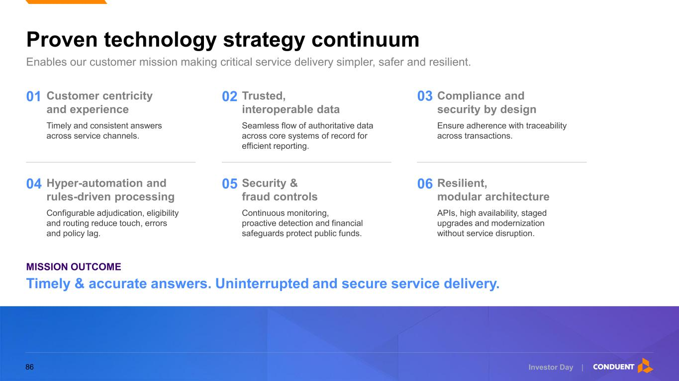
Enables our customer mission making critical service delivery simpler, safer and resilient. Proven technology strategy continuum MISSION OUTCOME Timely & accurate answers. Uninterrupted and secure service delivery. 01 Customer centricity and experience Timely and consistent answers across service channels. 04 Hyper-automation and rules-driven processing Configurable adjudication, eligibility and routing reduce touch, errors and policy lag. 02 Trusted, interoperable data Seamless flow of authoritative data across core systems of record for efficient reporting. 05 Security & fraud controls Continuous monitoring, proactive detection and financial safeguards protect public funds. 03 Compliance and security by design Ensure adherence with traceability across transactions. 06 Resilient, modular architecture APIs, high availability, staged upgrades and modernization without service disruption. Investor Day |86

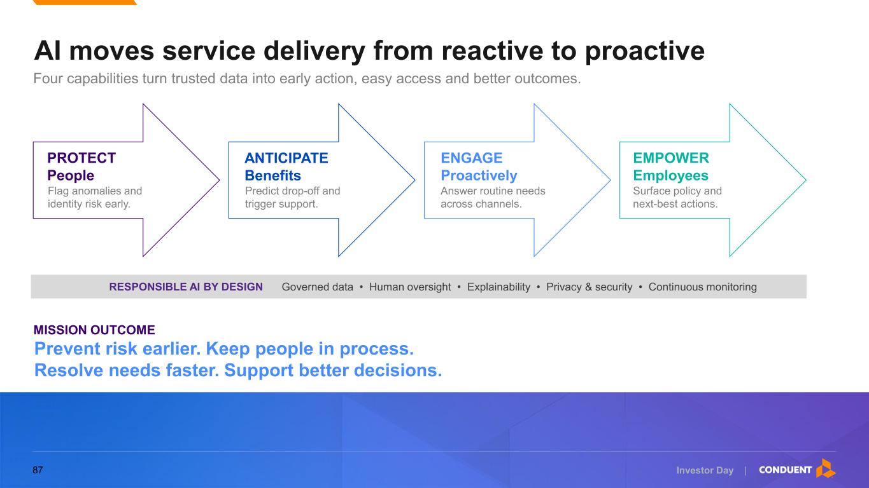
Four capabilities turn trusted data into early action, easy access and better outcomes. AI moves service delivery from reactive to proactive PROTECT People Flag anomalies and identity risk early. ANTICIPATE Benefits Predict drop-off and trigger support. ENGAGE Proactively Answer routine needs across channels. EMPOWER Employees Surface policy and next-best actions. RESPONSIBLE AI BY DESIGN Governed data • Human oversight • Explainability • Privacy & security • Continuous monitoring Prevent risk earlier. Keep people in process. Resolve needs faster. Support better decisions. MISSION OUTCOME Investor Day |87


Investor Day | Scale 88

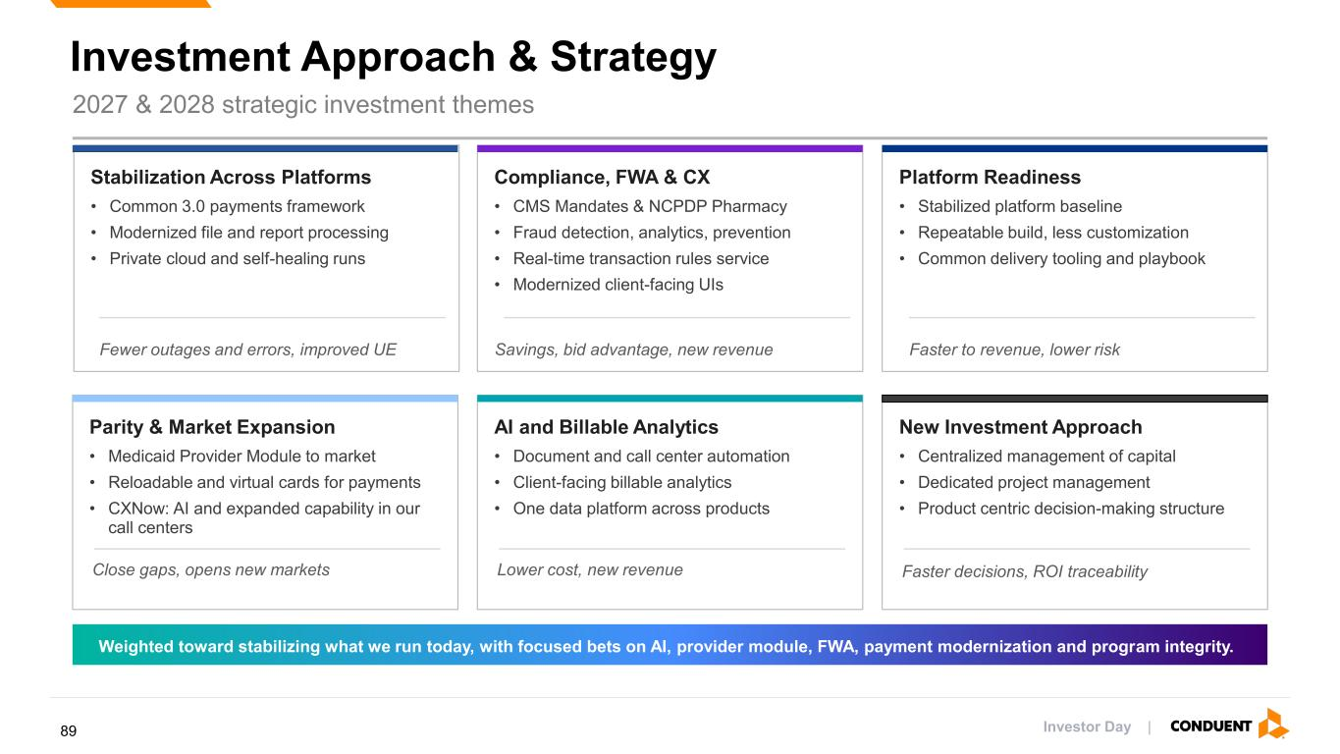
2027 & 2028 strategic investment themes Stabilization Across Platforms • Common 3.0 payments framework • Modernized file and report processing • Private cloud and self-healing runs Compliance, FWA & CX • CMS Mandates & NCPDP Pharmacy • Fraud detection, analytics, prevention • Real-time transaction rules service • Modernized client-facing UIs Platform Readiness • Stabilized platform baseline • Repeatable build, less customization • Common delivery tooling and playbook Parity & Market Expansion • Medicaid Provider Module to market • Reloadable and virtual cards for payments • CXNow: AI and expanded capability in our call centers AI and Billable Analytics • Document and call center automation • Client-facing billable analytics • One data platform across products New Investment Approach • Centralized management of capital • Dedicated project management • Product centric decision-making structure Weighted toward stabilizing what we run today, with focused bets on AI, provider module, FWA, payment modernization and program integrity. Fewer outages and errors, improved UE Savings, bid advantage, new revenue Faster to revenue, lower risk Close gaps, opens new markets Lower cost, new revenue Faster decisions, ROI traceability Investment Approach & Strategy Investor Day |89

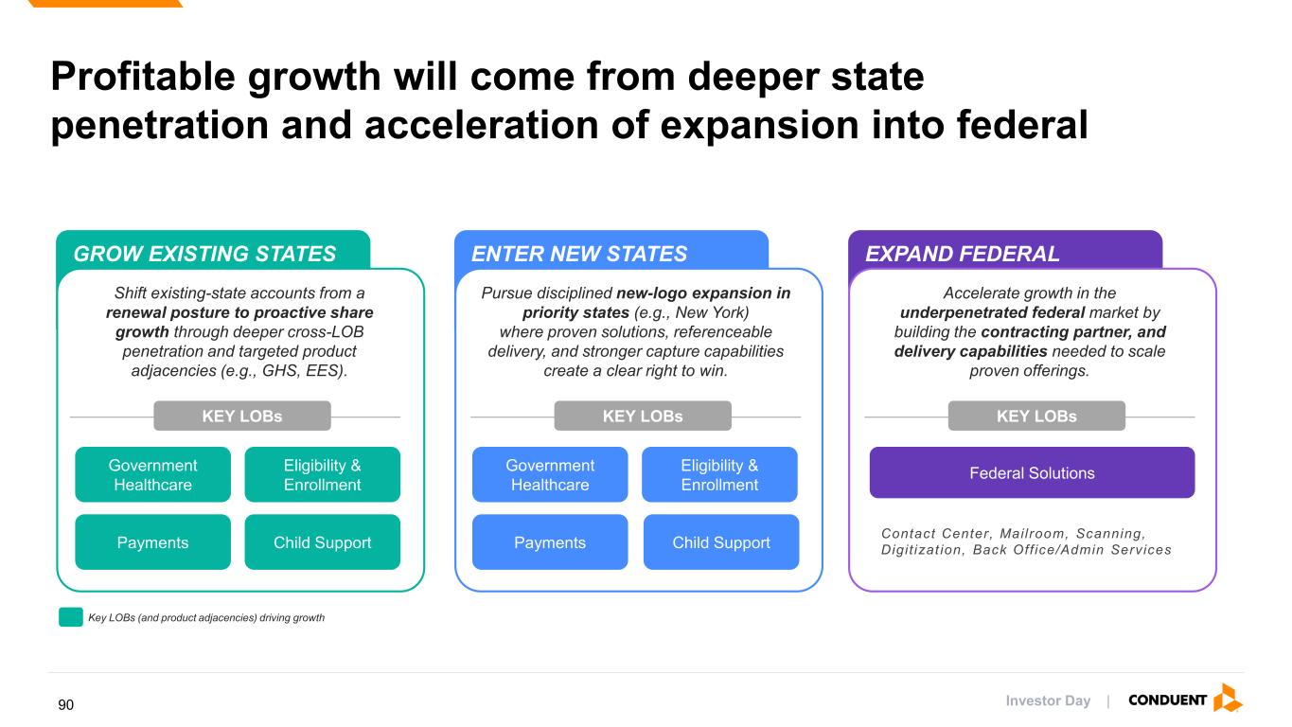
ENTER NEW STATESGROW EXISTING STATES EXPAND FEDERAL Profitable growth will come from deeper state penetration and acceleration of expansion into federal KEY LOBs Shift existing-state accounts from a renewal posture to proactive share growth through deeper cross-LOB penetration and targeted product adjacencies (e.g., GHS, EES). KEY LOBs Federal Solutions KEY LOBs Contact Center, Mailroom, Scanning, Digit izat ion, Back Off ice/Admin Services Penetration ~4.9% Pipeline4 $2.7B+ Revenues2 $0.02B Pipeline4 $0.4B+ TAM3 $93.2B TAM1 $18.4B Revenues2 $0.9B Pursue disciplined new-logo expansion in priority states (e.g., New York) where proven solutions, referenceable delivery, and stronger capture capabilities create a clear right to win. Accelerate growth in the underpenetrated federal market by building the contracting partner, and delivery capabilities needed to scale proven offerings. Government Healthcare Eligibility & Enrollment Government Healthcare Eligibility & Enrollment Payments Child Support Payments Child Support 2025 2026 - 2029 2026 - 20292025Key LOBs (and product adjacencies) driving growth Investor Day |90

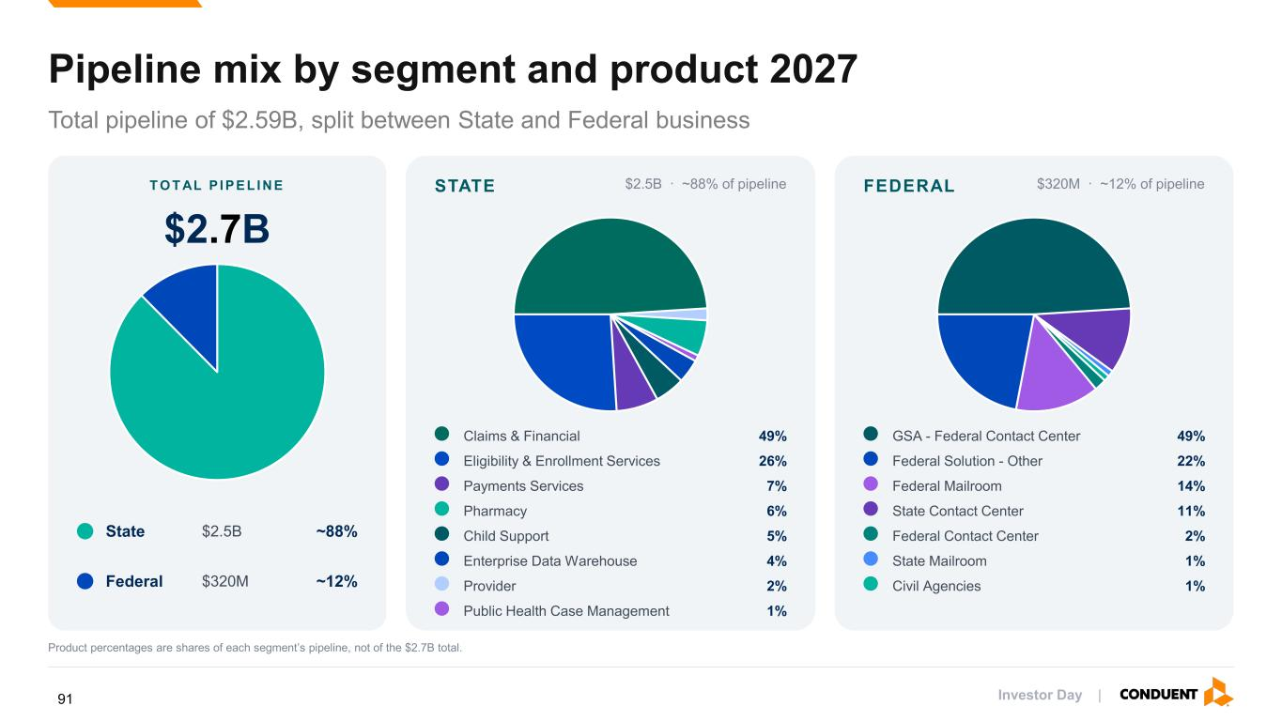
Pipeline mix by segment and product 2027 Total pipeline of $2.59B, split between State and Federal business T O T AL P I PEL I N E $2.7B State $2.5B ~88% Federal $320M ~12% STATE $2.5B · ~88% of pipeline Claims & Financial 49% Eligibility & Enrollment Services 26% Payments Services 7% Pharmacy 6% Child Support 5% Enterprise Data Warehouse 4% Provider 2% Public Health Case Management 1% FEDERAL $320M · ~12% of pipeline GSA - Federal Contact Center 49% Federal Solution - Other 22% Federal Mailroom 14% State Contact Center 11% Federal Contact Center 2% State Mailroom 1% Civil Agencies 1% Product percentages are shares of each segment’s pipeline, not of the $2.7B total. Investor Day |91

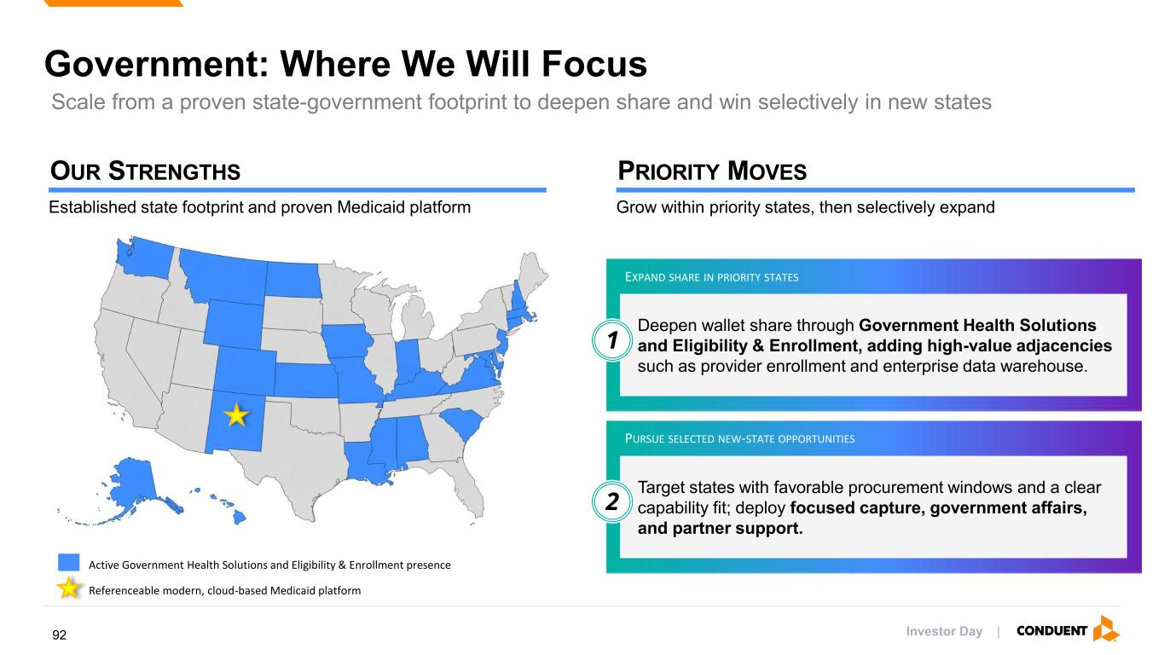
Government: Where We Will Focus Active Government Health Solutions and Eligibility & Enrollment presence Referenceable modern, cloud-based Medicaid platform Established state footprint and proven Medicaid platform OUR STRENGTHS Grow within priority states, then selectively expand PRIORITY MOVES Deepen wallet share through Government Health Solutions and Eligibility & Enrollment, adding high-value adjacencies such as provider enrollment and enterprise data warehouse. Target states with favorable procurement windows and a clear capability fit; deploy focused capture, government affairs, and partner support. EXPAND SHARE IN PRIORITY STATES PURSUE SELECTED NEW-STATE OPPORTUNITIES 1 2 Scale from a proven state-government footprint to deepen share and win selectively in new states Investor Day |92

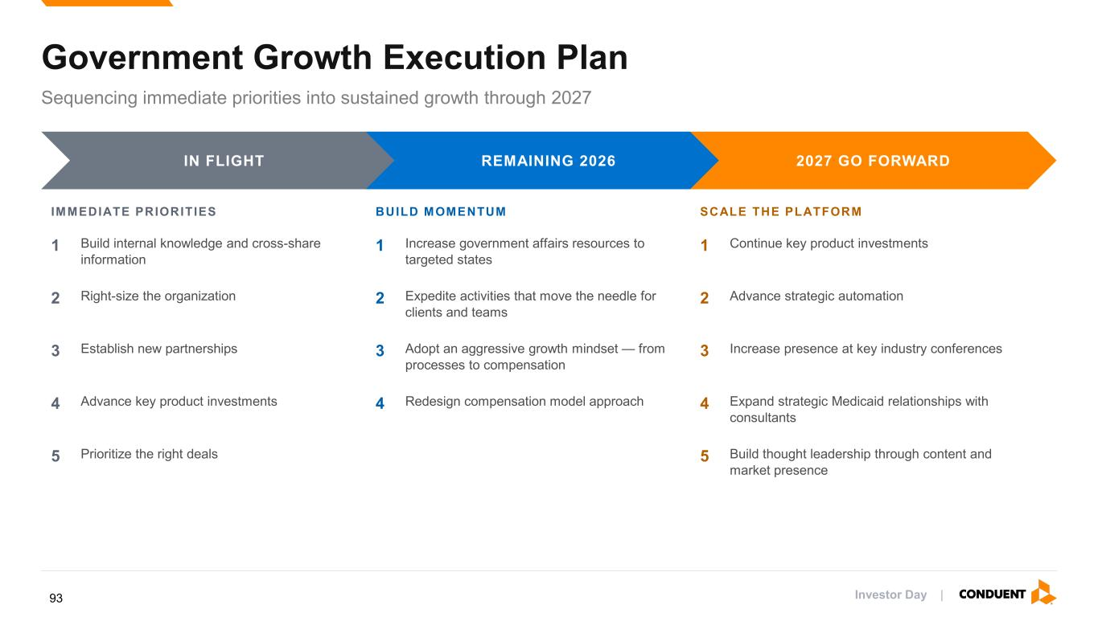
Government Growth Execution Plan Sequencing immediate priorities into sustained growth through 2027 IN FLIGHT REMAINING 2026 2027 GO FORWARD IMMEDIATE PRIORITIES 1 Build internal knowledge and cross-share information 2 Right-size the organization 3 Establish new partnerships 4 Advance key product investments 5 Prioritize the right deals BUILD MOMENTUM 1 Increase government affairs resources to targeted states 2 Expedite activities that move the needle for clients and teams 3 Adopt an aggressive growth mindset — from processes to compensation 4 Redesign compensation model approach SCALE THE PLATFORM 1 Continue key product investments 2 Advance strategic automation 3 Increase presence at key industry conferences 4 Expand strategic Medicaid relationships with consultants 5 Build thought leadership through content and market presence Investor Day |93

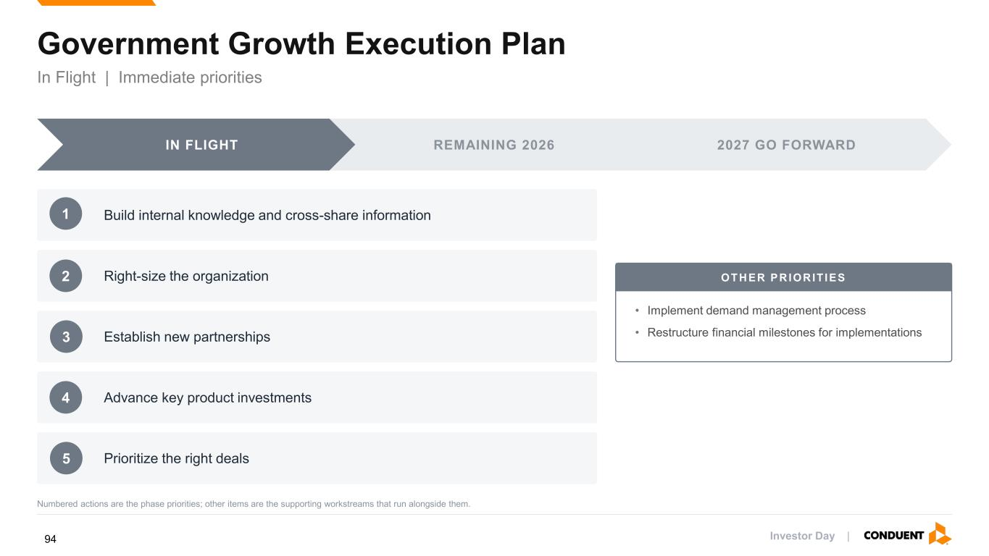
Government Growth Execution Plan In Flight | Immediate priorities IN FLIGHT REMAINING 2026 2027 GO FORWARD Build internal knowledge and cross-share information Right-size the organization Establish new partnerships Advance key product investments Prioritize the right deals OTH ER PR IOR IT IES • Implement demand management process • Restructure financial milestones for implementations Numbered actions are the phase priorities; other items are the supporting workstreams that run alongside them. 4 5 1 2 3 Investor Day |94

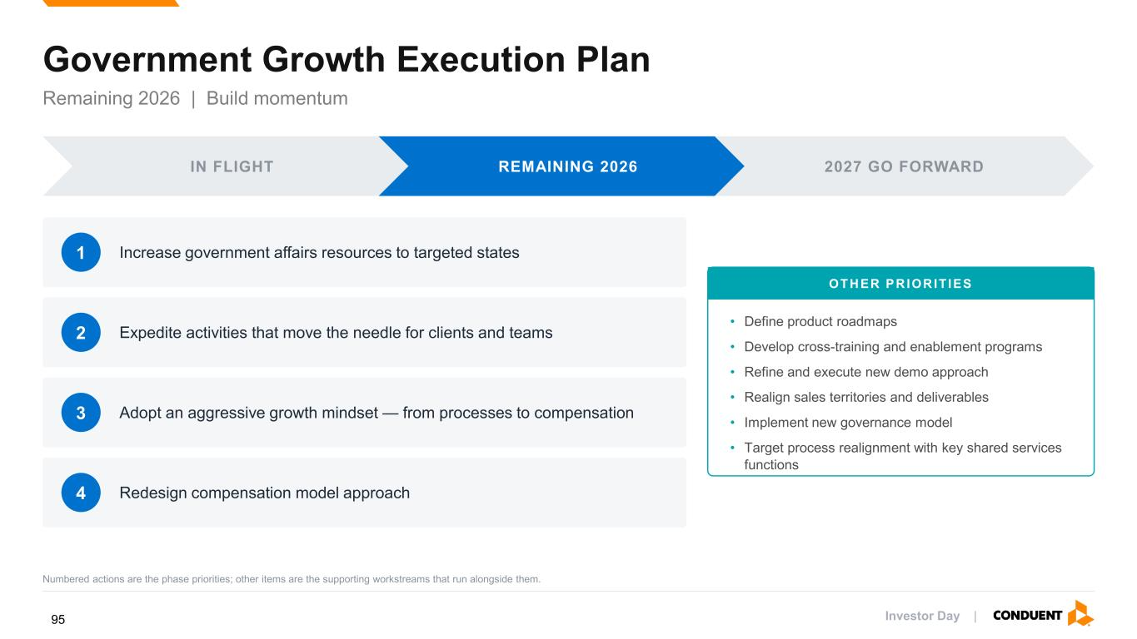
Government Growth Execution Plan Remaining 2026 | Build momentum IN FLIGHT REMAINING 2026 2027 GO FORWARD 1 Increase government affairs resources to targeted states 2 Expedite activities that move the needle for clients and teams 3 Adopt an aggressive growth mindset — from processes to compensation 4 Redesign compensation model approach OTH ER PR IOR IT IES • Define product roadmaps • Develop cross-training and enablement programs • Refine and execute new demo approach • Realign sales territories and deliverables • Implement new governance model • Target process realignment with key shared services functions Numbered actions are the phase priorities; other items are the supporting workstreams that run alongside them. Investor Day |95

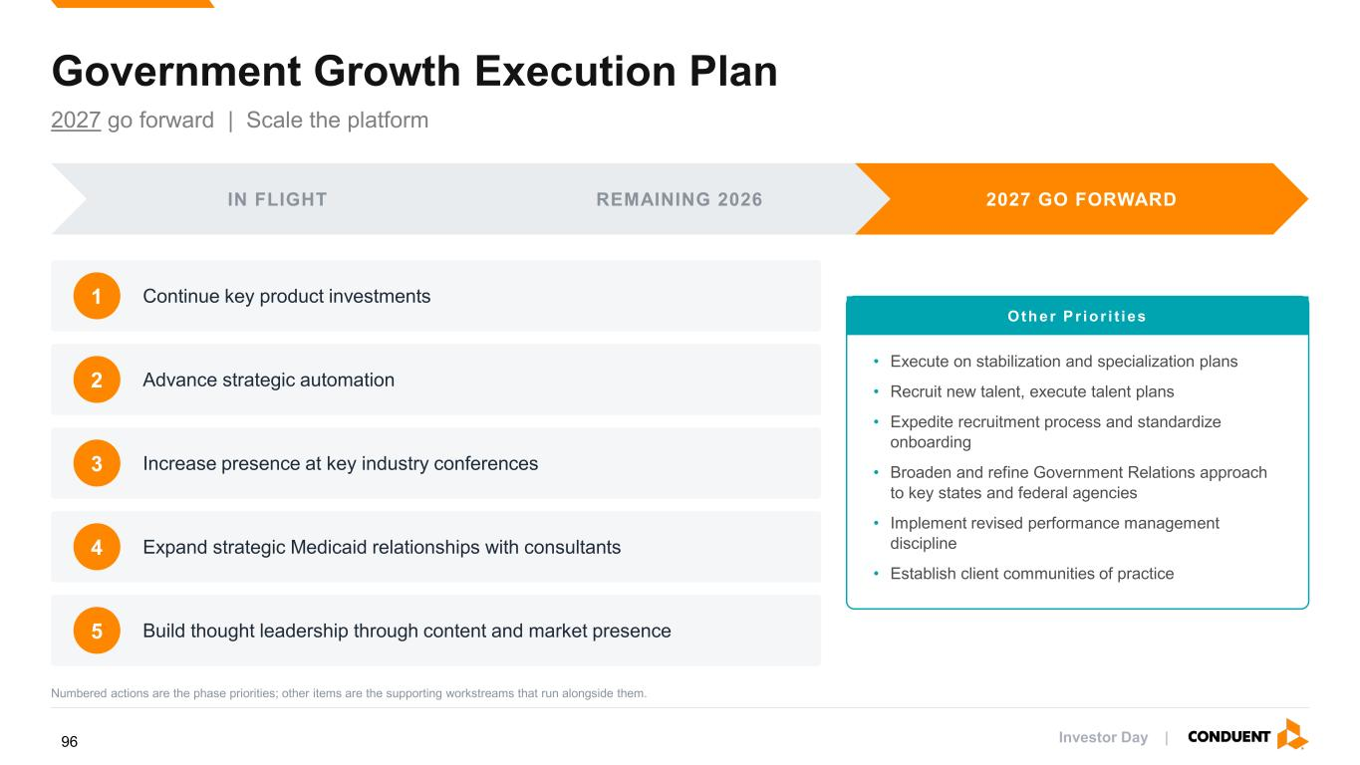
Government Growth Execution Plan 2027 go forward | Scale the platform IN FLIGHT REMAINING 2026 2027 GO FORWARD 1 Continue key product investments 2 Advance strategic automation 3 Increase presence at key industry conferences 4 Expand strategic Medicaid relationships with consultants 5 Build thought leadership through content and market presence Other P r io r i t ies • Execute on stabilization and specialization plans • Recruit new talent, execute talent plans • Expedite recruitment process and standardize onboarding • Broaden and refine Government Relations approach to key states and federal agencies • Implement revised performance management discipline • Establish client communities of practice Numbered actions are the phase priorities; other items are the supporting workstreams that run alongside them. Investor Day |96

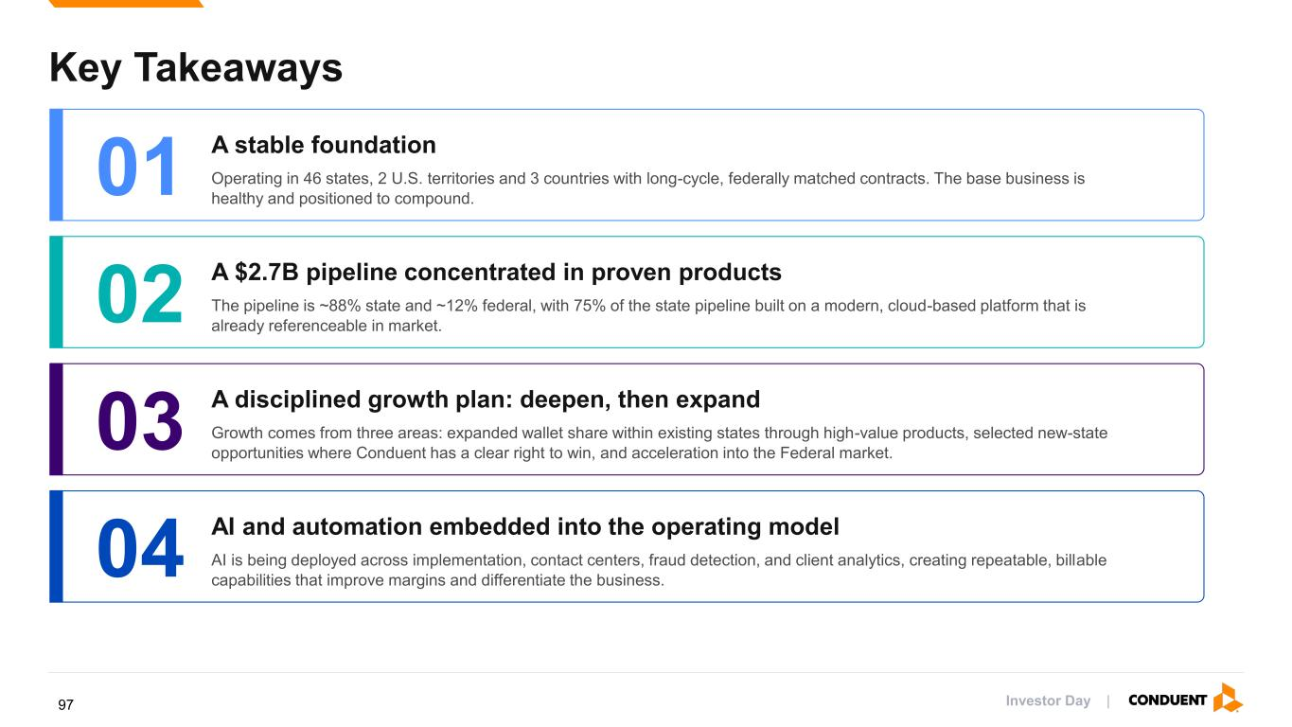
Key Takeaways 01 A stable foundation Operating in 46 states, 2 U.S. territories and 3 countries with long-cycle, federally matched contracts. The base business is healthy and positioned to compound. 02 A $2.7B pipeline concentrated in proven products The pipeline is ~88% state and ~12% federal, with 75% of the state pipeline built on a modern, cloud-based platform that is already referenceable in market. 03 A disciplined growth plan: deepen, then expand Growth comes from three areas: expanded wallet share within existing states through high-value products, selected new-state opportunities where Conduent has a clear right to win, and acceleration into the Federal market. 04 AI and automation embedded into the operating model AI is being deployed across implementation, contact centers, fraud detection, and client analytics, creating repeatable, billable capabilities that improve margins and differentiate the business. Investor Day |97

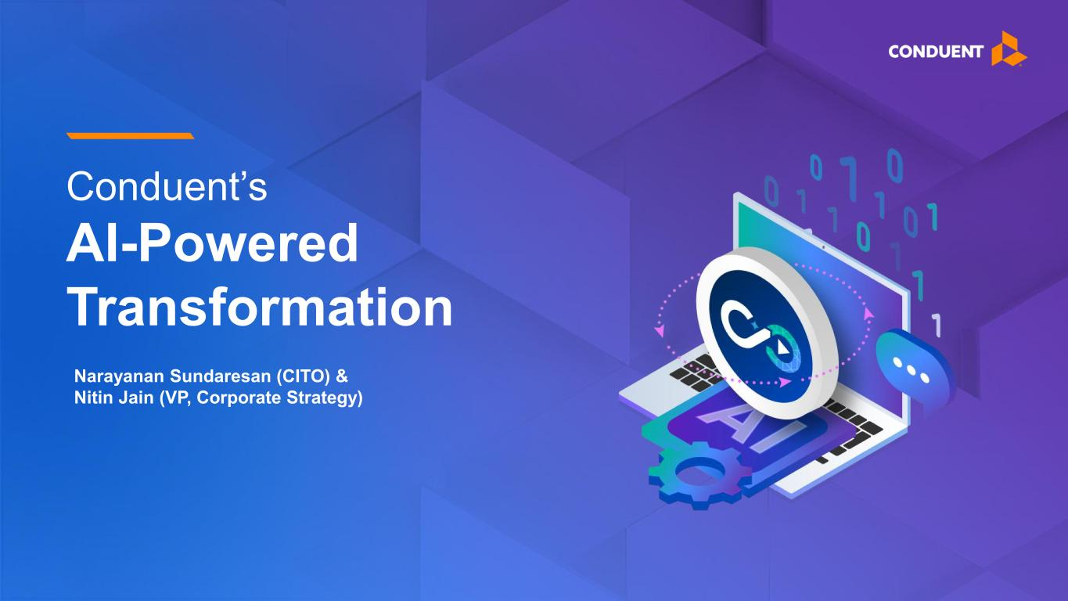
Conduent’s AI-Powered Transformation Narayanan Sundaresan (CITO) & Nitin Jain (VP, Corporate Strategy)

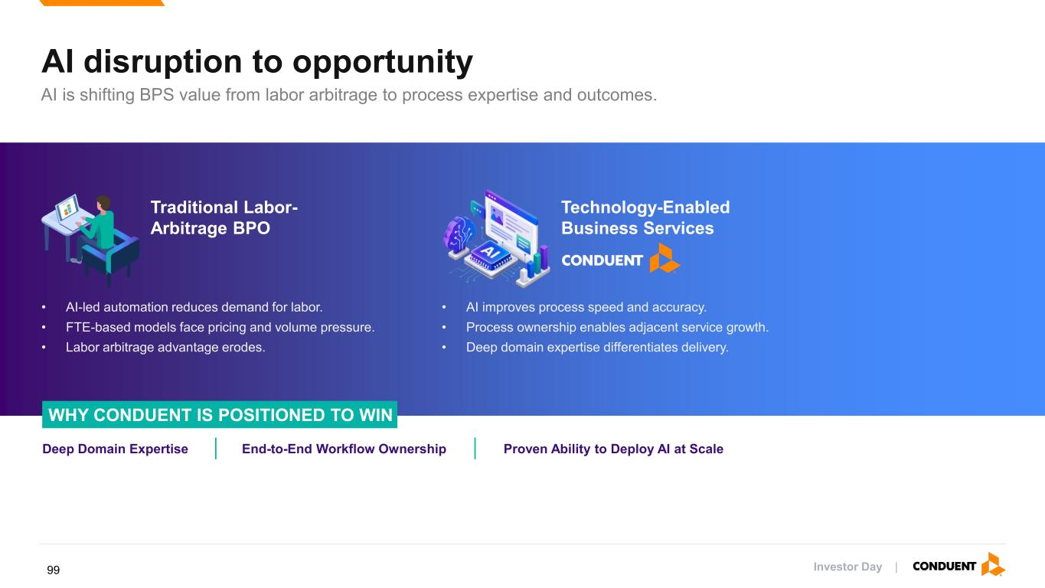
AI disruption to opportunity AI is shifting BPS value from labor arbitrage to process expertise and outcomes. Traditional Labor- Arbitrage BPO Technology-Enabled Business Services • AI-led automation reduces demand for labor. • FTE-based models face pricing and volume pressure. • Labor arbitrage advantage erodes. • AI improves process speed and accuracy. • Process ownership enables adjacent service growth. • Deep domain expertise differentiates delivery. WHY CONDUENT IS POSITIONED TO WIN Deep Domain Expertise End-to-End Workflow Ownership Proven Ability to Deploy AI at Scale Investor Day |99

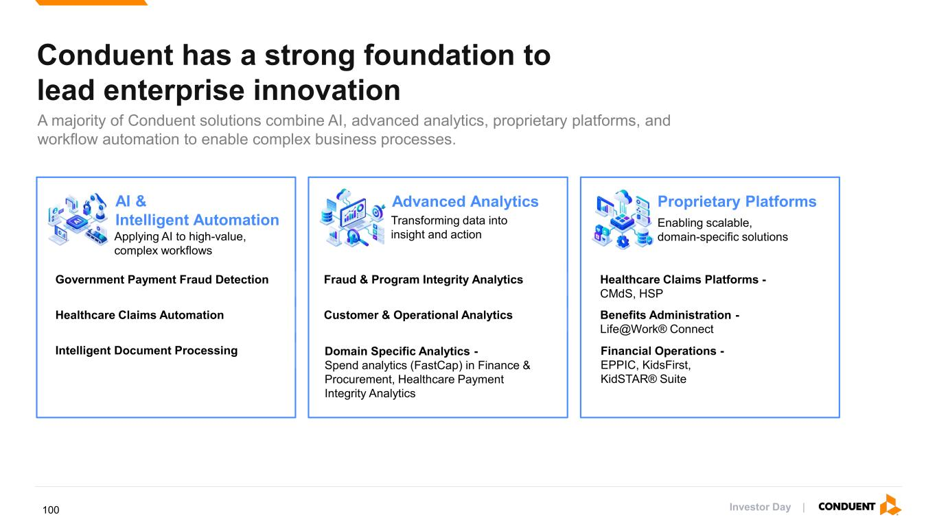
Conduent has a strong foundation to lead enterprise innovation A majority of Conduent solutions combine AI, advanced analytics, proprietary platforms, and workflow automation to enable complex business processes. AI & Intelligent Automation Applying AI to high-value, complex workflows Government Payment Fraud Detection Fraud & Program Integrity Analytics Healthcare Claims Platforms - CMdS, HSP Healthcare Claims Automation Customer & Operational Analytics Benefits Administration - Life@Work® Connect Intelligent Document Processing Domain Specific Analytics - Spend analytics (FastCap) in Finance & Procurement, Healthcare Payment Integrity Analytics Financial Operations - EPPIC, KidsFirst, KidSTAR® Suite Advanced Analytics Transforming data into insight and action Proprietary Platforms Enabling scalable, domain-specific solutions Investor Day |100

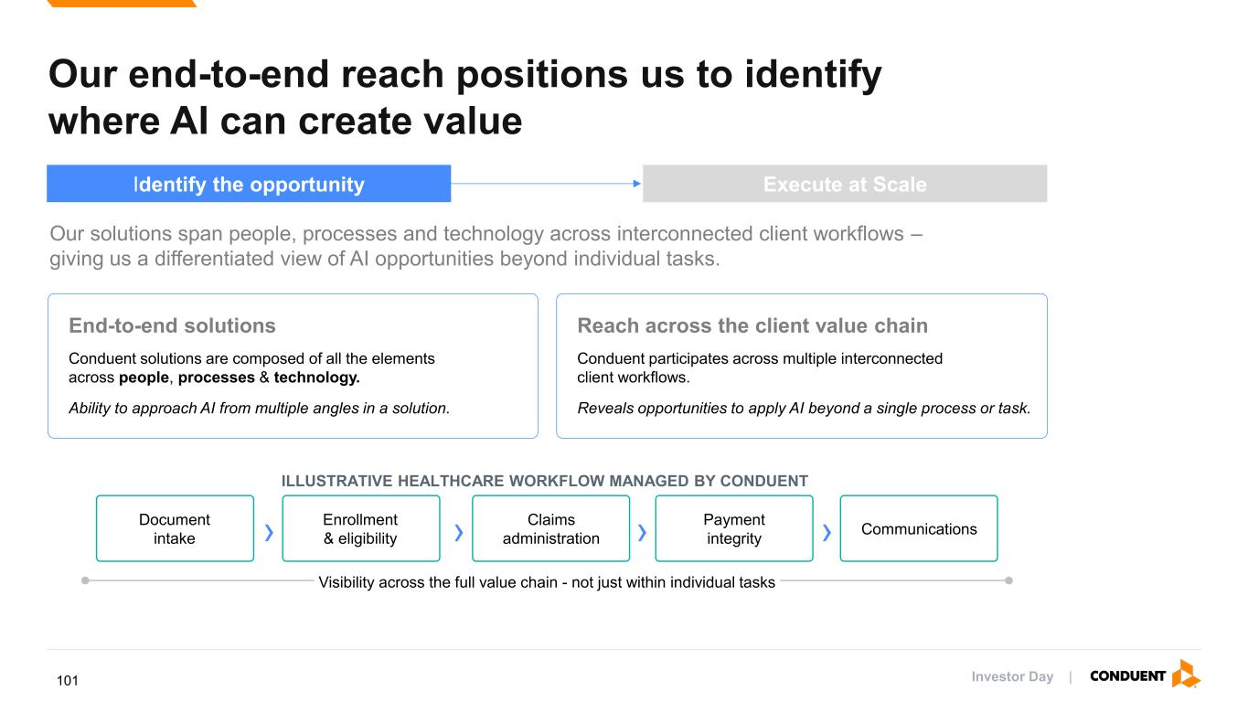
End-to-end solutions Conduent solutions are composed of all the elements across people, processes & technology. Ability to approach AI from multiple angles in a solution. Reach across the client value chain Conduent participates across multiple interconnected client workflows. Reveals opportunities to apply AI beyond a single process or task. ILLUSTRATIVE HEALTHCARE WORKFLOW MANAGED BY CONDUENT Document intake › Enrollment & eligibility › Claims administration › Payment integrity › Communications Visibility across the full value chain - not just within individual tasks. Our end-to-end reach positions us to identify where AI can create value Our solutions span people, processes and technology across interconnected client workflows – giving us a differentiated view of AI opportunities beyond individual tasks. Identify the opportunity Execute at Scale Investor Day |101

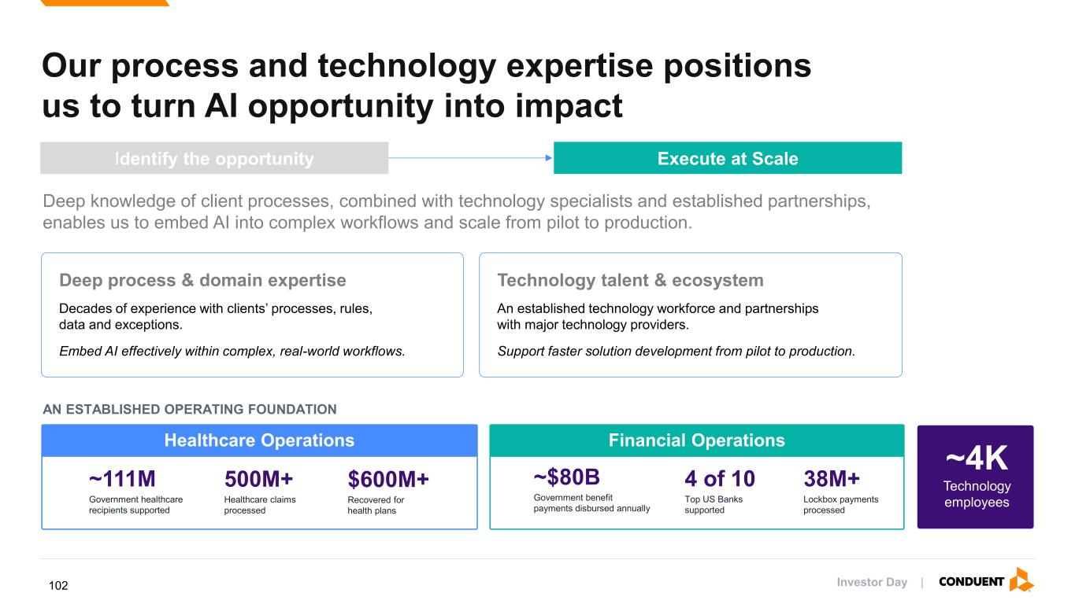
Deep process & domain expertise Decades of experience with clients’ processes, rules, data and exceptions. Embed AI effectively within complex, real-world workflows. Technology talent & ecosystem An established technology workforce and partnerships with major technology providers. Support faster solution development from pilot to production. AN ESTABLISHED OPERATING FOUNDATION Our process and technology expertise positions us to turn AI opportunity into impact Deep knowledge of client processes, combined with technology specialists and established partnerships, enables us to embed AI into complex workflows and scale from pilot to production. Healthcare Operations Financial Operations ~111M Government healthcare recipients supported 500M+ Healthcare claims processed $600M+ Recovered for health plans ~$80B Government benefit payments disbursed annually 4 of 10 Top US Banks supported 38M+ Lockbox payments processed ~4K Technology employees Identify the opportunity Execute at Scale Investor Day |102

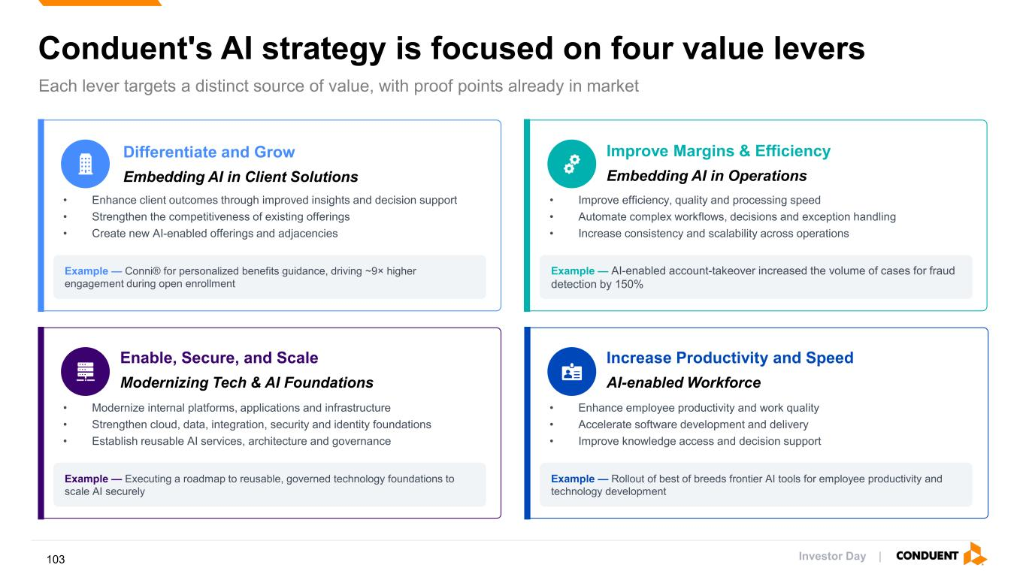
Conduent's AI strategy is focused on four value levers Each lever targets a distinct source of value, with proof points already in market Differentiate and Grow Embedding AI in Client Solutions • Enhance client outcomes through improved insights and decision support • Strengthen the competitiveness of existing offerings • Create new AI-enabled offerings and adjacencies Example — Conni® for personalized benefits guidance, driving ~9× higher engagement during open enrollment Improve Margins & Efficiency Embedding AI in Operations • Improve efficiency, quality and processing speed • Automate complex workflows, decisions and exception handling • Increase consistency and scalability across operations Example — AI-enabled account-takeover increased the volume of cases for fraud detection by 150% Enable, Secure, and Scale Modernizing Tech & AI Foundations • Modernize internal platforms, applications and infrastructure • Strengthen cloud, data, integration, security and identity foundations • Establish reusable AI services, architecture and governance Example — Executing a roadmap to reusable, governed technology foundations to scale AI securely Increase Productivity and Speed AI-enabled Workforce • Enhance employee productivity and work quality • Accelerate software development and delivery • Improve knowledge access and decision support Example — Rollout of best of breeds frontier AI tools for employee productivity and technology development Investor Day |103

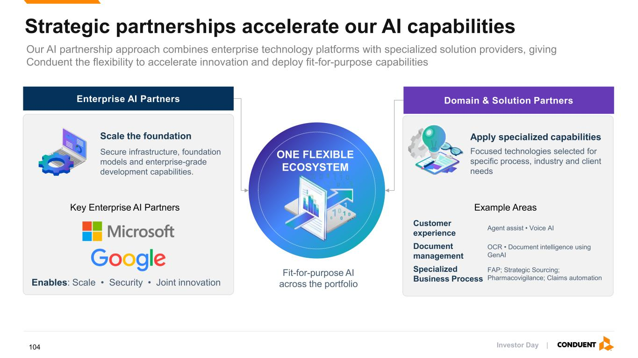
Strategic partnerships accelerate our AI capabilities Our AI partnership approach combines enterprise technology platforms with specialized solution providers, giving Conduent the flexibility to accelerate innovation and deploy fit-for-purpose capabilities Enterprise AI Partners Domain & Solution Partners Fit-for-purpose AI across the portfolio ONE FLEXIBLE ECOSYSTEM Scale the foundation Secure infrastructure, foundation models and enterprise-grade development capabilities. Enables: Scale • Security • Joint innovation Apply specialized capabilities Focused technologies selected for specific process, industry and client needs Customer experience Agent assist • Voice AI Document management OCR • Document intelligence using GenAI Specialized Business Process FAP; Strategic Sourcing; Pharmacovigilance; Claims automation Key Enterprise AI Partners Example Areas Investor Day |104

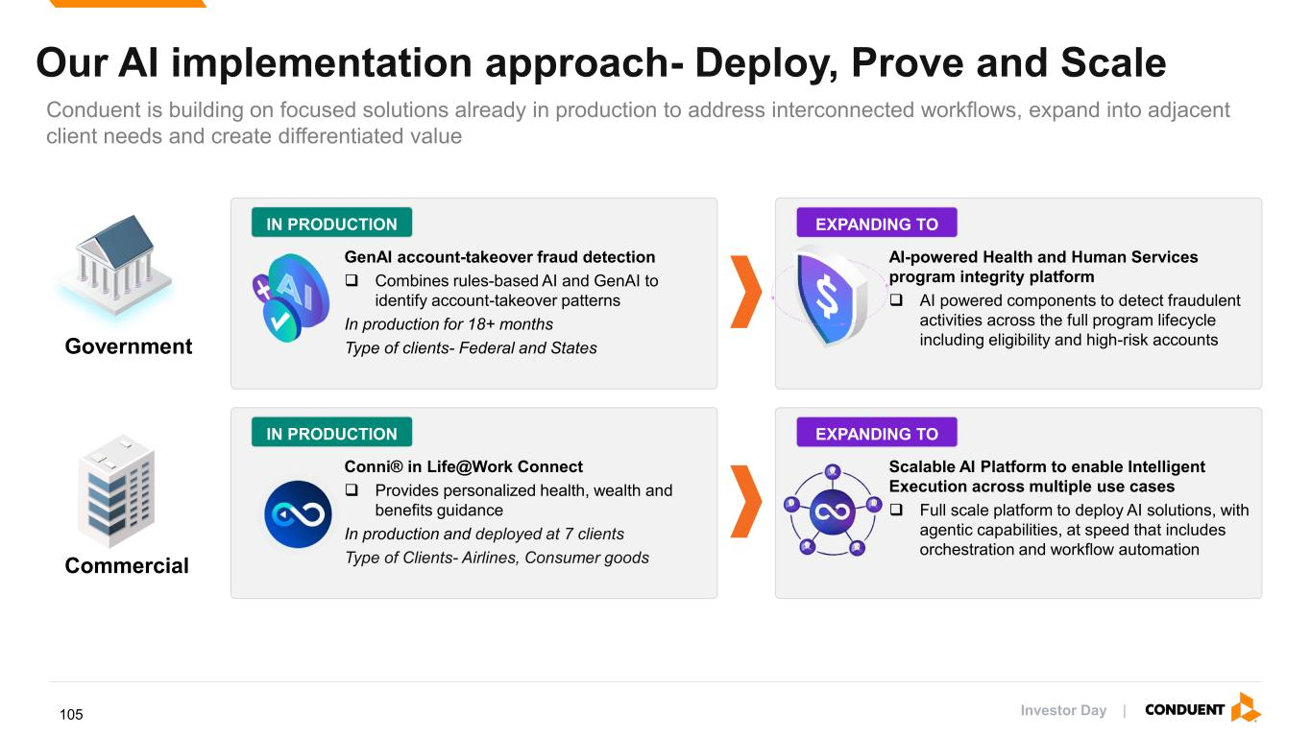
Our AI implementation approach- Deploy, Prove and Scale Conduent is building on focused solutions already in production to address interconnected workflows, expand into adjacent client needs and create differentiated value IN PRODUCTION GenAI account-takeover fraud detection ❑ Combines rules-based AI and GenAI to identify account-takeover patterns In production for 18+ months Type of clients- Federal and States AI-powered Health and Human Services program integrity platform ❑ AI powered components to detect fraudulent activities across the full program lifecycle including eligibility and high-risk accounts EXPANDING TO IN PRODUCTION Conni® in Life@Work Connect ❑ Provides personalized health, wealth and benefits guidance In production and deployed at 7 clients Type of Clients- Airlines, Consumer goods Scalable AI Platform to enable Intelligent Execution across multiple use cases ❑ Full scale platform to deploy AI solutions, with agentic capabilities, at speed that includes orchestration and workflow automation EXPANDING TO Government Commercial Investor Day |105

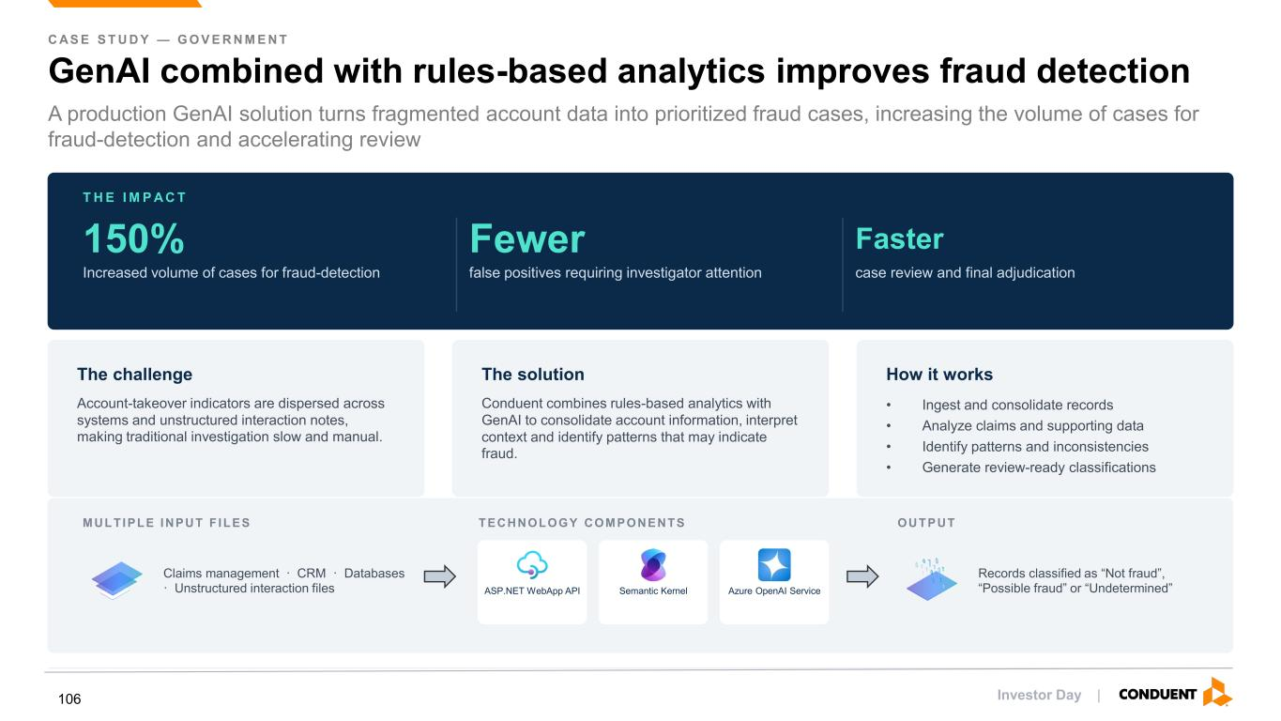
C AS E S T U D Y — G O V E R N M E N T GenAI combined with rules-based analytics improves fraud detection A production GenAI solution turns fragmented account data into prioritized fraud cases, increasing the volume of cases for fraud-detection and accelerating review T H E I M P A C T 150% Increased volume of cases for fraud-detection Fewer false positives requiring investigator attention Faster case review and final adjudication The challenge Account-takeover indicators are dispersed across systems and unstructured interaction notes, making traditional investigation slow and manual. The solution Conduent combines rules-based analytics with GenAI to consolidate account information, interpret context and identify patterns that may indicate fraud. How it works • Ingest and consolidate records • Analyze claims and supporting data • Identify patterns and inconsistencies • Generate review-ready classifications MULTIPLE INPUT F ILES Claims management · CRM · Databases · Unstructured interaction files TECHNOLOGY COMPONENTS ASP.NET WebApp API Semantic Kernel Azure OpenAI Service OUTPUT Records classified as “Not fraud”, “Possible fraud” or “Undetermined” Investor Day |106

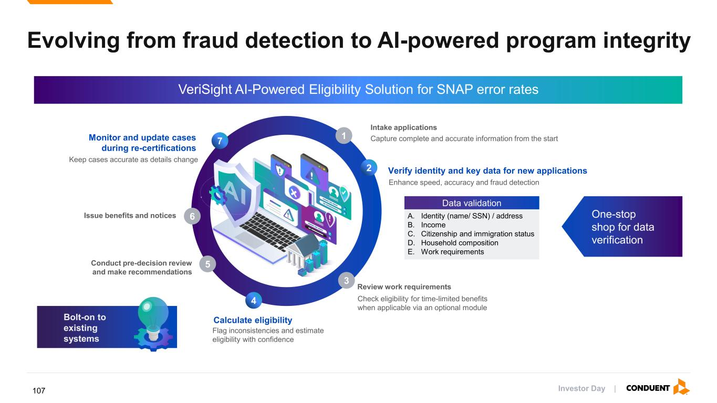
VeriSight AI-Powered Eligibility Solution for SNAP error rates Evolving from fraud detection to AI-powered program integrity Intake applications Capture complete and accurate information from the start Verify identity and key data for new applications Conduct pre-decision review and make recommendations Monitor and update cases during re-certifications Data validation A. Identity (name/ SSN) / address B. Income C. Citizenship and immigration status D. Household composition E. Work requirements Enhance speed, accuracy and fraud detection Keep cases accurate as details change Review work requirements Check eligibility for time-limited benefits when applicable via an optional module Issue benefits and notices Calculate eligibility Flag inconsistencies and estimate eligibility with confidence 1 2 3 5 7 4 6 One-stop shop for data verification Bolt-on to existing systems Investor Day |107

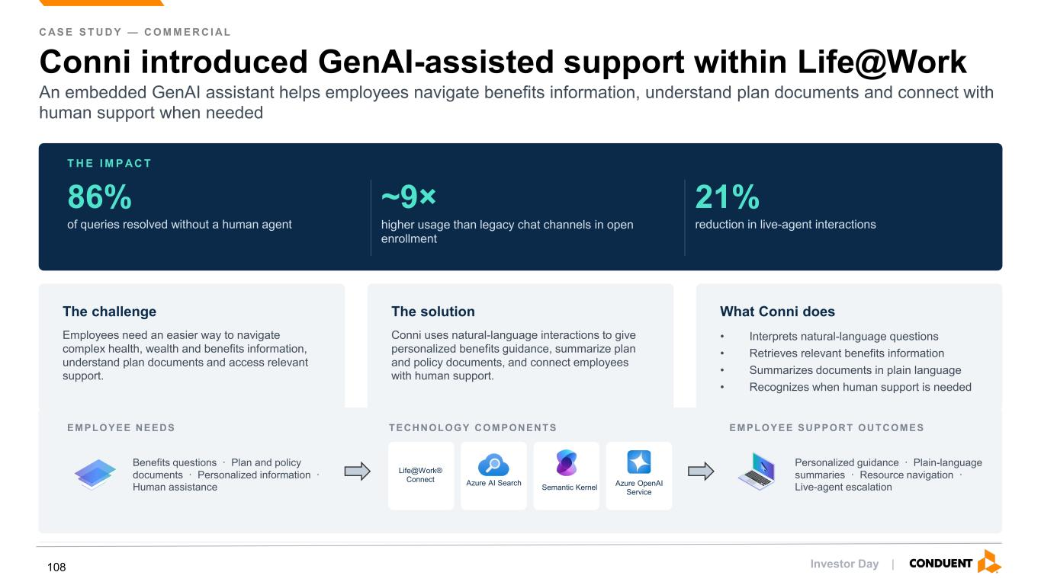
C AS E S T U D Y — C O M M E R C I AL Conni introduced GenAI-assisted support within Life@Work An embedded GenAI assistant helps employees navigate benefits information, understand plan documents and connect with human support when needed T H E I M P A C T 86% of queries resolved without a human agent ~9× higher usage than legacy chat channels in open enrollment 21% reduction in live-agent interactions The challenge Employees need an easier way to navigate complex health, wealth and benefits information, understand plan documents and access relevant support. The solution Conni uses natural-language interactions to give personalized benefits guidance, summarize plan and policy documents, and connect employees with human support. What Conni does • Interprets natural-language questions • Retrieves relevant benefits information • Summarizes documents in plain language • Recognizes when human support is needed EMPLOYEE NEEDS Benefits questions · Plan and policy documents · Personalized information · Human assistance TECHNOLOGY COMPONENTS Life@Work® Connect Azure AI Search Azure OpenAI Service EMPLOYEE SUPPORT OUTCOMES Personalized guidance · Plain-language summaries · Resource navigation · Live-agent escalationSemantic Kernel Investor Day |108

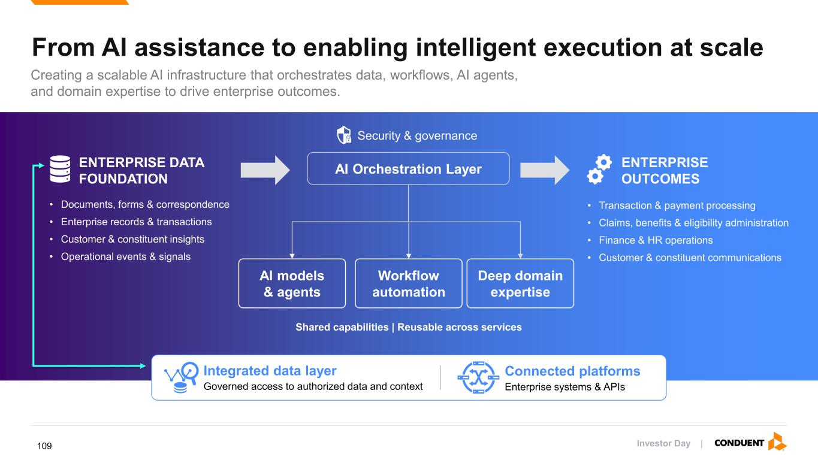
From AI assistance to enabling intelligent execution at scale Creating a scalable AI infrastructure that orchestrates data, workflows, AI agents, and domain expertise to drive enterprise outcomes. AI Orchestration Layer AI models & agents Workflow automation Deep domain expertise Shared capabilities | Reusable across services ENTERPRISE DATA FOUNDATION • Documents, forms & correspondence • Enterprise records & transactions • Customer & constituent insights • Operational events & signals ENTERPRISE OUTCOMES • Transaction & payment processing • Claims, benefits & eligibility administration • Finance & HR operations • Customer & constituent communications Integrated data layer Governed access to authorized data and context Connected platforms Enterprise systems & APIs Security & governance Investor Day |109

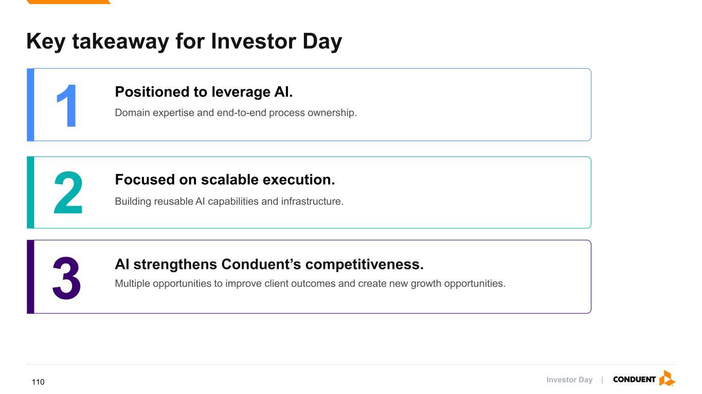
Key takeaway for Investor Day 1 Positioned to leverage AI. Domain expertise and end-to-end process ownership. 2 Focused on scalable execution. Building reusable AI capabilities and infrastructure. 3 AI strengthens Conduent’s competitiveness. Multiple opportunities to improve client outcomes and create new growth opportunities. Investor Day |110

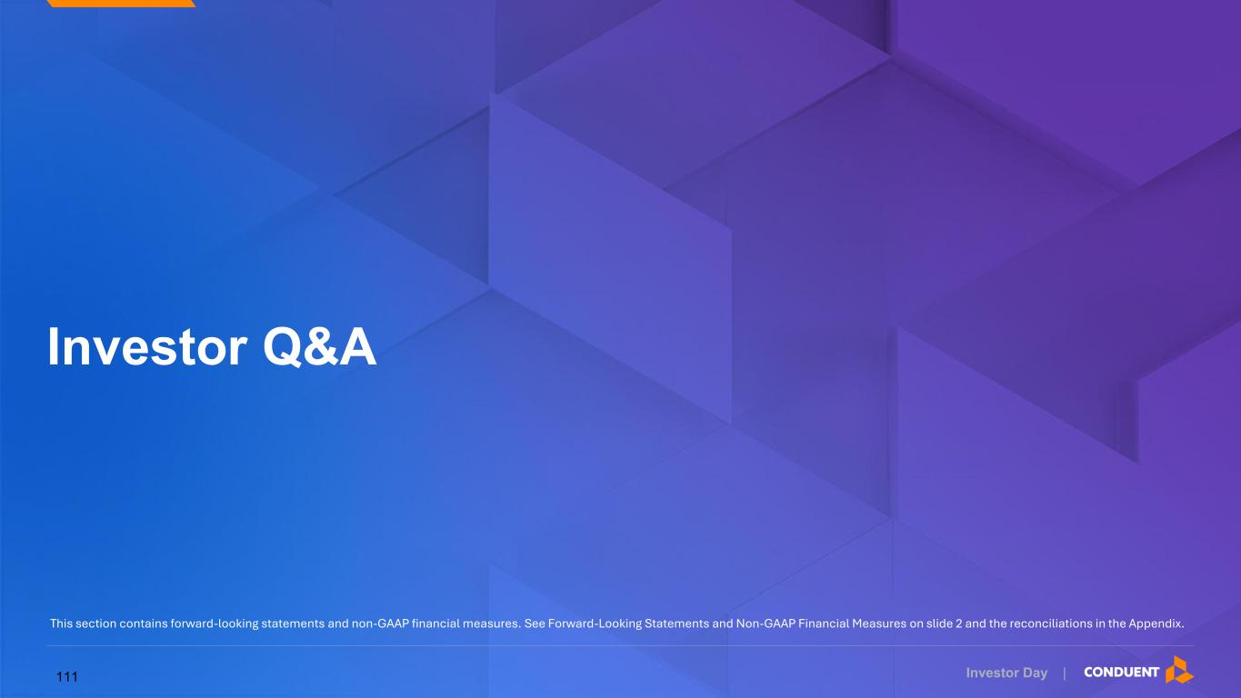
Investor Day | Investor Q&A This section contains forward-looking statements and non-GAAP financial measures. See Forward-Looking Statements and Non-GAAP Financial Measures on slide 2 and the reconciliations in the Appendix. 111

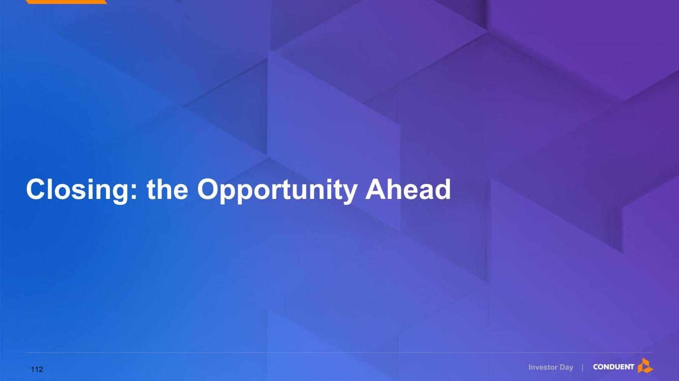
Investor Day | Closing: the Opportunity Ahead 112

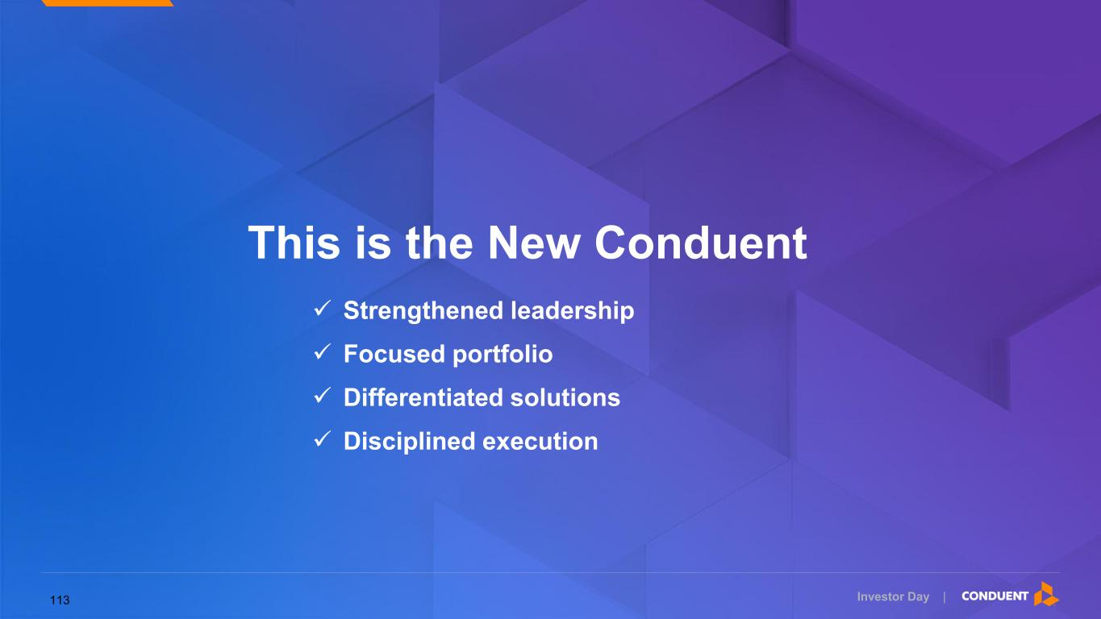
This is the New Conduent Investor Day | ✓ Strengthened leadership ✓ Focused portfolio ✓ Differentiated solutions ✓ Disciplined execution 113

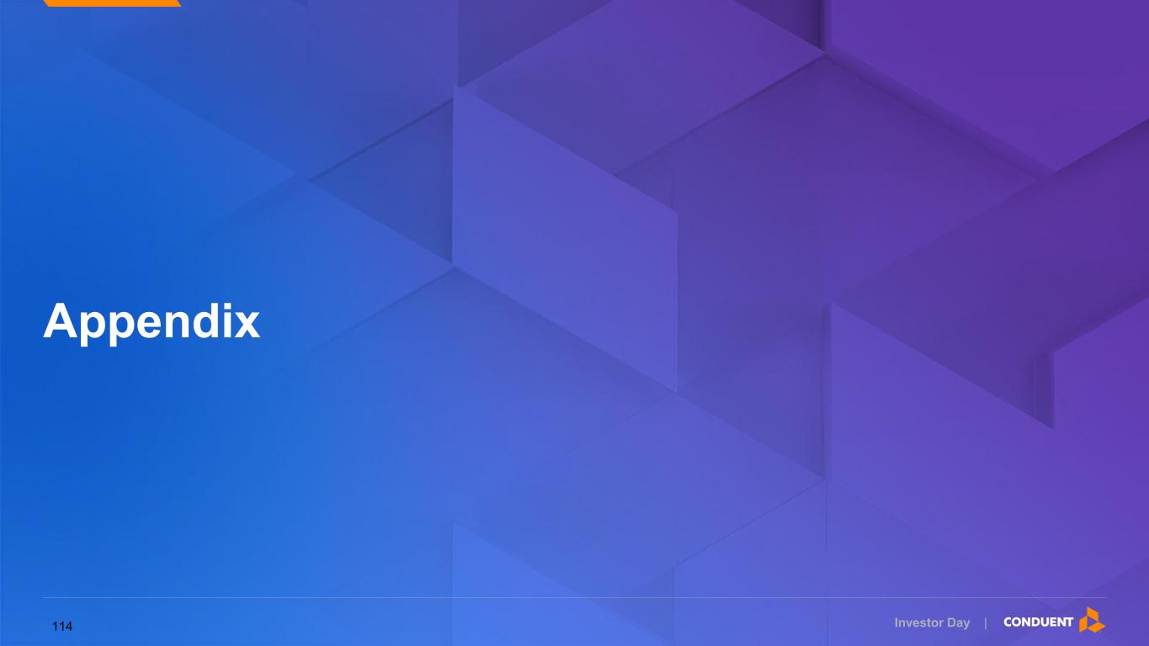
Investor Day | Appendix 114

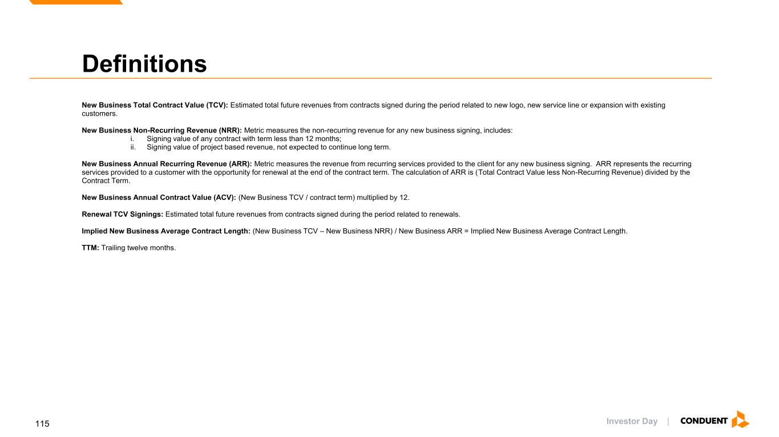
Investor Day | Definitions New Business Total Contract Value (TCV): Estimated total future revenues from contracts signed during the period related to new logo, new service line or expansion with existing customers. New Business Non-Recurring Revenue (NRR): Metric measures the non-recurring revenue for any new business signing, includes: i. Signing value of any contract with term less than 12 months; ii. Signing value of project based revenue, not expected to continue long term. New Business Annual Recurring Revenue (ARR): Metric measures the revenue from recurring services provided to the client for any new business signing. ARR represents the recurring services provided to a customer with the opportunity for renewal at the end of the contract term. The calculation of ARR is (Total Contract Value less Non-Recurring Revenue) divided by the Contract Term. New Business Annual Contract Value (ACV): (New Business TCV / contract term) multiplied by 12. Renewal TCV Signings: Estimated total future revenues from contracts signed during the period related to renewals. Implied New Business Average Contract Length: (New Business TCV – New Business NRR) / New Business ARR = Implied New Business Average Contract Length. TTM: Trailing twelve months. 115

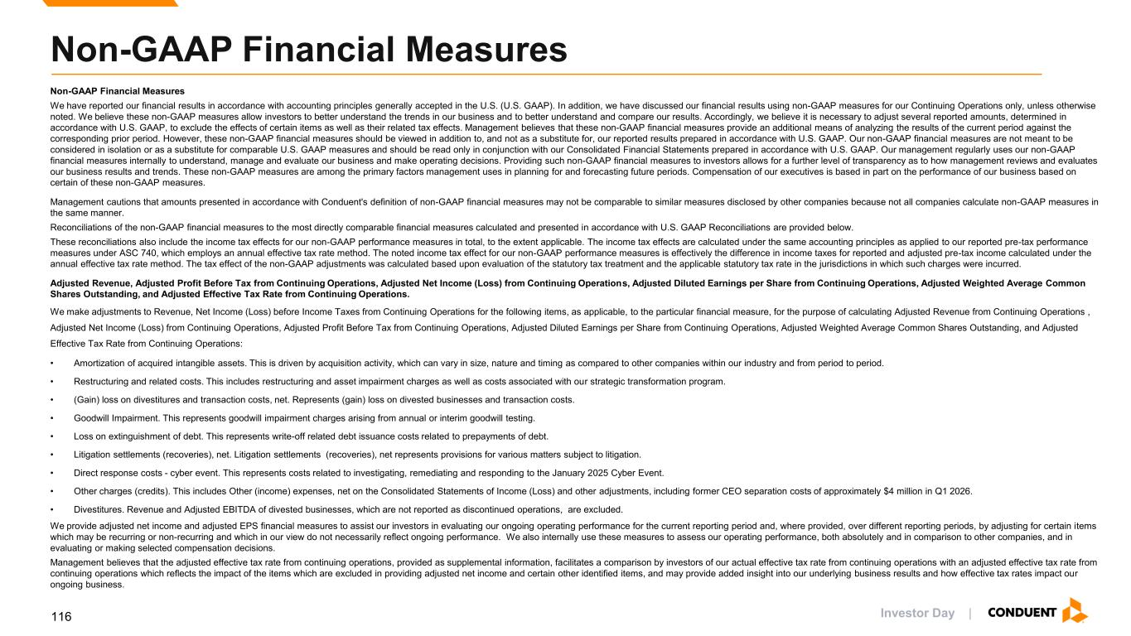
Investor Day | Non-GAAP Financial Measures We have reported our financial results in accordance with accounting principles generally accepted in the U.S. (U.S. GAAP). In addition, we have discussed our financial results using non-GAAP measures for our Continuing Operations only, unless otherwise noted. We believe these non-GAAP measures allow investors to better understand the trends in our business and to better understand and compare our results. Accordingly, we believe it is necessary to adjust several reported amounts, determined in accordance with U.S. GAAP, to exclude the effects of certain items as well as their related tax effects. Management believes that these non-GAAP financial measures provide an additional means of analyzing the results of the current period against the corresponding prior period. However, these non-GAAP financial measures should be viewed in addition to, and not as a substitute for, our reported results prepared in accordance with U.S. GAAP. Our non-GAAP financial measures are not meant to be considered in isolation or as a substitute for comparable U.S. GAAP measures and should be read only in conjunction with our Consolidated Financial Statements prepared in accordance with U.S. GAAP. Our management regularly uses our non-GAAP financial measures internally to understand, manage and evaluate our business and make operating decisions. Providing such non-GAAP financial measures to investors allows for a further level of transparency as to how management reviews and evaluates our business results and trends. These non-GAAP measures are among the primary factors management uses in planning for and forecasting future periods. Compensation of our executives is based in part on the performance of our business based on certain of these non-GAAP measures. Management cautions that amounts presented in accordance with Conduent's definition of non-GAAP financial measures may not be comparable to similar measures disclosed by other companies because not all companies calculate non-GAAP measures in the same manner. Reconciliations of the non-GAAP financial measures to the most directly comparable financial measures calculated and presented in accordance with U.S. GAAP Reconciliations are provided below. These reconciliations also include the income tax effects for our non-GAAP performance measures in total, to the extent applicable. The income tax effects are calculated under the same accounting principles as applied to our reported pre-tax performance measures under ASC 740, which employs an annual effective tax rate method. The noted income tax effect for our non-GAAP performance measures is effectively the difference in income taxes for reported and adjusted pre-tax income calculated under the annual effective tax rate method. The tax effect of the non-GAAP adjustments was calculated based upon evaluation of the statutory tax treatment and the applicable statutory tax rate in the jurisdictions in which such charges were incurred. Adjusted Revenue, Adjusted Profit Before Tax from Continuing Operations, Adjusted Net Income (Loss) from Continuing Operations, Adjusted Diluted Earnings per Share from Continuing Operations, Adjusted Weighted Average Common Shares Outstanding, and Adjusted Effective Tax Rate from Continuing Operations. We make adjustments to Revenue, Net Income (Loss) before Income Taxes from Continuing Operations for the following items, as applicable, to the particular financial measure, for the purpose of calculating Adjusted Revenue from Continuing Operations , Adjusted Net Income (Loss) from Continuing Operations, Adjusted Profit Before Tax from Continuing Operations, Adjusted Diluted Earnings per Share from Continuing Operations, Adjusted Weighted Average Common Shares Outstanding, and Adjusted Effective Tax Rate from Continuing Operations: • Amortization of acquired intangible assets. This is driven by acquisition activity, which can vary in size, nature and timing as compared to other companies within our industry and from period to period. • Restructuring and related costs. This includes restructuring and asset impairment charges as well as costs associated with our strategic transformation program. • (Gain) loss on divestitures and transaction costs, net. Represents (gain) loss on divested businesses and transaction costs. • Goodwill Impairment. This represents goodwill impairment charges arising from annual or interim goodwill testing. • Loss on extinguishment of debt. This represents write-off related debt issuance costs related to prepayments of debt. • Litigation settlements (recoveries), net. Litigation settlements (recoveries), net represents provisions for various matters subject to litigation. • Direct response costs - cyber event. This represents costs related to investigating, remediating and responding to the January 2025 Cyber Event. • Other charges (credits). This includes Other (income) expenses, net on the Consolidated Statements of Income (Loss) and other adjustments, including former CEO separation costs of approximately $4 million in Q1 2026. • Divestitures. Revenue and Adjusted EBITDA of divested businesses, which are not reported as discontinued operations, are excluded. We provide adjusted net income and adjusted EPS financial measures to assist our investors in evaluating our ongoing operating performance for the current reporting period and, where provided, over different reporting periods, by adjusting for certain items which may be recurring or non-recurring and which in our view do not necessarily reflect ongoing performance. We also internally use these measures to assess our operating performance, both absolutely and in comparison to other companies, and in evaluating or making selected compensation decisions. Management believes that the adjusted effective tax rate from continuing operations, provided as supplemental information, facilitates a comparison by investors of our actual effective tax rate from continuing operations with an adjusted effective tax rate from continuing operations which reflects the impact of the items which are excluded in providing adjusted net income and certain other identified items, and may provide added insight into our underlying business results and how effective tax rates impact our ongoing business. Non-GAAP Financial Measures 116

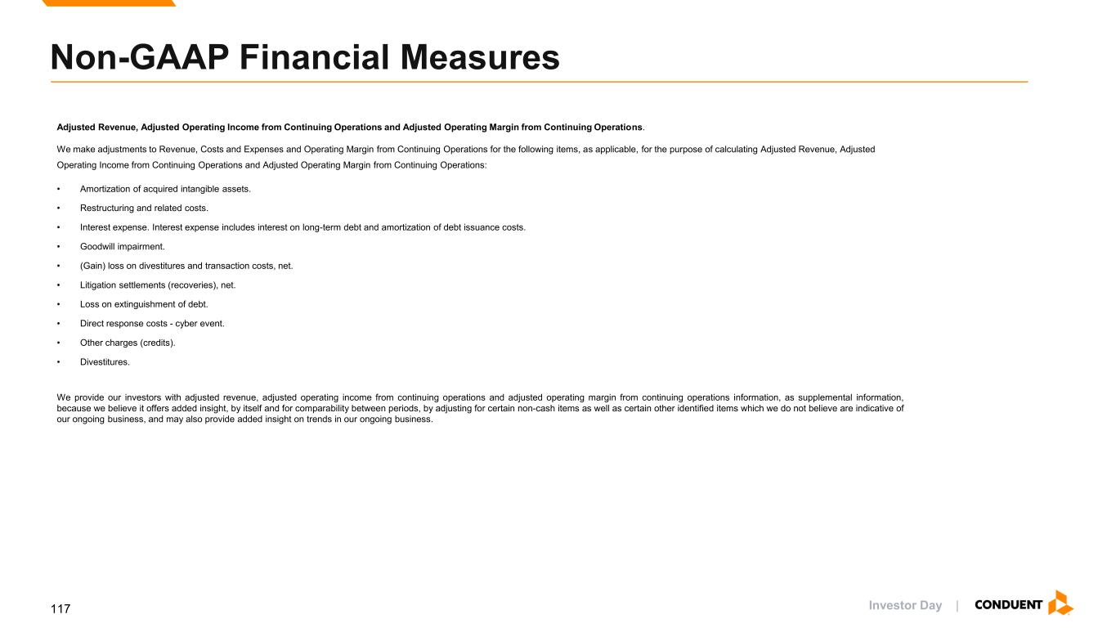
Investor Day | Non-GAAP Financial Measures Adjusted Revenue, Adjusted Operating Income from Continuing Operations and Adjusted Operating Margin from Continuing Operations. We make adjustments to Revenue, Costs and Expenses and Operating Margin from Continuing Operations for the following items, as applicable, for the purpose of calculating Adjusted Revenue, Adjusted Operating Income from Continuing Operations and Adjusted Operating Margin from Continuing Operations: • Amortization of acquired intangible assets. • Restructuring and related costs. • Interest expense. Interest expense includes interest on long-term debt and amortization of debt issuance costs. • Goodwill impairment. • (Gain) loss on divestitures and transaction costs, net. • Litigation settlements (recoveries), net. • Loss on extinguishment of debt. • Direct response costs - cyber event. • Other charges (credits). • Divestitures. We provide our investors with adjusted revenue, adjusted operating income from continuing operations and adjusted operating margin from continuing operations information, as supplemental information, because we believe it offers added insight, by itself and for comparability between periods, by adjusting for certain non-cash items as well as certain other identified items which we do not believe are indicative of our ongoing business, and may also provide added insight on trends in our ongoing business. 117

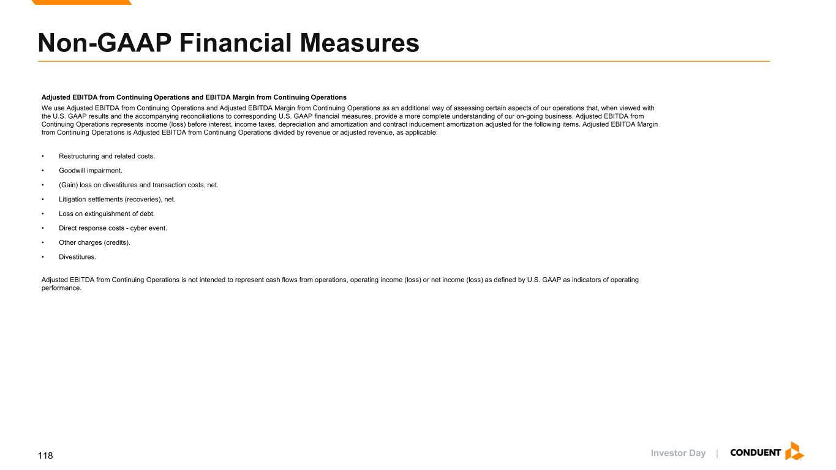
Investor Day | Non-GAAP Financial Measures Adjusted EBITDA from Continuing Operations and EBITDA Margin from Continuing Operations We use Adjusted EBITDA from Continuing Operations and Adjusted EBITDA Margin from Continuing Operations as an additional way of assessing certain aspects of our operations that, when viewed with the U.S. GAAP results and the accompanying reconciliations to corresponding U.S. GAAP financial measures, provide a more complete understanding of our on-going business. Adjusted EBITDA from Continuing Operations represents income (loss) before interest, income taxes, depreciation and amortization and contract inducement amortization adjusted for the following items. Adjusted EBITDA Margin from Continuing Operations is Adjusted EBITDA from Continuing Operations divided by revenue or adjusted revenue, as applicable: • Restructuring and related costs. • Goodwill impairment. • (Gain) loss on divestitures and transaction costs, net. • Litigation settlements (recoveries), net. • Loss on extinguishment of debt. • Direct response costs - cyber event. • Other charges (credits). • Divestitures. Adjusted EBITDA from Continuing Operations is not intended to represent cash flows from operations, operating income (loss) or net income (loss) as defined by U.S. GAAP as indicators of operating performance. 118

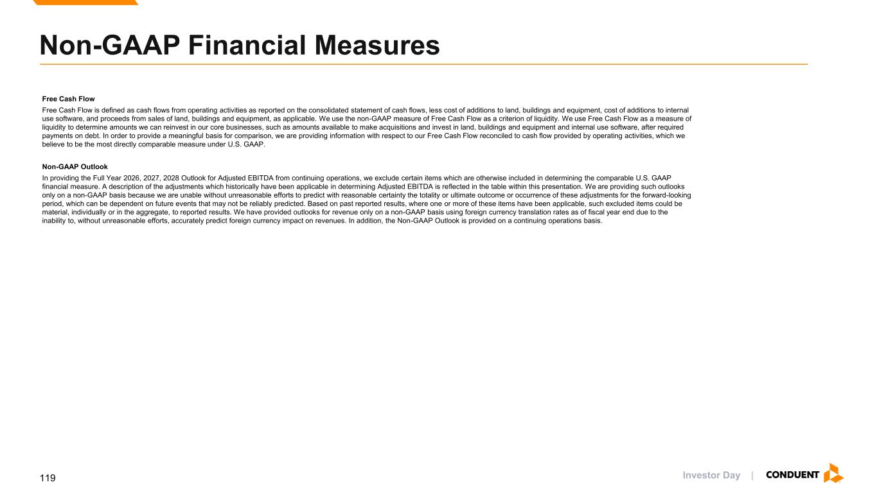
Investor Day | Free Cash Flow Free Cash Flow is defined as cash flows from operating activities as reported on the consolidated statement of cash flows, less cost of additions to land, buildings and equipment, cost of additions to internal use software, and proceeds from sales of land, buildings and equipment, as applicable. We use the non-GAAP measure of Free Cash Flow as a criterion of liquidity. We use Free Cash Flow as a measure of liquidity to determine amounts we can reinvest in our core businesses, such as amounts available to make acquisitions and invest in land, buildings and equipment and internal use software, after required payments on debt. In order to provide a meaningful basis for comparison, we are providing information with respect to our Free Cash Flow reconciled to cash flow provided by operating activities, which we believe to be the most directly comparable measure under U.S. GAAP. Non-GAAP Outlook In providing the Full Year 2026, 2027, 2028 Outlook for Adjusted EBITDA from continuing operations, we exclude certain items which are otherwise included in determining the comparable U.S. GAAP financial measure. A description of the adjustments which historically have been applicable in determining Adjusted EBITDA is reflected in the table within this presentation. We are providing such outlooks only on a non-GAAP basis because we are unable without unreasonable efforts to predict with reasonable certainty the totality or ultimate outcome or occurrence of these adjustments for the forward-looking period, which can be dependent on future events that may not be reliably predicted. Based on past reported results, where one or more of these items have been applicable, such excluded items could be material, individually or in the aggregate, to reported results. We have provided outlooks for revenue only on a non-GAAP basis using foreign currency translation rates as of fiscal year end due to the inability to, without unreasonable efforts, accurately predict foreign currency impact on revenues. In addition, the Non-GAAP Outlook is provided on a continuing operations basis. Non-GAAP Financial Measures 119

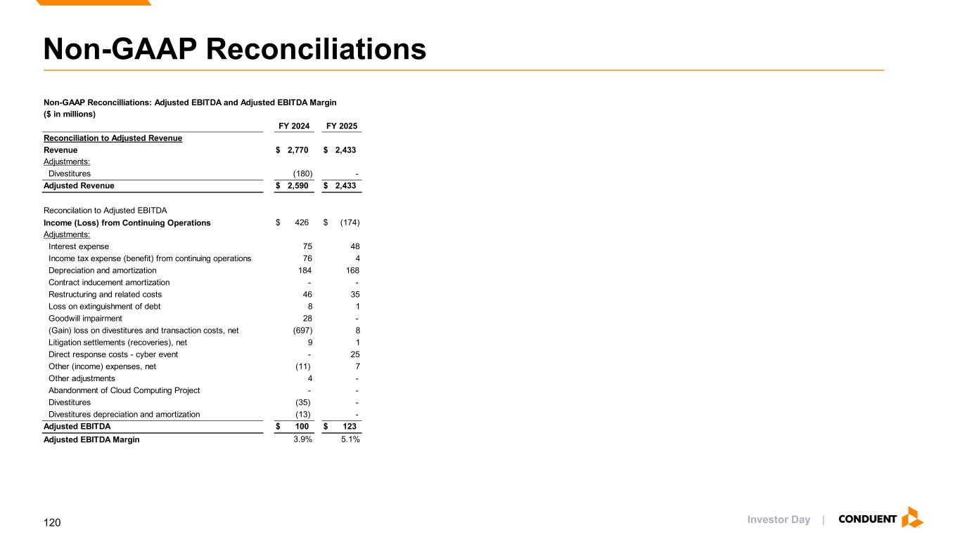
Investor Day | Non-GAAP Reconciliations ($ in millions) FY 2024 FY 2025 Reconciliation to Adjusted Revenue Revenue $ 2,770 $ 2,433 Adjustments: Divestitures (180) - Adjusted Revenue $ 2,590 $ 2,433 Reconcilation to Adjusted EBITDA Income (Loss) from Continuing Operations $ 426 $ (174) Adjustments: Interest expense 75 48 Income tax expense (benefit) from continuing operations 76 4 Depreciation and amortization 184 168 Contract inducement amortization - - Restructuring and related costs 46 35 Loss on extinguishment of debt 8 1 Goodwill impairment 28 - (Gain) loss on divestitures and transaction costs, net (697) 8 Litigation settlements (recoveries), net 9 1 Direct response costs - cyber event - 25 Other (income) expenses, net (11) 7 Other adjustments 4 - Abandonment of Cloud Computing Project - - Divestitures (35) - Divestitures depreciation and amortization (13) - Adjusted EBITDA $ 100 $ 123 Adjusted EBITDA Margin 3.9% 5.1% Non-GAAP Reconcilliations: Adjusted EBITDA and Adjusted EBITDA Margin 120

